**Instruction:**

Complete all questions in **2 hour.**

1. Construct 4 bit Serial In parallel Out shift register using D- flip flop. Explain the Working mechanism of the circuit taking Serial input 1010. Also draw the timing diagram according to the given input.

|  |  |  |  |  |  |
| --- | --- | --- | --- | --- | --- |
| **CLOCK** | **INPUT** | **Q3** | **Q2** | **Q1** | **Q0** |
| **0** | **INITIALLY** | **0** | **0** | **0** | **0** |
| **HIGH** | **1** | **0** | **0** | **0** | **0** |
| **HIGH** | **0** | **1** | **0** | **0** | **0** |
| **HIGH** | **1** | **0** | **1** | **0** | **0`** |
| **HIGH** | **0** | **1** | **0** | **1** | **0** |



The working mechanism is as follow:

when both clock and input are 0, the outputs are also 0. When the value of clock is high and input is 1, then all outputs are 0.

When clock is high and input is low, Q3 is 1 and the remaining are 0. And again, when clock is high and input is 1, then Q2 is 1 and remaining are 0. At last, when clock is high and input is low, Q3 and Q1 are 1 and Q2 and Q0 are 0. This is the working mechanism of 4 bit Serial In parallel Out shift register using D- flip flop with serial input 1010.

1. Design a 3 bit counter using Toggle D flip flop and draw the timing diagram.

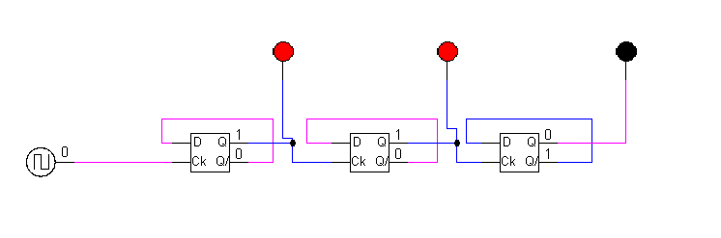

|  |  |  |  |
| --- | --- | --- | --- |
| **Clock(transition)** | **Q2** | **Q1** | **Q0** |
| **1** | **0** | **0** | **0** |
| **2** | **0** | **0** | **1** |
| **3** | **0** | **1** | **0** |
| **4** | **0** | **1** | **1** |
| **5** | **1** | **0** | **0** |
| **6** | **1** | **0** | **1** |
| **7** | **1** | **1** | **0** |
| **8** | **1** | **1** | **1** |

1. Load alu.cct file from the logsim folder. The circuit should look like this

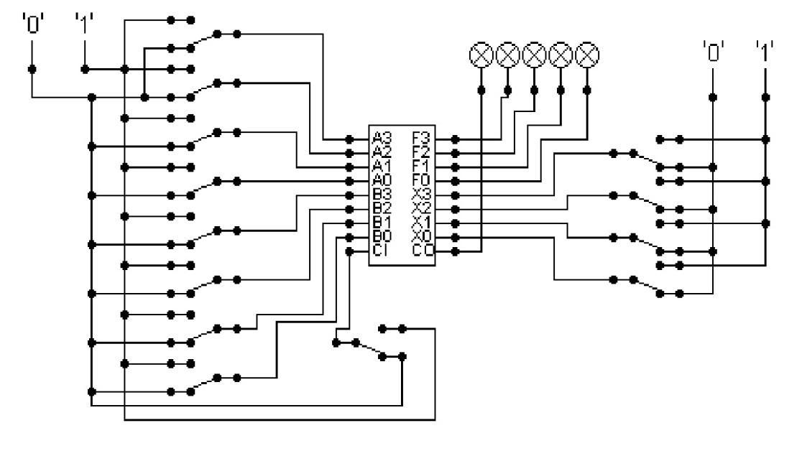

The circuit behaves like a simple arithmetic logic unit. The inputs A0-A3 represent a 4 bit binary number. Inputs B0-B3 represent another binary number. A0 and B0 are the least significant bits respectively. The following table details the functions supported by the chip. All other control lines = 0.

|  |  |  |
| --- | --- | --- |
| Function | Add | Subtract |
| X3-X0 | 1010 | 1011 |

1. Use A= 15 and B = 7

ADD:

SUBTRACT:

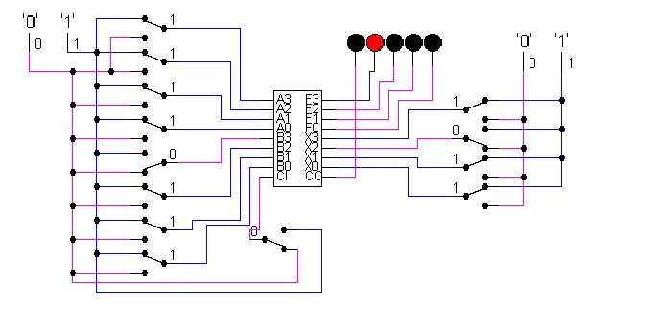

1. Use A = 13 and B = 9

ADD:

SUBTRACT:

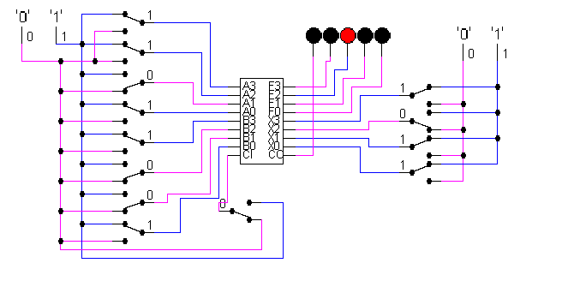

Write the corresponding result of the operations. Manually provide each operation has provided the correct result.

*Thank you.*