Instruction: Attempt all the questions

1. Write the appropriate queries to create the following table and answer the question below:

Create table_name as Employee

|  |  |  |
| --- | --- | --- |
| **Eid** | **Name** | **Address** |
| 1 | Ram | Ktm |
| 2 | Hari | Biratnagar |
| 3 | Shyam | Chitwan |
| 4 | Sita | Ktm |
| 5 | Sandesh | Pokhara |
| 6 | Saraswati | Pokhara |

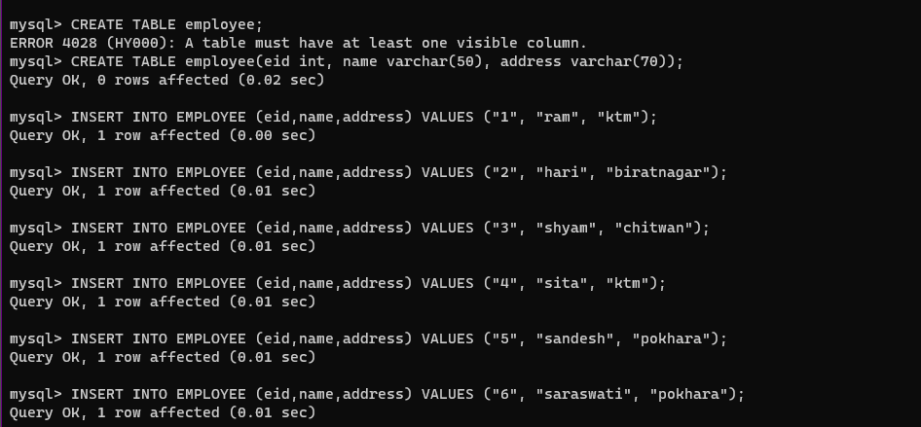

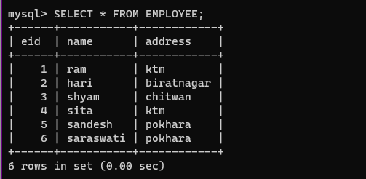

1. Display all records except Eid.

**Select name, address from Employee;**

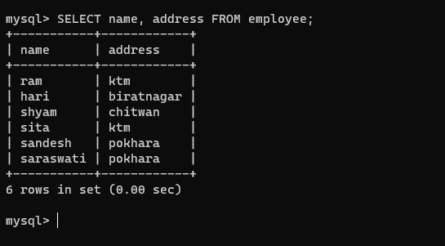

1. Display all Name of the employee in alphabetical order.

**Select * from Employee order by name;**

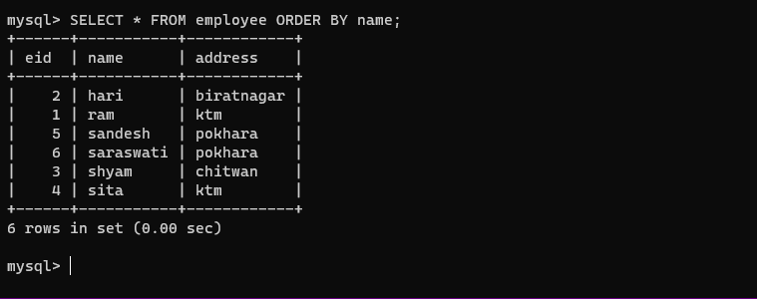

1. Write a query to display the name who lives in ktm and id>2.

**select * from Employee where address =”Kathmandu ” AND id >2;**

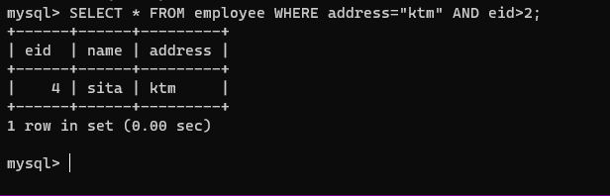

1. Write a query to display the name who lives either in ktm OR Pokhara.

**select * from Employee where address =”Kathmandu ” or address=”Pokhara”;**

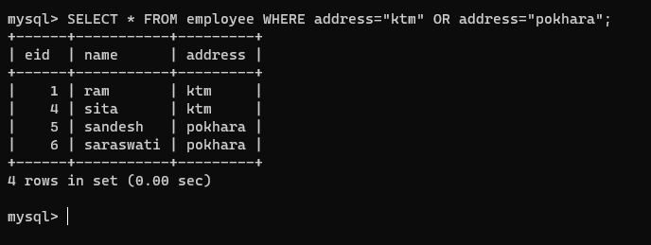

1. Write a query to display the name whose Eid is between 2 and 5.

**Select * from Employee where Eid > 2 and Eid <5;**

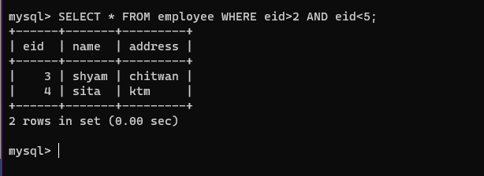

1. List the Name of Employee whose name start with letter ‘S’.

**Select name from Employee where name like(‘s%’);**

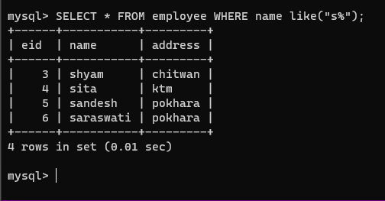

1. List the Name of Employee whose name containing letter ‘e’.

**Select name from Employee where name like(‘%e%’);**

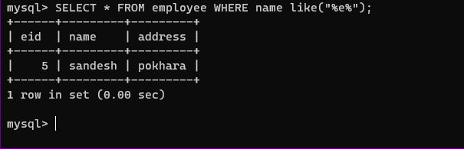

1. Add a new column Esalary in the table Employee after Address field.

**Alter table Employee add column Esalary varchar (40);**

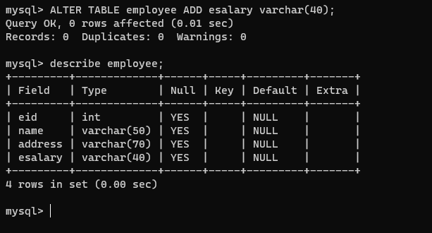

1. After that, delete Esalary field.

**Alter table Employee drop Esalary;**

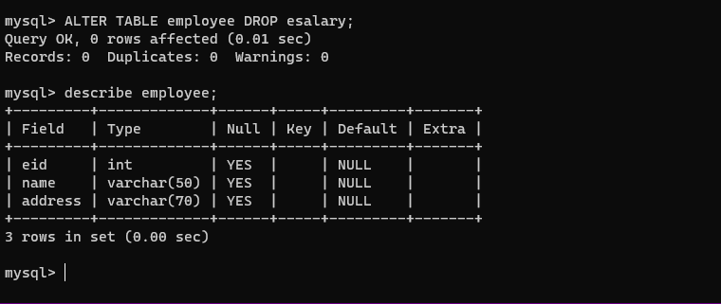

1. Delete all the records of Eid 6.

**Delete form Employee where Eid=6;**

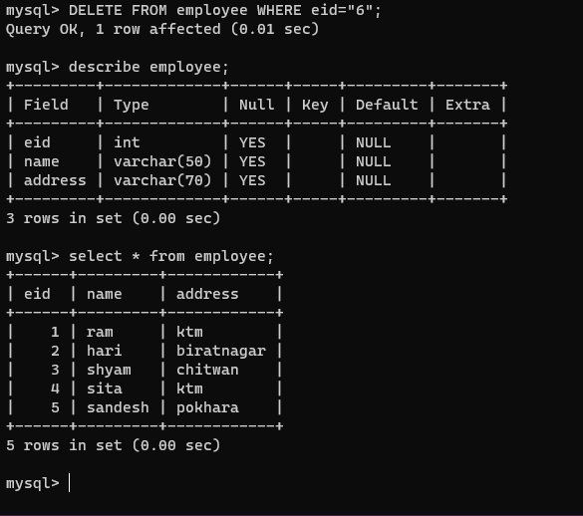

1. Write a SQL statement to create a table “**countries”** including columns country_id, country_name and region_id and make sure that the column country_id will be unique and store an auto incremented value.

**create table countries(country_id int, country_name varchar(20), region_id int, primary key(country_id));**

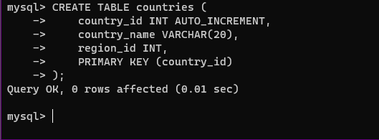

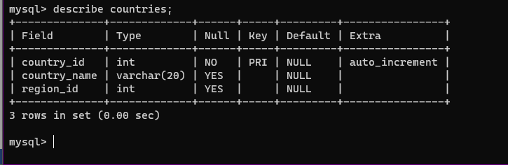

1. Write a SQL statement to create a table named **Jobs** including columns job_id, job_title, min_salary and max_salary, and make sure that, the default value for job_title is blank and min_salary is 8000 and max_salary is NULL will be entered automatically at the time of insertion if no value assigned for the specified columns.

**create table jobs(job_id int, job_title varchar(20) default ' ',min_salary float default 8000, max_salary float default NULL);**

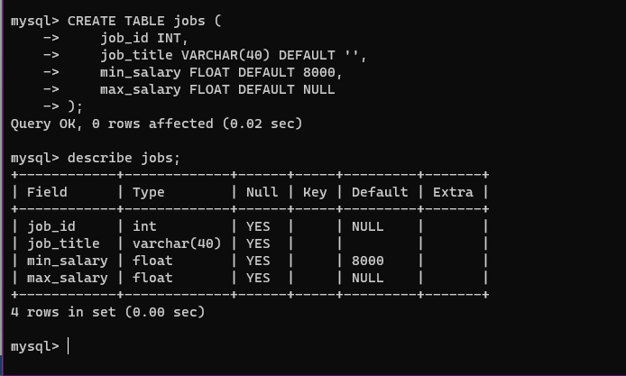

1. On the basis of following table answer the question below:

|  |  |  |  |  |
| --- | --- | --- | --- | --- |
| **Emp_id** | **Name** | **Dep_id** | **Job_title** | **Salary** |
| 1 | Ajit Kumar | 18 | Engineer | 25000.00 |
| 2 | Ujjwal | 5 | Programmer | 32000.00 |
| 3 | Ram Prashad | 5 | Supervisor | 23000.00 |
| 4 | Jyotirma | 18 | Receptionist | 20000.00 |
| 5 | Kanchan | 5 | Programmer | 21000.00 |
| 6 | Daya | 3 | Manager | 35000.00 |
| 7 | Samip | 18 | Supervisor | 24000.00 |

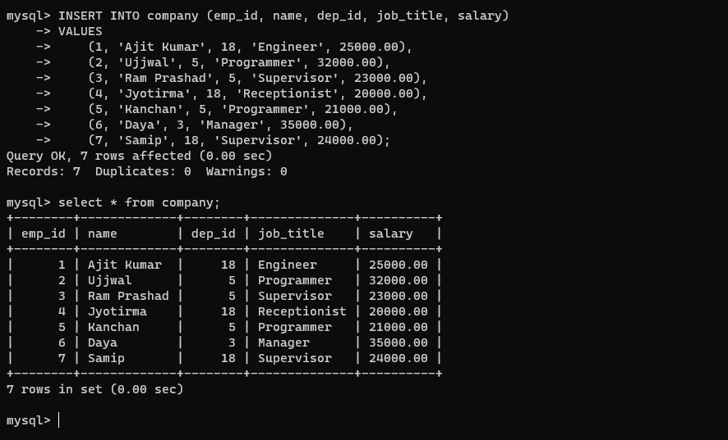

1. Write SQL statement for Emp_id using not null auto_increment.

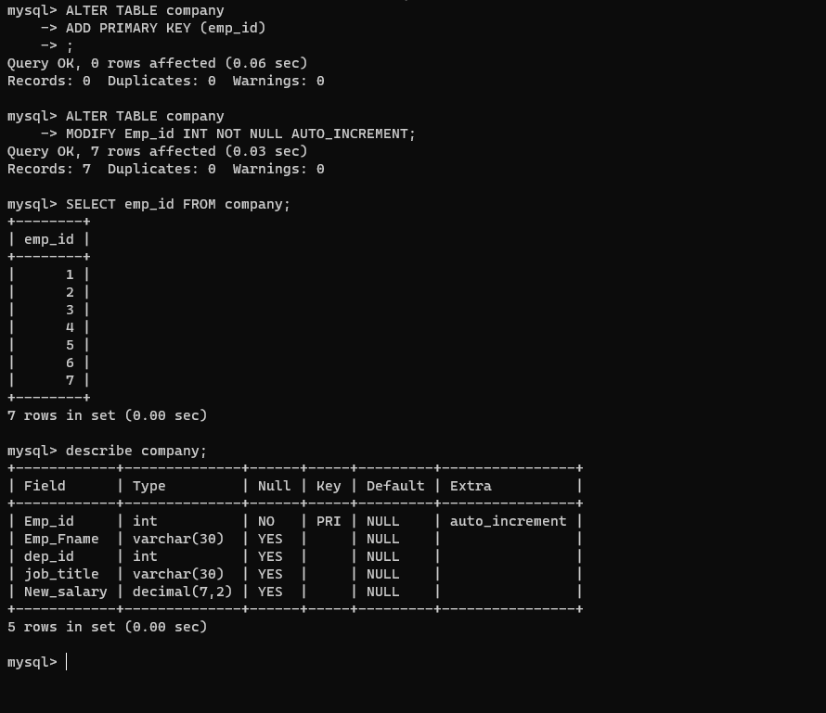

1. Display all the records from field Dep_id 18.

**Select * from table_name where dep_id =18;**

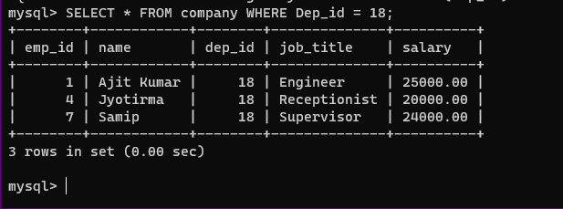

1. Display Emp_id, Name and Salary of all employee’s in ascending order of Salary.

**Select * from Employee order by salary;**

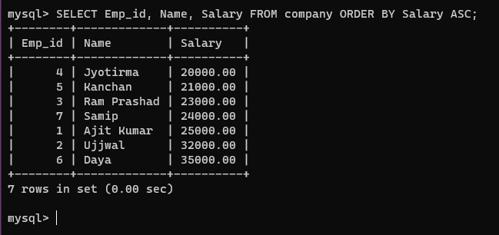

1. Display all the records where Emp_id is less than or equal to 4.

**Select * from Employee where id =4 or id <4;**

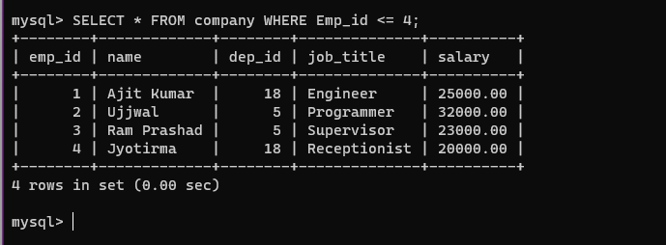

1. Display minimum, maximum, average, total sum salary from above table respectively.

**select max(salary) from emp;**

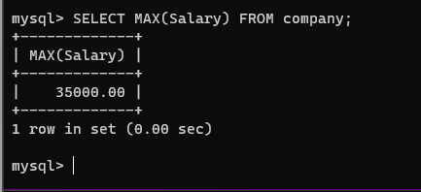

**select min(salary) from emp;**

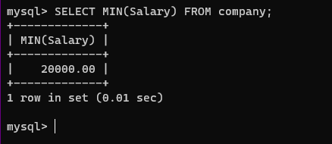

**select avg(salary) from emp;**

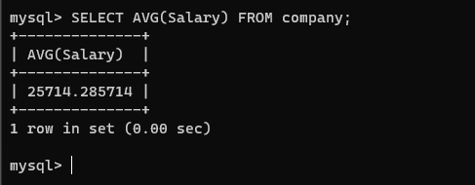

**select sum(salary) from emp;**

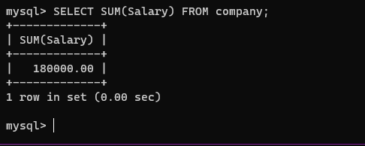

1. Change the column name Name as Emp_Fname.

**Alter table Employee rename column name to emp_name;**

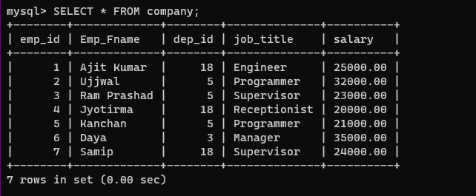

1. Count inserted row using SQL statement.

**Select count(salary) from emp;**

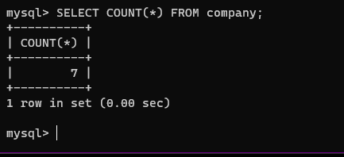

1. Update Emp_id 5 salary to 28000.00.

**Update emp**

**Set salary=28000**

**Where id =1;**

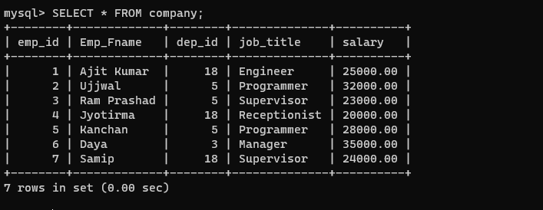

1. Increse all the employee’s salary by five thousand named as New_salary and display all the records from table.

**Alter table Employee rename column salary to new_salary;**

**Update Employee**

**Set new_salary =New_salary+5000**

**Where emp_id<10;**

