Instruction:

Complete all questions in 2:30 hrs

Let’s get started with some helpful Batch scripts:

1. What is Windows Start-up? How can all the start-up programs be viewed?

**Answer:** The programs that are executed when the Windows boots is called windows start-up. All the start-up programs can be viewed by entering "shell:startup" into the Run window.

1. Write a batch script to display a simple “Hello YourName” message during the startup.

**Note: Copy the file to the Startup folder**

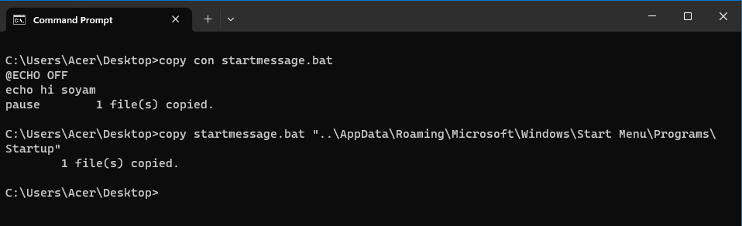

1. Write a batch script to schedule to automatically back up important files and folders to a different location at a scheduled time.

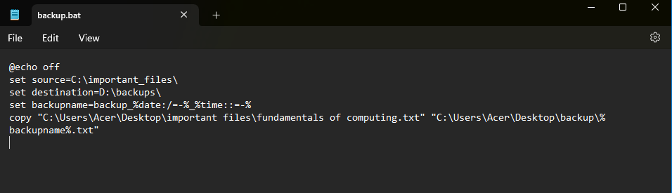

1. Write a Windows batch script that automatically deletes temporary files and clears out the recycle bin to free up space on the hard drive.

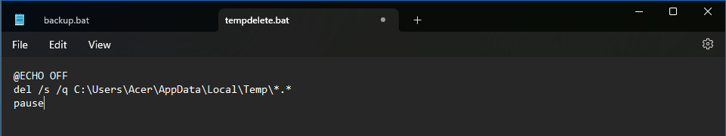

1. Write a windows batch script that can be run to diagnose and troubleshoot common network issues.

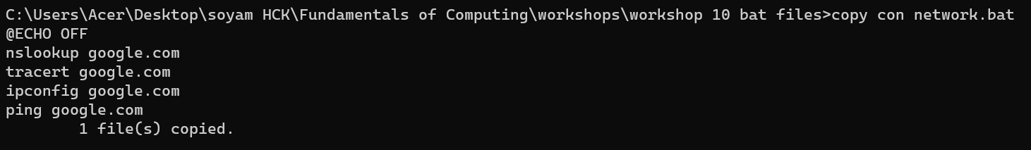

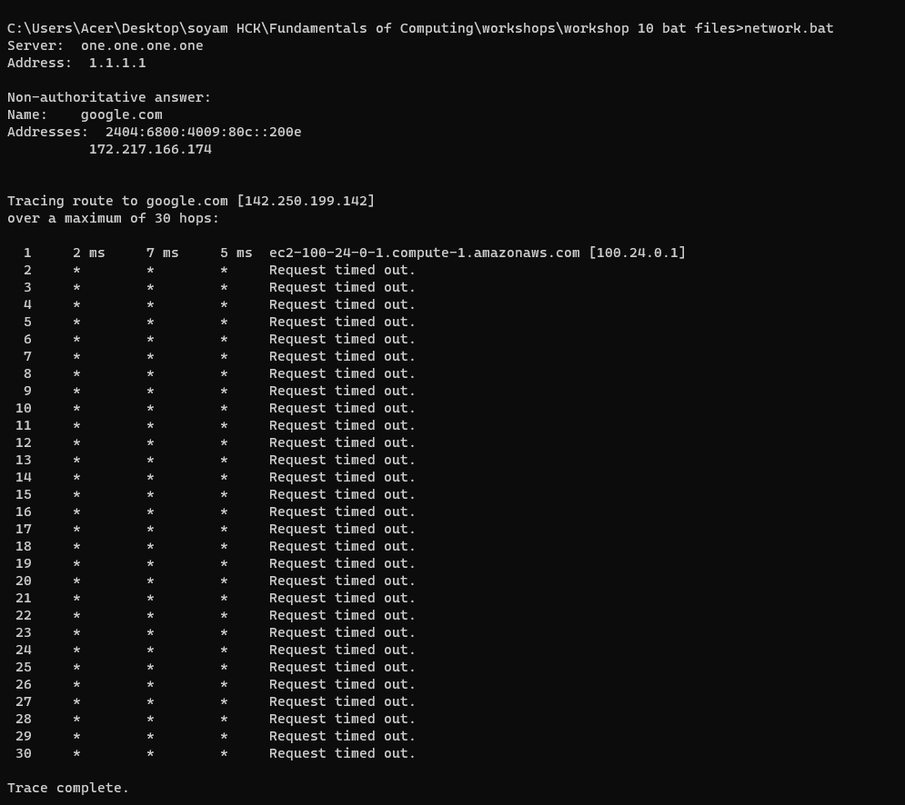

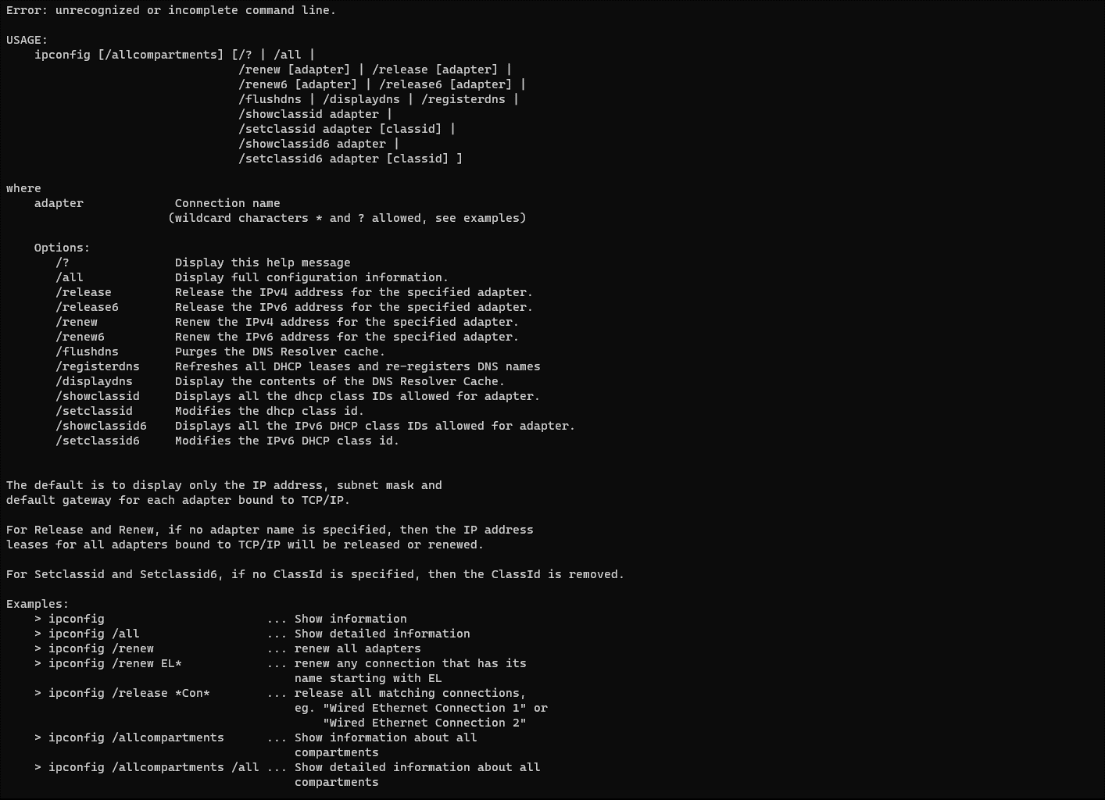



Nslookup: Name server lookup is a command line utility which is used to find the IP addresses or DNS record of a given hostname. For example “nslookup google.com” gives the IP addresses or DNS record of google.com.

Ipconfig: Ipconfig updates Dynamic Host Configuration Protocol (DHCP) & Domain Name System (DNS) settings and displays all current TCP/IP network configuration parameters.

Ping: Ping sends Internet Control Message Protocol (ICMP) Echo Request messages to another TCP/IP machine to confirm IP-level connectivity.

Tracert: Ping sends Internet Control Message Protocol (ICMP) Echo Request messages to another TCP/IP machine to confirm IP-level connectivity.

1. Write a batch script that can be scheduled to shut down the computer at a specific time(**using** **WINDOWS TASK SCHEDULER**).

|  |
| --- |
|  |
|  |
|  |
|  |
|  |
|  |

1. Copy the following script Save this and run this in the **Downloads** directory or any directory you want.

*@echo off*

*for %%a in (".\*") do (*

*if "%%~xa" NEQ "" if "%%~dpxa" NEQ "%~dpx0" (*

*if not exist "%%~xa" mkdir "%%~xa" (*

*move "%%a" "%%~dpa%%~xa\"*

*)*

*)*

*)*

What does the above script do? Elaborate on your answer.

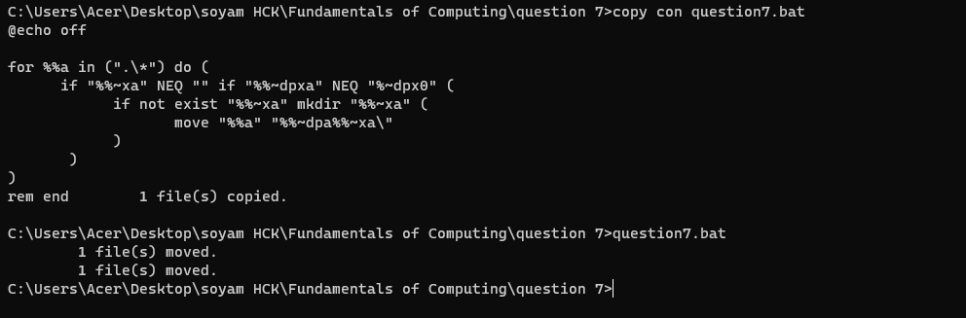

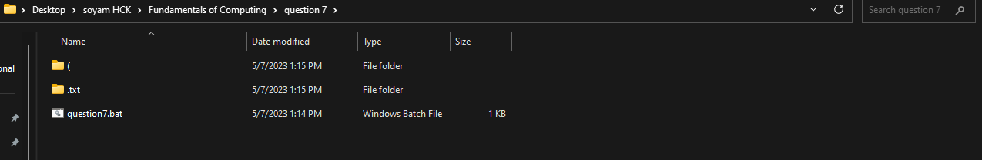

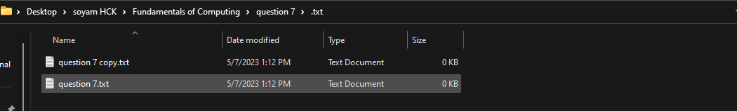

The given batch script code above, does the following things.

The bat file copies the files from the directory where it runs and creates different folders of different extensions within that directory, then it copies the files and pastes it to its matching extensions folder. For example, there are 3 files (fundamental.txt, fund.docx, fund.jpg) in the directory named “abc”. Then it makes three separate folders as txt, docx, and jpg. After that it copies the file fundamentals.txt to the folder “txt”. Same for fund.docx, copies to the folder “docx”. And copies fund.jpg to the folder “jpg”.