**Attempt all questions**

1. Write a command to check our windows version.

Answer: The command to check our windows version is “slmgr /dlv”

1. Show the current date of your system using the command.

Answer: We can show the current date of our system by using “date” command.

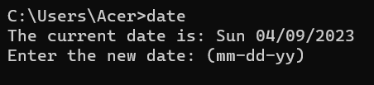

1. Create the directory date. Within that directory create a text file to show the current system date.

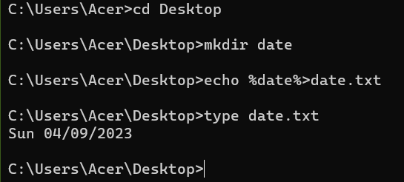

1. Show the system information using the command.

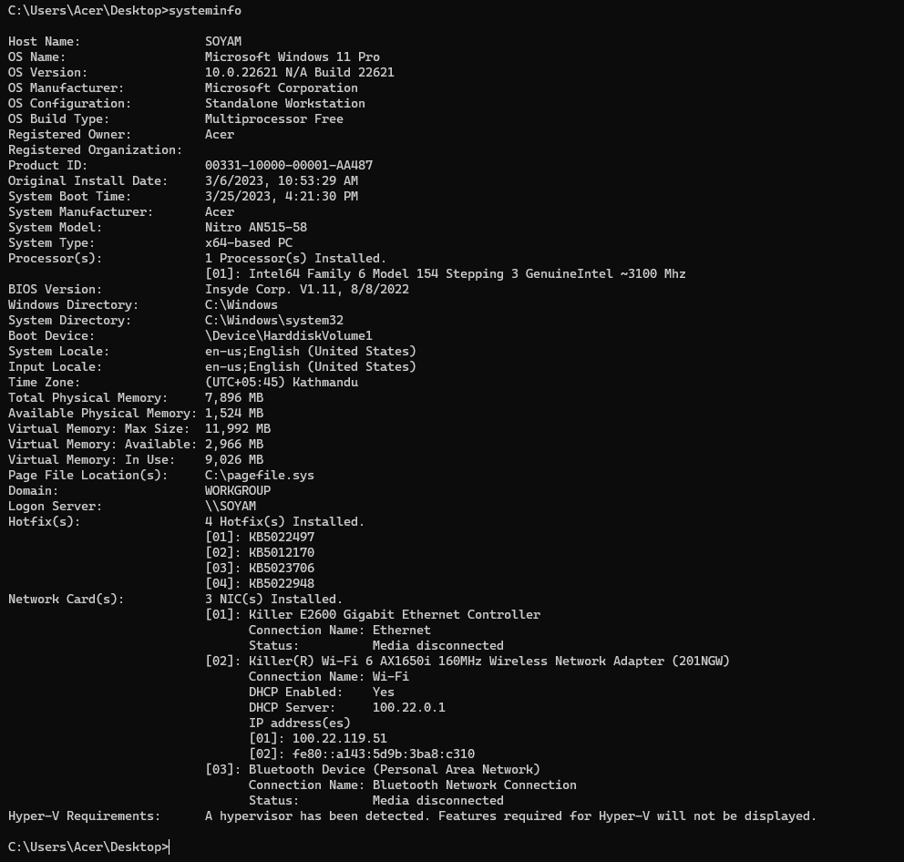

1. Create the directory called **systemInfo** and create the file name **systemInfo.txt**. In that file all your system information should be auto generated using the command.

1. Launch the **systeminfo.txt** using notepad using the command.

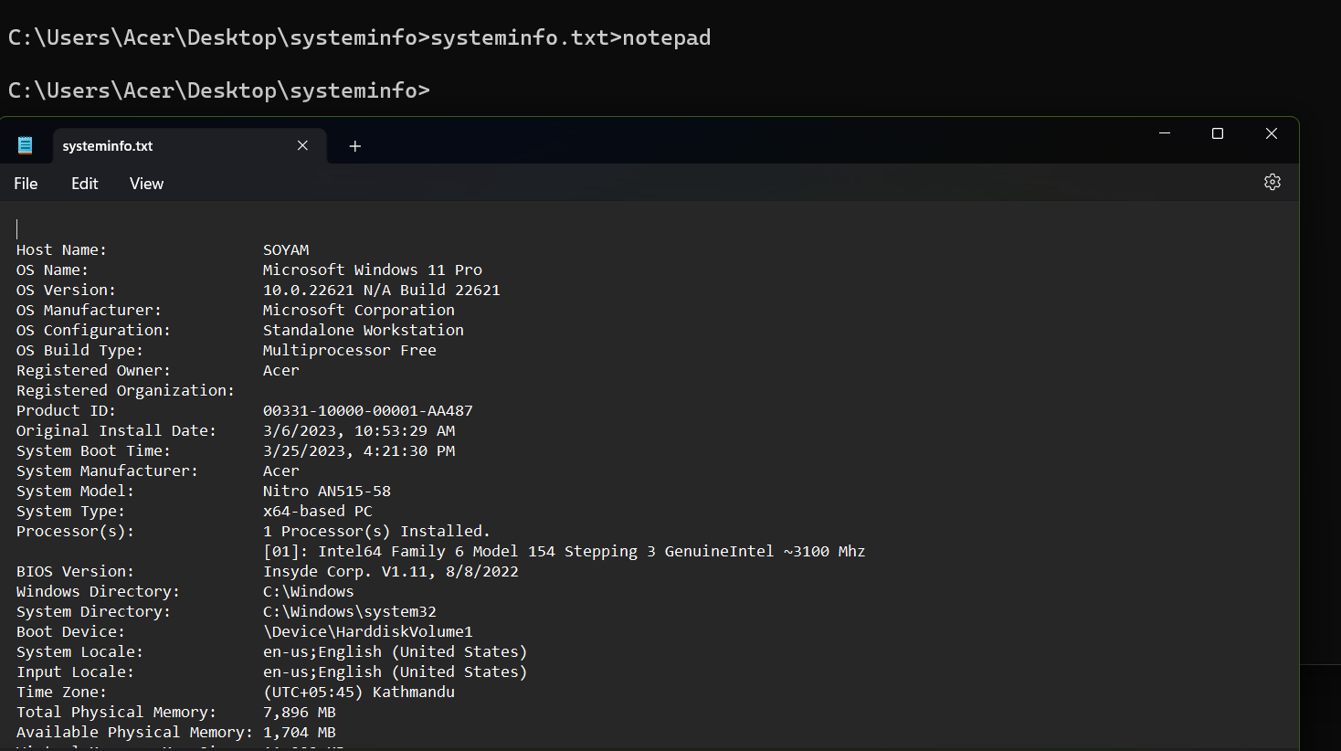

1. Briefly explain about the Ping, getmac, ipconfig, powercfg command.

Answer: The Ping command is used to test network connection. The ping command tests network connectivity between two devices by sending ICMP echo requests.

The getmac command is used to get mac address. This command returns the MAC address from all the network cards on a system.

The ipconfig command is used to get network adapter details. The ipconfig command is used to display a computers TCP/IP configuration. This command can also display the DNS cache on the local machine, flush DNS, release and renew the DHCP address on all network cards.

The powercfg command is used to get the following details Change monitor timeout, List all power schemes, List and configure power settings and more,

1. Ping the google domain and paste the screenshot.

1. Show the ip address of your device.

1. What is the use of the FC command?

Answer: The command which compares two files and displays the difference between the two is known as fc command. It used to compare and display the difference between two files.

1. Create the directory called difference. In that directory create two files File1.txt and File2.txt. Add contents in 2 files and perform the ascii comparison of these 2 files.

1. Generate the power efficiency diagnostics report using the command.

1. What does the CHKDSK do?

Answer: CHKDSK is a command line tool that checks disks. The CHKDSK command scans the file system on the disk and checks the integrity of the files and metadata.

1. Use the command in no.13 to check your disk space and repair any problem if it exists.

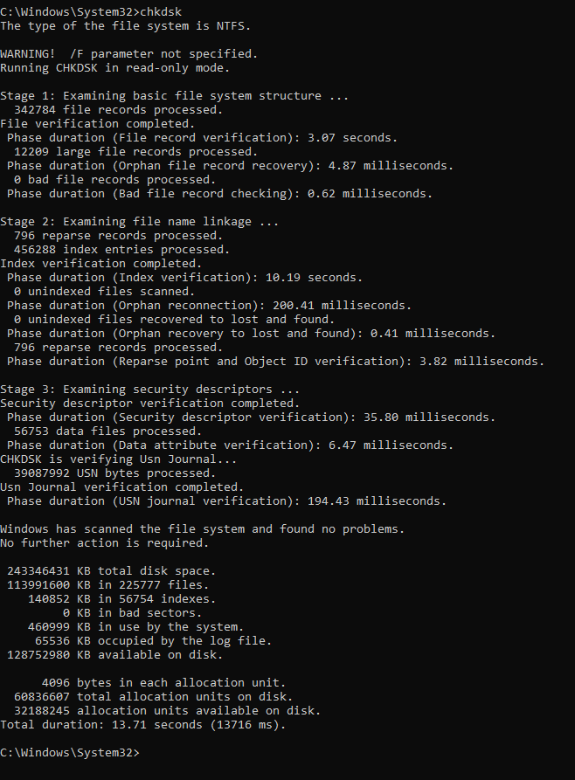

1. Explain doskey /history command.

Answer: Doskey is an MS-DOS utility that allows the user to keep a history of all commands used on a computer. Doskey allows frequently used commands to be executed without having to type them each time they are needed. This command displays all commands that are stored in memory.