Copy of Week 9 Instruction:

Complete all questions in 2 hrs.

1. Start the Terminal program from the top menu bar (Applications -> Accessories -> Terminal).

1. Use commands cd, cd .. , cd / to navigate through the directories. Create the directory HCK in the desktop.

1. Write the command to print the current working directory. List the files and directories in the current working directories. Insert the image of your terminal here.

The command to print the current working directory is “pwd” command.

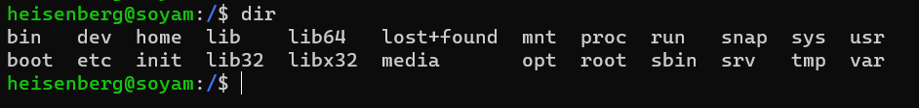

1. Create a New.txt file containing text “Herald College Kathmandu”, in the HCK directory.

1. Delete New.txt file from HCK directory.

1. Remove directory HCK from the Desktop.

1. Create directory Kathmandu in the desktop containing file Swayambhu.txt,

Rename Swayambhu.txt as Barahi.txt

1. Create Directory Pokhara in the Desktop and move Bahari.txt of directory

Kathmandu in directory Pokhara.

1. What is the command to list all the invisible files and to display the directories in detail?

**Answer:** The command to list all the invisible files is “ls -a” and to display the directories in detail is “ls -F”

1. What is the command to make a directory named IPHONE and IPAD and remove the directory named IPAD?

**Answer:** The command to make a directory named IPHONE and IPAD is “mkdir IPHONE, IPAD” and to remove the directory named IPAD is “rmdir IPAD”

1. Create file hck.txt containing text “Herald College Kathmandu” and another file hck1.txt containing text “Sanugaucharan, Naxal” concatenate these two files and give name heraldCollege.txt.

Hck

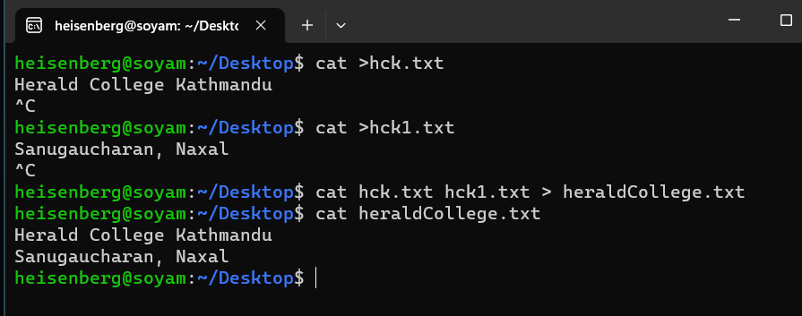

1. Create filename1.txt and filename2.txt in the Desktop and create a compressed file new.zip which contains filename1.txt and filename2.txt.

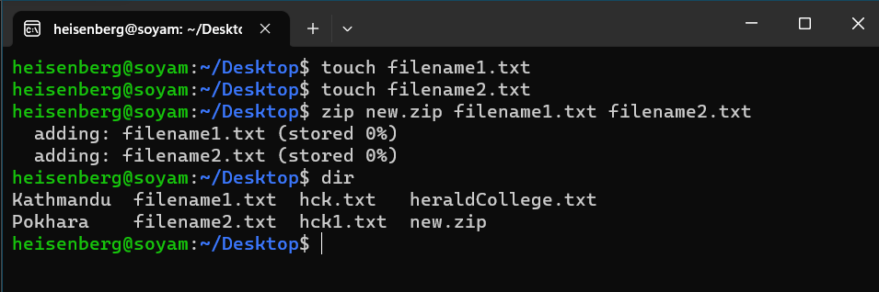

1. Check the permissions for User, group and world for new.zip and set read permission for user, read and write permission for group and read write and execute permission for world.

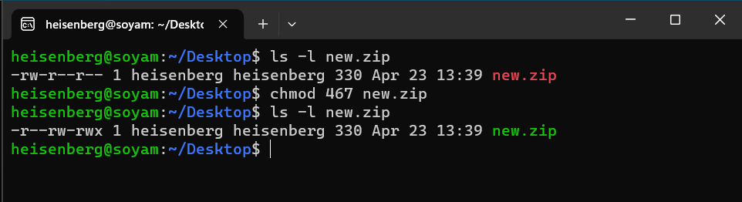

1. Write the command to check your last 10 commands.

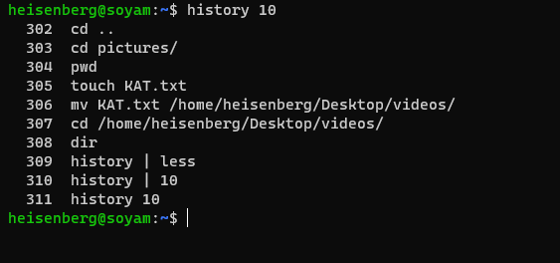

1. Write the command to check current user.

1. Write the command to add user having user name newuser and switch to newuser.

#there was an error doing the following question

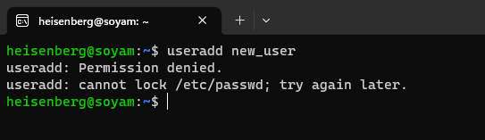

1. Create the following directories in and paste your result here.



