Instruction:

Complete all questions in 2:30 hrs

Let’s get started with some helpful Batch scripts:

1. What is Windows Start-up? How can all the start-up programs be viewed?

**Answer:** The programs that are executed when the Windows boots is called windows start-up. All the start-up programs can be viewed by entering "shell:startup" into the Run window.

1. Write a batch script to display a simple “Hello YourName” message during the startup.

**Note: Copy the file to the Startup folder**

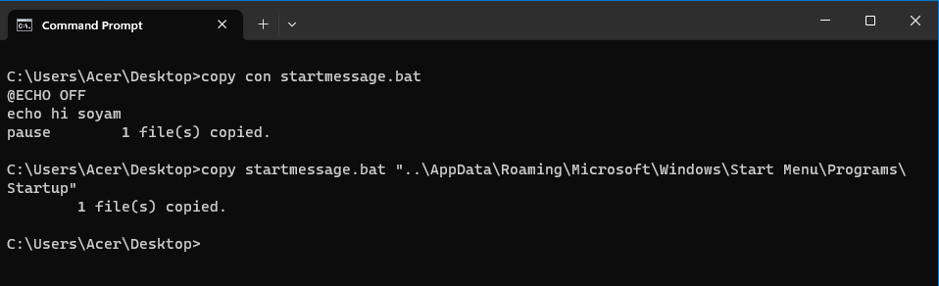

1. Write a batch script to schedule to automatically back up important files and folders to a different location at a scheduled time.
2. Write a Windows batch script that automatically deletes temporary files and clears out the recycle bin to free up space on the hard drive.
3. Write a windows batch script that can be run to diagnose and troubleshoot common network issues
4. Write a batch script that can be scheduled to shut down the computer at a specific time(**using** **WINDOWS TASK SCHEDULER**).
5. Copy the following script Save this and run this in the **Downloads** directory or any directory you want.

*@echo off*

*for %%a in (".\*") do (*

*if "%%~xa" NEQ "" if "%%~dpxa" NEQ "%~dpx0" (*

*if not exist "%%~xa" mkdir "%%~xa" (*

*move "%%a" "%%~dpa%%~xa\"*

*)*

*)*

*)*

What does the above script do? Elaborate on your answer.