Retesting [EBC-13916](https://jira.safeway.com/browse/EBC-13916) Mapping and code fix for following mentioned issue

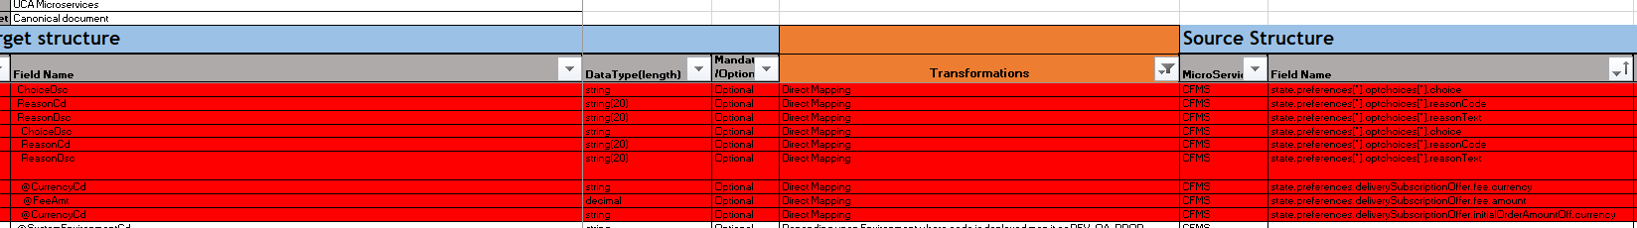

Test Result:Pass

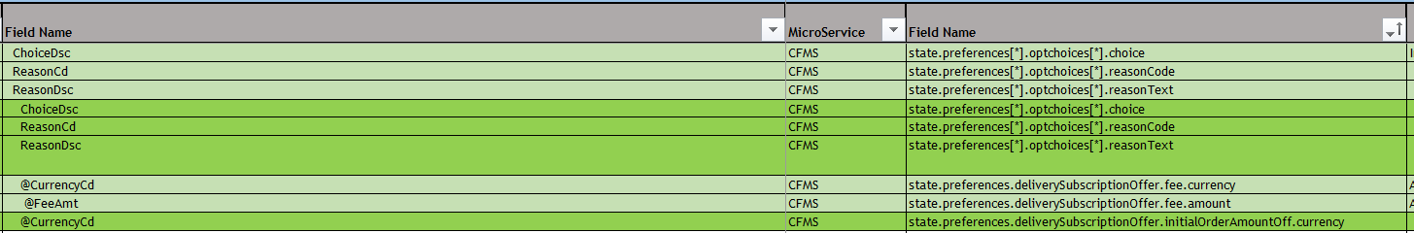

{"_id":"CustomerPreferences_3f47af31-7110-499f-9f7b-010202645bc0","_class":"PreferenceAggregateStateDomain_v1","aggregateId":"3f47af31-7110-499f-9f7b-010202645bc0","aggregateType":"CustomerPreferences","state":{"_class":"PreferenceAggregateDomain_v1","createTimestamp":{"$numberLong":"1571121879465"},"lastUpdateTimestamp":{"$numberLong":"1603443904787"},"createClientId":"EDSS","lastUpdateClientId":"web-portal","createHostName":"CustomerPreferenceManagementService-Prod-2","lastUpdateHostName":"172.31.192.65","aggregateId":"3f47af31-7110-499f-9f7b-010202645bc0","aggregateType":"CustomerPreferences","sequenceNumber":35,"timestamp":{"$numberLong":"1603443904773"},"aggregateRevision":35,"version":1,"eventId":"s414e09d-e21f-4b05-9cc6-15f6142b3a4a","guid":"{{guid}}","preferences":[{"_class":"DeliverySubscriptionPreferenceAggregateDomain_v1","preferenceId":0,"value":"f9b88f7e-5f54-4536-afc0-8b080d189cdf","type":"MONTHLYPLAN","categoryCode":"DELIVERY","subCategoryCode":"SUBSCRIPTION","optChoices":[{"_class":"OptChoiceAggregateDomain_v1","choice":"CANCELLED","reasonCode":"CHANGE_PLAN","reasonText":"Not Processed"}],"effectiveTimePeriods":[{"_class":"EffectiveTimePeriodAggregateDomain_v1","type":"ACTIVE","inclusiveInd":1,"endDate":"2019-12-13","endTime":"00:00"}],"deliverySubscriptionOffer":{"_class":"DeliverySubcriptionOfferAggregateDomain_v1","serviceFeeWaived":0,"deliveryFeeWaived":1,"fuelSurchargeWaived":1,"minBasketSize":30,"fee":{"_class":"CurrencyDomain_v1","currency":"USD","amount":14.99},"initialOrderAmountOff":{"_class":"CurrencyDomain_v1","currency":"USD","amount":20},"signUpFee":{"_class":"CurrencyDomain_v1","currency":"USD","amount":14.99}},"autoEnroll":0,"autoRenew":0,"serviceType":"1"},{"_class":"BasicPreferenceAggregateDomain_v1","preferenceId":1,"value":"1515","type":"J4U","categoryCode":"ENTERPRISE","subCategoryCode":"STORE","preferredInd":0,"lastUpdatedTimestamp":{"$numberLong":"1584461293000"}},{"_class":"BasicPreferenceAggregateDomain_v1","preferenceId":2,"value":"LC","categoryCode":"SHOPPING_LIST","subCategoryCode":"J4U","preferredInd":0},{"_class":"BasicPreferenceAggregateDomain_v1","preferenceId":3,"value":"AL","type":"ITEMS_PER_PAGE","categoryCode":"DISPLAY","subCategoryCode":"PAGINATION","preferredInd":0},{"_class":"BasicPreferenceAggregateDomain_v1","preferenceId":4,"value":"S","type":"YCS_TOP_10","categoryCode":"DISPLAY","subCategoryCode":"SORT","preferredInd":0},{"_class":"BasicPreferenceAggregateDomain_v1","preferenceId":5,"type":"1","categoryCode":"DISPLAY","subCategoryCode":"HIDDEN_CATEGORY","preferredInd":0,"optChoices":[{"_class":"OptChoiceAggregateDomain_v1","choice":"1"}]},{"_class":"BasicPreferenceAggregateDomain_v1","preferenceId":6,"type":"10","categoryCode":"DISPLAY","subCategoryCode":"HIDDEN_CATEGORY","preferredInd":0,"optChoices":[{"_class":"OptChoiceAggregateDomain_v1","choice":"1"}]},{"_class":"BasicPreferenceAggregateDomain_v1","preferenceId":7,"type":"19","categoryCode":"DISPLAY","subCategoryCode":"HIDDEN_CATEGORY","preferredInd":0,"optChoices":[{"_class":"OptChoiceAggregateDomain_v1","choice":"1"}]},{"_class":"BasicPreferenceAggregateDomain_v1","preferenceId":8,"type":"EMAIL_SAVE","categoryCode":"COMMUNICATION","subCategoryCode":"PROMOTIONAL","preferredInd":0,"optChoices":[{"_class":"OptChoiceAggregateDomain_v1","choice":"OPT_IN"}]},{"_class":"BasicPreferenceAggregateDomain_v1","preferenceId":9,"type":"J4U","categoryCode":"COMMUNICATION","subCategoryCode":"PROMOTIONAL","preferredInd":0,"optChoices":[{"_class":"OptChoiceAggregateDomain_v1","choice":"OPT_IN"}]},{"_class":"BasicPreferenceAggregateDomain_v1","preferenceId":10,"type":"GROCERY_DEL","categoryCode":"COMMUNICATION","subCategoryCode":"PROMOTIONAL","preferredInd":0,"optChoices":[{"_class":"OptChoiceAggregateDomain_v1","choice":"OPT_IN"}]},{"_class":"BasicPreferenceAggregateDomain_v1","preferenceId":11,"value":"DUG","categoryCode":"FULFILLMENT","subCategoryCode":"METHOD","preferredInd":0,"bannerId":"1","lastUpdatedTimestamp":{"$numberLong":"1596507326000"}},{"_class":"BasicPreferenceAggregateDomain_v1","preferenceId":12,"value":"1515","type":"DUG","categoryCode":"ENTERPRISE","subCategoryCode":"STORE","preferredInd":0,"bannerId":"1","lastUpdatedTimestamp":{"$numberLong":"1596507326000"}},{"_class":"BasicPreferenceAggregateDomain_v1","preferenceId":13,"type":"NAME_PRINTED","categoryCode":"RECEIPT","subCategoryCode":"PAPER","preferredInd":0,"lastUpdatedTimestamp":{"$numberLong":"1595699991000"},"optChoices":[{"_class":"OptChoiceAggregateDomain_v1","choice":"OPT_IN"}]},{"_class":"BasicPreferenceAggregateDomain_v1","preferenceId":14,"type":"GLOBAL","categoryCode":"COMMUNICATION","subCategoryCode":"PROMOTIONAL","preferredInd":0,"lastUpdatedTimestamp":{"$numberLong":"1595699991000"},"optChoices":[{"_class":"OptChoiceAggregateDomain_v1","choice":"OPT_IN"}]}]}}

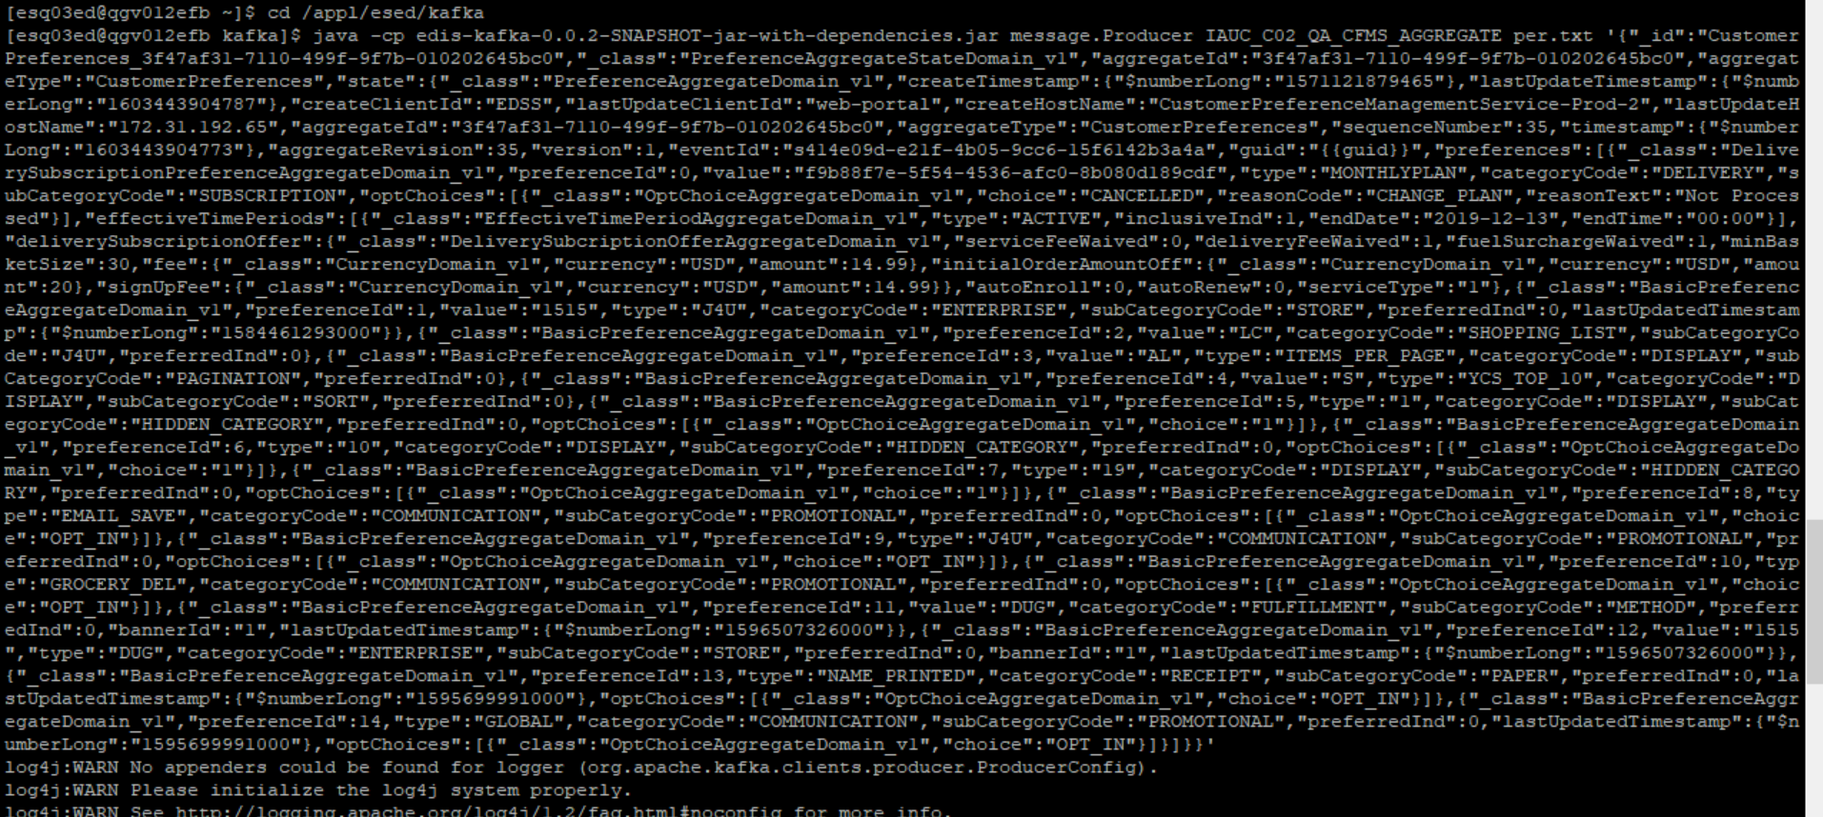

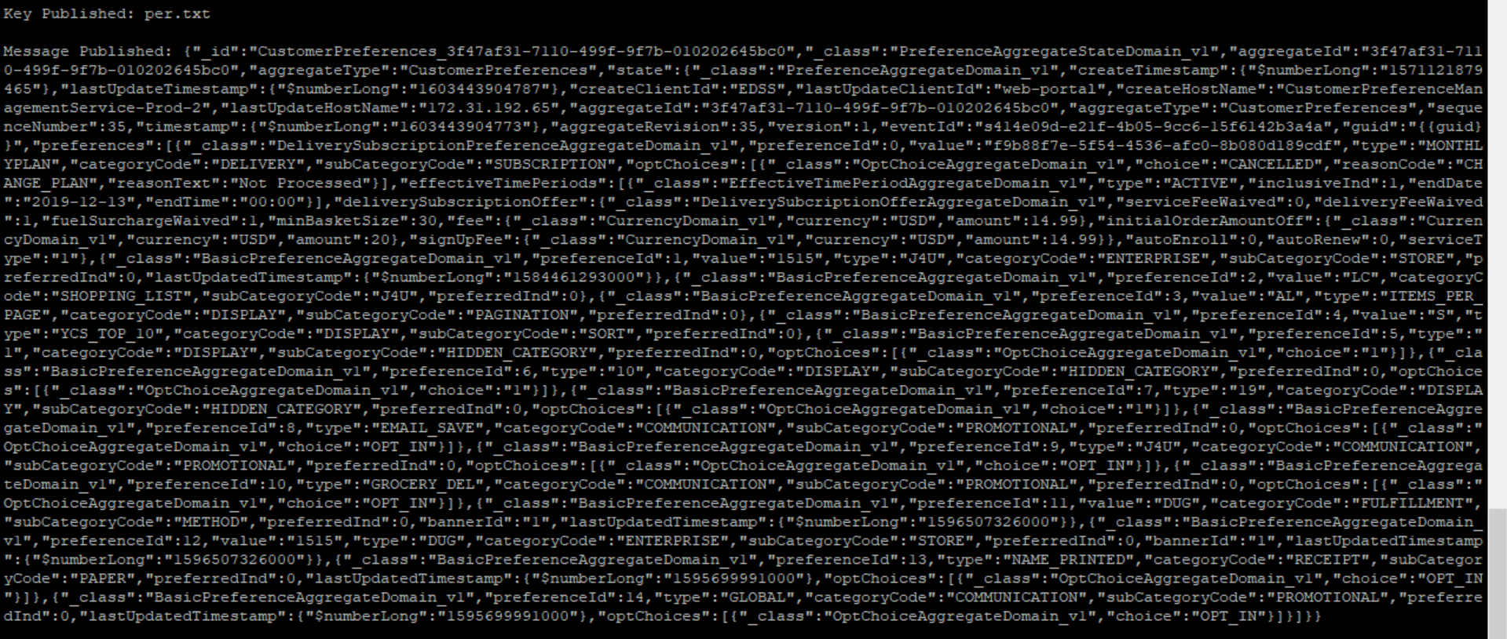

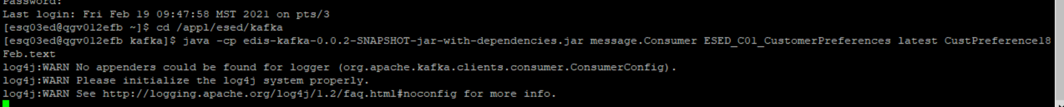

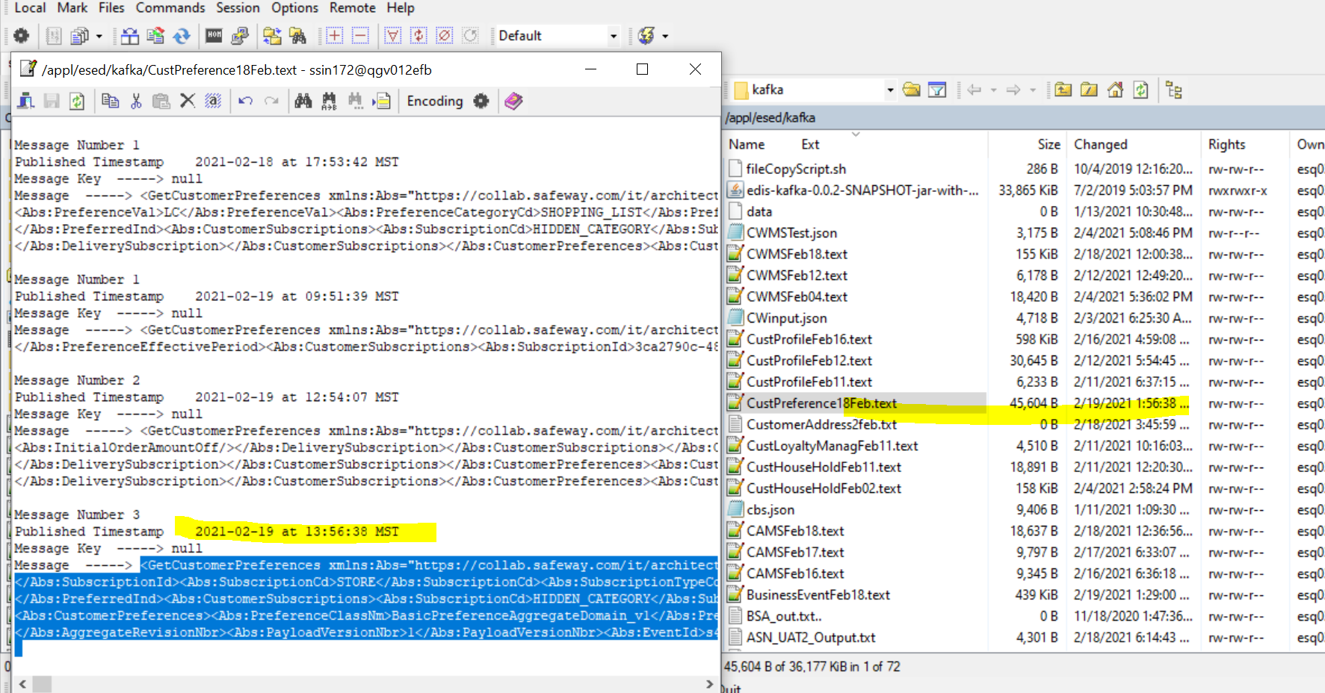

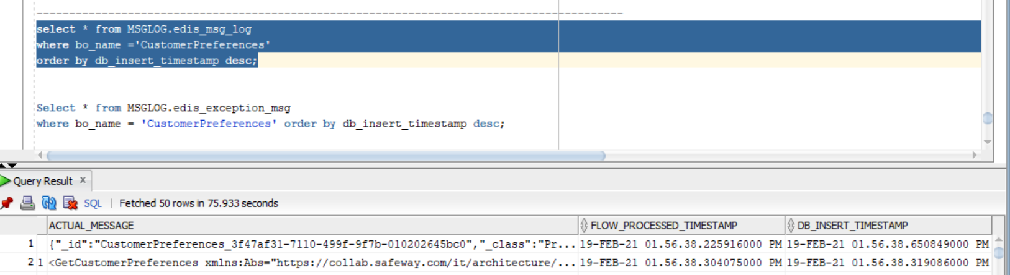

CMM xml-

<GetCustomerPreferences

xmlns:Abs="https://collab.safeway.com/it/architecture/info/default.aspx">

<DocumentData>

<Document VersionId="3.1.4.029" SystemEnvironmentCd="QA">

<Abs:DocumentID>IAUC_C02_QA_CFMS_AGGREGATE</Abs:DocumentID>

<Abs:AlternateDocumentID>IAUC_C02_QA_CFMS_AGGREGATE_1_950_20210219135638228678</Abs:AlternateDocumentID>

<Abs:InboundOutboundInd>Outbound from Albertsons</Abs:InboundOutboundInd>

<Abs:DocumentNm>GetCustomerPreference</Abs:DocumentNm>

<Abs:CreationDt>2021-02-19T13:56:38.228678</Abs:CreationDt>

<Abs:Description>Retail customer&apos;s generic preferences and the subscriptions</Abs:Description>

<Abs:SourceApplicationCd>CFMS</Abs:SourceApplicationCd>

<Abs:TargetApplicationCd>EDIS</Abs:TargetApplicationCd>

<Abs:InternalFileTransferInd>Y</Abs:InternalFileTransferInd>

<Abs:DataClassification>

<Abs:DataClassificationLevel>

<Abs:Code>Internal</Abs:Code>

</Abs:DataClassificationLevel>

<Abs:BusinessSensitivityLevel>

<Abs:Code>Low</Abs:Code>

</Abs:BusinessSensitivityLevel>

<Abs:PHIdataInd>N</Abs:PHIdataInd>

<Abs:PCIdataInd>N</Abs:PCIdataInd>

<Abs:PIIdataInd>N</Abs:PIIdataInd>

</Abs:DataClassification>

</Document>

<DocumentAction>

<Abs:ActionTypeCd>UPDATE</Abs:ActionTypeCd>

<Abs:RecordTypeCd>CHANGE</Abs:RecordTypeCd>

</DocumentAction>

</DocumentData>

<CustomerPreferencesData>

<Abs:CustomerId>3f47af31-7110-499f-9f7b-010202645bc0</Abs:CustomerId>

<Abs:CustomerPreferences>

<Abs:PreferenceClassNm>DeliverySubscriptionPreferenceAggregateDomain_v1</Abs:PreferenceClassNm>

<Abs:PreferenceCd>0</Abs:PreferenceCd>

<Abs:PreferenceTypeCd>MONTHLYPLAN</Abs:PreferenceTypeCd>

<Abs:PreferenceVal>f9b88f7e-5f54-4536-afc0-8b080d189cdf</Abs:PreferenceVal>

<Abs:PreferenceCategoryCd>DELIVERY</Abs:PreferenceCategoryCd>

<Abs:PreferenceSubCategoryCd>SUBSCRIPTION</Abs:PreferenceSubCategoryCd>

<Abs:OptChoice>

<Abs:ChoiceDsc>CANCELLED</Abs:ChoiceDsc>

<Abs:ReasonCd>CHANGE_PLAN</Abs:ReasonCd>

<Abs:ReasonDsc>Not Processed</Abs:ReasonDsc>

</Abs:OptChoice>

<Abs:PreferenceEffectivePeriod Abs:typeCode="ACTIVE">

<Abs:LastEffectiveDt>2019-12-13</Abs:LastEffectiveDt>

<Abs:LastEffectiveTm>00:00:00.000</Abs:LastEffectiveTm>

<Abs:InclusiveInd>1</Abs:InclusiveInd>

</Abs:PreferenceEffectivePeriod>

<Abs:CustomerSubscriptions>

<Abs:SubscriptionId>f9b88f7e-5f54-4536-afc0-8b080d189cdf</Abs:SubscriptionId>

<Abs:SubscriptionCd>SUBSCRIPTION</Abs:SubscriptionCd>

<Abs:SubscriptionTypeCd>MONTHLYPLAN</Abs:SubscriptionTypeCd>

<Abs:OptChoice>

<Abs:ChoiceDsc>CANCELLED</Abs:ChoiceDsc>

<Abs:ReasonCd>CHANGE_PLAN</Abs:ReasonCd>

<Abs:ReasonDsc>Not Processed</Abs:ReasonDsc>

</Abs:OptChoice>

<Abs:DeliverySubscription>

<Abs:Fee CurrencyCd="USD" FeeAmt="14.99"/>

<Abs:ServiceFeeWaivedInd>0</Abs:ServiceFeeWaivedInd>

<Abs:DeliveryFeeWaivedInd>1</Abs:DeliveryFeeWaivedInd>

<Abs:FuelSurchargeWaivedInd>1</Abs:FuelSurchargeWaivedInd>

<Abs:MinimumBasketSizeQty>30</Abs:MinimumBasketSizeQty>

<Abs:AutoRenewInd>0</Abs:AutoRenewInd>

<Abs:AutoEnrollInd>0</Abs:AutoEnrollInd>

<Abs:InitialOrderAmountOff CurrencyCd="USD" DiscountAmt="20.00"/>

</Abs:DeliverySubscription>

</Abs:CustomerSubscriptions>

</Abs:CustomerPreferences>

<Abs:CustomerPreferences>

<Abs:PreferenceClassNm>BasicPreferenceAggregateDomain_v1</Abs:PreferenceClassNm>

<Abs:PreferenceCd>1</Abs:PreferenceCd>

<Abs:PreferenceTypeCd>J4U</Abs:PreferenceTypeCd>

<Abs:PreferenceVal>1515</Abs:PreferenceVal>

<Abs:PreferenceCategoryCd>ENTERPRISE</Abs:PreferenceCategoryCd>

<Abs:PreferenceSubCategoryCd>STORE</Abs:PreferenceSubCategoryCd>

<Abs:PreferredInd>0</Abs:PreferredInd>

<Abs:CustomerSubscriptions>

<Abs:SubscriptionId>1515</Abs:SubscriptionId>

<Abs:SubscriptionCd>STORE</Abs:SubscriptionCd>

<Abs:SubscriptionTypeCd>J4U</Abs:SubscriptionTypeCd>

<Abs:DeliverySubscription>

<Abs:Fee/>

<Abs:InitialOrderAmountOff/>

</Abs:DeliverySubscription>

</Abs:CustomerSubscriptions>

</Abs:CustomerPreferences>

<Abs:CustomerPreferences>

<Abs:PreferenceClassNm>BasicPreferenceAggregateDomain_v1</Abs:PreferenceClassNm>

<Abs:PreferenceCd>2</Abs:PreferenceCd>

<Abs:PreferenceVal>LC</Abs:PreferenceVal>

<Abs:PreferenceCategoryCd>SHOPPING_LIST</Abs:PreferenceCategoryCd>

<Abs:PreferenceSubCategoryCd>J4U</Abs:PreferenceSubCategoryCd>

<Abs:PreferredInd>0</Abs:PreferredInd>

<Abs:CustomerSubscriptions>

<Abs:SubscriptionId>LC</Abs:SubscriptionId>

<Abs:SubscriptionCd>J4U</Abs:SubscriptionCd>

<Abs:DeliverySubscription>

<Abs:Fee/>

<Abs:InitialOrderAmountOff/>

</Abs:DeliverySubscription>

</Abs:CustomerSubscriptions>

</Abs:CustomerPreferences>

<Abs:CustomerPreferences>

<Abs:PreferenceClassNm>BasicPreferenceAggregateDomain_v1</Abs:PreferenceClassNm>

<Abs:PreferenceCd>3</Abs:PreferenceCd>

<Abs:PreferenceTypeCd>ITEMS_PER_PAGE</Abs:PreferenceTypeCd>

<Abs:PreferenceVal>AL</Abs:PreferenceVal>

<Abs:PreferenceCategoryCd>DISPLAY</Abs:PreferenceCategoryCd>

<Abs:PreferenceSubCategoryCd>PAGINATION</Abs:PreferenceSubCategoryCd>

<Abs:PreferredInd>0</Abs:PreferredInd>

<Abs:CustomerSubscriptions>

<Abs:SubscriptionId>AL</Abs:SubscriptionId>

<Abs:SubscriptionCd>PAGINATION</Abs:SubscriptionCd>

<Abs:SubscriptionTypeCd>ITEMS_PER_PAGE</Abs:SubscriptionTypeCd>

<Abs:DeliverySubscription>

<Abs:Fee/>

<Abs:InitialOrderAmountOff/>

</Abs:DeliverySubscription>

</Abs:CustomerSubscriptions>

</Abs:CustomerPreferences>

<Abs:CustomerPreferences>

<Abs:PreferenceClassNm>BasicPreferenceAggregateDomain_v1</Abs:PreferenceClassNm>

<Abs:PreferenceCd>4</Abs:PreferenceCd>

<Abs:PreferenceTypeCd>YCS_TOP_10</Abs:PreferenceTypeCd>

<Abs:PreferenceVal>S</Abs:PreferenceVal>

<Abs:PreferenceCategoryCd>DISPLAY</Abs:PreferenceCategoryCd>

<Abs:PreferenceSubCategoryCd>SORT</Abs:PreferenceSubCategoryCd>

<Abs:PreferredInd>0</Abs:PreferredInd>

<Abs:CustomerSubscriptions>

<Abs:SubscriptionId>S</Abs:SubscriptionId>

<Abs:SubscriptionCd>SORT</Abs:SubscriptionCd>

<Abs:SubscriptionTypeCd>YCS_TOP_10</Abs:SubscriptionTypeCd>

<Abs:DeliverySubscription>

<Abs:Fee/>

<Abs:InitialOrderAmountOff/>

</Abs:DeliverySubscription>

</Abs:CustomerSubscriptions>

</Abs:CustomerPreferences>

<Abs:CustomerPreferences>

<Abs:PreferenceClassNm>BasicPreferenceAggregateDomain_v1</Abs:PreferenceClassNm>

<Abs:PreferenceCd>5</Abs:PreferenceCd>

<Abs:PreferenceTypeCd>1</Abs:PreferenceTypeCd>

<Abs:PreferenceCategoryCd>DISPLAY</Abs:PreferenceCategoryCd>

<Abs:PreferenceSubCategoryCd>HIDDEN_CATEGORY</Abs:PreferenceSubCategoryCd>

<Abs:OptChoice>

<Abs:ChoiceDsc>1</Abs:ChoiceDsc>

</Abs:OptChoice>

<Abs:PreferredInd>0</Abs:PreferredInd>

<Abs:CustomerSubscriptions>

<Abs:SubscriptionCd>HIDDEN_CATEGORY</Abs:SubscriptionCd>

<Abs:SubscriptionTypeCd>1</Abs:SubscriptionTypeCd>

<Abs:OptChoice>

<Abs:ChoiceDsc>1</Abs:ChoiceDsc>

</Abs:OptChoice>

<Abs:DeliverySubscription>

<Abs:Fee/>

<Abs:InitialOrderAmountOff/>

</Abs:DeliverySubscription>

</Abs:CustomerSubscriptions>

</Abs:CustomerPreferences>

<Abs:CustomerPreferences>

<Abs:PreferenceClassNm>BasicPreferenceAggregateDomain_v1</Abs:PreferenceClassNm>

<Abs:PreferenceCd>6</Abs:PreferenceCd>

<Abs:PreferenceTypeCd>10</Abs:PreferenceTypeCd>

<Abs:PreferenceCategoryCd>DISPLAY</Abs:PreferenceCategoryCd>

<Abs:PreferenceSubCategoryCd>HIDDEN_CATEGORY</Abs:PreferenceSubCategoryCd>

<Abs:OptChoice>

<Abs:ChoiceDsc>1</Abs:ChoiceDsc>

</Abs:OptChoice>

<Abs:PreferredInd>0</Abs:PreferredInd>

<Abs:CustomerSubscriptions>

<Abs:SubscriptionCd>HIDDEN_CATEGORY</Abs:SubscriptionCd>

<Abs:SubscriptionTypeCd>10</Abs:SubscriptionTypeCd>

<Abs:OptChoice>

<Abs:ChoiceDsc>1</Abs:ChoiceDsc>

</Abs:OptChoice>

<Abs:DeliverySubscription>

<Abs:Fee/>

<Abs:InitialOrderAmountOff/>

</Abs:DeliverySubscription>

</Abs:CustomerSubscriptions>

</Abs:CustomerPreferences>

<Abs:CustomerPreferences>

<Abs:PreferenceClassNm>BasicPreferenceAggregateDomain_v1</Abs:PreferenceClassNm>

<Abs:PreferenceCd>7</Abs:PreferenceCd>

<Abs:PreferenceTypeCd>19</Abs:PreferenceTypeCd>

<Abs:PreferenceCategoryCd>DISPLAY</Abs:PreferenceCategoryCd>

<Abs:PreferenceSubCategoryCd>HIDDEN_CATEGORY</Abs:PreferenceSubCategoryCd>

<Abs:OptChoice>

<Abs:ChoiceDsc>1</Abs:ChoiceDsc>

</Abs:OptChoice>

<Abs:PreferredInd>0</Abs:PreferredInd>

<Abs:CustomerSubscriptions>

<Abs:SubscriptionCd>HIDDEN_CATEGORY</Abs:SubscriptionCd>

<Abs:SubscriptionTypeCd>19</Abs:SubscriptionTypeCd>

<Abs:OptChoice>

<Abs:ChoiceDsc>1</Abs:ChoiceDsc>

</Abs:OptChoice>

<Abs:DeliverySubscription>

<Abs:Fee/>

<Abs:InitialOrderAmountOff/>

</Abs:DeliverySubscription>

</Abs:CustomerSubscriptions>

</Abs:CustomerPreferences>

<Abs:CustomerPreferences>

<Abs:PreferenceClassNm>BasicPreferenceAggregateDomain_v1</Abs:PreferenceClassNm>

<Abs:PreferenceCd>8</Abs:PreferenceCd>

<Abs:PreferenceTypeCd>EMAIL_SAVE</Abs:PreferenceTypeCd>

<Abs:PreferenceCategoryCd>COMMUNICATION</Abs:PreferenceCategoryCd>

<Abs:PreferenceSubCategoryCd>PROMOTIONAL</Abs:PreferenceSubCategoryCd>

<Abs:OptChoice>

<Abs:ChoiceDsc>OPT_IN</Abs:ChoiceDsc>

</Abs:OptChoice>

<Abs:PreferredInd>0</Abs:PreferredInd>

<Abs:CustomerSubscriptions>

<Abs:SubscriptionCd>PROMOTIONAL</Abs:SubscriptionCd>

<Abs:SubscriptionTypeCd>EMAIL_SAVE</Abs:SubscriptionTypeCd>

<Abs:OptChoice>

<Abs:ChoiceDsc>OPT_IN</Abs:ChoiceDsc>

</Abs:OptChoice>

<Abs:DeliverySubscription>

<Abs:Fee/>

<Abs:InitialOrderAmountOff/>

</Abs:DeliverySubscription>

</Abs:CustomerSubscriptions>

</Abs:CustomerPreferences>

<Abs:CustomerPreferences>

<Abs:PreferenceClassNm>BasicPreferenceAggregateDomain_v1</Abs:PreferenceClassNm>

<Abs:PreferenceCd>9</Abs:PreferenceCd>

<Abs:PreferenceTypeCd>J4U</Abs:PreferenceTypeCd>

<Abs:PreferenceCategoryCd>COMMUNICATION</Abs:PreferenceCategoryCd>

<Abs:PreferenceSubCategoryCd>PROMOTIONAL</Abs:PreferenceSubCategoryCd>

<Abs:OptChoice>

<Abs:ChoiceDsc>OPT_IN</Abs:ChoiceDsc>

</Abs:OptChoice>

<Abs:PreferredInd>0</Abs:PreferredInd>

<Abs:CustomerSubscriptions>

<Abs:SubscriptionCd>PROMOTIONAL</Abs:SubscriptionCd>

<Abs:SubscriptionTypeCd>J4U</Abs:SubscriptionTypeCd>

<Abs:OptChoice>

<Abs:ChoiceDsc>OPT_IN</Abs:ChoiceDsc>

</Abs:OptChoice>

<Abs:DeliverySubscription>

<Abs:Fee/>

<Abs:InitialOrderAmountOff/>

</Abs:DeliverySubscription>

</Abs:CustomerSubscriptions>

</Abs:CustomerPreferences>

<Abs:CustomerPreferences>

<Abs:PreferenceClassNm>BasicPreferenceAggregateDomain_v1</Abs:PreferenceClassNm>

<Abs:PreferenceCd>10</Abs:PreferenceCd>

<Abs:PreferenceTypeCd>GROCERY_DEL</Abs:PreferenceTypeCd>

<Abs:PreferenceCategoryCd>COMMUNICATION</Abs:PreferenceCategoryCd>

<Abs:PreferenceSubCategoryCd>PROMOTIONAL</Abs:PreferenceSubCategoryCd>

<Abs:OptChoice>

<Abs:ChoiceDsc>OPT_IN</Abs:ChoiceDsc>

</Abs:OptChoice>

<Abs:PreferredInd>0</Abs:PreferredInd>

<Abs:CustomerSubscriptions>

<Abs:SubscriptionCd>PROMOTIONAL</Abs:SubscriptionCd>

<Abs:SubscriptionTypeCd>GROCERY_DEL</Abs:SubscriptionTypeCd>

<Abs:OptChoice>

<Abs:ChoiceDsc>OPT_IN</Abs:ChoiceDsc>

</Abs:OptChoice>

<Abs:DeliverySubscription>

<Abs:Fee/>

<Abs:InitialOrderAmountOff/>

</Abs:DeliverySubscription>

</Abs:CustomerSubscriptions>

</Abs:CustomerPreferences>

<Abs:CustomerPreferences>

<Abs:PreferenceClassNm>BasicPreferenceAggregateDomain_v1</Abs:PreferenceClassNm>

<Abs:PreferenceCd>11</Abs:PreferenceCd>

<Abs:PreferenceVal>DUG</Abs:PreferenceVal>

<Abs:PreferenceCategoryCd>FULFILLMENT</Abs:PreferenceCategoryCd>

<Abs:PreferenceSubCategoryCd>METHOD</Abs:PreferenceSubCategoryCd>

<Abs:BannerCd>1</Abs:BannerCd>

<Abs:PreferredInd>0</Abs:PreferredInd>

<Abs:CustomerSubscriptions>

<Abs:SubscriptionId>DUG</Abs:SubscriptionId>

<Abs:SubscriptionCd>METHOD</Abs:SubscriptionCd>

<Abs:DeliverySubscription>

<Abs:Fee/>

<Abs:InitialOrderAmountOff/>

</Abs:DeliverySubscription>

</Abs:CustomerSubscriptions>

</Abs:CustomerPreferences>

<Abs:CustomerPreferences>

<Abs:PreferenceClassNm>BasicPreferenceAggregateDomain_v1</Abs:PreferenceClassNm>

<Abs:PreferenceCd>12</Abs:PreferenceCd>

<Abs:PreferenceTypeCd>DUG</Abs:PreferenceTypeCd>

<Abs:PreferenceVal>1515</Abs:PreferenceVal>

<Abs:PreferenceCategoryCd>ENTERPRISE</Abs:PreferenceCategoryCd>

<Abs:PreferenceSubCategoryCd>STORE</Abs:PreferenceSubCategoryCd>

<Abs:BannerCd>1</Abs:BannerCd>

<Abs:PreferredInd>0</Abs:PreferredInd>

<Abs:CustomerSubscriptions>

<Abs:SubscriptionId>1515</Abs:SubscriptionId>

<Abs:SubscriptionCd>STORE</Abs:SubscriptionCd>

<Abs:SubscriptionTypeCd>DUG</Abs:SubscriptionTypeCd>

<Abs:DeliverySubscription>

<Abs:Fee/>

<Abs:InitialOrderAmountOff/>

</Abs:DeliverySubscription>

</Abs:CustomerSubscriptions>

</Abs:CustomerPreferences>

<Abs:CustomerPreferences>

<Abs:PreferenceClassNm>BasicPreferenceAggregateDomain_v1</Abs:PreferenceClassNm>

<Abs:PreferenceCd>13</Abs:PreferenceCd>

<Abs:PreferenceTypeCd>NAME_PRINTED</Abs:PreferenceTypeCd>

<Abs:PreferenceCategoryCd>RECEIPT</Abs:PreferenceCategoryCd>

<Abs:PreferenceSubCategoryCd>PAPER</Abs:PreferenceSubCategoryCd>

<Abs:OptChoice>

<Abs:ChoiceDsc>OPT_IN</Abs:ChoiceDsc>

</Abs:OptChoice>

<Abs:PreferredInd>0</Abs:PreferredInd>

<Abs:CustomerSubscriptions>

<Abs:SubscriptionCd>PAPER</Abs:SubscriptionCd>

<Abs:SubscriptionTypeCd>NAME_PRINTED</Abs:SubscriptionTypeCd>

<Abs:OptChoice>

<Abs:ChoiceDsc>OPT_IN</Abs:ChoiceDsc>

</Abs:OptChoice>

<Abs:DeliverySubscription>

<Abs:Fee/>

<Abs:InitialOrderAmountOff/>

</Abs:DeliverySubscription>

</Abs:CustomerSubscriptions>

</Abs:CustomerPreferences>

<Abs:CustomerPreferences>

<Abs:PreferenceClassNm>BasicPreferenceAggregateDomain_v1</Abs:PreferenceClassNm>

<Abs:PreferenceCd>14</Abs:PreferenceCd>

<Abs:PreferenceTypeCd>GLOBAL</Abs:PreferenceTypeCd>

<Abs:PreferenceCategoryCd>COMMUNICATION</Abs:PreferenceCategoryCd>

<Abs:PreferenceSubCategoryCd>PROMOTIONAL</Abs:PreferenceSubCategoryCd>

<Abs:OptChoice>

<Abs:ChoiceDsc>OPT_IN</Abs:ChoiceDsc>

</Abs:OptChoice>

<Abs:PreferredInd>0</Abs:PreferredInd>

<Abs:CustomerSubscriptions>

<Abs:SubscriptionCd>PROMOTIONAL</Abs:SubscriptionCd>

<Abs:SubscriptionTypeCd>GLOBAL</Abs:SubscriptionTypeCd>

<Abs:OptChoice>

<Abs:ChoiceDsc>OPT_IN</Abs:ChoiceDsc>

</Abs:OptChoice>

<Abs:DeliverySubscription>

<Abs:Fee/>

<Abs:InitialOrderAmountOff/>

</Abs:DeliverySubscription>

</Abs:CustomerSubscriptions>

</Abs:CustomerPreferences>

<Abs:SourceAuditData>

<Abs:SourceNm>CustomerPreferences</Abs:SourceNm>

<Abs:CreateTs>2019-10-15T06:44:39.465Z</Abs:CreateTs>

<Abs:LastUpdateTs>2020-10-23T09:05:04.787Z</Abs:LastUpdateTs>

<Abs:CreateClientId>EDSS</Abs:CreateClientId>

<Abs:LastUpdateClientId>web-portal</Abs:LastUpdateClientId>

<Abs:CreateHostNm>CustomerPreferenceManagementService-Prod-2</Abs:CreateHostNm>

<Abs:LastUpdateHostNm>172.31.192.65</Abs:LastUpdateHostNm>

<Abs:SequenceNbr>35</Abs:SequenceNbr>

<Abs:AggregateTs>2020-10-23T09:05:04.773Z</Abs:AggregateTs>

<Abs:AggregateRevisionNbr>35</Abs:AggregateRevisionNbr>

<Abs:PayloadVersionNbr>1</Abs:PayloadVersionNbr>

<Abs:EventId>s414e09d-e21f-4b05-9cc6-15f6142b3a4a</Abs:EventId>

</Abs:SourceAuditData>

</CustomerPreferencesData>

</GetCustomerPreferences>