Scenario: To validate that missing tag is coming in CMM xml if tag &value is present in source JSON.

1.GetGroceryOrder/GroceryOrderData/GroceryOrderHeader/RetailCustomer/Contact/Address/PostalZoneCd

Test Result:

PostalZoneCd is present in xml now.

GetGroceryOrder/GroceryOrderData/GrocerySubOrder/GroceryOrderDetail/CustomerOffers/CustomerRewards/RewardsProgramId ---this is not required field in xml (as per NItika)

Input JSON:

{"orderNumber":"19240000R","versionNumber":1,"orderStatus":"CREATED","companyId":"1","banner":"Safeway","storeNumber":"1477","messageAction":"CREATE","orderCreatedDate":"2020-09-24T22:02:27.060Z","sourceInfo":{"source":"ECOMMERCE","enteredBy":"CUSTOMER","deviceType":"MOBILE"},"orderTotal":{"amount":106.02,"currency":"USD","totalCardSavings":10,"cardSavings":[{"savingsCategoryId":123234,"savingsCategoryName":"J4U Saving","savingsAmount":10}]},"customer":{"customerId":"557-055-1597123458254","clubCardNumber":"49123827342","isSubscription":false,"memberId":"1231321323","name":{"firstName":"Some","lastName":"Name"},"address":[{"addressType":"SHIP-TO","addressLine1":"1423 NW Market St","city":"Seattle","state":"WA","zipCode":"98107","country":"USA"}],"contact":[{"number":"2113813719","type":"MOBILE"}],"email":[{"id":"abc123@gmail.com","type":"PERSONAL"}],"preference":{"optIn":[{"type":"TEXT","id":"2533813719","isOptin":true}]}},"paymentDetails":[{"paymentType":"CREDITCARD","paymentSubType":"DISCOVER","tokenNumber":"1221212123139208","cardExpiryMonth":"01","cardExpiryYear":"99","zipcode":"94109","reqAuthorizationAmount":"106.02","cardHolderName":"some name","address":{"zipCode":"94109"},"paymentStatus":{"status":"NOTAUTHORIZED","authorizationCode":"01848B","authorizationDate":"2020-09-18T22:02:27.098Z"}}],"subOrders":[{"subOrderNumber":1,"fulfillmentType":"DUG","customerService":{"contact":[{"number":"2023489210","type":"PHONE","subType":"DUG_VIRTUAL_PHONE"},{"number":"8712235404","type":"PHONE","subType":"CUST_SERV_PHONE"}]},"deliveryInfo":{"slotInfo":{"slotPlan":"STANDARD","slotType":"ONEHR","slotId":"d4873de2-44ab-47cd-992c-a1a61908fcab","timeZone":"America/Los_Angeles","startTime":"2020-09-19T02:00:00.000Z","endTime":"2020-09-19T03:00:00.000Z","editingCutoffDate":"2020-09-18T23:00:00.000Z","lastPickupTime":"2020-09-19T03:00:00.000Z"},"instructions":"","pickupInfo":{"locationType":"STORE","locationId":"1477"},"stageByDateTime":"2020-09-19T03:00:00.000Z"},"charges":[],"promoCodes":[],"orderLines":[{"itemId":"960099665","itemDescription":"Columbia Winery Washington Red Blend Red Wine - 750 Ml","orderedQuantity":9,"unitOfMeasure":"ML","unitPrice":{"amount":10.99,"currency":"USD"},"substitutionCode":"2","substitutionValue":"Same Brand Diff Size","isRegulatedItem":true,"comments":"","itemPrice":{"unitPrice":10.05,"itemCode":"0000713113","entryId":0,"department":1122,"extendedPrice":5.2,"quantityType":"EA","quantityValue":1,"linkPluNumber":"","startDate":"2020-09-07T06:02:58.825+0000","endDate":"2020-09-08T06:02:58.825+0000","itemPluNumber":"","discountAllowed":true,"pointsApplyItem":false,"wic":true,"netPromotionAmount":2.99,"savings":[{"offerId":"998320991","category":67,"source":"LOGIX","linkPluNumber":"0","programCode":"SC","startDate":"2020-08-10T18:34:52.000+0000","endDate":"2021-09-28T18:34:52.000+0000","discountAmount":0.12,"discountType":"Fixed Amount Off","description":"Cent Offer","discountMessage":"Cent Offer","discountLevel":"Basket Level","promotionPrice":0.05,"netPromotionAmount":1.88,"externalOfferId":"123432","points":[{"programName":"Dollar Point Accumulation 20 August","earn":120,"burn":1}]}]}}],"messageAction":"CREATE"}],"storeInfo":[{"key":"isHybridStore","value":"false"},{"key":"isMFC","value":"false"},{"key":"isErumsEnabled","value":"true"},{"key":"isPremiumStore","value":"false"},{"key":"is3PLStore","value":"false"},{"key":"isDUGArrivalEnabled","value":"false"},{"key":"isWYSIWYGEnabled","value":"true"}]}

Publish Message on Kafka-

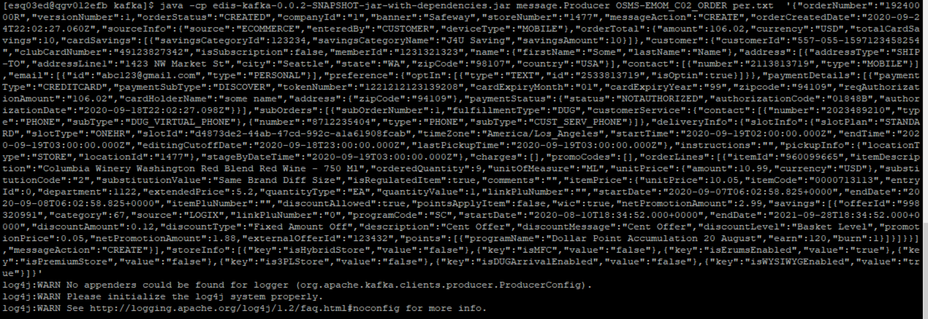  
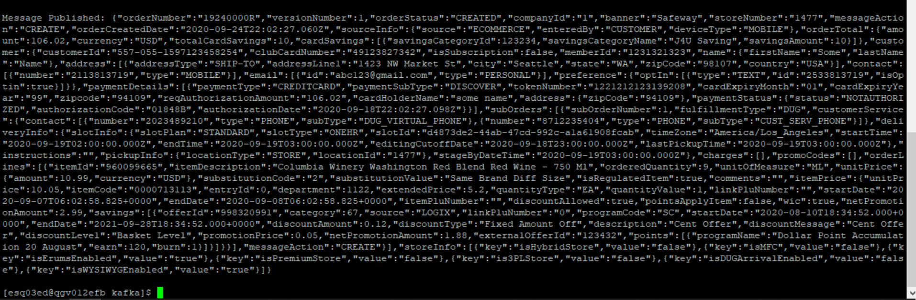

Consume message on Kafka-

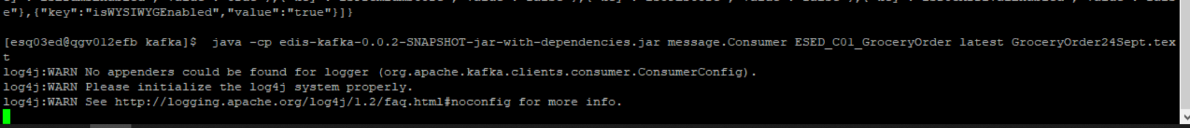

Validation in Audit table-

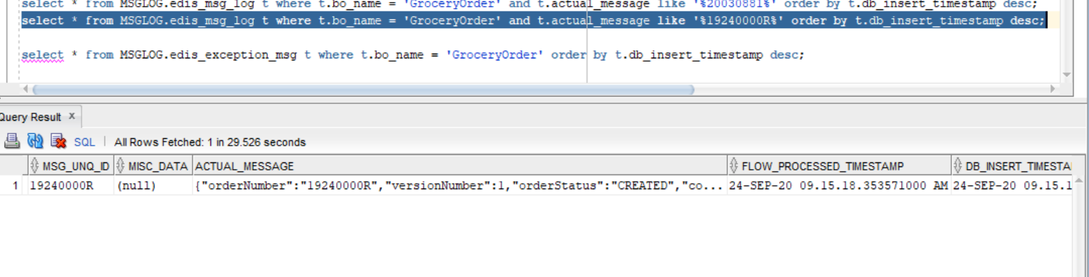

Output message CMM xml-

<GetGroceryOrder xmlns:Abs="https://collab.safeway.com/it/architecture/info/default.aspx"><DocumentData><Abs:Document VersionId="1.4.003" SystemEnvironmentCd="QA"><Abs:DocumentID>GROCERY_ORDER</Abs:DocumentID><Abs:AlternateDocumentID>OSMS-EMOM_C02_ORDER-20200924091518357212</Abs:AlternateDocumentID><Abs:DocumentNm>GroceryOrder</Abs:DocumentNm><Abs:CreationDt>2020-09-24T09:15:18.357212</Abs:CreationDt><Abs:Description>GroceryOrderDetail</Abs:Description><Abs:SourceApplicationCd>eRUMS</Abs:SourceApplicationCd><Abs:TargetApplicationCd>EDIS</Abs:TargetApplicationCd><Abs:InternalFileTransferInd>Y</Abs:InternalFileTransferInd><Abs:DataClassification><Abs:DataClassificationLevel><Abs:Code>Internal</Abs:Code></Abs:DataClassificationLevel><Abs:BusinessSensitivityLevel><Abs:Code>Low</Abs:Code></Abs:BusinessSensitivityLevel><Abs:PHIdataInd>N</Abs:PHIdataInd><Abs:PCIdataInd>Y</Abs:PCIdataInd><Abs:PIIdataInd>Y</Abs:PIIdataInd></Abs:DataClassification></Abs:Document><Abs:DocumentAction><Abs:ActionTypeCd>UPDATE</Abs:ActionTypeCd><Abs:RecordTypeCd>CHANGE</Abs:RecordTypeCd></Abs:DocumentAction></DocumentData><GroceryOrderData><Abs:GroceryOrderHeader><Abs:OrderId>19240000R</Abs:OrderId><Abs:OrderCreateTS>2020-09-24T22:02:27.060Z</Abs:OrderCreateTS><Abs:CompanyId>1</Abs:CompanyId><Abs:VersionNbr>1</Abs:VersionNbr><Abs:OrderStatus><Abs:StatusTypeCd>CREATED</Abs:StatusTypeCd></Abs:OrderStatus><Abs:OrderActionStatus><Abs:StatusTypeCd>CREATE</Abs:StatusTypeCd></Abs:OrderActionStatus><Abs:FulfillingFacility><Abs:RetailStoreId>1477</Abs:RetailStoreId><Abs:BannerCd>Safeway</Abs:BannerCd><Abs:HybridStoreInd>N</Abs:HybridStoreInd><Abs:MFCInd>N</Abs:MFCInd><Abs:ERUMSEnabledInd>Y</Abs:ERUMSEnabledInd><Abs:PremiumStoreInd>N</Abs:PremiumStoreInd><Abs:ThirdPartyDeliveryOnlyInd>N</Abs:ThirdPartyDeliveryOnlyInd></Abs:FulfillingFacility><Abs:GroceryOrderProfileType><Abs:ProfileType><Abs:Code>WYSIWYG</Abs:Code></Abs:ProfileType><Abs:ProfileValueInd>true</Abs:ProfileValueInd></Abs:GroceryOrderProfileType><Abs:RetailCustomer><Abs:CustomerId>557-055-1597123458254</Abs:CustomerId><Abs:CustomerNm><Abs:GivenNm>aom8</Abs:GivenNm><Abs:FamilyNm>JO5O</Abs:FamilyNm></Abs:CustomerNm><Abs:Contact><Abs:PhoneFaxContact TypeCode="MOBILE"><Abs:PhoneNbr>dXyDUxxTvg</Abs:PhoneNbr></Abs:PhoneFaxContact></Abs:Contact><Abs:Contact><Abs:DigitalContact><Abs:DigitalAddress>bkkihC@RdkHY.hNB</Abs:DigitalAddress><Abs:EmailStatuses Abs:typeCode="PERSONAL"/></Abs:DigitalContact></Abs:Contact><Abs:Contact><Abs:Address><Abs:AddressUsageTypeCd>epgj-qg</Abs:AddressUsageTypeCd><Abs:AddressLine1txt>roRe Em xw6RuI P3</Abs:AddressLine1txt><Abs:CityNm>4ufeGQJ</Abs:CityNm><Abs:PostalZoneCd>EraCq</Abs:PostalZoneCd><Abs:StateCd>5PJ</Abs:StateCd><Abs:CountryCd>USA</Abs:CountryCd></Abs:Address></Abs:Contact><Abs:ClubCardNbr>TzYm8gUfSIF</Abs:ClubCardNbr><Abs:CustomerPreference><Abs:PreferenceType><Abs:Code>TEXT</Abs:Code></Abs:PreferenceType><Abs:OptInContactNbr>2533813719</Abs:OptInContactNbr><Abs:OptInInd>true</Abs:OptInInd></Abs:CustomerPreference><Abs:CustomerSubscription><Abs:OptInInd>false</Abs:OptInInd></Abs:CustomerSubscription></Abs:RetailCustomer><Abs:CurrencyCd>USD</Abs:CurrencyCd><Abs:TotalAmt>106.02</Abs:TotalAmt><Abs:CustomerPayment><Abs:Tender><Abs:TenderId>J40Z1AH8G0foteRJ</Abs:TenderId><Abs:TenderTypeCd>CREDITCARD</Abs:TenderTypeCd><Abs:TenderSubTypeCd>DISCOVER</Abs:TenderSubTypeCd><Abs:HolderNm>ZyP1 BjO4</Abs:HolderNm><Abs:ExpireMonthYearTxt>bVCZ</Abs:ExpireMonthYearTxt><Abs:BillingAddress><Abs:PostalZoneCd>no0PY</Abs:PostalZoneCd></Abs:BillingAddress><Abs:PostalCd>pwLmZ</Abs:PostalCd><Abs:Token><Abs:TokenId>J40Z1AH8G0foteRJ</Abs:TokenId><Abs:TokenTypeCd>CREDITCARD</Abs:TokenTypeCd></Abs:Token><Abs:Status><Abs:StatusCd>NOTAUTHORIZED</Abs:StatusCd></Abs:Status><Abs:RequiredAuthAmt>106.02</Abs:RequiredAuthAmt><Abs:AuthCd>ktwX2k</Abs:AuthCd><Abs:AuthDt>2020-09-18T22:02:27.098Z</Abs:AuthDt></Abs:Tender></Abs:CustomerPayment><Abs:CustomerSavings><Abs:SavingsCategoryType><Abs:SavingsCategoryId>123234</Abs:SavingsCategoryId><Abs:SavingsCategoryNm>J4U Saving</Abs:SavingsCategoryNm><Abs:SavingsAmt>10.00</Abs:SavingsAmt></Abs:SavingsCategoryType></Abs:CustomerSavings><Abs:OrderRecordDateInfo><Abs:CreateUserId>CUSTOMER</Abs:CreateUserId></Abs:OrderRecordDateInfo><Abs:OrderCreatedDeviceType><Abs:Code>MOBILE</Abs:Code></Abs:OrderCreatedDeviceType><Abs:AffiliatePartnerType/><Abs:OrderSourceSystemType><Abs:Code>ECOMMERCE</Abs:Code></Abs:OrderSourceSystemType></Abs:GroceryOrderHeader><Abs:GrocerySubOrder><Abs:SubOrderNbr>1</Abs:SubOrderNbr><Abs:SubOrderStatus/><Abs:SubOrderActionStatus><Abs:StatusTypeCd>CREATE</Abs:StatusTypeCd></Abs:SubOrderActionStatus><Abs:GroceryOrderDetail><Abs:CartLineNbr>0</Abs:CartLineNbr><Abs:ItemId><Abs:SystemSpecificItemId>960099665</Abs:SystemSpecificItemId><Abs:InternalItemId>0000713113</Abs:InternalItemId><Abs:BaseProductNbr>960099665</Abs:BaseProductNbr><Abs:ItemDescription>Columbia Winery Washington Red Blend Red Wine - 750 Ml</Abs:ItemDescription></Abs:ItemId><Abs:UnitPriceAmt>10.9900</Abs:UnitPriceAmt><Abs:ExtendedUnitPriceAmt>5.2000</Abs:ExtendedUnitPriceAmt><Abs:Quantity>9.0000</Abs:Quantity><Abs:UOM><Abs:UOMCd>ML</Abs:UOMCd></Abs:UOM><Abs:DiscountAllowedInd>true</Abs:DiscountAllowedInd><Abs:RewardAllowedInd>false</Abs:RewardAllowedInd><Abs:SubstitutionType><Abs:Code>2</Abs:Code><Abs:Description>Same Brand Diff Size</Abs:Description></Abs:SubstitutionType><Abs:CurrencyCd>USD</Abs:CurrencyCd><Abs:RegulatedItemInd>true</Abs:RegulatedItemInd><Abs:LinkPLUNbr></Abs:LinkPLUNbr><Abs:CouponPLUNbr></Abs:CouponPLUNbr><Abs:CustomerOffers><Abs:OfferId>998320991</Abs:OfferId><Abs:OfferSourceType><Abs:Code>LOGIX</Abs:Code></Abs:OfferSourceType><Abs:CustomerRewards><Abs:RewardsProgramNm>Dollar Point Accumulation 20 August</Abs:RewardsProgramNm><Abs:EarnedQty>120</Abs:EarnedQty><Abs:UsedQty>1</Abs:UsedQty></Abs:CustomerRewards></Abs:CustomerOffers><Abs:Department><Abs:Code>1122</Abs:Code></Abs:Department><Abs:WICItemInd>true</Abs:WICItemInd><Abs:DeliveredItem><Abs:UOM/></Abs:DeliveredItem></Abs:GroceryOrderDetail><Abs:FullFillmentType><Abs:Code>DUG</Abs:Code></Abs:FullFillmentType><Abs:PickupInfo><Abs:PickupSlot><Abs:Code>1477</Abs:Code></Abs:PickupSlot><Abs:PickupSlotType><Abs:Code>STORE</Abs:Code></Abs:PickupSlotType><Abs:DisplayEndDttm>2020-09-19T03:00:00.000Z</Abs:DisplayEndDttm></Abs:PickupInfo><Abs:DeliveryInfo><Abs:CustomerType/><Abs:DeliverySlotId>d4873de2-44ab-47cd-992c-a1a61908fcab</Abs:DeliverySlotId><Abs:DeliverySlotType><Abs:Code>ONEHR</Abs:Code></Abs:DeliverySlotType><Abs:DeliveryServiceType/><Abs:SlotPlan><Abs:Code>STANDARD</Abs:Code></Abs:SlotPlan><Abs:StartDttm>2020-09-19T02:00:00.000Z</Abs:StartDttm><Abs:EndDttm>2020-09-19T03:00:00.000Z</Abs:EndDttm><Abs:SlotExpiryDttm>2020-09-19T03:00:00.000Z</Abs:SlotExpiryDttm><Abs:StageByDttm>2020-09-19T03:00:00.000Z</Abs:StageByDttm><Abs:EditCutoffDttm>2020-09-18T23:00:00.000Z</Abs:EditCutoffDttm><Abs:CustomerInstructionTxt></Abs:CustomerInstructionTxt><Abs:DeliveryTimeZoneCd>America/Los_Angeles</Abs:DeliveryTimeZoneCd></Abs:DeliveryInfo><Abs:CustomerService><Abs:PhoneFaxContact TypeCode="PHONE"><Abs:PhoneNbr>2023489210</Abs:PhoneNbr><Abs:PhonePurposes><Abs:PurposeDsc>DUG_VIRTUAL_PHONE</Abs:PurposeDsc></Abs:PhonePurposes></Abs:PhoneFaxContact></Abs:CustomerService><Abs:CustomerService><Abs:PhoneFaxContact TypeCode="PHONE"><Abs:PhoneNbr>8712235404</Abs:PhoneNbr><Abs:PhonePurposes><Abs:PurposeDsc>CUST_SERV_PHONE</Abs:PurposeDsc></Abs:PhonePurposes></Abs:PhoneFaxContact></Abs:CustomerService></Abs:GrocerySubOrder></GroceryOrderData></GetGroceryOrder>