{"partner_id":"324","discnt_amt":0.69,"fuel_grade_cd":"001","fuel_pump_id":"","non_fuel_purchase_amt":0.1,"partner_transaction_id":null,"postal_cd":"59722","promotion_price_amt":0.1,"purchase_discnt_limit_amt":0.2,"purchase_uom_cd":"GA","recon_error_type_cd_set":"","recon_status_cd":"0000","regular_price_amt":0.33,"safeway_settlement_amt":3.55,"site_id":"311226","tender_type_code":"0","total_fuel_purchase_amt":1.4,"total_purchase_amt":0.25,"total_purchase_qty":3,"total_savings_val_amt":0.69,"transaction_id":"2400456134","txn_fee_amt":0.12075,"txn_net_payment_amt":0.56925,"modified_ts":"2021-04-21T21:23:38.502Z"}

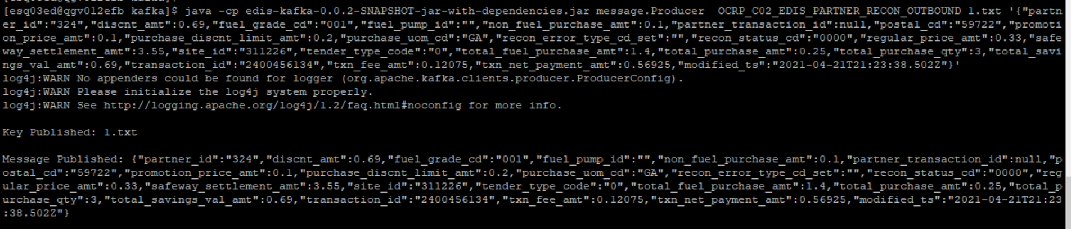



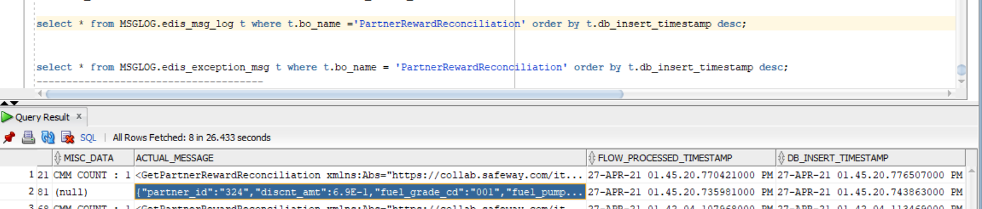

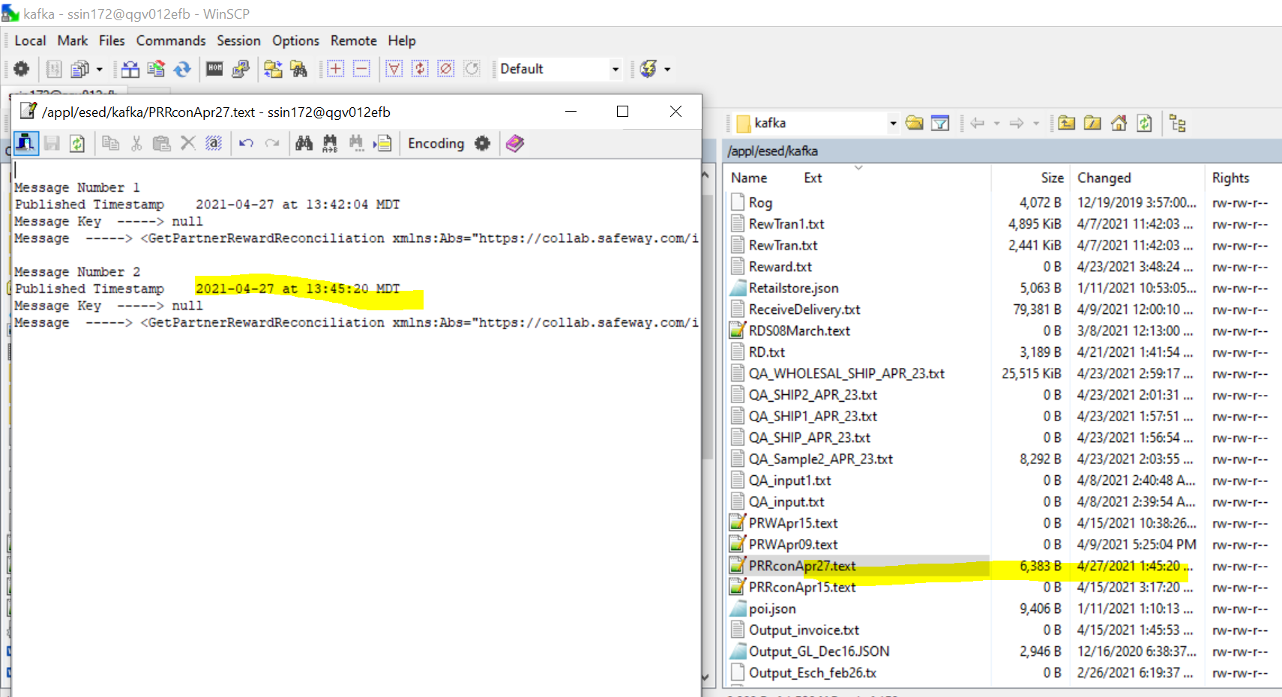

CMM XML-

<GetPartnerRewardReconciliation

xmlns:Abs="https://collab.safeway.com/it/architecture/info/default.aspx">

<DocumentData>

<Document VersionId="v1.2.1" SystemEnvironmentCd="QA">

<Abs:DocumentID>OCRP_C02_EDIS_PARTNER_RECON_OUTBOUND</Abs:DocumentID>

<Abs:AlternateDocumentID>OCRP_C02_EDIS_PARTNER_RECON_OUTBOUND_0_7_20210427134520739079</Abs:AlternateDocumentID>

<Abs:DocumentNm>PartnerRewardReconciliation</Abs:DocumentNm>

<Abs:CreationDt>2021-04-27T13:45:20.739079</Abs:CreationDt>

<Abs:Description>PartnerRewardReconciliationData</Abs:Description>

<Abs:SourceApplicationCd>OCRP</Abs:SourceApplicationCd>

<Abs:TargetApplicationCd>EDIS</Abs:TargetApplicationCd>

<Abs:InternalFileTransferInd>Y</Abs:InternalFileTransferInd>

<Abs:DataClassification>

<Abs:DataClassificationLevel>

<Abs:Code>Internal</Abs:Code>

</Abs:DataClassificationLevel>

<Abs:BusinessSensitivityLevel>

<Abs:Code>Low</Abs:Code>

</Abs:BusinessSensitivityLevel>

<Abs:PHIdataInd>N</Abs:PHIdataInd>

<Abs:PCIdataInd>Y</Abs:PCIdataInd>

<Abs:PIIdataInd>Y</Abs:PIIdataInd>

</Abs:DataClassification>

</Document>

<DocumentAction>

<Abs:ActionTypeCd>UPDATE</Abs:ActionTypeCd>

<Abs:RecordTypeCd>CHANGE</Abs:RecordTypeCd>

</DocumentAction>

</DocumentData>

<PartnerRewardReconciliationData>

<Abs:PartnerId>324</Abs:PartnerId>

<Abs:TransactionType>

<Abs:TransactionId>2400456134</Abs:TransactionId>

<Abs:AltTransaction>

<Abs:AltTransactionId/>

</Abs:AltTransaction>

</Abs:TransactionType>

<Abs:PartnerSiteId>311226</Abs:PartnerSiteId>

<Abs:PostalZoneCd>59722</Abs:PostalZoneCd>

<Abs:StatusType>

<Abs:StatusCd>0000</Abs:StatusCd>

</Abs:StatusType>

<Abs:RewardReconciliation>

<Abs:FuelPumpId/>

<Abs:FuelGradeCd>

<Abs:Code>001</Abs:Code>

</Abs:FuelGradeCd>

<Abs:ReconErrorTypeCd>

<Abs:Code/>

</Abs:ReconErrorTypeCd>

<Abs:TotalPurchQty>3</Abs:TotalPurchQty>

<Abs:PurchUOMCd>

<Abs:Code>GA</Abs:Code>

</Abs:PurchUOMCd>

<Abs:TenderTypeCd>

<Abs:Code>0</Abs:Code>

</Abs:TenderTypeCd>

<Abs:PurchDiscLimitAmt>

<Abs:TransactionAmt>0.2000</Abs:TransactionAmt>

</Abs:PurchDiscLimitAmt>

<Abs:RegularPriceAmt>

<Abs:TransactionAmt>0.3300</Abs:TransactionAmt>

</Abs:RegularPriceAmt>

<Abs:PromoPriceAmt>

<Abs:TransactionAmt>0.1000</Abs:TransactionAmt>

</Abs:PromoPriceAmt>

<Abs:TotalSavingValAmt>

<Abs:TransactionAmt>0.6900</Abs:TransactionAmt>

</Abs:TotalSavingValAmt>

<Abs:TotalFuelPurchAmt>

<Abs:TransactionAmt>1.4000</Abs:TransactionAmt>

</Abs:TotalFuelPurchAmt>

<Abs:NonFuelPurchAmt>

<Abs:TransactionAmt>0.1000</Abs:TransactionAmt>

</Abs:NonFuelPurchAmt>

<Abs:TotalPurchaseAmt>

<Abs:TransactionAmt>0.2500</Abs:TransactionAmt>

</Abs:TotalPurchaseAmt>

<Abs:DiscountAmt>

<Abs:TransactionAmt>0.6900</Abs:TransactionAmt>

</Abs:DiscountAmt>

<Abs:TxnFeeAmt>

<Abs:TransactionAmt>0.1208</Abs:TransactionAmt>

</Abs:TxnFeeAmt>

<Abs:TxnNetPymtAmt>

<Abs:TransactionAmt>0.5692</Abs:TransactionAmt>

</Abs:TxnNetPymtAmt>

<Abs:SettlementAmt>

<Abs:TransactionAmt>3.5500</Abs:TransactionAmt>

</Abs:SettlementAmt>

<Abs:AccountData/>

</Abs:RewardReconciliation>

<Abs:AuditData>

<Abs:UpdateTs>2021-04-21T21:23:38.502Z</Abs:UpdateTs>

</Abs:AuditData>

</PartnerRewardReconciliationData>

</GetPartnerRewardReconciliation>