

Scenario-1 Input file contain single message

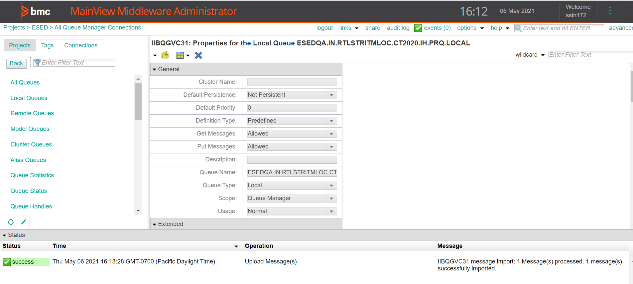

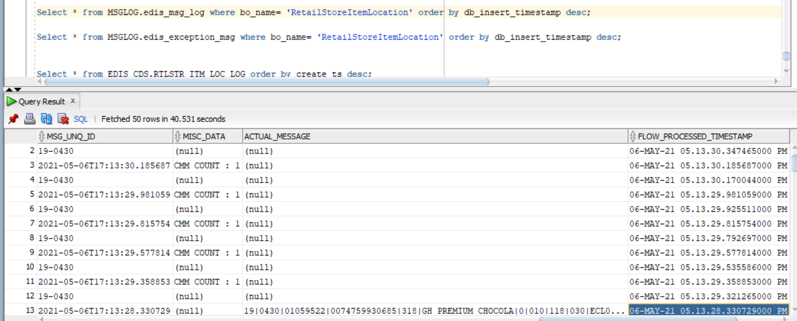

No exception – on 06-May-21 05.13.30

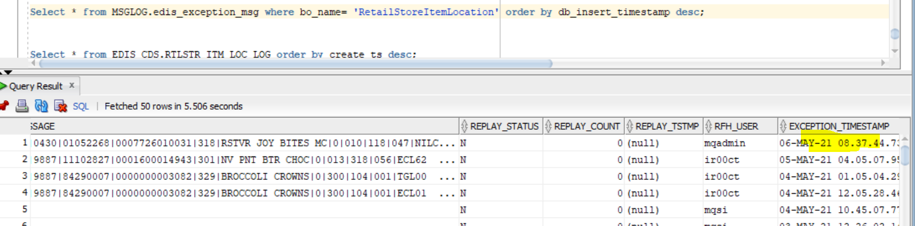

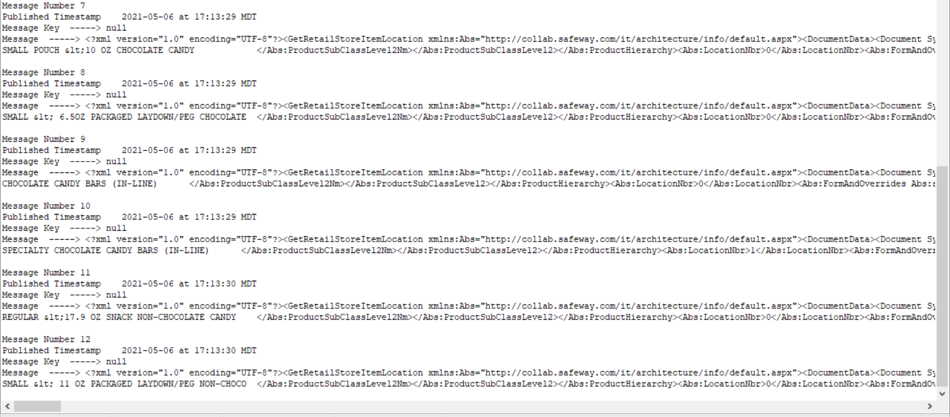

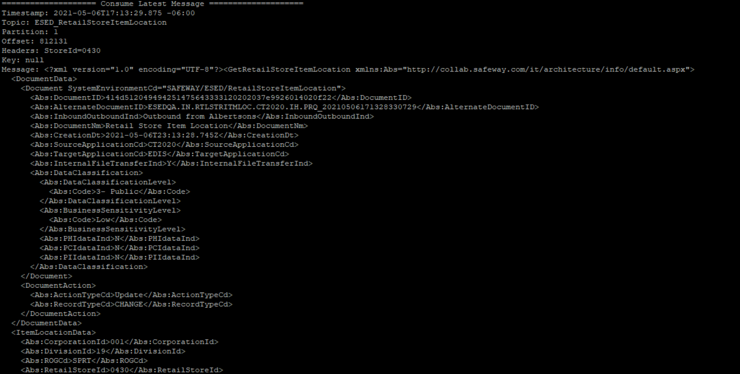

==================== Consume Latest Message ====================

Timestamp: 2021-05-06T17:13:29.875 -06:00

Topic: ESED_RetailStoreItemLocation

Partition: 1

Offset: 812131

Headers: StoreId=0430

Key: null

Message: <?xml version="1.0" encoding="UTF-8"?><GetRetailStoreItemLocation xmlns:Abs="http://collab.safeway.com/it/architecture/info/default.aspx">

<DocumentData>

<Document SystemEnvironmentCd="SAFEWAY/ESED/RetailStoreItemLocation">

<Abs:DocumentID>414d512049494251475643333120202037e9926014020f22</Abs:DocumentID>

<Abs:AlternateDocumentID>ESEDQA.IN.RTLSTRITMLOC.CT2020.IH.PRQ_20210506171328330729</Abs:AlternateDocumentID>

<Abs:InboundOutboundInd>Outbound from Albertsons</Abs:InboundOutboundInd>

<Abs:DocumentNm>Retail Store Item Location</Abs:DocumentNm>

<Abs:CreationDt>2021-05-06T23:13:28.745Z</Abs:CreationDt>

<Abs:SourceApplicationCd>CT2020</Abs:SourceApplicationCd>

<Abs:TargetApplicationCd>EDIS</Abs:TargetApplicationCd>

<Abs:InternalFileTransferInd>Y</Abs:InternalFileTransferInd>

<Abs:DataClassification>

<Abs:DataClassificationLevel>

<Abs:Code>3- Public</Abs:Code>

</Abs:DataClassificationLevel>

<Abs:BusinessSensitivityLevel>

<Abs:Code>Low</Abs:Code>

</Abs:BusinessSensitivityLevel>

<Abs:PHIdataInd>N</Abs:PHIdataInd>

<Abs:PCIdataInd>N</Abs:PCIdataInd>

<Abs:PIIdataInd>N</Abs:PIIdataInd>

</Abs:DataClassification>

</Document>

<DocumentAction>

<Abs:ActionTypeCd>Update</Abs:ActionTypeCd>

<Abs:RecordTypeCd>CHANGE</Abs:RecordTypeCd>

</DocumentAction>

</DocumentData>

<ItemLocationData>

<Abs:CorporationId>001</Abs:CorporationId>

<Abs:DivisionId>19</Abs:DivisionId>

<Abs:ROGCd>SPRT</Abs:ROGCd>

<Abs:RetailStoreId>0430</Abs:RetailStoreId>

<Abs:ItemLocation>

<Abs:Department>

<Abs:IdNbr>318</Abs:IdNbr>

</Abs:Department>

<Abs:Aisle>

<Abs:IdNbr>010</Abs:IdNbr>

<Abs:AisleSection>

<Abs:IdNbr>118</Abs:IdNbr>

<Abs:AisleSectionShelf>

<Abs:IdNbr>012</Abs:IdNbr>

<Abs:CorporateItemCd>01059127</Abs:CorporateItemCd>

<Abs:ItemId>

<Abs:UPC>

<Abs:UPCNbr>0003701400020</Abs:UPCNbr>

<Abs:UPCTxt>0003701400020</Abs:UPCTxt>

</Abs:UPC>

<Abs:UPCComponents>

<Abs:PackInd>0</Abs:PackInd>

<Abs:ManufacturerId>37014</Abs:ManufacturerId>

<Abs:SalesId>00020</Abs:SalesId>

<Abs:CountryId>0</Abs:CountryId>

<Abs:SystemId>0</Abs:SystemId>

</Abs:UPCComponents>

<Abs:VendorProductID>10037014020004</Abs:VendorProductID>

<Abs:InternalItemId>1059127</Abs:InternalItemId>

<Abs:ItemDescription>ENDAN CHOC BAR DRK</Abs:ItemDescription>

</Abs:ItemId>

<Abs:ItemDsc>

<Abs:WarehouseItemDsc>ENDAN DRK CHOC SSLT ALMDS 72% </Abs:WarehouseItemDsc>

<Abs:InternetItemDsc>ENDAN DRK CHOC SSLT ALMONDS 72% </Abs:InternetItemDsc>

<Abs:RetailItemDsc>ENDAN DRK CHOC SSLT ALMONDS 72% </Abs:RetailItemDsc>

<Abs:VendorItemDsc>ENDAN DRK CHOC SSLT ALMONDS 72% </Abs:VendorItemDsc>

</Abs:ItemDsc>

<Abs:ProductHierarchy>

<Abs:ProductGroup>

<Abs:ProductGroupCd>1</Abs:ProductGroupCd>

<Abs:ProductGroupNm>CANDY, GUM &amp; MINTS </Abs:ProductGroupNm>

</Abs:ProductGroup>

<Abs:ProductCategoryCd>

<Abs:ProductCategoryCd>5</Abs:ProductCategoryCd>

<Abs:ProductCategoryNm>TAKE HOME CANDY/GUM/MINTS (IN-LINE) </Abs:ProductCategoryNm>

</Abs:ProductCategoryCd>

<Abs:ProductClassCd>

<Abs:ProductClassCd>10</Abs:ProductClassCd>

<Abs:ProductClassNm>CHOCOLATE TAKE HOME CANDY (IN-LINE) </Abs:ProductClassNm>

<Abs:RetailSectionCd>318</Abs:RetailSectionCd>

</Abs:ProductClassCd>

<Abs:ProductSubClassLevel1>

<Abs:ProductSubClassLevel1Cd>1</Abs:ProductSubClassLevel1Cd>

<Abs:ProductSubClassLevel1Nm>LARGE/GIANT/SPECIALTY CHOCOLATE TAKE HOME </Abs:ProductSubClassLevel1Nm>

</Abs:ProductSubClassLevel1>

<Abs:ProductSubClassLevel2>

<Abs:ProductSubClassLevel2Cd>5</Abs:ProductSubClassLevel2Cd>

<Abs:ProductSubClassLevel2Nm>SPECIALTY CHOCOLATE CANDY BARS (IN-LINE) </Abs:ProductSubClassLevel2Nm>

</Abs:ProductSubClassLevel2>

</Abs:ProductHierarchy>

<Abs:LocationNbr>1</Abs:LocationNbr>

<Abs:FormAndOverrides Abs:sequenceNbr="1">

<Abs:FormId>ECL14</Abs:FormId>

<Abs:FormQty>0</Abs:FormQty>

<Abs:OverrideQty>1</Abs:OverrideQty>

<Abs:OverrideFlag>1</Abs:OverrideFlag>

</Abs:FormAndOverrides>

<Abs:FormAndOverrides Abs:sequenceNbr="2">

<Abs:FormQty>0</Abs:FormQty>

<Abs:OverrideQty>0</Abs:OverrideQty>

<Abs:OverrideFlag>0</Abs:OverrideFlag>

</Abs:FormAndOverrides>

<Abs:FormAndOverrides Abs:sequenceNbr="3">

<Abs:FormId>SCD02</Abs:FormId>

<Abs:FormQty>0</Abs:FormQty>

<Abs:OverrideQty>0</Abs:OverrideQty>

<Abs:OverrideFlag>1</Abs:OverrideFlag>

</Abs:FormAndOverrides>

<Abs:FormAndOverrides Abs:sequenceNbr="4">

<Abs:FormId>SCM02</Abs:FormId>

<Abs:FormQty>0</Abs:FormQty>

<Abs:OverrideQty>0</Abs:OverrideQty>

<Abs:OverrideFlag>1</Abs:OverrideFlag>

</Abs:FormAndOverrides>

<Abs:FormAndOverrides Abs:sequenceNbr="5">

<Abs:FormId>SCT02</Abs:FormId>

<Abs:FormQty>0</Abs:FormQty>

<Abs:OverrideQty>0</Abs:OverrideQty>

<Abs:OverrideFlag>1</Abs:OverrideFlag>

</Abs:FormAndOverrides>

<Abs:AltLocationInd>0</Abs:AltLocationInd>

<Abs:DocumentAction>

<Abs:ActionTypeCd>Update</Abs:ActionTypeCd>

<Abs:RecordTypeCd>CHANGE</Abs:RecordTypeCd>

</Abs:DocumentAction>

</Abs:AisleSectionShelf>

</Abs:AisleSection>

</Abs:Aisle>

</Abs:ItemLocation>

</ItemLocationData>

</GetRetailStoreItemLocation>

Scenario-2



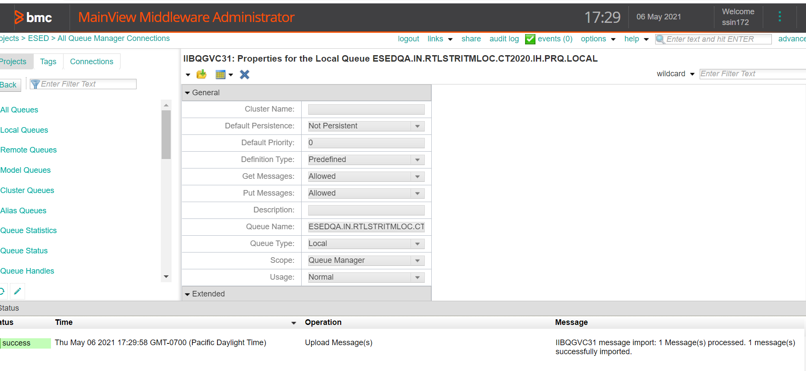

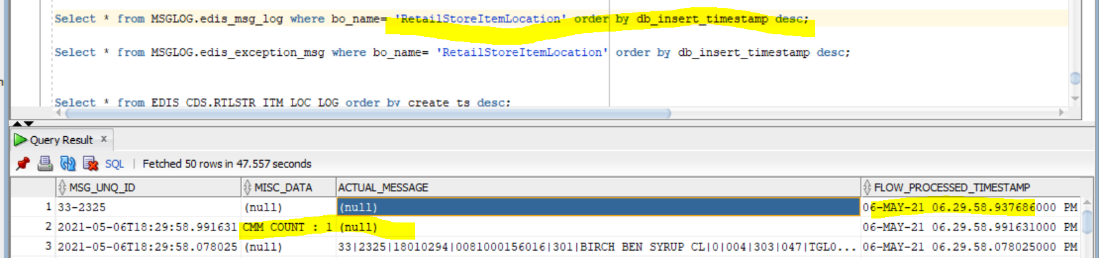

No exception at 06-May-21 06.29.58

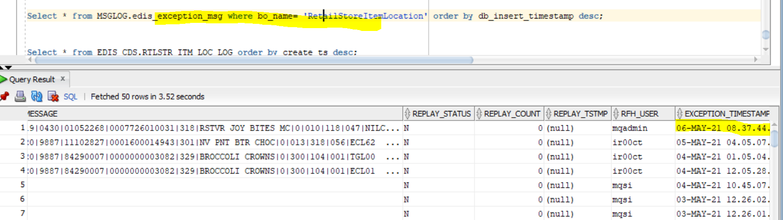

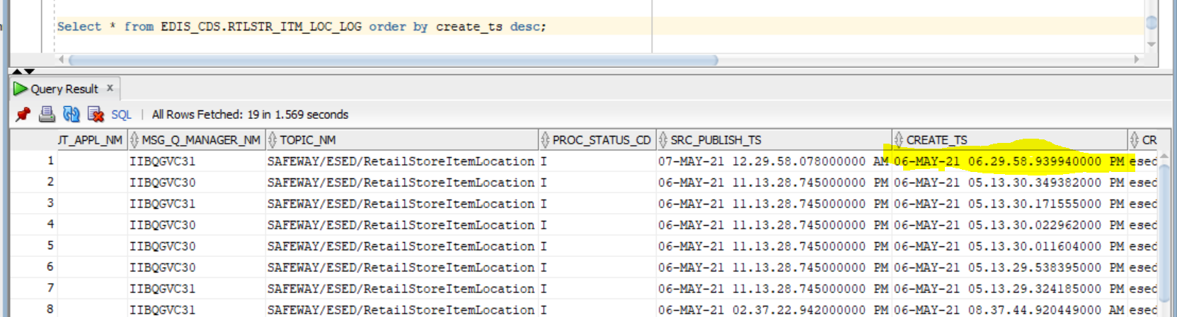

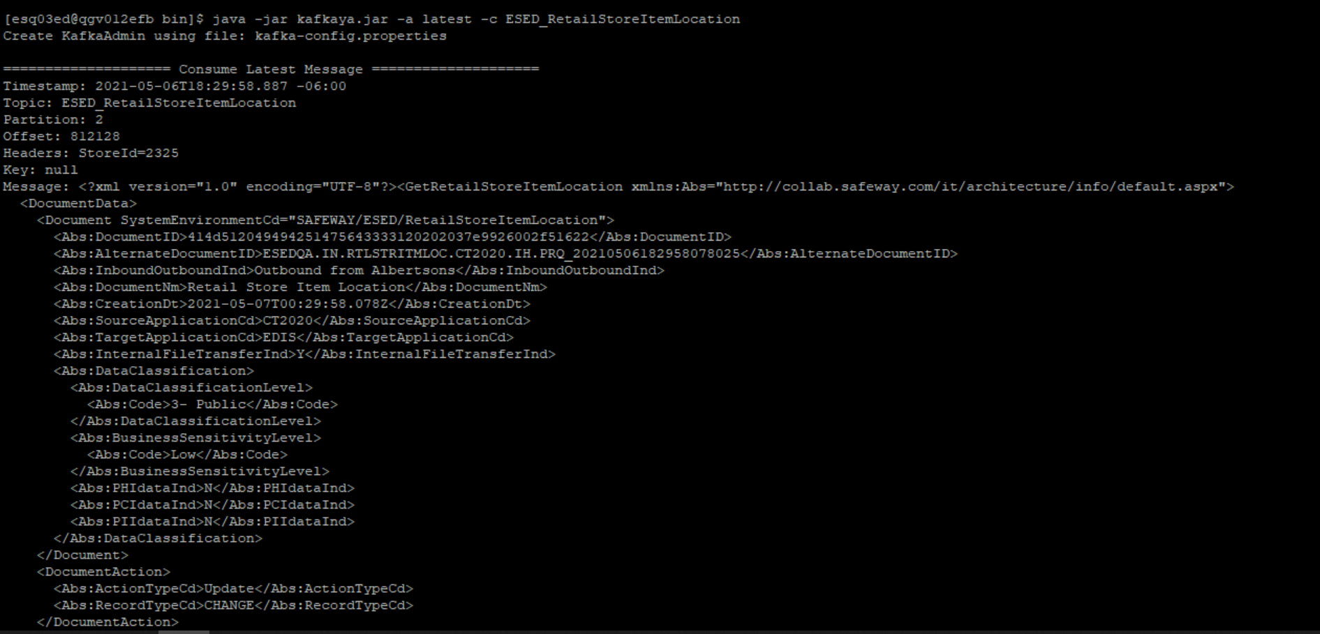

[esq03ed@qgv012efb bin]$ java -jar kafkaya.jar -a latest -c ESED_RetailStoreItemLocation

Create KafkaAdmin using file: kafka-config.properties

==================== Consume Latest Message ====================

Timestamp: 2021-05-06T18:29:58.887 -06:00

Topic: ESED_RetailStoreItemLocation

Partition: 2

Offset: 812128

Headers: StoreId=2325

Key: null

Message: <?xml version="1.0" encoding="UTF-8"?><GetRetailStoreItemLocation xmlns:Abs="http://collab.safeway.com/it/architecture/info/default.aspx">

<DocumentData>

<Document SystemEnvironmentCd="SAFEWAY/ESED/RetailStoreItemLocation">

<Abs:DocumentID>414d512049494251475643333120202037e9926002f51622</Abs:DocumentID>

<Abs:AlternateDocumentID>ESEDQA.IN.RTLSTRITMLOC.CT2020.IH.PRQ_20210506182958078025</Abs:AlternateDocumentID>

<Abs:InboundOutboundInd>Outbound from Albertsons</Abs:InboundOutboundInd>

<Abs:DocumentNm>Retail Store Item Location</Abs:DocumentNm>

<Abs:CreationDt>2021-05-07T00:29:58.078Z</Abs:CreationDt>

<Abs:SourceApplicationCd>CT2020</Abs:SourceApplicationCd>

<Abs:TargetApplicationCd>EDIS</Abs:TargetApplicationCd>

<Abs:InternalFileTransferInd>Y</Abs:InternalFileTransferInd>

<Abs:DataClassification>

<Abs:DataClassificationLevel>

<Abs:Code>3- Public</Abs:Code>

</Abs:DataClassificationLevel>

<Abs:BusinessSensitivityLevel>

<Abs:Code>Low</Abs:Code>

</Abs:BusinessSensitivityLevel>

<Abs:PHIdataInd>N</Abs:PHIdataInd>

<Abs:PCIdataInd>N</Abs:PCIdataInd>

<Abs:PIIdataInd>N</Abs:PIIdataInd>

</Abs:DataClassification>

</Document>

<DocumentAction>

<Abs:ActionTypeCd>Update</Abs:ActionTypeCd>

<Abs:RecordTypeCd>CHANGE</Abs:RecordTypeCd>

</DocumentAction>

</DocumentData>

<ItemLocationData>

<Abs:CorporationId>001</Abs:CorporationId>

<Abs:DivisionId>33</Abs:DivisionId>

<Abs:ROGCd>AVMT</Abs:ROGCd>

<Abs:RetailStoreId>2325</Abs:RetailStoreId>

<Abs:ItemLocation>

<Abs:Department>

<Abs:IdNbr>301</Abs:IdNbr>

</Abs:Department>

<Abs:Aisle>

<Abs:IdNbr>004</Abs:IdNbr>

<Abs:AisleSection>

<Abs:IdNbr>303</Abs:IdNbr>

<Abs:AisleSectionShelf>

<Abs:IdNbr>047</Abs:IdNbr>

<Abs:CorporateItemCd>18010294</Abs:CorporateItemCd>

<Abs:ItemId>

<Abs:UPC>

<Abs:UPCNbr>0081000156016</Abs:UPCNbr>

<Abs:UPCTxt>0081000156016</Abs:UPCTxt>

</Abs:UPC>

<Abs:UPCComponents>

<Abs:PackInd>0</Abs:PackInd>

<Abs:ManufacturerId>10001</Abs:ManufacturerId>

<Abs:SalesId>56016</Abs:SalesId>

<Abs:CountryId>0</Abs:CountryId>

<Abs:SystemId>8</Abs:SystemId>

</Abs:UPCComponents>

<Abs:VendorProductID>00000000000000</Abs:VendorProductID>

<Abs:InternalItemId>18010294</Abs:InternalItemId>

<Abs:ItemDescription>BIRCH BEN SYRUP CL</Abs:ItemDescription>

</Abs:ItemId>

<Abs:ItemDsc>

<Abs:WarehouseItemDsc>BIRCH BEN SYRUP CLASSIC MAPLE </Abs:WarehouseItemDsc>

<Abs:InternetItemDsc>BIRCH BEN SYRUP CLASSIC MAPLE </Abs:InternetItemDsc>

<Abs:RetailItemDsc>BIRCH BEN SYRUP CLASSIC MAPLE </Abs:RetailItemDsc>

<Abs:VendorItemDsc>BIRCH BEN SYRUP CLASSIC MAPLE </Abs:VendorItemDsc>

</Abs:ItemDsc>

<Abs:ProductHierarchy>

<Abs:ProductGroup>

<Abs:ProductGroupCd>18</Abs:ProductGroupCd>

<Abs:ProductGroupNm>SYRUPS &amp; PANCAKE/WAFFLE MIX </Abs:ProductGroupNm>

</Abs:ProductGroup>

<Abs:ProductCategoryCd>

<Abs:ProductCategoryCd>1</Abs:ProductCategoryCd>

<Abs:ProductCategoryNm>SYRUPS </Abs:ProductCategoryNm>

</Abs:ProductCategoryCd>

<Abs:ProductClassCd>

<Abs:ProductClassCd>5</Abs:ProductClassCd>

<Abs:ProductClassNm>COOKING SYRUPS </Abs:ProductClassNm>

<Abs:RetailSectionCd>301</Abs:RetailSectionCd>

</Abs:ProductClassCd>

<Abs:ProductSubClassLevel1>

<Abs:ProductSubClassLevel1Cd>5</Abs:ProductSubClassLevel1Cd>

<Abs:ProductSubClassLevel1Nm>CORN SYRUPS </Abs:ProductSubClassLevel1Nm>

</Abs:ProductSubClassLevel1>

<Abs:ProductSubClassLevel2>

<Abs:ProductSubClassLevel2Cd>0</Abs:ProductSubClassLevel2Cd>

<Abs:ProductSubClassLevel2Nm>CORN SYRUPS </Abs:ProductSubClassLevel2Nm>

</Abs:ProductSubClassLevel2>

</Abs:ProductHierarchy>

<Abs:LocationNbr>0</Abs:LocationNbr>

<Abs:FormAndOverrides Abs:sequenceNbr="1">

<Abs:FormId>TGL00</Abs:FormId>

<Abs:FormQty>1</Abs:FormQty>

<Abs:OverrideQty>0</Abs:OverrideQty>

<Abs:OverrideFlag>0</Abs:OverrideFlag>

</Abs:FormAndOverrides>

<Abs:FormAndOverrides Abs:sequenceNbr="2">

<Abs:FormQty>0</Abs:FormQty>

<Abs:OverrideQty>0</Abs:OverrideQty>

<Abs:OverrideFlag>0</Abs:OverrideFlag>

</Abs:FormAndOverrides>

<Abs:FormAndOverrides Abs:sequenceNbr="3">

<Abs:FormId>RQD01</Abs:FormId>

<Abs:FormQty>0</Abs:FormQty>

<Abs:OverrideQty>0</Abs:OverrideQty>

<Abs:OverrideFlag>0</Abs:OverrideFlag>

</Abs:FormAndOverrides>

<Abs:FormAndOverrides Abs:sequenceNbr="4">

<Abs:FormId>RQM01</Abs:FormId>

<Abs:FormQty>0</Abs:FormQty>

<Abs:OverrideQty>0</Abs:OverrideQty>

<Abs:OverrideFlag>0</Abs:OverrideFlag>

</Abs:FormAndOverrides>

<Abs:FormAndOverrides Abs:sequenceNbr="5">

<Abs:FormId>RQT01</Abs:FormId>

<Abs:FormQty>1</Abs:FormQty>

<Abs:OverrideQty>0</Abs:OverrideQty>

<Abs:OverrideFlag>0</Abs:OverrideFlag>

</Abs:FormAndOverrides>

<Abs:AltLocationInd>0</Abs:AltLocationInd>

<Abs:DocumentAction>

<Abs:ActionTypeCd>Update</Abs:ActionTypeCd>

<Abs:RecordTypeCd>CHANGE</Abs:RecordTypeCd>

</Abs:DocumentAction>

</Abs:AisleSectionShelf>

</Abs:AisleSection>

</Abs:Aisle>

</Abs:ItemLocation>

</ItemLocationData>

</GetRetailStoreItemLocation>

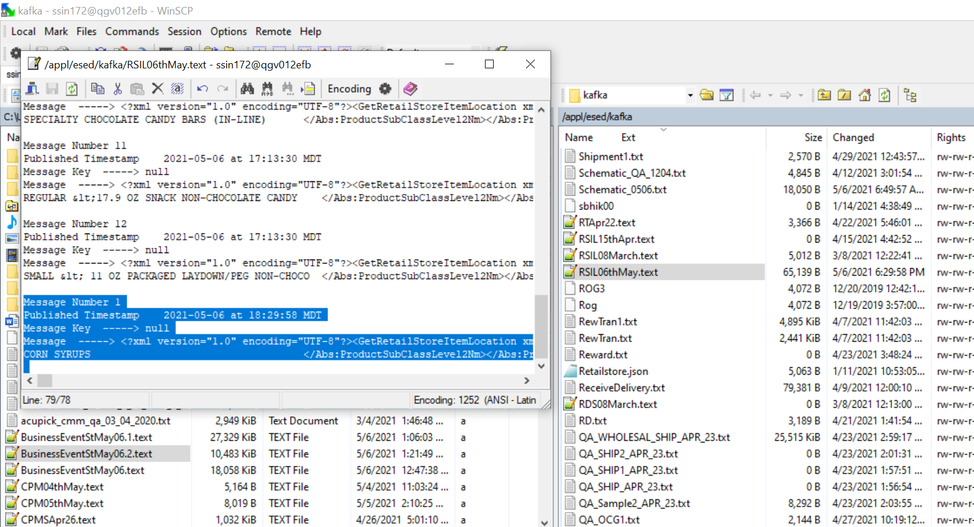

Message Number 1

Published Timestamp 2021-05-06 at 18:29:58 MDT

Message Key -----> null

Message -----> <?xml version="1.0" encoding="UTF-8"?><GetRetailStoreItemLocation xmlns:Abs="http://collab.safeway.com/it/architecture/info/default.aspx"><DocumentData><Document SystemEnvironmentCd="SAFEWAY/ESED/RetailStoreItemLocation"><Abs:DocumentID>414d512049494251475643333120202037e9926002f51622</Abs:DocumentID><Abs:AlternateDocumentID>ESEDQA.IN.RTLSTRITMLOC.CT2020.IH.PRQ_20210506182958078025</Abs:AlternateDocumentID><Abs:InboundOutboundInd>Outbound from Albertsons</Abs:InboundOutboundInd><Abs:DocumentNm>Retail Store Item Location</Abs:DocumentNm><Abs:CreationDt>2021-05-07T00:29:58.078Z</Abs:CreationDt><Abs:SourceApplicationCd>CT2020</Abs:SourceApplicationCd><Abs:TargetApplicationCd>EDIS</Abs:TargetApplicationCd><Abs:InternalFileTransferInd>Y</Abs:InternalFileTransferInd><Abs:DataClassification><Abs:DataClassificationLevel><Abs:Code>3- Public</Abs:Code></Abs:DataClassificationLevel><Abs:BusinessSensitivityLevel><Abs:Code>Low</Abs:Code></Abs:BusinessSensitivityLevel><Abs:PHIdataInd>N</Abs:PHIdataInd><Abs:PCIdataInd>N</Abs:PCIdataInd><Abs:PIIdataInd>N</Abs:PIIdataInd></Abs:DataClassification></Document><DocumentAction><Abs:ActionTypeCd>Update</Abs:ActionTypeCd><Abs:RecordTypeCd>CHANGE</Abs:RecordTypeCd></DocumentAction></DocumentData><ItemLocationData><Abs:CorporationId>001</Abs:CorporationId><Abs:DivisionId>33</Abs:DivisionId><Abs:ROGCd>AVMT</Abs:ROGCd><Abs:RetailStoreId>2325</Abs:RetailStoreId><Abs:ItemLocation><Abs:Department><Abs:IdNbr>301</Abs:IdNbr></Abs:Department><Abs:Aisle><Abs:IdNbr>004</Abs:IdNbr><Abs:AisleSection><Abs:IdNbr>303</Abs:IdNbr><Abs:AisleSectionShelf><Abs:IdNbr>047</Abs:IdNbr><Abs:CorporateItemCd>18010294</Abs:CorporateItemCd><Abs:ItemId><Abs:UPC><Abs:UPCNbr>0081000156016</Abs:UPCNbr><Abs:UPCTxt>0081000156016</Abs:UPCTxt></Abs:UPC><Abs:UPCComponents><Abs:PackInd>0</Abs:PackInd><Abs:ManufacturerId>10001</Abs:ManufacturerId><Abs:SalesId>56016</Abs:SalesId><Abs:CountryId>0</Abs:CountryId><Abs:SystemId>8</Abs:SystemId></Abs:UPCComponents><Abs:VendorProductID>00000000000000</Abs:VendorProductID><Abs:InternalItemId>18010294</Abs:InternalItemId><Abs:ItemDescription>BIRCH BEN SYRUP CL</Abs:ItemDescription></Abs:ItemId><Abs:ItemDsc><Abs:WarehouseItemDsc>BIRCH BEN SYRUP CLASSIC MAPLE </Abs:WarehouseItemDsc><Abs:InternetItemDsc>BIRCH BEN SYRUP CLASSIC MAPLE </Abs:InternetItemDsc><Abs:RetailItemDsc>BIRCH BEN SYRUP CLASSIC MAPLE </Abs:RetailItemDsc><Abs:VendorItemDsc>BIRCH BEN SYRUP CLASSIC MAPLE </Abs:VendorItemDsc></Abs:ItemDsc><Abs:ProductHierarchy><Abs:ProductGroup><Abs:ProductGroupCd>18</Abs:ProductGroupCd><Abs:ProductGroupNm>SYRUPS &amp; PANCAKE/WAFFLE MIX </Abs:ProductGroupNm></Abs:ProductGroup><Abs:ProductCategoryCd><Abs:ProductCategoryCd>1</Abs:ProductCategoryCd><Abs:ProductCategoryNm>SYRUPS </Abs:ProductCategoryNm></Abs:ProductCategoryCd><Abs:ProductClassCd><Abs:ProductClassCd>5</Abs:ProductClassCd><Abs:ProductClassNm>COOKING SYRUPS </Abs:ProductClassNm><Abs:RetailSectionCd>301</Abs:RetailSectionCd></Abs:ProductClassCd><Abs:ProductSubClassLevel1><Abs:ProductSubClassLevel1Cd>5</Abs:ProductSubClassLevel1Cd><Abs:ProductSubClassLevel1Nm>CORN SYRUPS </Abs:ProductSubClassLevel1Nm></Abs:ProductSubClassLevel1><Abs:ProductSubClassLevel2><Abs:ProductSubClassLevel2Cd>0</Abs:ProductSubClassLevel2Cd><Abs:ProductSubClassLevel2Nm>CORN SYRUPS </Abs:ProductSubClassLevel2Nm></Abs:ProductSubClassLevel2></Abs:ProductHierarchy><Abs:LocationNbr>0</Abs:LocationNbr><Abs:FormAndOverrides Abs:sequenceNbr="1"><Abs:FormId>TGL00</Abs:FormId><Abs:FormQty>1</Abs:FormQty><Abs:OverrideQty>0</Abs:OverrideQty><Abs:OverrideFlag>0</Abs:OverrideFlag></Abs:FormAndOverrides><Abs:FormAndOverrides Abs:sequenceNbr="2"><Abs:FormQty>0</Abs:FormQty><Abs:OverrideQty>0</Abs:OverrideQty><Abs:OverrideFlag>0</Abs:OverrideFlag></Abs:FormAndOverrides><Abs:FormAndOverrides Abs:sequenceNbr="3"><Abs:FormId>RQD01</Abs:FormId><Abs:FormQty>0</Abs:FormQty><Abs:OverrideQty>0</Abs:OverrideQty><Abs:OverrideFlag>0</Abs:OverrideFlag></Abs:FormAndOverrides><Abs:FormAndOverrides Abs:sequenceNbr="4"><Abs:FormId>RQM01</Abs:FormId><Abs:FormQty>0</Abs:FormQty><Abs:OverrideQty>0</Abs:OverrideQty><Abs:OverrideFlag>0</Abs:OverrideFlag></Abs:FormAndOverrides><Abs:FormAndOverrides Abs:sequenceNbr="5"><Abs:FormId>RQT01</Abs:FormId><Abs:FormQty>1</Abs:FormQty><Abs:OverrideQty>0</Abs:OverrideQty><Abs:OverrideFlag>0</Abs:OverrideFlag></Abs:FormAndOverrides><Abs:AltLocationInd>0</Abs:AltLocationInd><Abs:DocumentAction><Abs:ActionTypeCd>Update</Abs:ActionTypeCd><Abs:RecordTypeCd>CHANGE</Abs:RecordTypeCd></Abs:DocumentAction></Abs:AisleSectionShelf></Abs:AisleSection></Abs:Aisle></Abs:ItemLocation></ItemLocationData></GetRetailStoreItemLocation>

**Scenario:2**

Validate header if input file is having multiple message in the single file.

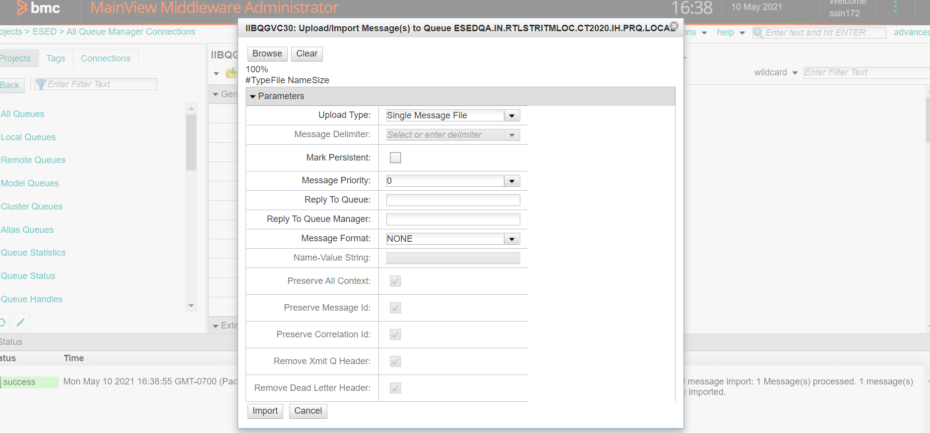

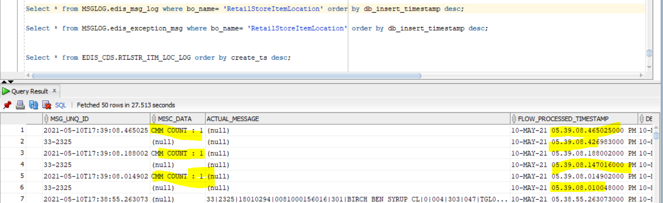

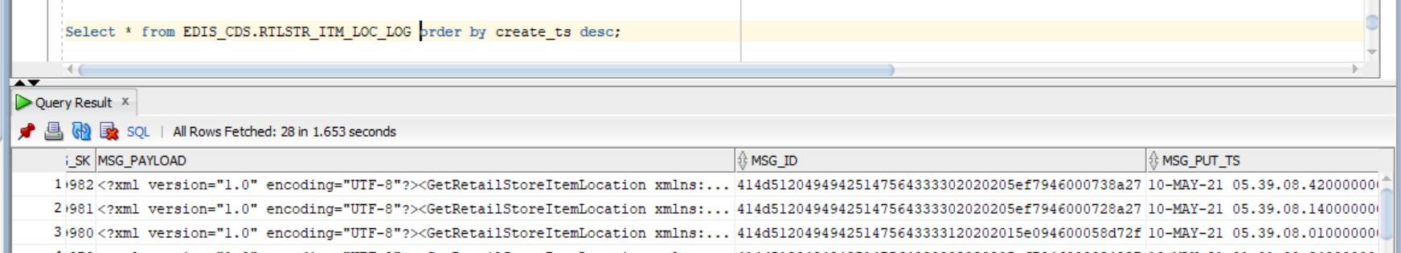

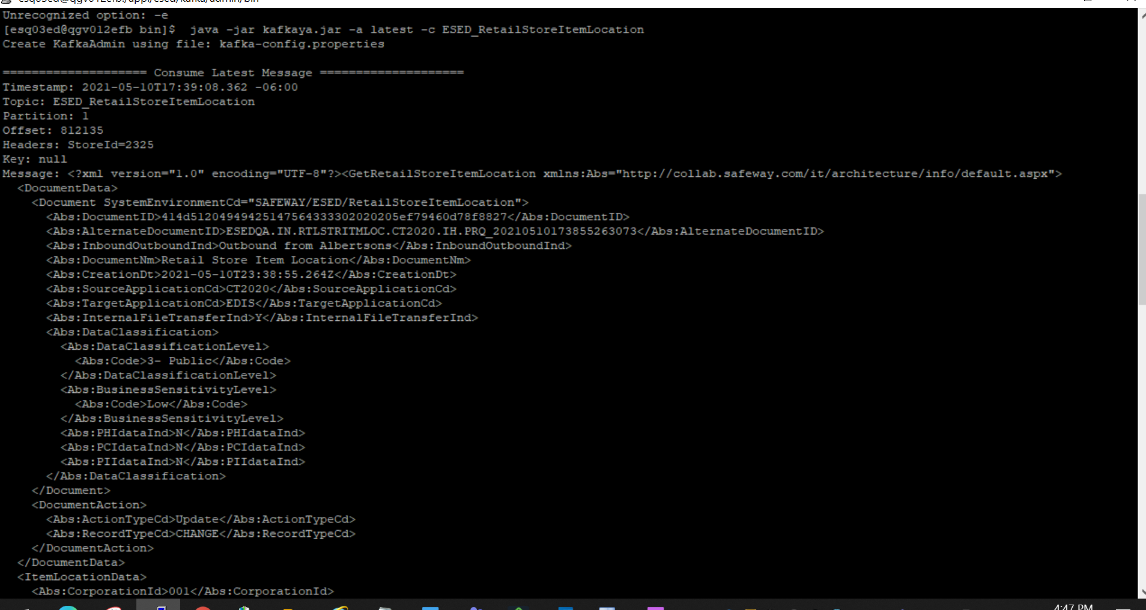

[esq03ed@qgv012efb bin]$ java -jar kafkaya.jar -a latest -c ESED_RetailStoreItemLocation

Create KafkaAdmin using file: kafka-config.properties

==================== Consume Latest Message ====================

Timestamp: 2021-05-10T17:39:08.362 -06:00

Topic: ESED_RetailStoreItemLocation

Partition: 1

Offset: 812135

Headers: StoreId=2325

Key: null

Message: <?xml version="1.0" encoding="UTF-8"?><GetRetailStoreItemLocation xmlns:Abs="http://collab.safeway.com/it/architecture/info/default.aspx">

<DocumentData>

<Document SystemEnvironmentCd="SAFEWAY/ESED/RetailStoreItemLocation">

<Abs:DocumentID>414d51204949425147564333302020205ef79460d78f8827</Abs:DocumentID>

<Abs:AlternateDocumentID>ESEDQA.IN.RTLSTRITMLOC.CT2020.IH.PRQ_20210510173855263073</Abs:AlternateDocumentID>

<Abs:InboundOutboundInd>Outbound from Albertsons</Abs:InboundOutboundInd>

<Abs:DocumentNm>Retail Store Item Location</Abs:DocumentNm>

<Abs:CreationDt>2021-05-10T23:38:55.264Z</Abs:CreationDt>

<Abs:SourceApplicationCd>CT2020</Abs:SourceApplicationCd>

<Abs:TargetApplicationCd>EDIS</Abs:TargetApplicationCd>

<Abs:InternalFileTransferInd>Y</Abs:InternalFileTransferInd>

<Abs:DataClassification>

<Abs:DataClassificationLevel>

<Abs:Code>3- Public</Abs:Code>

</Abs:DataClassificationLevel>

<Abs:BusinessSensitivityLevel>

<Abs:Code>Low</Abs:Code>

</Abs:BusinessSensitivityLevel>

<Abs:PHIdataInd>N</Abs:PHIdataInd>

<Abs:PCIdataInd>N</Abs:PCIdataInd>

<Abs:PIIdataInd>N</Abs:PIIdataInd>

</Abs:DataClassification>

</Document>

<DocumentAction>

<Abs:ActionTypeCd>Update</Abs:ActionTypeCd>

<Abs:RecordTypeCd>CHANGE</Abs:RecordTypeCd>

</DocumentAction>

</DocumentData>

<ItemLocationData>

<Abs:CorporationId>001</Abs:CorporationId>

<Abs:DivisionId>33</Abs:DivisionId>

<Abs:ROGCd>AVMT</Abs:ROGCd>

<Abs:RetailStoreId>2325</Abs:RetailStoreId>

<Abs:ItemLocation>

<Abs:Department>

<Abs:IdNbr>302</Abs:IdNbr>

</Abs:Department>

<Abs:Aisle>

<Abs:IdNbr>004</Abs:IdNbr>

<Abs:AisleSection>

<Abs:IdNbr>303</Abs:IdNbr>

<Abs:AisleSectionShelf>

<Abs:IdNbr>031</Abs:IdNbr>

<Abs:CorporateItemCd>04010015</Abs:CorporateItemCd>

<Abs:ItemId>

<Abs:UPC>

<Abs:UPCNbr>0081442202005</Abs:UPCNbr>

<Abs:UPCTxt>0081442202005</Abs:UPCTxt>

</Abs:UPC>

<Abs:UPCComponents>

<Abs:PackInd>0</Abs:PackInd>

<Abs:ManufacturerId>14422</Abs:ManufacturerId>

<Abs:SalesId>02005</Abs:SalesId>

<Abs:CountryId>0</Abs:CountryId>

<Abs:SystemId>8</Abs:SystemId>

</Abs:UPCComponents>

<Abs:VendorProductID>00000000000000</Abs:VendorProductID>

<Abs:InternalItemId>4010015</Abs:InternalItemId>

<Abs:ItemDescription>WEDDERSPOON MANUKA</Abs:ItemDescription>

</Abs:ItemId>

<Abs:ItemDsc>

<Abs:WarehouseItemDsc>WEDDERSPOON MANUKA HNY KFACTOR</Abs:WarehouseItemDsc>

<Abs:InternetItemDsc>WEDDERSPOON MANUKA HONEY KFACTOR 16 </Abs:InternetItemDsc>

<Abs:RetailItemDsc>WEDDERSPOON MANUKA HONEY KFACTOR 16 </Abs:RetailItemDsc>

<Abs:VendorItemDsc>WEDDERSPOON MANUKA HONEY KFACTOR 16 </Abs:VendorItemDsc>

</Abs:ItemDsc>

<Abs:ProductHierarchy>

<Abs:ProductGroup>

<Abs:ProductGroupCd>4</Abs:ProductGroupCd>

<Abs:ProductGroupNm>JAMS, JELLIES &amp; SPREADS </Abs:ProductGroupNm>

</Abs:ProductGroup>

<Abs:ProductCategoryCd>

<Abs:ProductCategoryCd>1</Abs:ProductCategoryCd>

<Abs:ProductCategoryNm>HONEY </Abs:ProductCategoryNm>

</Abs:ProductCategoryCd>

<Abs:ProductClassCd>

<Abs:ProductClassCd>1</Abs:ProductClassCd>

<Abs:ProductClassNm>REGULAR HONEY </Abs:ProductClassNm>

<Abs:RetailSectionCd>302</Abs:RetailSectionCd>

</Abs:ProductClassCd>

<Abs:ProductSubClassLevel1>

<Abs:ProductSubClassLevel1Cd>1</Abs:ProductSubClassLevel1Cd>

<Abs:ProductSubClassLevel1Nm>REGULAR HONEY (&lt;=30 OZ) </Abs:ProductSubClassLevel1Nm>

</Abs:ProductSubClassLevel1>

<Abs:ProductSubClassLevel2>

<Abs:ProductSubClassLevel2Cd>0</Abs:ProductSubClassLevel2Cd>

<Abs:ProductSubClassLevel2Nm>REGULAR HONEY (&lt;=30 OZ) </Abs:ProductSubClassLevel2Nm>

</Abs:ProductSubClassLevel2>

</Abs:ProductHierarchy>

<Abs:LocationNbr>0</Abs:LocationNbr>

<Abs:FormAndOverrides Abs:sequenceNbr="1">

<Abs:FormId>ECL01</Abs:FormId>

<Abs:FormQty>1</Abs:FormQty>

<Abs:OverrideQty>0</Abs:OverrideQty>

<Abs:OverrideFlag>0</Abs:OverrideFlag>

</Abs:FormAndOverrides>

<Abs:FormAndOverrides Abs:sequenceNbr="2">

<Abs:FormQty>0</Abs:FormQty>

<Abs:OverrideQty>0</Abs:OverrideQty>

<Abs:OverrideFlag>0</Abs:OverrideFlag>

</Abs:FormAndOverrides>

<Abs:FormAndOverrides Abs:sequenceNbr="3">

<Abs:FormId>SCD02</Abs:FormId>

<Abs:FormQty>0</Abs:FormQty>

<Abs:OverrideQty>0</Abs:OverrideQty>

<Abs:OverrideFlag>0</Abs:OverrideFlag>

</Abs:FormAndOverrides>

<Abs:FormAndOverrides Abs:sequenceNbr="4">

<Abs:FormId>SCM02</Abs:FormId>

<Abs:FormQty>0</Abs:FormQty>

<Abs:OverrideQty>0</Abs:OverrideQty>

<Abs:OverrideFlag>0</Abs:OverrideFlag>

</Abs:FormAndOverrides>

<Abs:FormAndOverrides Abs:sequenceNbr="5">

<Abs:FormId>SCT02</Abs:FormId>

<Abs:FormQty>1</Abs:FormQty>

<Abs:OverrideQty>0</Abs:OverrideQty>

<Abs:OverrideFlag>0</Abs:OverrideFlag>

</Abs:FormAndOverrides>

<Abs:AltLocationInd>0</Abs:AltLocationInd>

<Abs:DocumentAction>

<Abs:ActionTypeCd>Update</Abs:ActionTypeCd>

<Abs:RecordTypeCd>CHANGE</Abs:RecordTypeCd>

</Abs:DocumentAction>

</Abs:AisleSectionShelf>

</Abs:AisleSection>

</Abs:Aisle>

</Abs:ItemLocation>

</ItemLocationData>

</GetRetailStoreItemLocation>

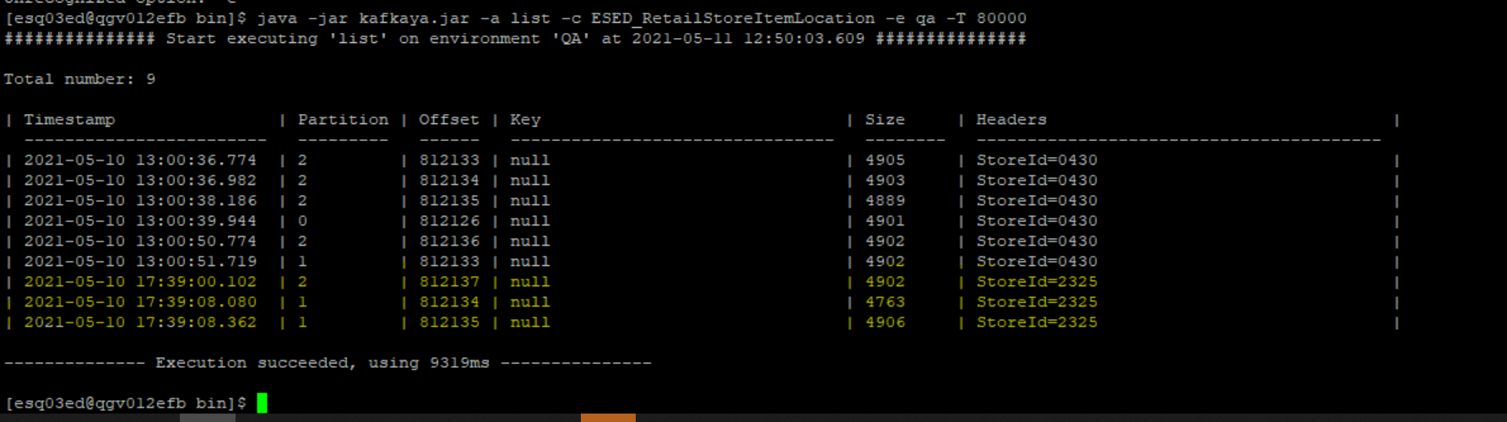

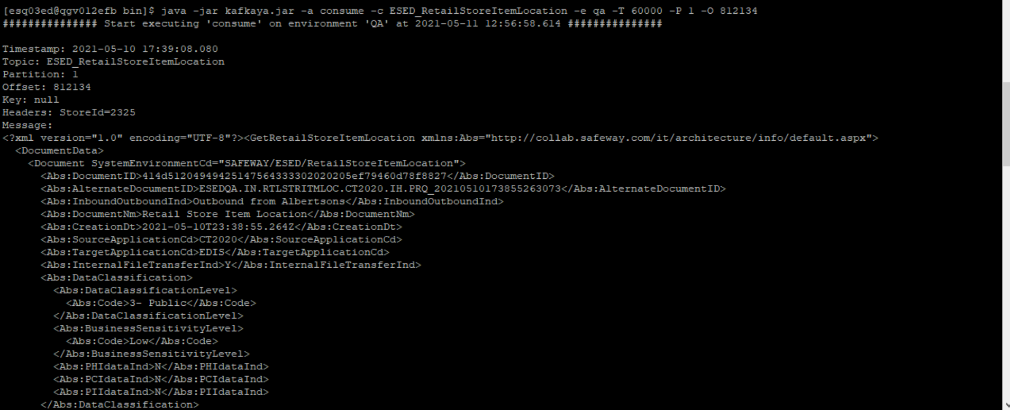

[esq03ed@qgv012efb bin]$ java -jar kafkaya.jar -a consume -c ESED_RetailStoreItemLocation -e qa -T 60000 -P 1 -O 812134

############### Start executing 'consume' on environment 'QA' at 2021-05-11 12:56:58.614 ###############

Timestamp: 2021-05-10 17:39:08.080

Topic: ESED_RetailStoreItemLocation

Partition: 1

Offset: 812134

Key: null

Headers: StoreId=2325

Message:

<?xml version="1.0" encoding="UTF-8"?><GetRetailStoreItemLocation xmlns:Abs="http://collab.safeway.com/it/architecture/info/default.aspx">

<DocumentData>

<Document SystemEnvironmentCd="SAFEWAY/ESED/RetailStoreItemLocation">

<Abs:DocumentID>414d51204949425147564333302020205ef79460d78f8827</Abs:DocumentID>

<Abs:AlternateDocumentID>ESEDQA.IN.RTLSTRITMLOC.CT2020.IH.PRQ_20210510173855263073</Abs:AlternateDocumentID>

<Abs:InboundOutboundInd>Outbound from Albertsons</Abs:InboundOutboundInd>

<Abs:DocumentNm>Retail Store Item Location</Abs:DocumentNm>

<Abs:CreationDt>2021-05-10T23:38:55.264Z</Abs:CreationDt>

<Abs:SourceApplicationCd>CT2020</Abs:SourceApplicationCd>

<Abs:TargetApplicationCd>EDIS</Abs:TargetApplicationCd>

<Abs:InternalFileTransferInd>Y</Abs:InternalFileTransferInd>

<Abs:DataClassification>

<Abs:DataClassificationLevel>

<Abs:Code>3- Public</Abs:Code>

</Abs:DataClassificationLevel>

<Abs:BusinessSensitivityLevel>

<Abs:Code>Low</Abs:Code>

</Abs:BusinessSensitivityLevel>

<Abs:PHIdataInd>N</Abs:PHIdataInd>

<Abs:PCIdataInd>N</Abs:PCIdataInd>

<Abs:PIIdataInd>N</Abs:PIIdataInd>

</Abs:DataClassification>

</Document>

<DocumentAction>

<Abs:ActionTypeCd>Delete</Abs:ActionTypeCd>

<Abs:RecordTypeCd>CHANGE</Abs:RecordTypeCd>

</DocumentAction>

</DocumentData>

<ItemLocationData>

<Abs:CorporationId>001</Abs:CorporationId>

<Abs:DivisionId>33</Abs:DivisionId>

<Abs:ROGCd>AVMT</Abs:ROGCd>

<Abs:RetailStoreId>2325</Abs:RetailStoreId>

<Abs:ItemLocation>

<Abs:Department>

<Abs:IdNbr>301</Abs:IdNbr>

</Abs:Department>

<Abs:Aisle>

<Abs:IdNbr/>

<Abs:AisleSection>

<Abs:IdNbr/>

<Abs:AisleSectionShelf>

<Abs:IdNbr/>

<Abs:CorporateItemCd>18010323</Abs:CorporateItemCd>

<Abs:ItemId>

<Abs:UPC>

<Abs:UPCNbr>0081000156018</Abs:UPCNbr>

<Abs:UPCTxt>0081000156018</Abs:UPCTxt>

</Abs:UPC>

<Abs:UPCComponents>

<Abs:PackInd>0</Abs:PackInd>

<Abs:ManufacturerId>10001</Abs:ManufacturerId>

<Abs:SalesId>56018</Abs:SalesId>

<Abs:CountryId>0</Abs:CountryId>

<Abs:SystemId>8</Abs:SystemId>

</Abs:UPCComponents>

<Abs:VendorProductID>00000000000000</Abs:VendorProductID>

<Abs:InternalItemId>18010323</Abs:InternalItemId>

<Abs:ItemDescription>BIRCH BEN SYRUP MA</Abs:ItemDescription>

</Abs:ItemId>

<Abs:ItemDsc>

<Abs:WarehouseItemDsc>BIRCH BEN SYRUP MAPLE BOURBON </Abs:WarehouseItemDsc>

<Abs:InternetItemDsc/>

<Abs:RetailItemDsc/>

<Abs:VendorItemDsc>BIRCH BEN SYRUP MAPLE BOURBON </Abs:VendorItemDsc>

</Abs:ItemDsc>

<Abs:ProductHierarchy>

<Abs:ProductGroup>

<Abs:ProductGroupCd>18</Abs:ProductGroupCd>

<Abs:ProductGroupNm>SYRUPS &amp; PANCAKE/WAFFLE MIX </Abs:ProductGroupNm>

</Abs:ProductGroup>

<Abs:ProductCategoryCd>

<Abs:ProductCategoryCd>1</Abs:ProductCategoryCd>

<Abs:ProductCategoryNm>SYRUPS </Abs:ProductCategoryNm>

</Abs:ProductCategoryCd>

<Abs:ProductClassCd>

<Abs:ProductClassCd>5</Abs:ProductClassCd>

<Abs:ProductClassNm>COOKING SYRUPS </Abs:ProductClassNm>

<Abs:RetailSectionCd>301</Abs:RetailSectionCd>

</Abs:ProductClassCd>

<Abs:ProductSubClassLevel1>

<Abs:ProductSubClassLevel1Cd>10</Abs:ProductSubClassLevel1Cd>

<Abs:ProductSubClassLevel1Nm>CANE &amp; ALL OTHER </Abs:ProductSubClassLevel1Nm>

</Abs:ProductSubClassLevel1>

<Abs:ProductSubClassLevel2>

<Abs:ProductSubClassLevel2Cd>0</Abs:ProductSubClassLevel2Cd>

<Abs:ProductSubClassLevel2Nm>CANE &amp; ALL OTHER </Abs:ProductSubClassLevel2Nm>

</Abs:ProductSubClassLevel2>

</Abs:ProductHierarchy>

<Abs:LocationNbr>0</Abs:LocationNbr>

<Abs:FormAndOverrides Abs:sequenceNbr="1">

<Abs:FormId>ECL62</Abs:FormId>

<Abs:FormQty>1</Abs:FormQty>

<Abs:OverrideQty>0</Abs:OverrideQty>

<Abs:OverrideFlag>0</Abs:OverrideFlag>

</Abs:FormAndOverrides>

<Abs:FormAndOverrides Abs:sequenceNbr="2">

<Abs:FormQty>0</Abs:FormQty>

<Abs:OverrideQty>0</Abs:OverrideQty>

<Abs:OverrideFlag>0</Abs:OverrideFlag>

</Abs:FormAndOverrides>

<Abs:FormAndOverrides Abs:sequenceNbr="3">

<Abs:FormId>SCD62</Abs:FormId>

<Abs:FormQty>0</Abs:FormQty>

<Abs:OverrideQty>0</Abs:OverrideQty>

<Abs:OverrideFlag>0</Abs:OverrideFlag>

</Abs:FormAndOverrides>

<Abs:FormAndOverrides Abs:sequenceNbr="4">

<Abs:FormId>SCM62</Abs:FormId>

<Abs:FormQty>0</Abs:FormQty>

<Abs:OverrideQty>0</Abs:OverrideQty>

<Abs:OverrideFlag>0</Abs:OverrideFlag>

</Abs:FormAndOverrides>

<Abs:FormAndOverrides Abs:sequenceNbr="5">

<Abs:FormId>SCT62</Abs:FormId>

<Abs:FormQty>1</Abs:FormQty>

<Abs:OverrideQty>0</Abs:OverrideQty>

<Abs:OverrideFlag>0</Abs:OverrideFlag>

</Abs:FormAndOverrides>

<Abs:AltLocationInd>0</Abs:AltLocationInd>

<Abs:DocumentAction>

<Abs:ActionTypeCd>Delete</Abs:ActionTypeCd>

<Abs:RecordTypeCd>CHANGE</Abs:RecordTypeCd>

</Abs:DocumentAction>

</Abs:AisleSectionShelf>

</Abs:AisleSection>

</Abs:Aisle>

</Abs:ItemLocation>

</ItemLocationData>

</GetRetailStoreItemLocation>

-------------- Execution succeeded, using 8311ms ---------------