Interactive Display of Population Soybean Genomic Data with Shiny

Susan VanderPlas, Nathan Weeks, Jim Specht, Di Cook, Michelle Graham

09/03/2014

# Abstract

# Interactive Display of Biological Data

* Literature review?

http://kbroman.org/qtlcharts/

http://www.ncbi.nlm.nih.gov/pubmed/23729504

* Discuss size of the data
* What is Shiny, how does it work, etc.

## Why Shiny?

Explain interactivity, server backend, advantage of serving up data over the web.

# Data

Describe magnitude of data, CNV analysis steps, etc.

# Basic Usage

## Copy Number Variation

* Describe different tabs in the applet, explaining the CNV methodology in minimal detail? Discuss the inclusion of genetic data and phenotype information (for reference purposes).

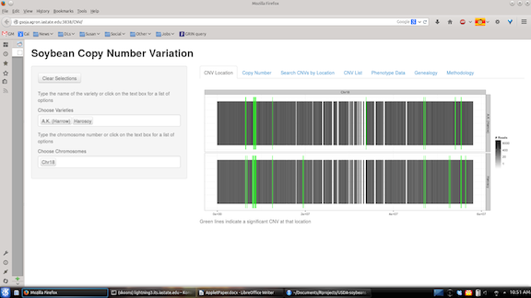

Copy Number Variation Sites

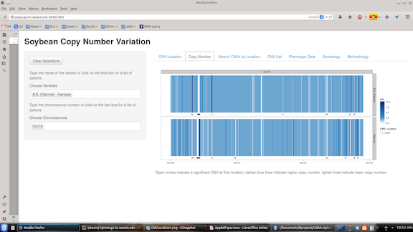

Copy Numbers

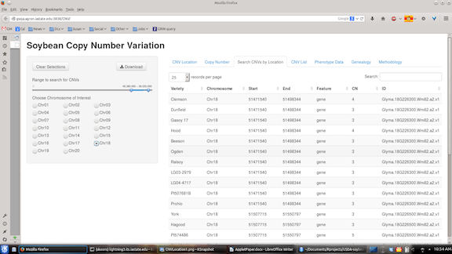

Copy Number List with Chromosome Position Search

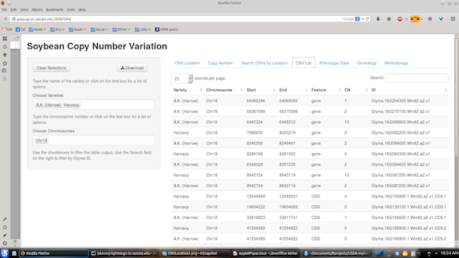

Copy Number List with Filters by Variety and Chromosome

* Include example video of Michelle using the applet.
* [Applet Link](http://gsoja.agron.iastate.edu:3838/CNV/)

## Single Nucleotide Polymorphisms

* Describe tabs, data workflow
* Include example video of Michelle using the applet
* [Applet Link](http://gsoja.agron.iastate.edu:3838/SNP/)

## Genealogy and Phenotype Reference

* Describe spin-off of CNV applet - genealogy of (most) soybean varieties
* [Applet Link](http://gsoja.agron.iastate.edu:3838/Genealogy/)

## Ubder the hood

## How does this slot into a different database like soybase?