class04.R

Gaby Canto

2024-01-19

#This is just a text file  
x<-1:50  
plot(x,sin(x))

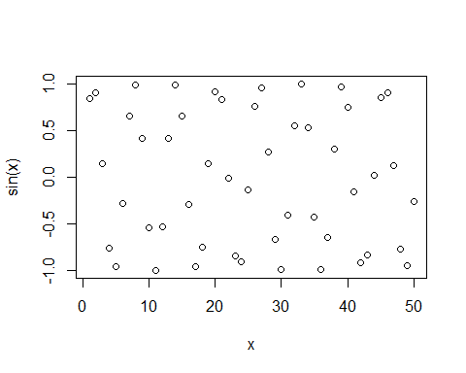

plot(x,sin(x),typ = "l")

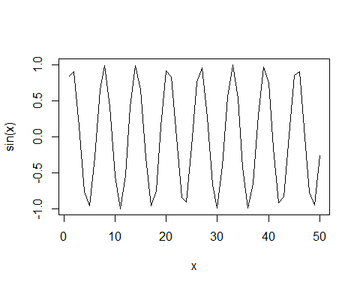

plot(x,sin(x),typ = "l",col="blue")

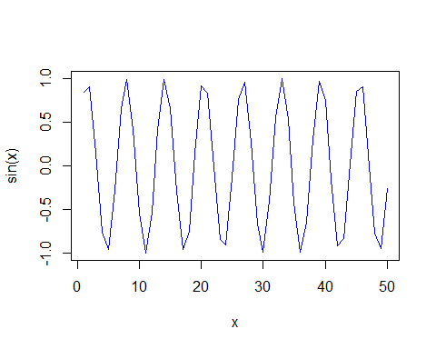

plot(x,sin(x),typ = "l",col="blue",lwd=2, xlab="hello")

