**HTML**

Introduction

* HTML stands for Hyper Text Markup Language.
* It is used to create web pages.
* HTML consists of several markup tags.
* HTML tags are most commonly used in pairs like <html> and </html>.
* Each HTML tag describes different document content.

Advantages

* HTML is platform independent.
* It is freely available for use.
* It is case-insensitive.
* HTML is very easy to learn and use.
* It has features like tables and applets.

Disadvantages

* Dynamic web pages cannot be created using HTML.
* HTML does not have good security features.
* HTML does not pass information to web pages.
* Most of the browsers may not support all the tags of HTML.

HTML Tags

* Tags are enclosed in angular brackets i.e. '<' and '>'.
* An HTML code begins with the tag <HTML> and finishes with </HTML>. All other tags are used between two tags.
* First tag in a pair is the start tag, and the second tag is end tag.
* A complete tag is called as an element.
* A tag has three major parts: opening tag, content and closing tag.

**Syntax:** <tagname>content</tagname>

**There are two types of tags:**

1. **Empty tag:** A tag which does not have any end tag.  
   **Example:** <hr>, <br>
2. **Paired tag:** A tag which has starting tag as well as ending tag.  
   **Example:** <h1>content</h1>

## Basic Structure of HTML

* Every HTML document starts with <html> tag and ends with </html> tag.
* This <html> tag tells the browser where the document starts and </html> tag tells where the document ends.
* The HTML document is divided into two parts i.e. head and body.

**Following figure shows the basic structure of HTML document.**  
  
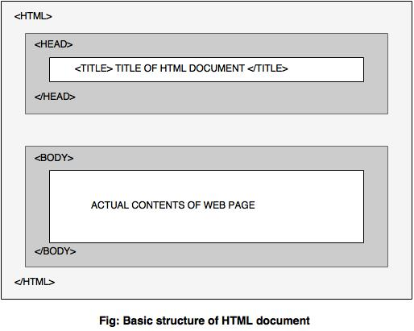

#### Example: Structure of HTML page

<!DOCTYPE html>  
<html>  
     <head>  
          <title>HTML page</title>  
     </head>  
     <body>  
          This is my first HTML page.  
     </body>  
</html>

**Output:**  
This is my first HTML page.