In the implementation phase of our project, we decided to implement the project directly on the printed circuit board. Since in a single sided PCB, we encountered some problems related the location of some signal and power traces, we designed our board in a 2 layer PCB. However, since the manufacturer is also us, we rarely use second layer of our PCB. Moreover, out controller, LM5030, comes in a very fine pitch package(MSOP10) it is hard to directly use it in a hand manufactured PCB. To reduce the risk, we order a breakout board which converts msop10 package to DIP10 package.

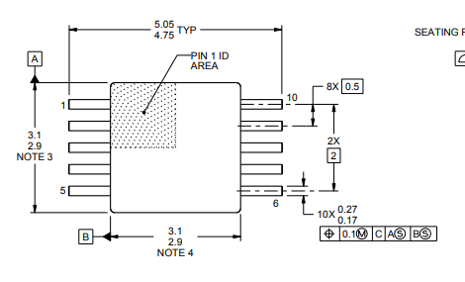

Figure : Dimensions of our controller

After the selection of implementation type and main components, we started to design our PCB in Proteus. Parts of our schematic can be seen below.

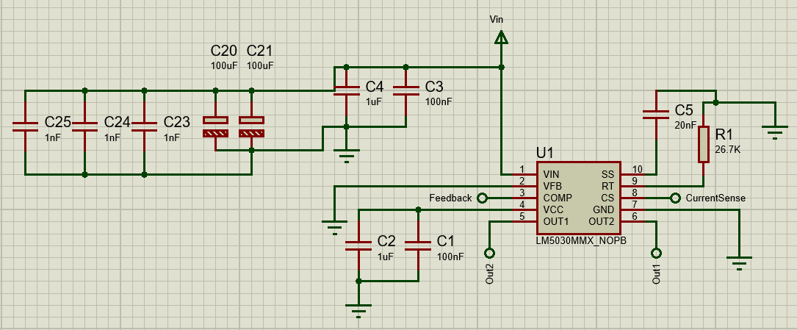

Figure : Schematic of controller

Our controller can be used in other feedback techniques, both isolated and non-isolated, however since we create the voltage feedback through optocoupler, we pulled down the input of error amplifier. In our feedback type, main components of the error amplifier is the TL431(which located in the secondary) and optocoupler. We directly connected our error path to comp line, which is originally output of the error amplifier of the controller. The second required feedback, current feedback, mainly requires feedback of the switch currents, to achieve this, source legs of the NMOS switches connected a shunt resistor.

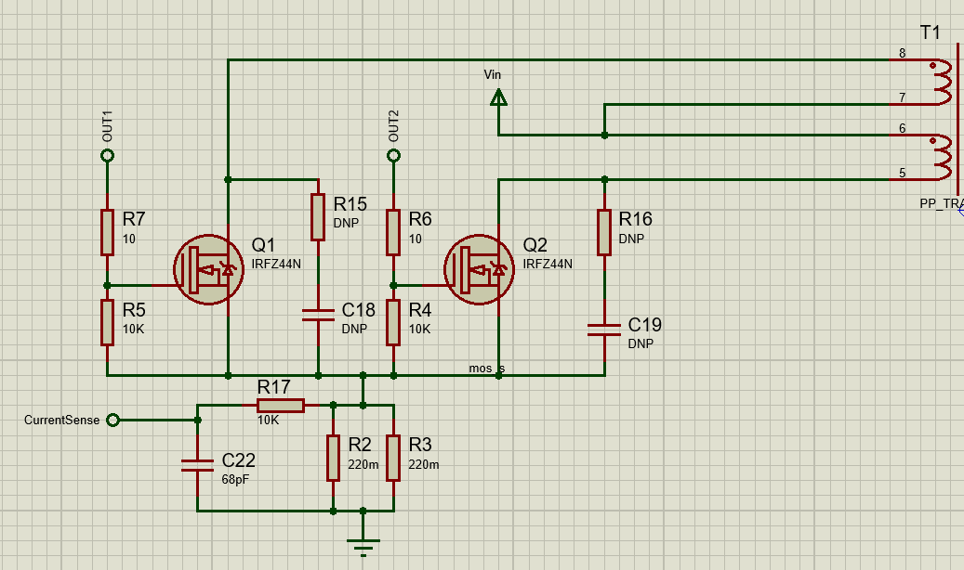

Figure : Switch part of the schematic

As can be seen above, we added a RC filter in the path of the current feedback. Corner frequency of the frequency calculated a little bit higher than the frequency of the signal to be measure. Since the snubber values is hard to decide on the schematic, we only create space for them. After the production and test final values decided as 1nF and 100Ohm, since packages of that components allow 1W of power dissipation, we doesn’t encountered any snubber problem related to heat.

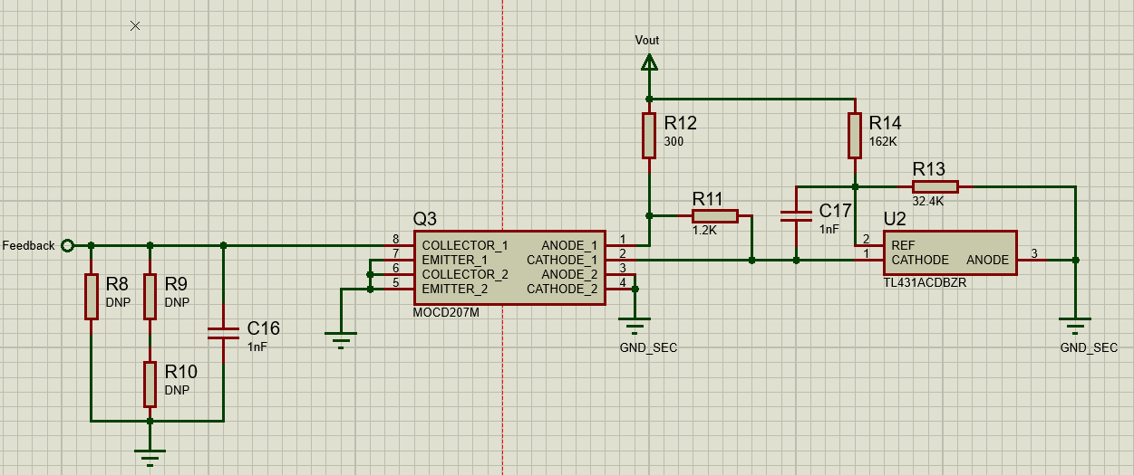

Figure : Schematic of feedback with isolation line

Due to high current transfer ratio and availability we decided to MOCD207M as optocoupler. We designed a type 2 compensation network for our circuit for best steady state and transient response. Location of pole and zero calculated by considering switching frequency, and values of passive components calculated by considering our pole and zero locations, characteristics of TL431 and our controller. We added R8, R9 and R10 if we need a locate any additional components in our circuit. With that configuration location we have open loop gain of approximately 17dB. Calculated values give us required performance in that project, hence no further improvement made in the test phase.

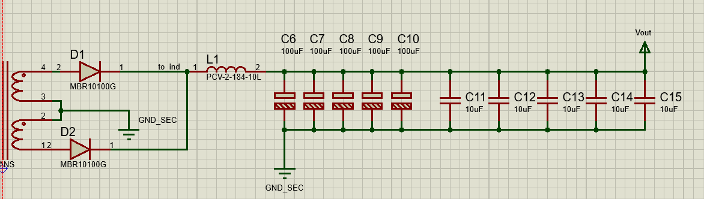

Figure : Secondary side of the project

Last part of our schematic is secondary side, which is composed of diodes, inductor and output capacitors. This part of our schematic has a lot of modification on the PCB. Firstly, we replaced our first electrolytic capacitors due to problems about their ESL and ESR with a better one. Moreover, we added some film capacitors, and increase the number of MLCC. Every ceramic capacitor at out phase works in DC bias of 15V, which reduces our capacitance value to 2.5uF for every ceramic capacitor. Last modification in that part is the snubbers of the diodes, we forgot the add snubber to the diodes. While testing the project we saw a 5Mhz signal on the corners of the diode voltage waveform, so we again add a 1nF and 100Ohm snubber to solve it. Our RC snubber network result in a overdamped response in that signal.

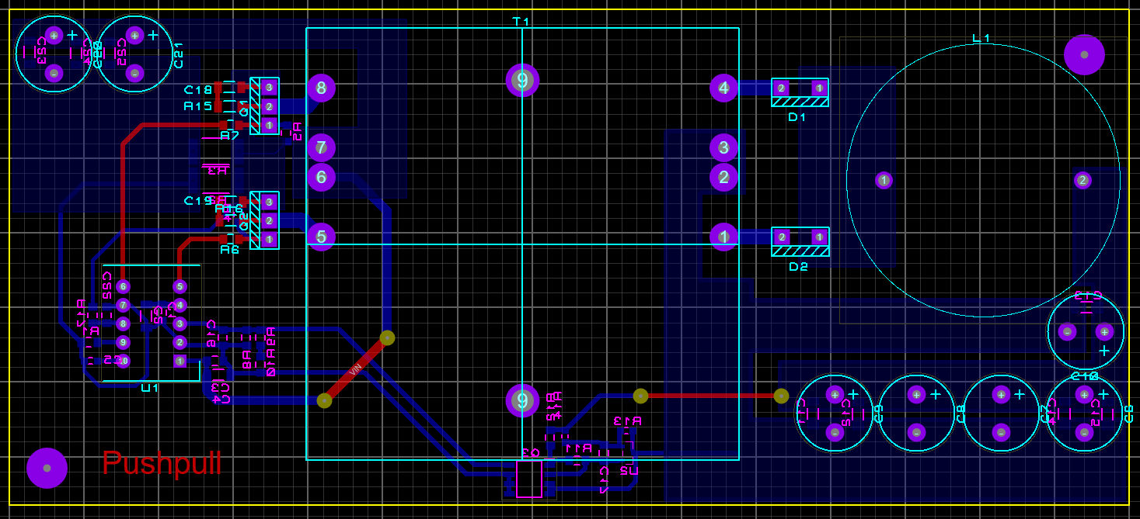

Figure : Layout of our circuit (Red: top copper, blue: bottom copper)

Some photos related to our circuit and soldering phase can be seen below.

metin, kişi, iç mekan, el içeren bir resim

Açıklama otomatik olarak oluşturuldu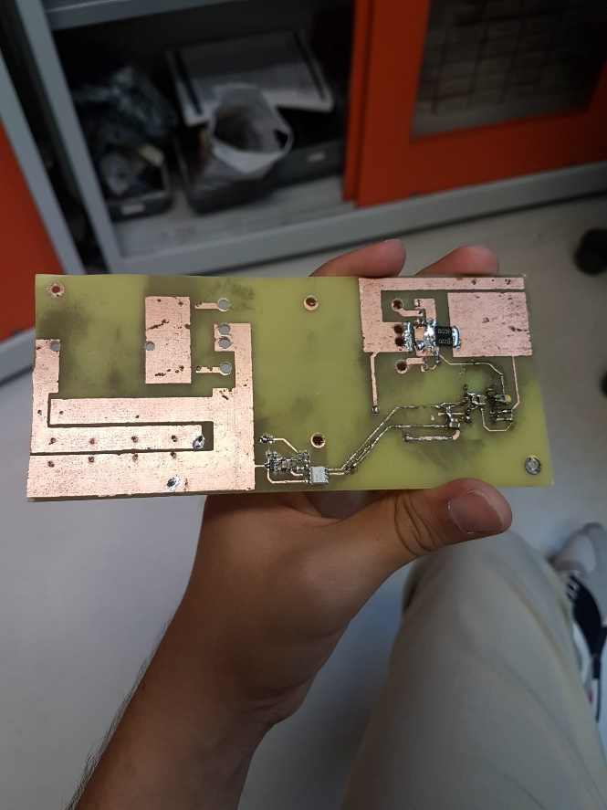

Figure : Soldering stage

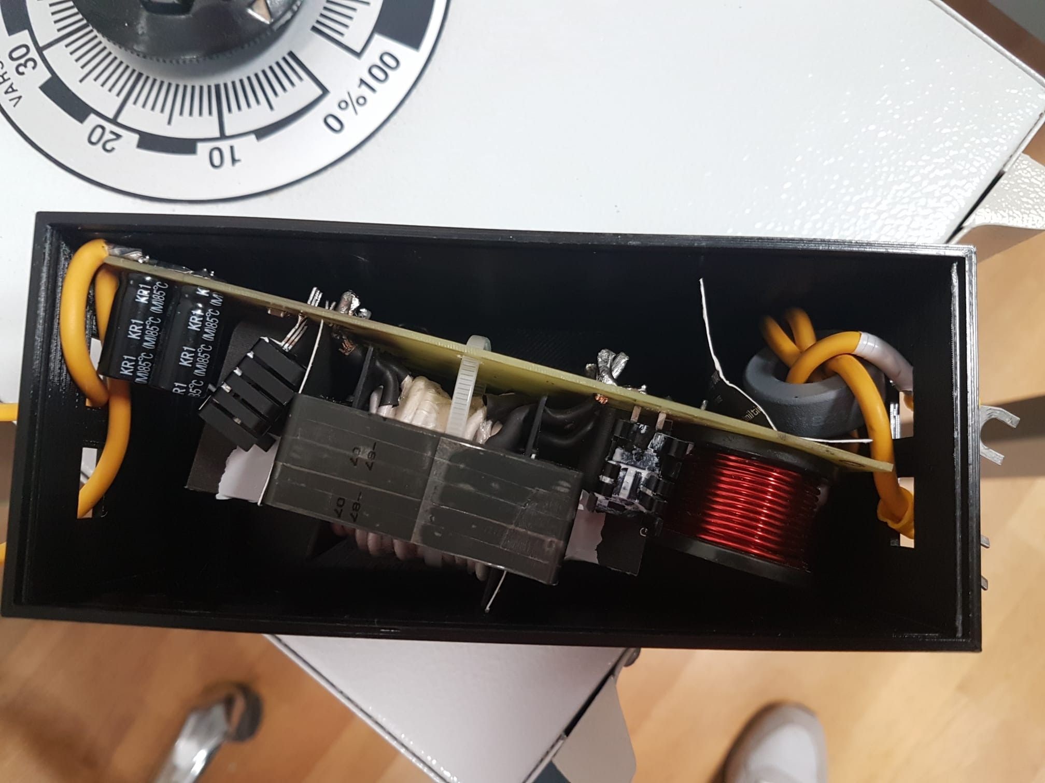

Figure : Final product in box.