# **Curriculum Vitae**

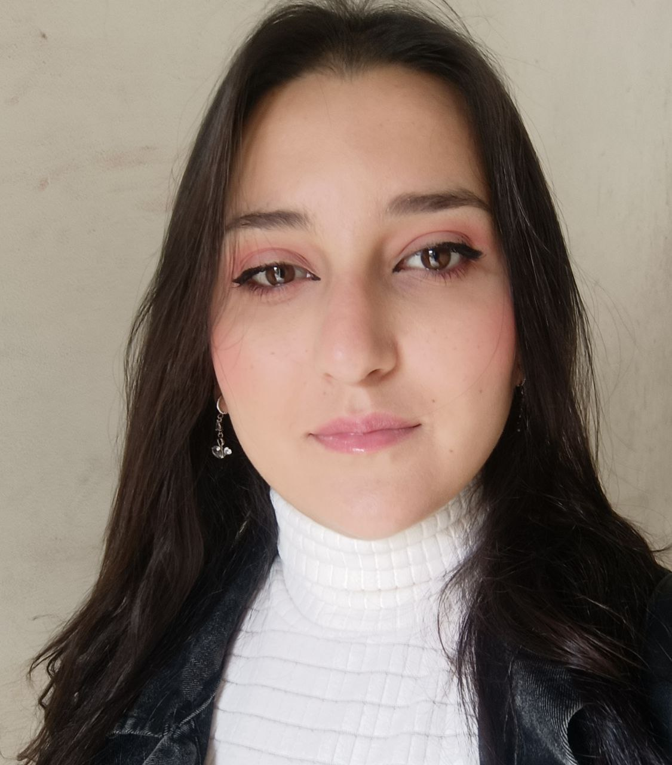

Name: Sozana Blidy

Date of Birth: 09/08/2000

Nationality: Syrian

**Profile**

* Innovative and dedicated data scientist with 4+ years of experience in AI and machine learning.
* Proficient in dataset preprocessing, model evaluation, and deployment.
* Fast learner with strong problem-solving and analytical thinking skills.

**Work Experience**

**AI developer (Al-joud company)**

**Avocado Platform** | *Feb 2025 – Present*

• Developed an AI-powered e-learning platform to enhance online education for students across various age groups.

• Implemented text-to-speech and avatar narration features to make lessons more interactive and accessible.

**AI developer (Davinda company)**

**CV Assessments**| *Oct 2024 – Dec 2024*

* Develop an AI model for reviewing and summarizing Resumes and give recommendations for making it better. The website powered-by AI contains virtual interviews for better preparing for job haunting.

**AI developer (Al-Joud company)**

**HR Consulting** | *Mar 2024 – Sep 2024*

* + - * Develop a website powered by AI for HR consulting services which are competencies, skill assessments, and development plans using AI models to generate the best results for each service based on specific elements. Django was used for building the website and SQL was used as the database.

**Data Science specialist (Freelancing since Sept. 2021)**

**Brain Stroke Detection** | *Apr 2025– June 2025*

* Train deep learning model to detect strokes for early prediction task using medical reports related to heart beating, pressure, etc..

**Crime Rate Prediction**  | *May 2023 – June 2024*

* Preprocess Chicago crimes dataset and convert it to time series to follow the crime rate in this country.
* Train LSTM model to predict the crime rate and type in each area

**Drug target interaction** | *Oct 2023 – Feb 202*4

* Preprocess a medical dataset and convert it to fingerprints and sequences
* Train many machine learning and deep learning models to classify if there is interaction between drug and protein sequence to create new medicine or not

**Horse detection and tracking**  | *July 2023 – Dec 2023*

* Horses in races dataset
* Train YOLOv7 model to detect horses during races

**Food ingredients forecasting** | *July 2023 – Nov 202*3

Collect a real dataset from some restaurant in Turkey and apply preprocessing.

* Apply data analysis to discover the needed amounts for each ingredient in the next five days.

**Human heartbeat recognition**  | *Dec 2022 – May 2023*

* Preprocess ECG-ID medical database
* Train machine learning model (LightGBM) to recognize heartbeat signals

**Self-Driving Car** | *Mar 2022 – Nov 2022*

Dataset consist of 46 type of road signs and lights

* Object detection model with YOLOv7 is built to extract ROI from street view
* Multi-task learning model was built to classify images to traffic light or signs
* Apply real time prediction on Al-Rydah streets

**Covid19 Detection** | *Mar 2022 – June 2022*

* Dataset consists of CT scan images of patients got pandemic and normal people
* Transfer learning is used with state-of-the-art pre-trained models
* The highest result was 99.6% the model able to detect covid19

**Signature verification system** | *Jan 2022 –Mar 202*2

Write an academic research for a novel signature verification system methodology

**Deepfake Detection** | *Sep 2021 – Nov 2021*

* Dataset consists of fake and real videos from deepfake challenge on Kaggle website
* MISO pre-trained model is used to classify videos to real or fake

The highest result was 98% the model able to detect fake videos

**AI Mentor (Ada Lovelace Hackathon (Teens in AI) event, October 2021)**

* Mentoring a teenager team in the hackathon to build useful AI project.
* Encouraged them to create their own projects

**Designing, writing, and translating (Freelancing since Sept. 2021)**

* Translate texts to and from English
* Create PowerPoint presentations
* Establishing scientific research and publishing it in international journals

**Personal Projects**

**EpiAI – Epilepsy Detection System** | *Oct 2024 – Present*

Designed and developed an AI-based system to detect epilepsy using EEG data.

• Implemented advanced feature extraction methods (FFT, Hjorth, ZCR, etc.) from various EEG formats (EDF, MAT, CSV, DICOM).

• Trained a Bi-directional CNN-LSTM model for accurate seizure prediction.

• Created a hospital dashboard to manage patient records and display real-time results securely.

**Bright Brain – AI-powered Educational Platform for Children** | *May 2025 – Present*

• Built an interactive educational platform for children aged 2–10, featuring AI-generated stories, learning games, and videos.

• Developed story viewer with animated page turning using React and Tailwind CSS.

• Integrated GPT for story generation and text-to-speech for narration.

• Designed a parental dashboard and multi-language support for broader accessibility.

**Education**

**Information Technology Engineering (Bachelor)** 79%, Tishreen University, Latakia (Syria) | *Oct 2017 – Sep 2023*

* Major: Artificial Intelligence
* Thesis: Convert text-to-image using generative adversarial networks with degree 95%

**Languages**

**Arabic:** Native **English:** Full Professional Working Proficiency **Spanish:** Beginner  **Turkish:** Beginner

**Volunteering**

**Skills and Career Center, IT team** | *Mar 2020 – Sep 2022*

**Link:** https://drive.google.com/file/d/1c6FFy2W6xEBoso7inE7ZO3--ZjiejRNO/view?usp=sharing

**Skills**

**Digital skills:** Python Language, Machine Learning, Deep Learning, Computer Vision, Natural Languages Preprocessing, Django, SQL, HTML, CSS, Keras, scikit-learn, TensorFlow, Java Script, Git, Flask, Drow.io, Data Mining, good knowing in Java and C++ Languages, Microsoft Word, and Microsoft Excel

**Personal skills:** Project Management, Decision Making, Team Work, Flexibility, Fast Learning, Problem Solving, Time Management, and Communication Skills

**Personal Interests**

Movies, AI & robotics, Music, and Photographing 01/06/2025 