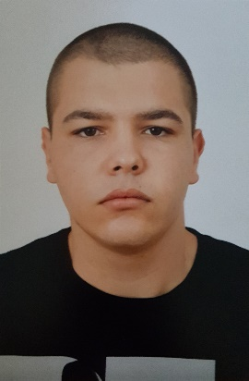

Personal Information

**Name**

**E-Mail**

**LinkedIn**

**GitHub**

**Nationality**

**Date of birth**

**Gender**

**Desired position**

Education and Training

**University**

**Specialty**

**Period**

**High School**

**Specialty**

**Period**

Skills and Competences

**Mother Language**

**Other Language(s)**

**Social skills and competences**

**Computer Skills and competences**

Rosen Runtev

[runtev.rosen@gmail.com](mailto:runtev.rosen@gmail.com)

<https://www.linkedin.com/in/rosen-runtev>

<https://github.com/rosenruntev>

Bulgarian

24.11.1999

Male

Senior Java developer

Plovdiv University “Paisii Hilendarski”

Software engineering – bachelor

2018 – Present

Professional Gymnasium of Mechanotechnics, Plovdiv

Mechatronics

2013 – 2018

Bulgarian

English

Positive, ambitious, responsible, communicative and very motivated software engineer with ability to work in team

Java, Object-oriented programming principles, design patterns, MySQL, MongoDB, Maven, Spring framework and Spring boot, HTML, CSS, Javascript, Angular, Git, Elasticsearch