Experiment Start
- Consent
- Welcome to the Experiment
- The stimuli
  - 
  - In this experiment, you will be classifying turtles. Here are a couple examples:
- Here are a couple more examples:
  - 
- Each turtle belongs to a species of turtle: Species F or Species J.
- You are tasked with determining which turtle belongs to Species F or Species J . There are TWO components related to the turtles’ species classification. You should consider both the height of the green shell (illustrated by the white arrow in the picture):
  - 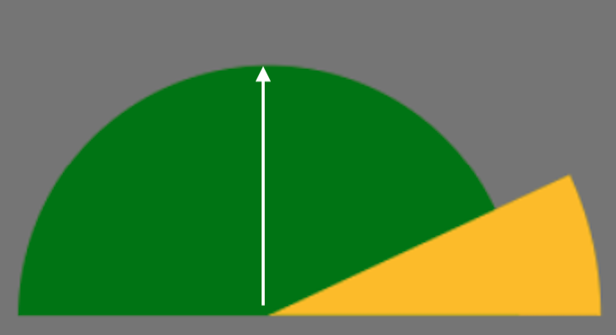
- And you should consider the size of the angle of the yellow head...
  - 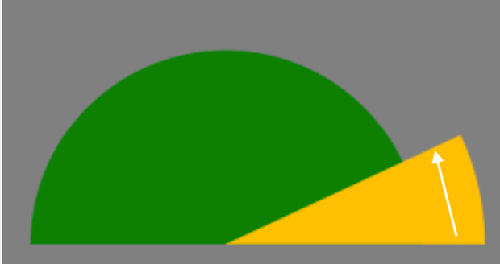
- Learning the species
  - The experiment is broken into two phases. In the first phase, you will learn Species F and Species J.
  - There will be a second phase in which you will use what you've learned to make more classifications - but instructions for that will come later.
- For now, you will learn to classify a single turtle on each trial.
  - Before each trial, you will see a plus sign. This will let you know that you are about to see a new turtle.
  - When the trial begins, you will be shown a turtle.
  - Press 'f' on the keyboard if the turtle belongs to Species F, and 'j' if it belongs to Species J.
  - After each response you will be told whether or not your answer was correct.
  - This feedback will help you get better at classifying these turtles.
- If you have any questions, ask the experimenter now.
- Click to begin the first phase of the experiment.

Transfer Phase
- Using what you've learned
  - The learning phase is now complete.
  - You will now use what you've learned to classify some new turtles.
- This part of the experiment will be the same as before, except…
  - 1. You will not be told whether you were correct after each trial.
  - 2.
    - [Standard/switch] You won’t always classify a turtle. Sometimes we will just show you a turtle, and you will hit the spacebar to go the next trial.
    - [Switch/standard] You won’t always classify a turtle. Sometimes we will ask you another question, and you will respond using the keyboard.
- You will still use the f and j keys to respond.
- The decision will sometimes be difficult, just do your best!
- Halfway through this phase, you will get a short break.
- Click to begin the second phase of the experiment.

Break:
- you are halfway through this phase of the experiment.
- Take a short break (wait 30 seconds)
- This part of the experiment will be the same as before, except…
  - 1. You will not be told whether you were correct after each trial.
  - 2.
    - [Standard/switch] You still won’t always classify a turtle. However, sometimes we will ask you another question, and you will respond using the keyboard.
    - [Switch/standard] You won’t always classify a turtle. Sometimes we will just show you a turtle, and you will hit the spacebar to go the next trial.
- Click to begin the second part of this phase.

Demographics
The experiment is almost done. Before we finish, we just have a few questions to ask you to get a better idea of the participants in our study.

- How old are you?
  - box to enter age
- What race(s) do you consider yourself to be?
  - American Indian or Alaska Native
  - Asian
  - Black or African-American
  - White
  - Other
- Ethnicity: Do you consider yourself to be Hispanic or Latino?
  - Yes
  - No
- Which best describes your gender?
  - Female
  - Male
  - Non-binary/third gender
  - Prefer not to say
  - Other

