**API Integration Architecture with PrIA**

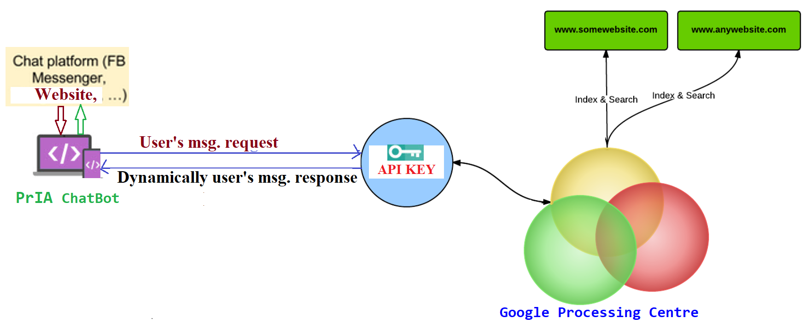

Fig. Diagram shows how ChatBot works to fetch dynamic data from google based on user’s queries

Below is the step by step process that we have used to fetch the dynamic data on google based on user’s request.

**Step 1:**

First, we have created the project by using google cloud console link to create custom search credentials and after creating it we have enabled API before using it, to make it search based on user’s request.

Here is the link: <https://console.developers.google.com/apis/> and diagram shown in below.

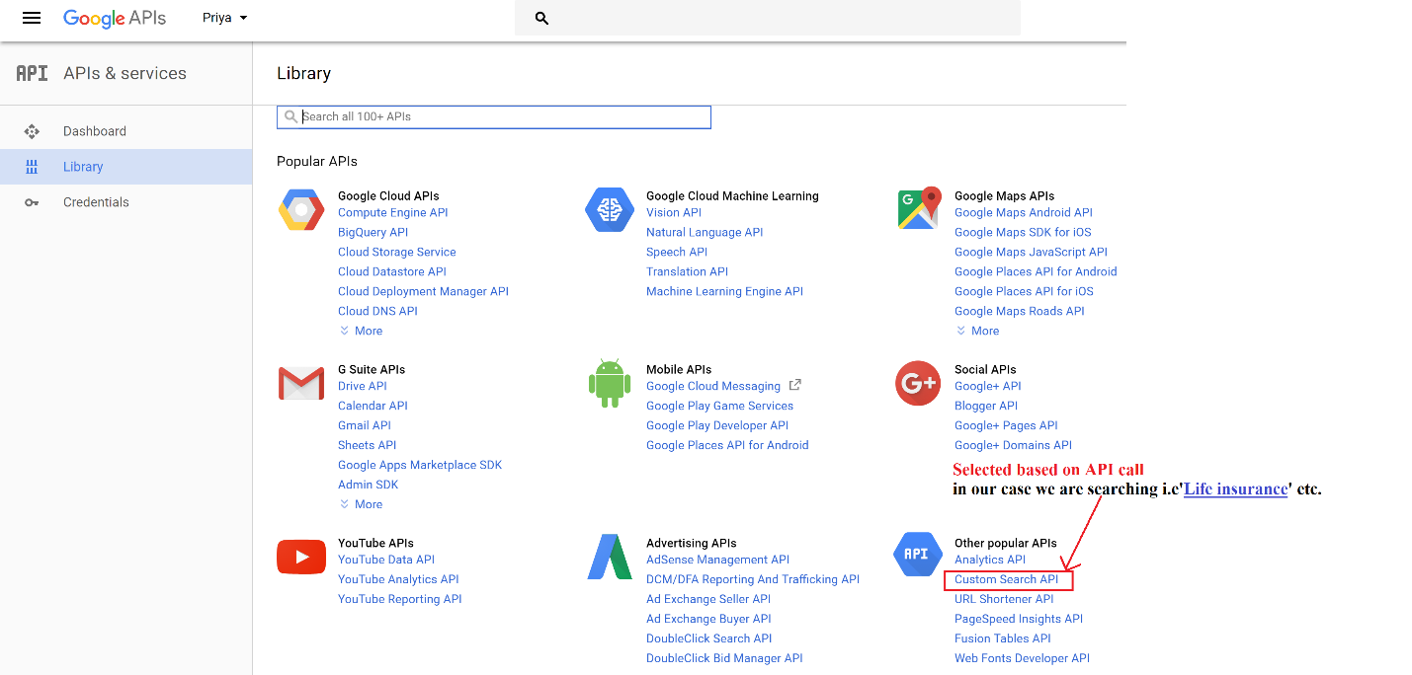

Fig: Shows the selection of custom search API inorder use custom search API

**Step 2:**

Second, we have used Google CSE URL, to create our custom search engine, to get CSE key from Public URL.

Link: <https://cse.google.com/cse/> and images are shown in below

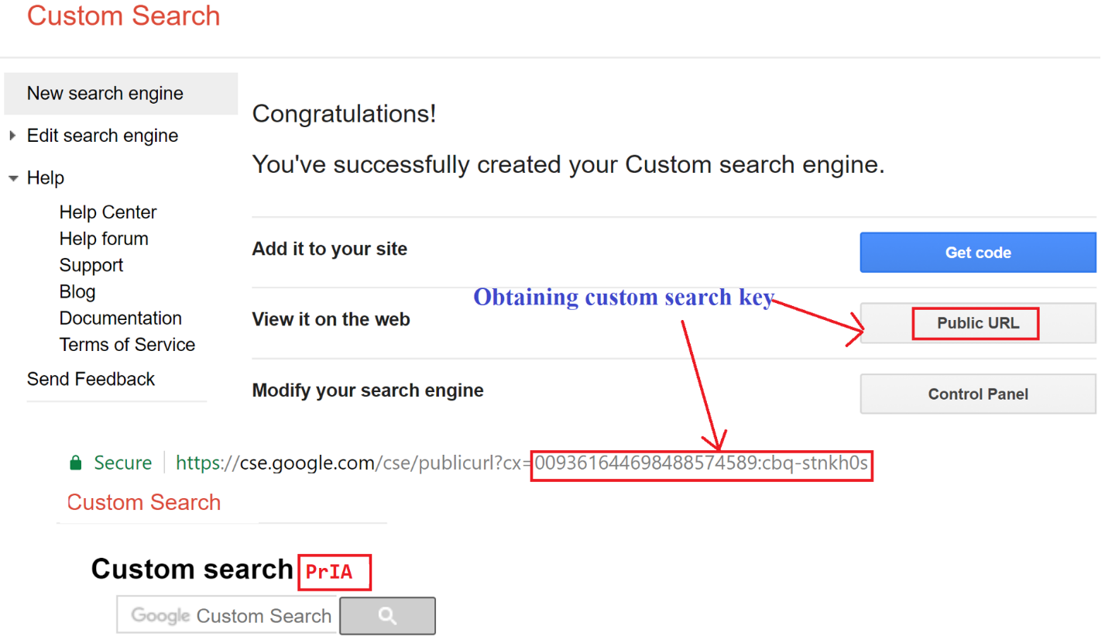

Fig: Above figure shows the custom search API obtaining process

**Step 3:**

Finally, we have made API call using URL, this URL we have used in FlowXo tolls to make the dynamic search based on user’s queries from user’s through Priya ChatBot.

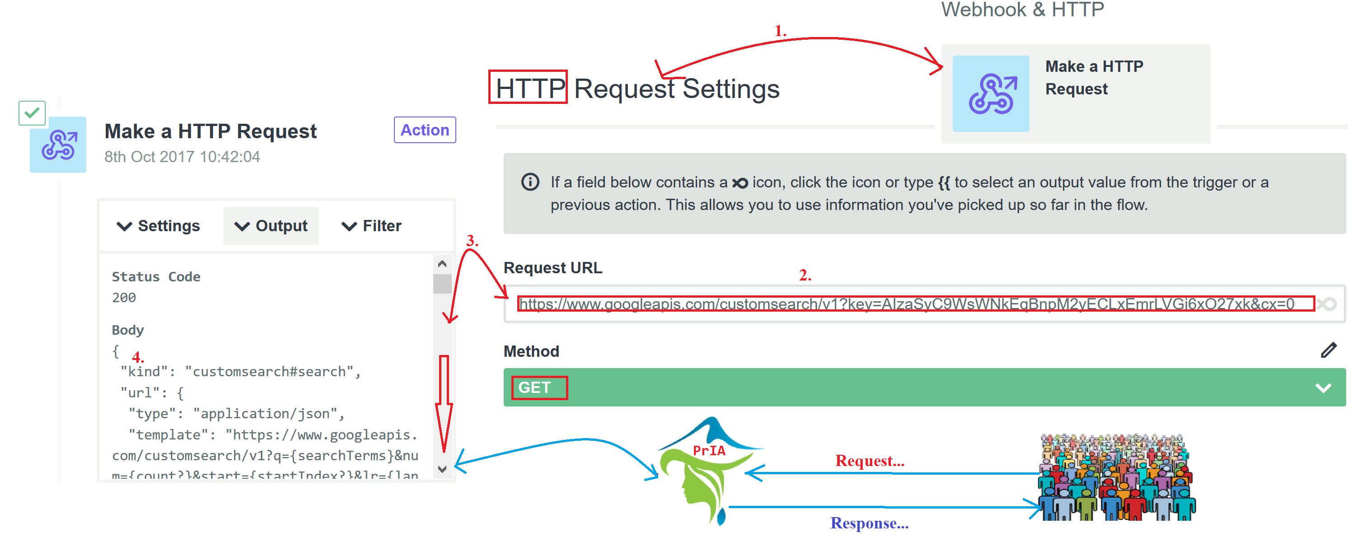

Fig: Above figure shows the complete internal working structure of FlowXo tool in our Priya ChatBot

As we have mentioned above based on above descriptions, here is the final URL obtaining process that is shown in below…

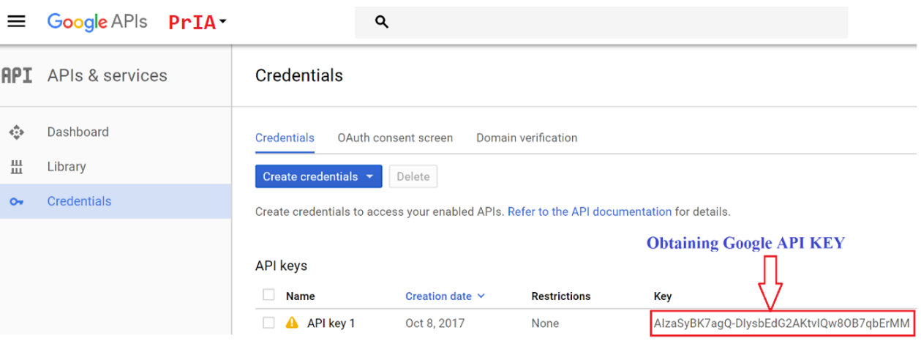

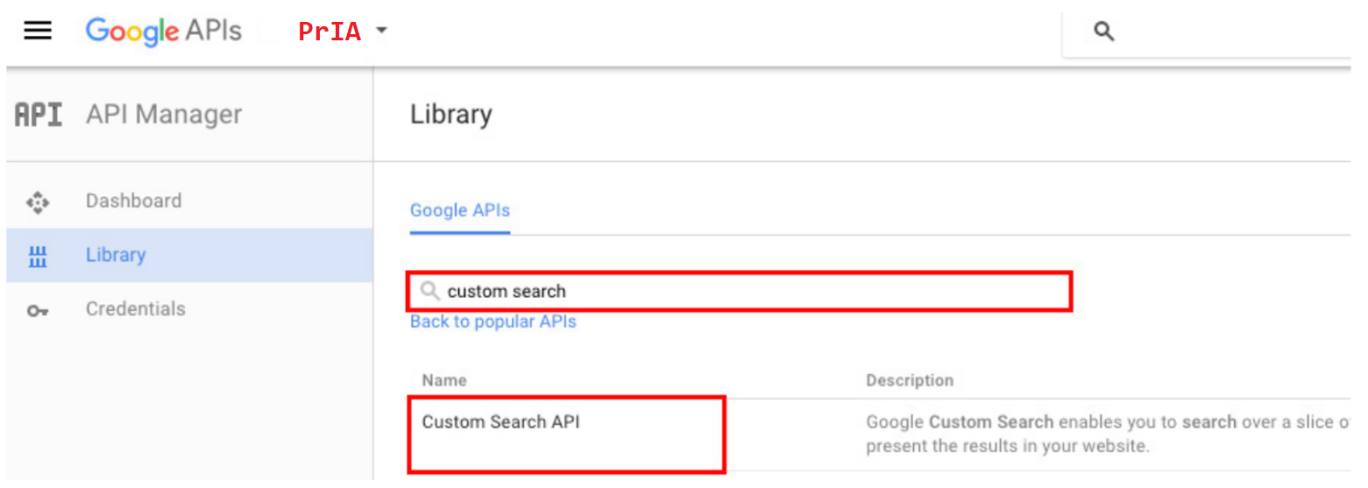

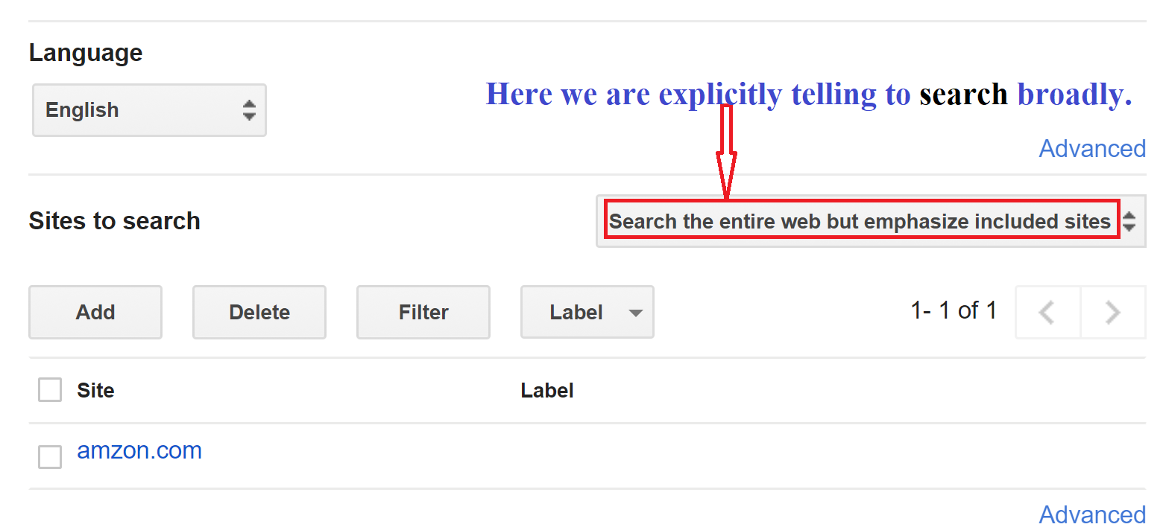

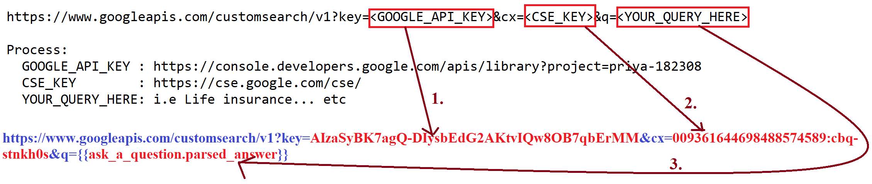

**Integrating Google Sheets**

We used Google sheet as of our database for example to search, add and update information based on user’s queries.

**Gmail**

To send the information based on user’s searched and their request, we have integrated Gmail to send the details for life insurance.

**FlowXO help links inspiration:**

https://community.flowxo.com/t/tutorials-other-resources/1118

https://support.flowxo.com/category/4-user-guide

https://support.flowxo.com/category/3-integrations

https://support.flowxo.com/article/22-webhooks