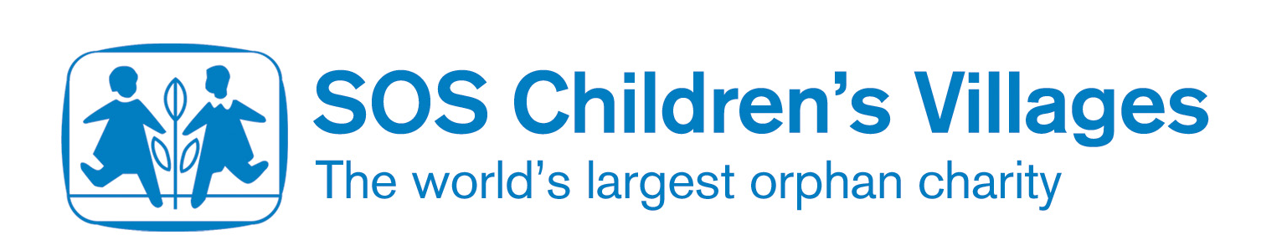

HIV/AIDS

HIV and AIDS are two parts of an illness which still has no cure, even though doctors and researchers have been looking for ways to prevent it and treat it for a long time. There are ways to prevent catching the disease, but in African countries with lots of remote areas and a general lack of education, it is difficult to tell everybody about these.
AIDS stands for ‘acquired immune deficiency syndrome’.

HIV stands for ‘human immunodeficiency virus’ and people who have this can look and feel well.

People often refer to the ‘AIDS epidemic’, meaning that it is a growing illness across the world, which is difficult to control.

Sub-Saharan Africa is by far the region in the world worst affected by HIV and AIDS, according to the UN and the World Health Organization. This is partly because it is difficult to educate people about the infection.

A report called the AIDS Epidemic Update published in 2006 makes extremely depressing reading. It says there were 3.4 million new HIV infections in Africa in 2001, almost 70% of the total for the whole world.
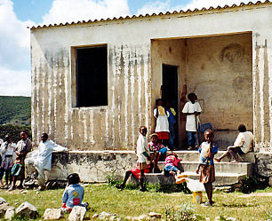
AIDS is the biggest threat to Africa's development. This is because people who hold important jobs in the country are dying. Without these people, the country struggles to maintain its vital services like schools and medical centres.

- Farmers
- Health-workers
- Civil servants
- Young professionals
- Teachers

Angola: African Beauty and Tragedy

The Republic of Angola has breathtaking scenery and pure white beaches, and is one of Africa's most beautiful countries. With its vast reserves of diamonds, it is also potentially one of the wealthiest. But most of its 13 million people live in terrible poverty as a result of over 25 years of civil war.

HIV/AIDS in Angola

Angola, as well as recovering from the affects of a prolonged civil war, has to come to terms with a rising rate of HIV/AIDS.

- Nearly 4% of the adult population is affected
- More than 100,000 children were orphaned as a result of HIV/AIDS in 2003

SOS Children works in Benguela and Lubango, reaching out to AIDS orphans and other vulnerable children and their families in the local communities. SOS Children works with the local health departments and other NGOs on prevention through education and voluntary testing.

