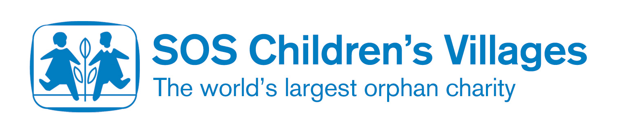
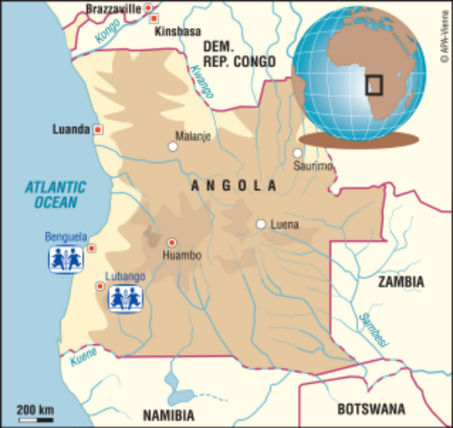

Angola in a nutshell

Situated in south-central Africa, Angola is the fifth largest country on the continent. It neighbours Namibia to the south, the Democratic Republic of Congo to the north, Zambia to the east and borders the Atlantic Ocean to the West. Luanda, on the northern coast, is the capital and one of the country’s major ports.

Population of Angola: 15.5 million
Life expectancy: 40.7 years
Languages: Portuguese, Bantu and other African languages
HIV/AIDS rate: 3.7%
Adult literacy rate: 67.4%
Population without clean water: 47%

History of Angola

The country was inhabited by a number of tribes, including the Bantu, before Portuguese settlers arrived in the country in 1483 and made Angola part of their overseas colony.

Angola was one of the last African nations to gain independence from its European colonisers, which was declared in November 1975. Unfortunately, however, different ethnic groups clashed over who was to control the newly independent country and civil war broke out almost immediately.

Thanks to these groups’ control of the country’s considerable natural wealth (from oil, diamonds and other minerals), the war continued for 27 years before peace was restored in February 2002 when the People's Movement for the Liberation of Angola (MPLA) came to power.

Social situation

After so many years of civil war, Angolan people still face a number of difficulties in their everyday lives. Roads have been badly damaged by the fighting, landmines litter the countryside and many people, who fled their homes to escape the fighting, are still living as refugees in their own country.

With so much of the land unusable as a result of the landmines and because transport links are poor, food is often in short supply or too expensive for the poorer communities to buy. Food aid is therefore an important support for much of the population.

SOS Children’s Villages in Angola

The war also split up many families and orphaned many children, which is why SOS Children’s Villages’ work in the country is so important for the communities in which it works.

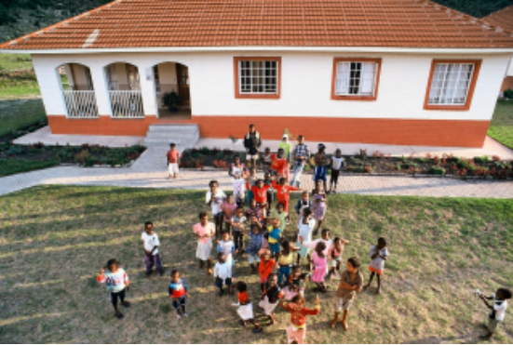
The first SOS Children’s Village was built in Lubango, in south west Angola, in 1996, where 12 family houses provide a new home for 120 vulnerable children. Nearby, the charity also has four flats where teenagers are able to begin to live independently.

Perhaps the most exciting part about the village is the football pitch that FIFA provided a few years ago, where all the children from the surrounding community enjoy a good kick about.

There is a second SOS Children’s Village in Benguela, close to the Atlantic coast. This is also home to 120 children. Both villages also have a nursery and primary school, where children from the village are educated, as well as a medical centre to provide healthcare and community development programmes to support the poor and vulnerable families living nearby.

The SOS Vocational Training Centre in Lubango also offers young people the chance to learn a trade and helps them on their career path.

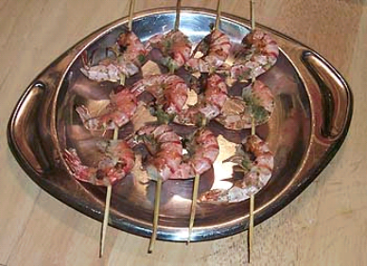
Traditional Angolan Recipe
Camarao Grelhado com Molho Cru - Grilled Prawns with Raw Sauce
Ingredients
- 1 lb prawns
- 2 cloves garlic, crushed
- 1/2 cup chopped green onions
- 1 tsp ground cumin
- 1/4 tsp salt
- 4 tbsp wine vinegar
- 4 tbsp water
Instructions
Make the sauce by combining all the ingredients and grinding them into a paste. Put the prawns on the skewers and brush with sauce. Grill until done about 3-4 minutes on each side (they should lose their translucent color). Serve with extra sauce on the side.

For more information:

United Nations Development Programme - Human Development Report 2006: http://hdr.undp.org/hdr2006/

BBC
http://news.bbc.co.uk/1/hi/world/africa/country_profiles/1063073.stm

