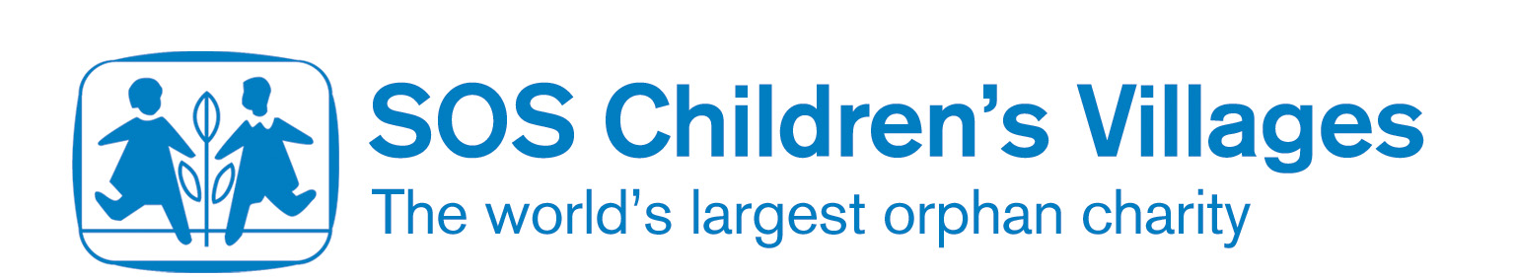

What is a child soldier?

A child soldier is any child who works for a military group – including the army and other organisations that are armed.
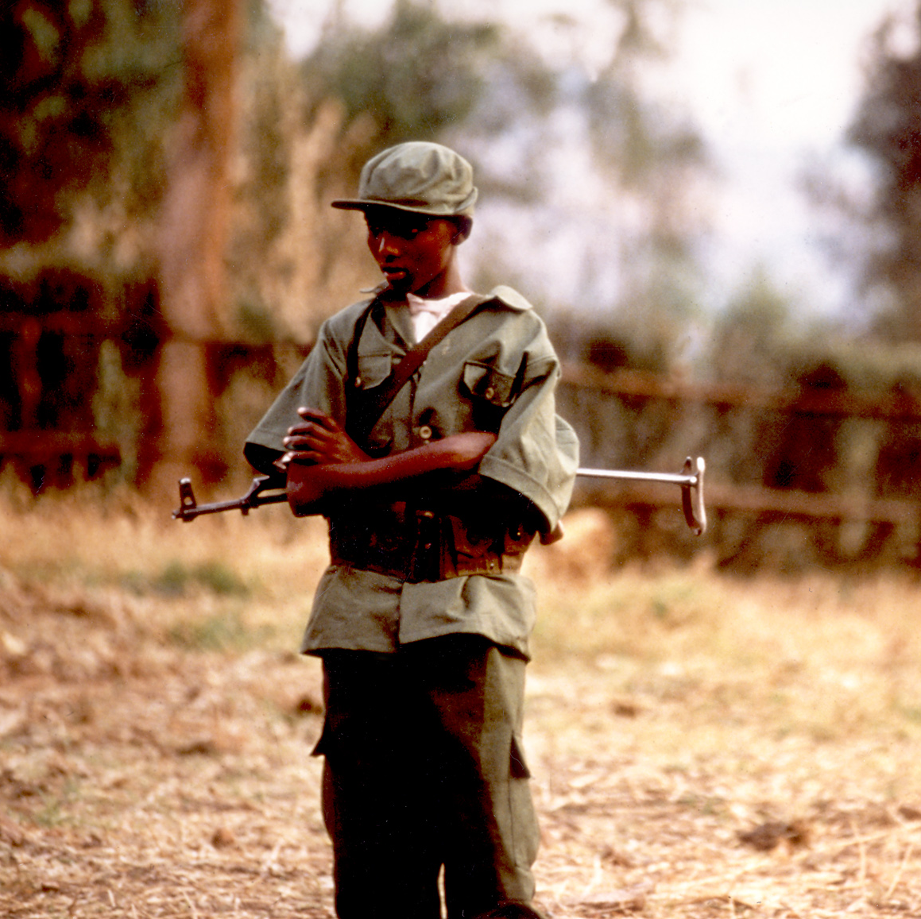
Who are child soldiers?

Both boys and girls can be child soldiers, some as young as nine years old. Most are between 14 and 18 years old.

The U. N. Convention on the Rights of the Child states 15 years as the minimum recruitment age. Most countries have agreed to increase this age to 18 (this is called the Optional Protocol). Even in the UK, there are soldiers aged 16 to 18 – but they do not go to combat areas.

Why do they join up?

Children join up for various reasons; sometimes because they are forced to by the armed groups, some are forced to because their lives and families have been destroyed because of conflict, and some choose to join.

Most child soldiers are poor and can’t find any other way to make a living. Some join because they have no chances to go to school or find work.

They might join because it is the only way to survive after their families have been separated because of war, or because they have seen their family killed by soldiers and they want to fight against them.

Many girls enlist to escape domestic servitude, violence and sexual abuse.

What do they do?

Children involved in armed conflict are frequently killed or injured during combat or while carrying out other tasks.

They are forced to engage in hazardous activities such as laying mines or explosives, as well as using weapons.

Child soldiers are usually forced to live under harsh conditions with insufficient food and little or no access to healthcare. They are almost always treated brutally, subjected to beatings and humiliating treatment.

Punishments for mistakes or desertion are often very severe. Girl soldiers are particularly at risk of rape, sexual harassment and abuse as well as being involved in combat and other tasks.

Angola

Statistics from the Child Soldiers Global Report 2004 and UNDP Human Development Report 2006:

Population of Angola: 15.5 million (7.2 million of these are under the age of 18)
Government armed forces: 129,000-131,000
Compulsory recruitment age: 20
Voluntary recruitment age: 18 for men, 20 for women
Voting age: 18
Optional Protocol: not signed

The Child Soldiers report states that:
“Child soldiers were used extensively during the civil war by both government armed forces and the armed opposition group, UNITA (União Nacional para a Independência Total de Angola), National Union for the Total Independence of Angola. As many as 30,000 girls were estimated to have been abducted by fighting forces. An estimated 16,000 children in the forces of both sides required demobilization when the conflict ended in April 2002. After the conflict ended some soldiers recruited as children during the war remained with government forces, especially in rural areas, many having reached adulthood.”

Recruitment of children by the Angolan government:

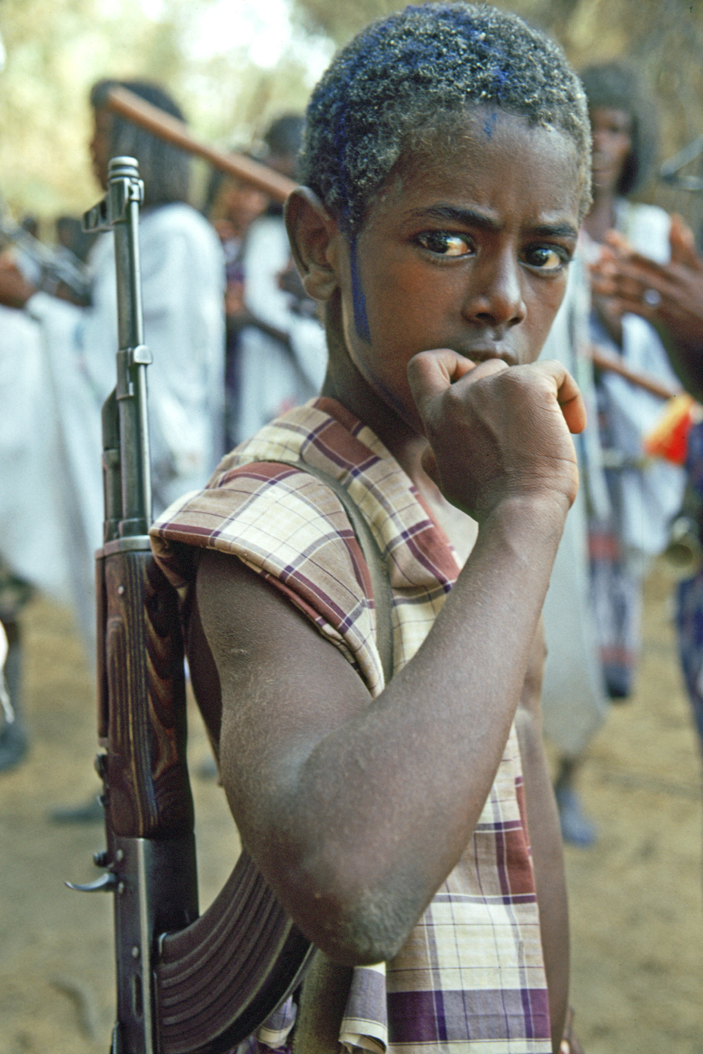
Up until the ceasefire between the government and oppositional forces in 2002, thousands of child soldiers were used in government forces. Children had been rounded up in recruitment drives in government-held areas and forced to fight. After the ceasefire, although boys stationed in the capital were released from military service, child soldiers serving in rural areas were still being reported in December 2002. In March 2003 the government estimated that under-18s had composed 10 per cent of the armed forces at the end of the war; this equates to around 10,000 children. As it is very hard to make accurate estimates when dealing with child soldiers, the actual number may have been a lot higher. As many as 30,000 girls were estimated to have been abducted by fighting forces during the war.

Recruitment of children by armed political groups:

After the 2002 ceasefire, the government estimated that there were at least 6,000 – and possibly many more – underage UNITA combatants to be demobilized. Before the ceasefire, there were many reports that child soldiers were being used by UNITA as combatants, domestic servants and sex slaves. Younger children were used as cooks, and gathered firewood and food, and older children were used to carry weapons and fight. Girls were taken as ‘wives’ by some soldiers. All the children were punished for not following orders, and sent on dangerous missions in areas controlled by the government forces.

DDR in Angola:

Disarmament, demobilization and reintegration, or DDR, is a very important part of helping children to leave the military and become normal children again. Disarmament means taking the weapons away form children and making sure that they do not have to use them in combat. Demobilization means that the children are taken away from the armed force that they have been fighting with, and away from combat situations. Reintegration means helping the children to become normal children again, and move back into the lives that they had before they became child soldiers.

Reintegration is very hard because the children have seen some horrible situations and some may have been forced to do terrible things. This makes normal life very difficult. Also, sometimes the villages and communities that they grew up in have been destroyed, or do not want to look after the children. Sometimes the parents do not want to have their children back again if they have killed people.

Children need to have lots of support when they leave the military. In Angola, children were promised a ‘child rights package’ which included a birth certificate, identification documents, family tracing help to find their families again, education and skills training, and psychosocial support. However it is not clear how many children actually received this package.

For more information:

Coalition to stop the use of Child Soldiers
The Coalition to Stop the Use of Child Soldiers works to prevent the recruitment and use of children as soldiers, to secure their demobilisation and reintegration into their communities. It also does a large amount of campaigning and information gathering:
http://www.child-soldiers.org/

Child Soldiers Global Report (2004) information on Angola:
http://www.child-soldiers.org/document_get.php?id=757

UNDP Human Development Reports
http://hdr.undp.org/

2006 Human Development Report on Angola:
http://hdr.undp.org/hdr2006/statistics/countries/data_sheets/cty_ds_AGO.html

Human Rights Watch
http://www.hrw.org/doc?t=africa&c=angola

