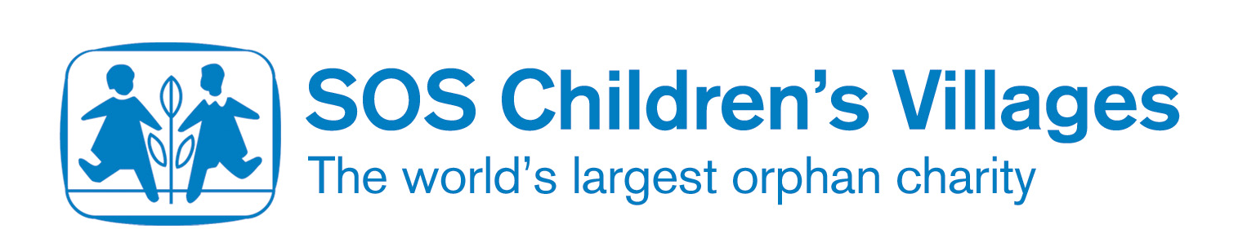

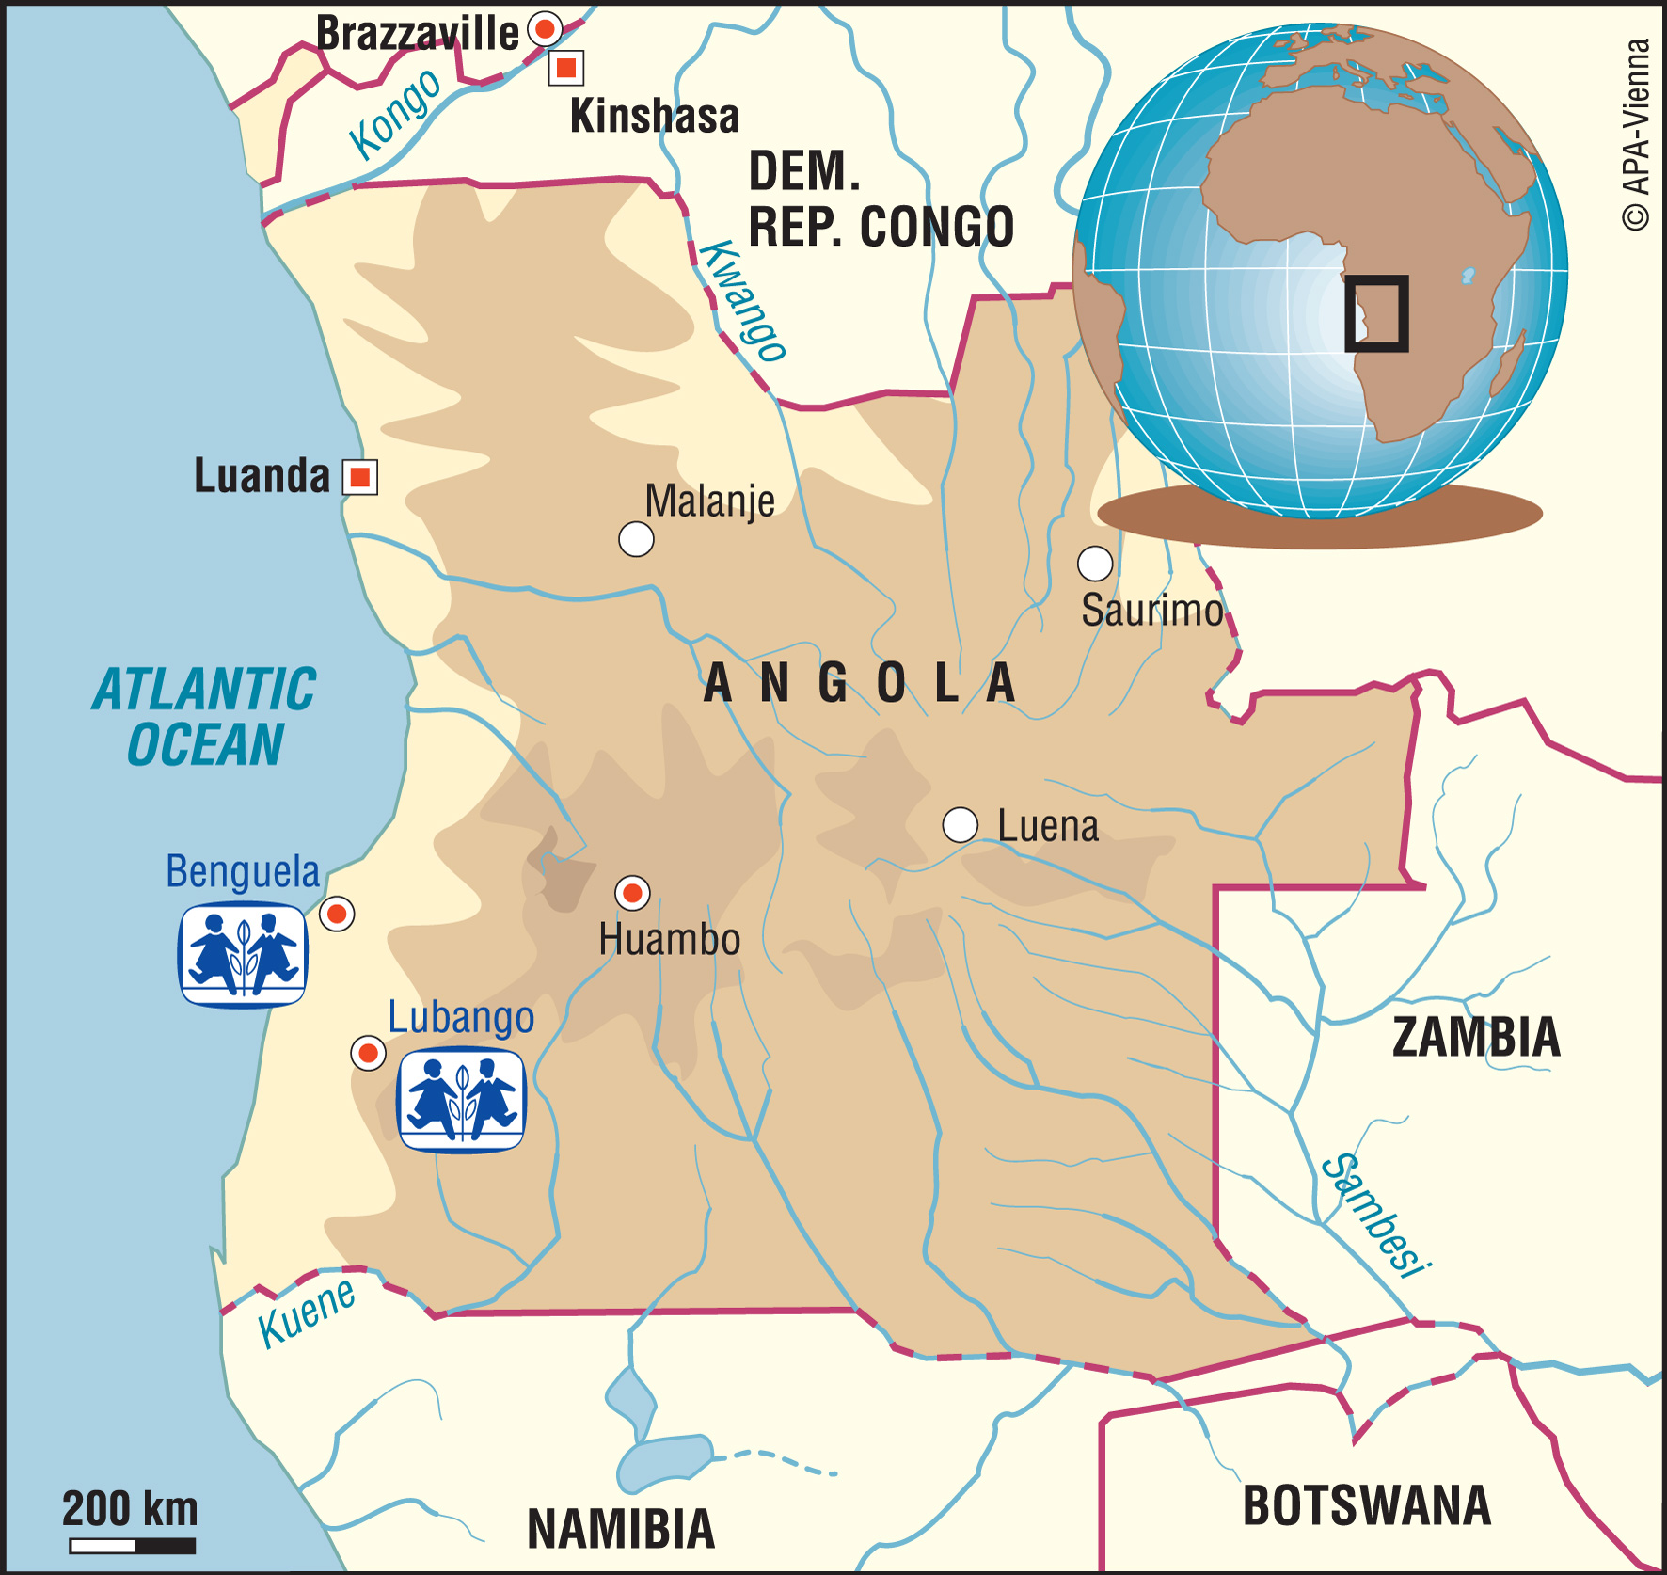
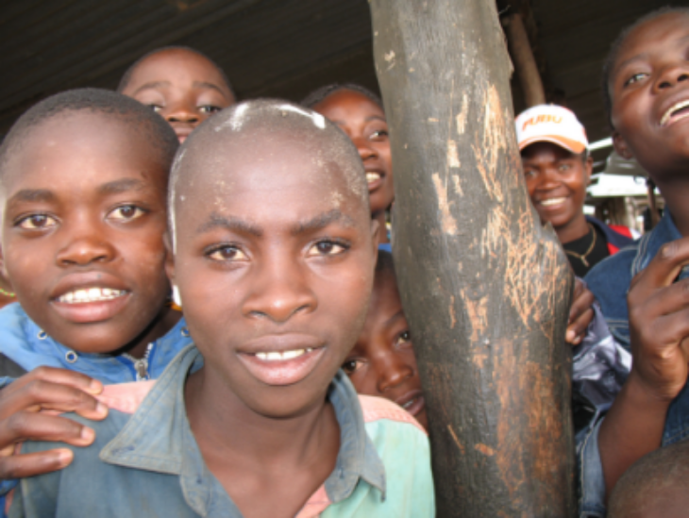

Child Soldiers

What are the different kinds of military groups that have child soldiers?

Why do you think that they make children fight?

What do you know about the U. N. Convention on the Rights of the Child?

What is a ceasefire?

Why do you think it is hard to estimate how many child soldiers there are in Angola?

Why is it important for children to be ‘demobilized’ after a ceasefire?

Why is it important for charities like the Red Cross and SOS Children to help former child soldiers to find their families?

