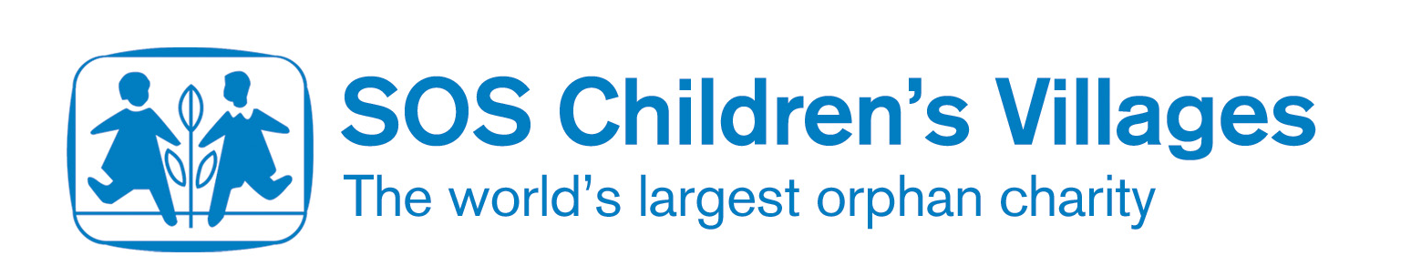
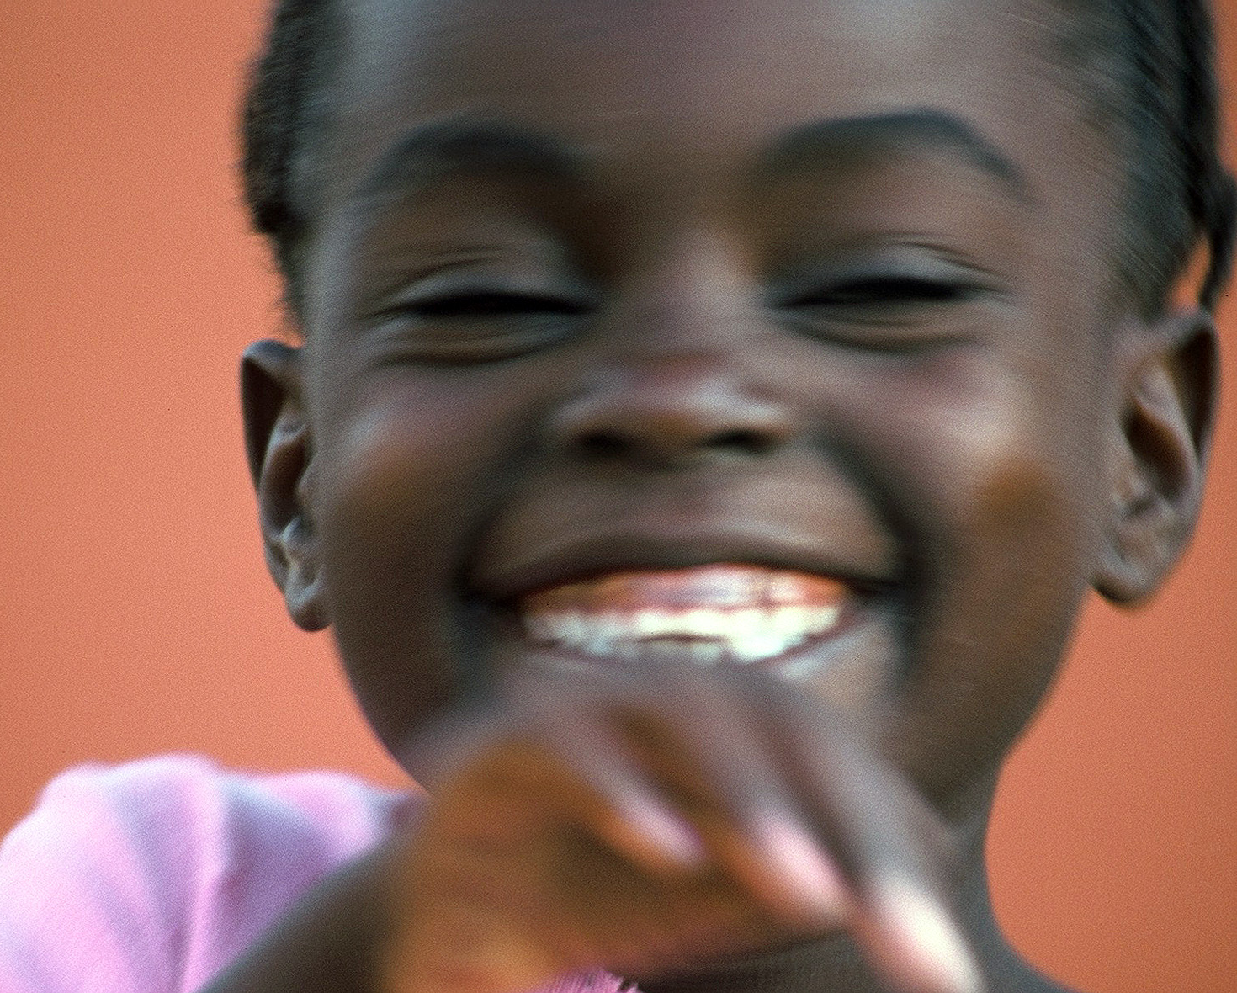

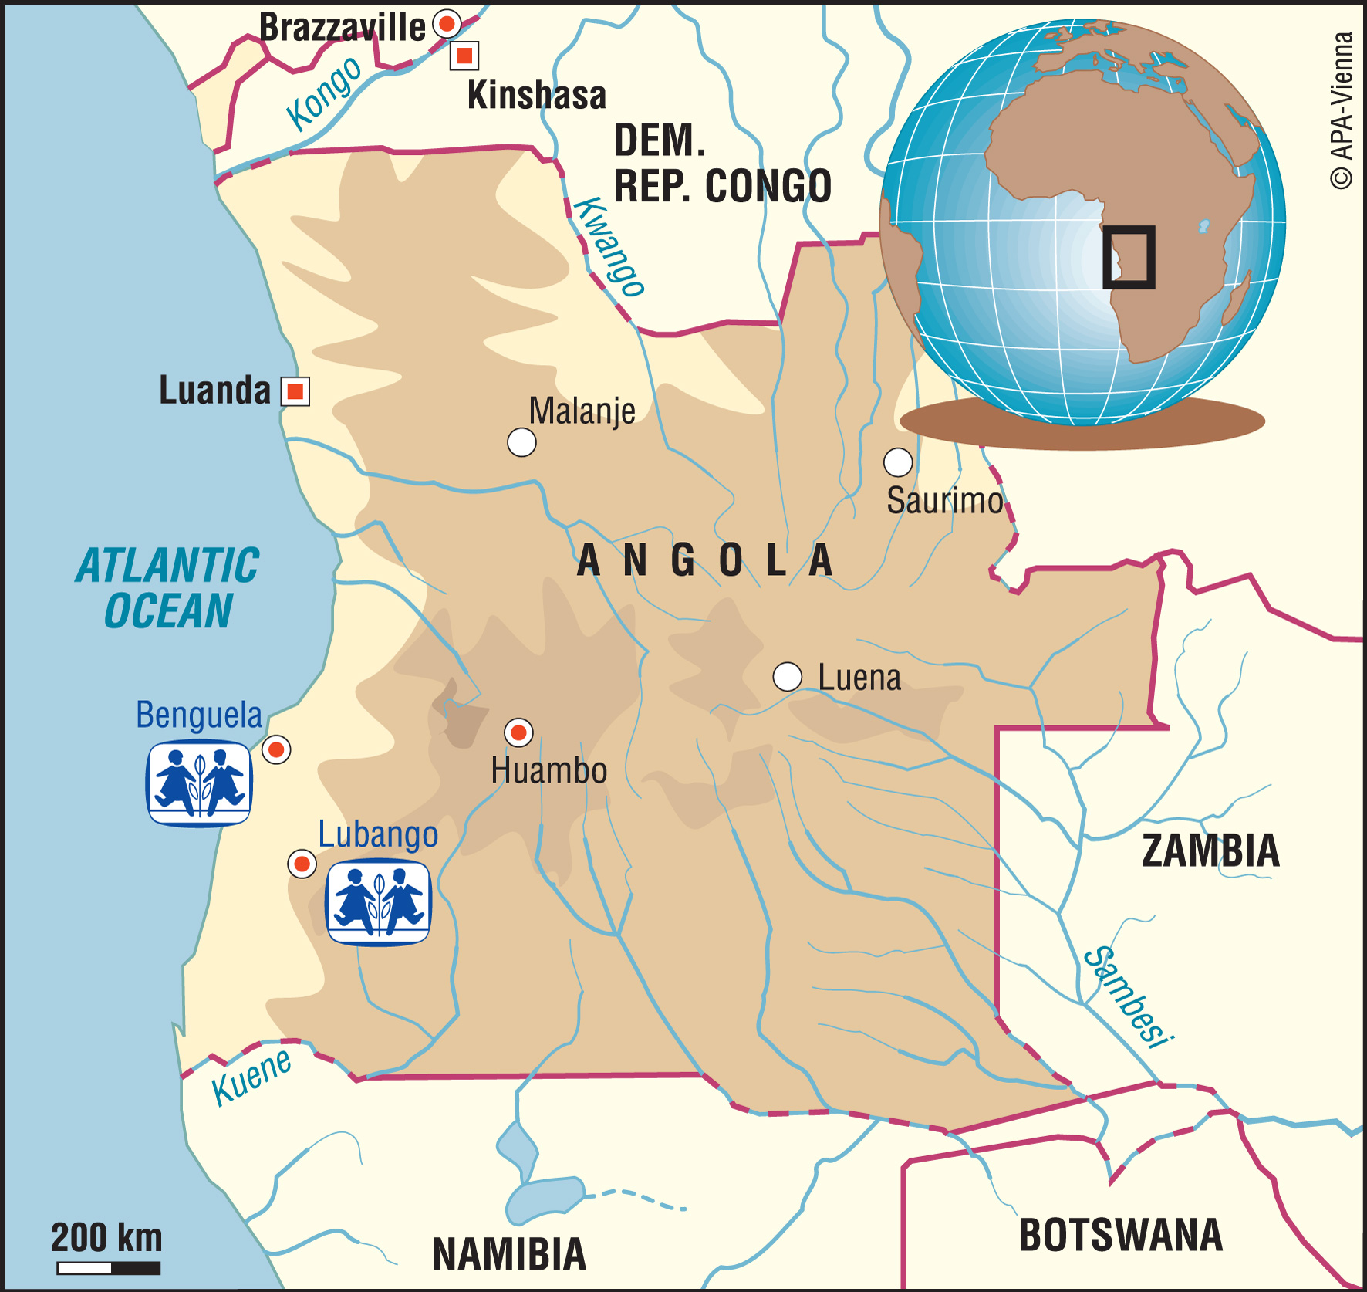

Education

What do the following terms mean?

The poverty line
The poverty cycle

What do you think ‘standard of living’ means? What is the difference between your standard of living and that of an orphaned child in Angola?

What does it mean to be empowered, and how does this mean that you can demand your rights?

Why is it important to be self-sufficient? Who helps you every day, are you self-sufficient?

How do you think that education can improve health? What health issues do you learn about in school?

What do you think ‘economic growth’ means? How does education help economic growth in a country in Africa? Will it help economic growth in the UK as well?

What do you think SOS Children means when we call ourselves a ‘gutter-to-school’ charity?

