AI Engineering and Architecture - MOFSL
The Five-Platform Architecture for MOSL
EXECUTIVE SUMMARY
MOSL requires a comprehensive five-platform AI strategy combining Perplexity Enterprise (real-time research), Perplexity Computer (agentic automation), Claude Enterprise (governance and reasoning), AWS Bedrock (production agents), and Google Gemini (multimodal processing). This document evaluates each platform across six critical dimensions: Enterprise Security, Indian Regulatory Compliance, Internal Integration, Cloud Hosting, Costing, and Change Management.
Key Findings & Recommendations:
- Claude Enterprise is the primary platform for all PII workflows, governance-heavy work, and DPDP-sensitive processing with confirmed India data residency.
- Perplexity Enterprise Pro serves broad knowledge workers for non-PII research, competitive intelligence, and regulatory monitoring at $40/seat/month.
- AWS Bedrock provides secure, production-grade agents for eKYC pipelines, trade reconciliation, and compliance workflows with VPC-native governance.
- Google Gemini handles specialized multimodal tasks including document processing with Agentic Vision and earnings call ingestion.
- Perplexity Computer (Enterprise Max) pilots on non-PII workflows once enterprise rollout is confirmed and India data residency is certified.

Strategic Principle: No single platform owns the full stack. Perplexity owns retrieval and task execution, Claude owns reasoning and drafting, Gemini owns vision and multimodal processing, and Bedrock owns production pipelines. This diversified strategy ensures MOSL is never locked into one vendor.

AI Engineering and Architecture - MOFSL
Before diving into use cases, here is how each tool's identity changes with all five players:
Platform | Primary Identity | Target User at MOSL | Budget Model
AWS Bedrock | Secure agentic production runtime | Engineering/Cloud teams | Per-token + infra usage
Claude Enterprise | Deep reasoning + governance copilot | Research, Legal, Strategy, Senior leadership | Per-seat (custom)
Google AI Studio / Gemini API | Multimodal + Agentic Vision dev engine | Developers, Ops tech teams | Free UI, API pay-per-token
Perplexity Enterprise Pro | Real-time cited research + knowledge retrieval | Analysts, RMs, Compliance, HR | ~$40/seat/month
Perplexity Computer (Enterprise Max) | Multi-model autonomous workflow agent | Power users, Back-office leads | ~$325/seat/month

1. Where Perplexity Enterprise Fits at MOSL
Perplexity Enterprise's core differentiator is real-time, cited, web-grounded answers with enterprise privacy — something neither Claude nor Bedrock does natively. It is SOC 2 Type II compliant with no training on our data.
Equity Research, Institutional Equities, AMC: Analysts use Perplexity's Deep Research mode to synthesize multi-source market intelligence with inline citations. Enterprise Spaces create shared repositories where house views, research notes, and proprietary files are co-searched alongside live web content.
MO-Alternates (Private Equity, Private Credit, Real Estate): Associates upload term sheets, IC memos, market comps, and financial statements into private Spaces. Perplexity Deep Research synthesizes against live market data. Real estate teams benchmark project valuations against live market indices.
Compliance and Legal: Monitor SEBI/RBI/IRDAI circulars, exchange notifications, and court judgments in near real-time. Perplexity's cited answers mean compliance officers have traceable sources for regulatory interpretations.
Franchisee Support and RMs: RMs use Perplexity as a fast-lookup companion — product comparisons, regulatory eligibility checks, tax rule queries, all sourced and cited. Franchisee support teams resolve partner queries faster using cited answers.
HR, Admin, Strategy: HR uses Deep Research for salary benchmarking, talent market analysis, and policy comparisons. Strategy teams use it for competitor intelligence, sector sizing, and investor sentiment analysis.

2. Perplexity Computer — The Agentic Game Changer
Perplexity Computer, launched February 2026, is a multi-model computer-use agent that orchestrates 19 AI models to autonomously execute complex, multi-step workflows — navigating browsers, filling forms, extracting data from spreadsheets, and creating sub-agents for sub-tasks.

How it works at MOSL
- User states an outcome goal, e.g., 'Prepare a weekly client NAV reconciliation report, pull data from the fund accounting portal, cross-check with exchange reports, and flag mismatches.'
- Computer formulates a plan, spins up sub-agents, accesses real filesystems and browsers, checks in only when blocked, and returns a completed artifact.
- Runs asynchronously — multiple Computers can run in parallel for different users or departments.

Target use cases at MOSL
Back-Office Ops: Automated trade reconciliation across NSE/BSE/clearing house portals. Computer navigates portals, downloads reports, identifies breaks, and prepares exception files.
eKYC Ops: Pulls client data from multiple portals, cross-validates across sources, and drafts compliance sign-off notes.
Alternates & AMC: Automated NAV computation cross-checks, investor reporting compilation from multiple fund administration systems.
CFO Dept: Monthly MIS data pulls across BU dashboards, standardized into consolidated format with anomaly flags.
Advisory: Client portfolio reviews — Computer pulls positions from OMS, overlays current market data from Perplexity's web, and drafts personalized review notes.
Important caveat: Perplexity Computer for Enterprise Max is expected to roll out to enterprise users soon. We should plan for this in our 6–12 month roadmap, not immediate deployment.

3. Gemini AI Studio — Updated Role with Agentic Vision and Gemini Agent

Agentic Vision (Gemini 3 Flash via API)
Gemini's new Agentic Vision uses a 'Think-Act-Observe' loop where the model iteratively zooms, crops, annotates, and runs Python code on images — not a single static glance but an active investigation. This delivers consistent 5–10% quality boost on vision benchmarks.
MOSL-specific use cases:
eKYC document processing: Physical form scanning where the model actively inspects, zooms into, and validates Aadhaar/PAN numbers, signatures, and addresses from uploaded images.
Physical contract digitization: Iterative inspection of legacy paper contracts to extract clause-level structured data.
Franchisee onboarding forms: Detect data quality issues in submitted physical forms across geographies.

Gemini Agent (via API, Gemini 3 series)
Gemini Agent combines live web browsing, Deep Research, and Google app integrations for multi-step autonomous task planning. It's available as an API for dev team to embed in internal portals, not as a consumer app.
MOSL-specific use cases:
Internal research portal: Developers embed Gemini Agent as the 'research backbone' — analysts describe what they need and the agent browses, synthesizes, and returns a structured brief.
Complex reasoning tasks: Gemini 3.1 Pro and Deep Think power computationally intensive reasoning — complex portfolio scenario modeling, scientific analysis.

Gemini API — Cost & Enterprise Data Safety
This is the critical security distinction: the web-based AI Studio UI may use prompts for model improvement, but once we move to paid Gemini API / Vertex AI, data is not used for training and we get enterprise data isolation. MOSL developers must only use AI Studio UI with synthetic data; all real data flows must use the paid API.

4. Revised Platform-to-Department Assignment

Optimized 'Who Uses What' Decision Framework
Is it real-time cited research or market intelligence?
→ Perplexity Enterprise Pro
Is it a long multi-step autonomous workflow across browser tabs and portals?
→ Perplexity Computer (Enterprise Max)
Is it image/video/multimodal processing, long-context document ingestion, or AI Studio prototyping?
→ Google AI Studio / Gemini API
Is it deep reasoning, document drafting, strategic analysis, code, or high-governance content creation?
→ Claude Enterprise
Is it a production backend agent, system integration, automated transaction workflow, or KYC/compliance pipeline?
→ AWS Bedrock
Department / BU | Perplexity Enterprise | Perplexity Computer | Gemini API/AI Studio | Claude Enterprise | AWS Bedrock
Equity Research | ✅ Deep Research, briefs | 🔜 Report compilation | Dev: video ingestion | ✅ Drafting, analysis | ✅ Screening agents
Wealth / PWM | ✅ RM lookup, market Q&A | 🔜 Portfolio drafts | Dev: voice advisory | ✅ Strategy notes | ✅ Suitability agents
MO-Alternates | ✅ Due diligence | 🔜 NAV reconciliation | Dev: doc ingestion | ✅ IC drafting | ✅ Fund ops
Institutional Broking | ✅ Market intelligence | 🔜 Trade data pulls | Dev: multimodal extraction | ✅ Client briefings | ✅ Reconciliation
Back-Office / Clearing | — | 🔜 Trade break resolution | Dev: Agentic Vision | — | ✅ Core production
eKYC | — | 🔜 Cross-portal validation | Dev: Agentic Vision docs | — | ✅ Production pipeline
Compliance / Legal | ✅ SEBI/RBI monitoring | — | Dev: doc digitization | ✅ Drafting, analysis | ✅ Surveillance
Strategy / CFO | ✅ Competitor intelligence | 🔜 MIS consolidation | — | ✅ Board notes | ✅ Anomaly detection
HR / Admin | ✅ Benchmarking, policy | — | — | ✅ Policy authoring | ✅ Ticket routing
Technology/Cloud | ✅ Tech research | — | Dev: prototyping | ✅ Claude Code | ✅ Core platform
🔜 = Plan for within 6–12 months (Perplexity Computer enterprise rollout)

5. Security, UX, Budget & Future-Proofing — Holistic Assessment

Security
Risk | Platform | Mitigation
Web UI data leakage | Gemini AI Studio | Enforce policy: only synthetic data in UI; real data via paid API only
Autonomous agent financial actions | Perplexity Computer + Bedrock Agents | Human-in-the-loop checkpoints; read-only API first pass
Incorrect regulatory answers | Perplexity Enterprise | Mandate human verification for SEBI/RBI decisions
Model data training | Perplexity, Claude | Both SOC 2 compliant with no enterprise data training
IAM over-privilege in Bedrock | AWS Bedrock | Strict least-privilege IAM, tool allowlists, Guardrails per agent

User Experience
- Perplexity Enterprise Pro has lowest onboarding friction — instant adoption for analysts and RMs with zero training.
- Perplexity Computer requires change management workshops for ops teams but delivers high UX payoff.
- Claude Enterprise suits deep, iterative session work. Power users love it; casual users prefer Perplexity's faster format.
- Gemini Agentic Vision is invisible to end users — embedded by tech team into internal portals. Benefit felt in faster, higher-accuracy processing.

Budget Optimisation
Largest cohort (200–500 users): Perplexity Enterprise Pro at ~$40/seat/month — best ROI for broad knowledge worker access.
Selective high-value seats (50–150 users): Claude Enterprise for research, legal, strategy, senior tech.
Small power-user cohort (20–50 users): Perplexity Enterprise Max (~$325/seat) for ops leads and back-office heads.
Developer/API costs: Gemini API (pay-per-token, very competitive) and Bedrock (metered per workflow).

Future-Proofing
Perplexity Computer's multi-model orchestration: 19 models, best-model-for-task routing. Enterprise AI future.
Gemini Agentic Vision and Deep Think: Frontier of scientific and quantitative reasoning. Quant-adjacent research.
AWS Bedrock's model-agnostic design: VPC-native, vendor-neutral. Never locked into one vendor.
Claude's MCP (Model Context Protocol): Becoming open standard for AI-to-tools connectivity. Institutional capability.

6. Phased Rollout Recommendation
Phase 1 (0–3 months) — Quick wins, high visibility
- Deploy Perplexity Enterprise Pro for Equity Research, Compliance, HR, select RM teams
- Activate Claude Enterprise for Research, Legal, Strategy, Cloud Engineering
- Lock down Google AI Studio policy: UI for dev with synthetic data only
Phase 2 (3–6 months) — Agentic foundations
- Stand up 3–5 Bedrock production agents (eKYC pipeline, trade reconciliation, customer service)
- Build Gemini Agentic Vision document processing for eKYC and back-office ops (via Gemini API)
- Begin Perplexity Computer pilots with select ops leads once Enterprise rollout confirmed
Phase 3 (6–18 months) — Scale and converge
- Scale Perplexity Computer for back-office automation across all BUs
- Connect Claude Cowork/MCP to internal portals and Bedrock agent gateway
- Establish unified AI governance: cost attribution by BU, audit trails across platforms
Core Strategic Principle: No single platform owns the full stack. Perplexity owns retrieval and task execution, Claude owns reasoning and drafting, Gemini owns vision and multimodal processing, and Bedrock owns production pipelines and system integration. This is intentional and defensible.

7. The Core Decision Frame
- PII-safe, DPDP-compliant
- Integration with internal files, models, and databases
- Hostable on AWS or Google Cloud
- UI-based tool for all enterprise employees
- Future-proof and agentic
This makes it a platform-level decision, not just a feature comparison.

Dimension 1: Enterprise Security Architecture
Security Feature | Claude Enterprise | Perplexity Enterprise Pro / Max
SOC 2 Type II | ✅ Independently audited | ✅ Independently audited
GDPR | ✅ | ✅
HIPAA | ✅ | ✅
PCI Compliance | ✅ | ✅
SSO (SAML/OIDC) | ✅ Okta, Azure AD, Google Workspace | ✅ SAML SSO
SCIM Provisioning | ✅ Auto user lifecycle mgmt | ✅
RBAC | ✅ Fine-grained, role and project level | ✅ Admin controls per Space
Exportable Audit Logs | ✅ API + user action logs | ✅ Real-time alert + analytics
No model training on our data | ✅ Guaranteed | ✅ Guaranteed
Zero Standing Access | ✅ | ✅ JIT access only
IP Allowlisting | ✅ | ✅
Data Encryption | ✅ | ✅
Configurable Retention | ✅ Custom retention periods | ✅ Auto-delete, down to 1 day
Agentic tool-call security | ✅ MCP connector allowlisting | ⚠️ Cloud-only sandboxes, governance maturing
Verdict: Both are enterprise-grade at baseline. Claude has slight advantage in agentic security maturity (MCP connector control, Claude Code permission management). Perplexity Computer's cloud-only sandboxed execution is well-designed, but enterprise connector governance controls need further testing at MOSL scale.

Dimension 2: Indian Regulatory Compliance (DPDP, SEBI, RBI)
This is the most critical dimension for MOSL as a SEBI-regulated entity. The DPDP Act mandates lawful data processing, consent management, breach notification, data principal rights, and for Significant Data Fiduciaries: a DPO in India and periodic DPIAs. Penalties reach INR 250 crore.
DPDP Requirement | Claude Enterprise | Perplexity Enterprise
Data Residency in India | ✅ AWS Mumbai/Hyderabad | ⚠️ Not yet formally confirmed
Data Processing Agreement | ✅ Enterprise DPA available | ✅ Enterprise DPA available
Data Principal Rights | ✅ Configurable retention + deletion | ✅ Configurable retention
Breach Notification | ✅ SOC 2 covers incident response | ✅ SOC 2 covers incident response
Indian Language Support | ✅ Anthropic actively expanding Hindi | ⚠️ Limited specific investment
Regulated Sector Procurement | ✅ AWS Marketplace availability | ⚠️ No equivalent path
Verdict: Claude Enterprise wins significantly on India regulatory compliance. Anthropic opened Bengaluru office, doubled India revenue, confirmed data residency via AWS Mumbai/Hyderabad, specifically targeting regulated sectors. Until Perplexity confirms India data residency, restrict to non-PII workflows only.

Dimension 3: Internal Model & File Integration
Integration Capability | Claude Enterprise | Perplexity Enterprise
Internal file search | ✅ Projects with persistent context | ✅ Spaces with persistent upload
Knowledge base connectors | ✅ Native MCP + custom connectors | ✅ App Connectors (Google Drive, etc.)
Custom internal model | ✅ Via AWS Bedrock API / Vertex AI | ⚠️ API-level but no native path
Internal database / CRM | ✅ MCP tool-use to internal APIs | ⚠️ Pre-built SaaS only, limited custom
Pre-built app connectors | ✅ GitHub, Google, Atlassian, Zapier | ✅ Google Drive, Slack, Notion, Zendesk
Custom instructions | ✅ System prompts per Project | ✅ Custom instructions per Space
Multi-model access | ⚠️ Claude models only | ✅ 19 models (Claude, GPT, Gemini, Grok)
Internal model hosting | ✅ AWS Marketplace deployment | ❌ No equivalent
Verdict: Claude Enterprise wins for internal system integration. MCP standard gives tech team clean, standards-based way to connect to OMS, CRM, research databases, and Bedrock-hosted proprietary models. Perplexity's connectors strong for SaaS apps but don't bridge to internal AWS infrastructure.

Dimension 4: Enterprise Cloud Hosting (AWS / Google)
Hosting Dimension | Claude Enterprise | Perplexity Enterprise
AWS Marketplace availability | ✅ Full VPC deployment | ⚠️ SaaS only (external to VPC)
Google Vertex AI deployment | ✅ Available with regional controls | ❌ Not available
VPC / private cloud deployment | ✅ Via Bedrock — within AWS VPC | ❌ Perplexity cloud only
Data residency control | ✅ Inference geo independently configurable | ❌ No infrastructure control
AWS infra integration | ✅ Unified IAM, cost allocation, CloudWatch | ❌ Not applicable
On-premise option | ⚠️ Not available for standard | ⚠️ Limited documentation
Verdict: Claude Enterprise unambiguously wins for cloud hosting. Only platform genuinely hosted within our AWS/Google Cloud boundary with full VPC isolation, IAM integration, data residency selection (including India regions), cost attribution. Perplexity is cloud SaaS consumed externally.

Dimension 5: Costing
Cost Dimension | Claude Enterprise | Perplexity Enterprise Pro/Max
Pricing model | Per-seat subscription (custom) | Pro: ~$40/seat/month; Max: ~$325/seat/month
Transparency | Custom / negotiated | Published tiers — more predictable
Scalability cost risk | Low once contract signed | Max tier expensive for 100+ users
AWS Marketplace billing | ✅ Consolidated into AWS bill | ⚠️ Separate billing
ROI profile | Higher per-seat for power users | Pro tier excellent for research cohorts
Cost for broad deployment | Higher — 100–300 high-impact users | Pro tier economical for 300–1000+ workers
Verdict: Complementary, not competing. Claude's per-seat cost justified only for high-impact users. For broad employee deployment (RMs, HR, admin, ops), Perplexity Pro at ~$40/seat offers far better economics.

Dimension 6: Enterprise Change Management
Change Management Factor | Claude Enterprise | Perplexity Enterprise
User onboarding complexity | Medium — Chat, Code, Cowork distinct interfaces | Low — premium search tool feel
Adoption curve | Steeper — requires prompt engineering literacy | Very fast — Day 1 value
Training investment | High for Cowork + Code; moderate for Chat | Minimal — intuitive UX
Enterprise admin tooling | Mature — SSO, SCIM, analytics, audit logs | Mature — SSO, SAML, dashboard
Collaboration features | ✅ Cowork enables multi-person workflows | ✅ Spaces enable shared research hubs
Vendor support in India | ✅ Bengaluru office, dedicated support | ⚠️ No India office, remote support
Change resistance risk | High for Code; Medium for Chat/Cowork | Low — minimal disruption
Internal advocacy path | Via tech leads, research heads, legal teams | Bottom-up by individual workers
Verdict: Perplexity is faster adoption path. Claude requires change management workshops and prompt engineering education. For phased rollout, start with Perplexity for quick wins, then move to Claude.

Final Recommendation: Use Both, With Clear Boundaries
Given MOSL's specific requirements, neither platform alone satisfies all conditions. The right answer is a tiered, purpose-driven deployment:

Claude Enterprise — Our Primary PII-Safe, Infra-Integrated Platform
Deploy Claude Enterprise as the primary enterprise AI platform for all workflows involving:
- Customer data, employee PII, financial account data
- Internal model integration (Bedrock models, CRM, OMS, research databases)
- Governance-intensive workflows (Legal, Compliance, Regulatory)
- DPDP-sensitive processing
- Deploy via AWS Marketplace on existing AWS infrastructure for full VPC isolation, data residency in AWS Mumbai/Hyderabad, unified IAM and billing, SEBI-compliant procurement.

Perplexity Enterprise Pro — Broad Knowledge Worker Research Layer
Deploy for all workflows that do not involve customer PII or regulated internal data:
- Market research, competitive intelligence, sector analysis
- Regulatory monitoring (public circulars, public court judgments)
- Vendor evaluation, benchmarking, HR research
- Quick Q&A with cited, verifiable answers
- Impose a data classification policy: only Green-tier (public, non-sensitive) data may flow into Perplexity Enterprise until India data residency is confirmed.

Perplexity Computer (Enterprise Max) — Conditional, Phased Pilot
Pilot only on non-client-facing, non-PII workflows (MIS consolidation, internal report compilation) once enterprise rollout is confirmed and India data residency is addressed. Use existing MOSL AI Policy v2.1 framework to govern connector scope and approve workflows before production deployment.

Claude Enterprise Platform - MOSL AI Architecture
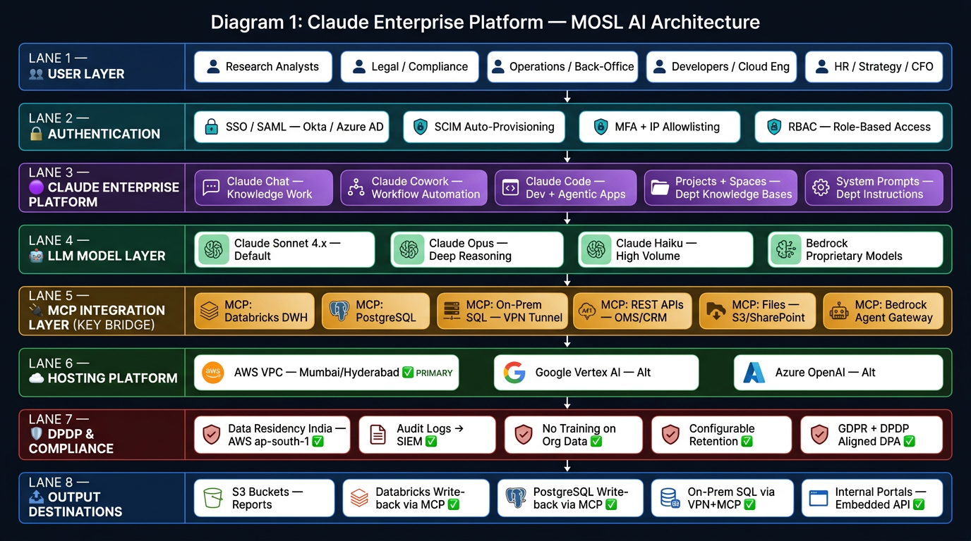

Layer 1 — User Layer
All MOSL employee personas (Research, Legal, Ops, Developers, HR/CFO) enter through a single, governed front door.

Layer 2 — Authentication
SSO via SAML (Okta / Azure AD), SCIM for automated provisioning, MFA, and IP allowlisting sit before any Claude interaction. RBAC governs what each role can access.

Layer 3 — Claude Enterprise Platform
Three distinct interfaces serve different use cases:
Claude Chat: Knowledge work, analysis, document drafting
Claude Cowork: Multi-person business process workflow orchestration; shared sessions and artifacts
Claude Code: Developer copilot, agentic app building, IDE integration (VS Code, JetBrains), automated code review
Plus: Projects + Spaces (persistent, department-level knowledge bases with uploaded files, SOPs, research docs), System Prompts (custom instructions per department)

Layer 4 — LLM Layer
Claude Sonnet 4.x (default), Opus (deep reasoning for complex legal/strategy tasks), Haiku (high-volume, low-latency ops), and our own Bedrock-hosted proprietary models (risk scoring, suitability models) — all callable from within Claude's interface.

Layer 5 — MCP Integration Layer (The Critical Middle)
All database and system connectivity flows through MCP Servers — purpose-built secure connectors. This means:
- Databricks (AWS-hosted DWH): Read and write via MCP; no direct DB credential exposure to Claude
- PostgreSQL (Cloud-hosted): Full read/write-back via MCP
- On-Prem SQL Server: VPN tunnel → MCP Server → Claude (data never leaves network boundary)
- REST APIs: OMS, CRM, Research portal — Claude calls tools, gets structured results
- Files: S3, SharePoint, Google Drive — Claude reads and indexes securely
- Bedrock Agent Gateway: Claude can invoke our Bedrock agents as tools, creating human-in-the-loop front-end

Layer 6 — Hosting (AWS Primary)
Claude Enterprise is available via AWS Marketplace and runs inside our AWS VPC in ap-south-1 (Mumbai) or ap-south-2 (Hyderabad). Google Vertex AI and Azure are available as alternate deployment options.

Layer 7 — DPDP & Compliance
- Data residency confirmed in India via AWS Mumbai/Hyderabad
- Audit logs export to our SIEM (CloudWatch + Splunk) for SEBI-level audit trails
- No model training on org data — Anthropic DPA signed
- Configurable retention per department

Layer 8 — Output Destinations
- S3 Buckets: Automatic report/artifact storage
- Databricks Tables: Write-back via MCP ✅ Available
- PostgreSQL: Write-back via MCP ✅ Available
- On-Prem SQL: Via VPN + MCP tunnel ✅ Available
- Internal Portals: Claude API embeds into our employee portals

Perplexity Enterprise Platform - MOSL AI Architecture
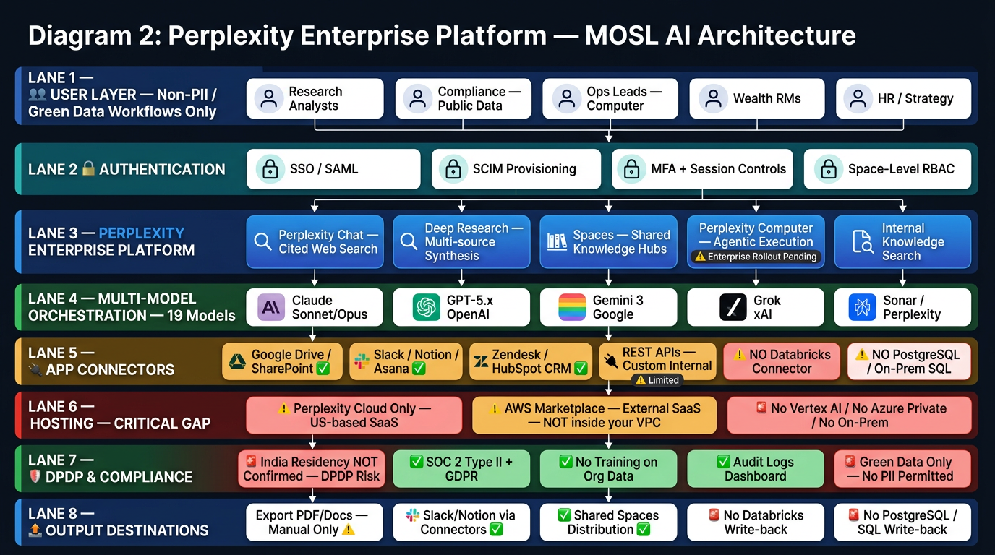

How to read this diagram (top to bottom)

Layer 1 — User Layer
Same employee personas, but restricted to non-PII, Green-tier workflows only until India data residency is confirmed.

Layer 2 — Authentication
SSO/SAML, SCIM, MFA, and Space-level RBAC — admin controls are per-Space, not system-wide like Claude.

Layer 3 — Perplexity Enterprise Platform
Perplexity Chat: Cited real-time web search with verified sources
Deep Research: Multi-source synthesis across web + uploaded files; ideal for due diligence and market intelligence
Spaces: Shared knowledge hubs per team or department; files + web co-searched
Perplexity Computer: Agentic task execution: browser automation, multi-step workflow completion, portal navigation ⚠️ Enterprise rollout pending
Internal Knowledge Search: File repository search alongside web results

Layer 4 — Multi-Model Orchestration (19 Models)
Perplexity's biggest differentiator over Claude — it routes to the best model for the task across Claude, GPT-5.x, Gemini 3, Grok, and its own Sonar models. Users or admins choose which models are permitted.

Layer 5 — App Connectors (Key Limitations in Red)
- ✅ Available: Google Drive, Slack, Notion, Asana, Zendesk, HubSpot, REST APIs
- 🚨 Not Available: No native Databricks MCP, no PostgreSQL direct connection, no On-Prem SQL connectivity — most significant infrastructure gap vs. Claude
- Perplexity Computer uses browser automation to navigate web portals — useful for NSE/BSE/clearing house portal data pulls, but not structured DB integration.

Layer 6 — Hosting (Critical Gap)
Perplexity runs entirely in Perplexity's US-based cloud — it is available on AWS Marketplace only as an external SaaS product, not inside our VPC. No Google Vertex AI, no Azure private deployment, no on-premise option. This is the fundamental infrastructure boundary that separates it from Claude.

Layer 7 — DPDP & Compliance (Amber Flags)
- 🚨 India data residency not confirmed — policy requirement: Green data only (no customer PII, no MNPI, no employee sensitive data)
- ✅ SOC 2 Type II, GDPR, HIPAA, PCI — strong baseline compliance
- ✅ No training on org data guaranteed
- Enforce our MOSL AI Policy v2.1 data classification framework before any deployment

Layer 8 — Output Destinations (Significant Gaps)
- ✅ Export PDF/Docs manually, Slack/Notion via connectors, Shared Spaces
- 🚨 No direct write-back to Databricks, PostgreSQL, or On-Prem SQL — outputs must be manually handled or routed through intermediate SaaS connectors

Additional Architecture Diagrams
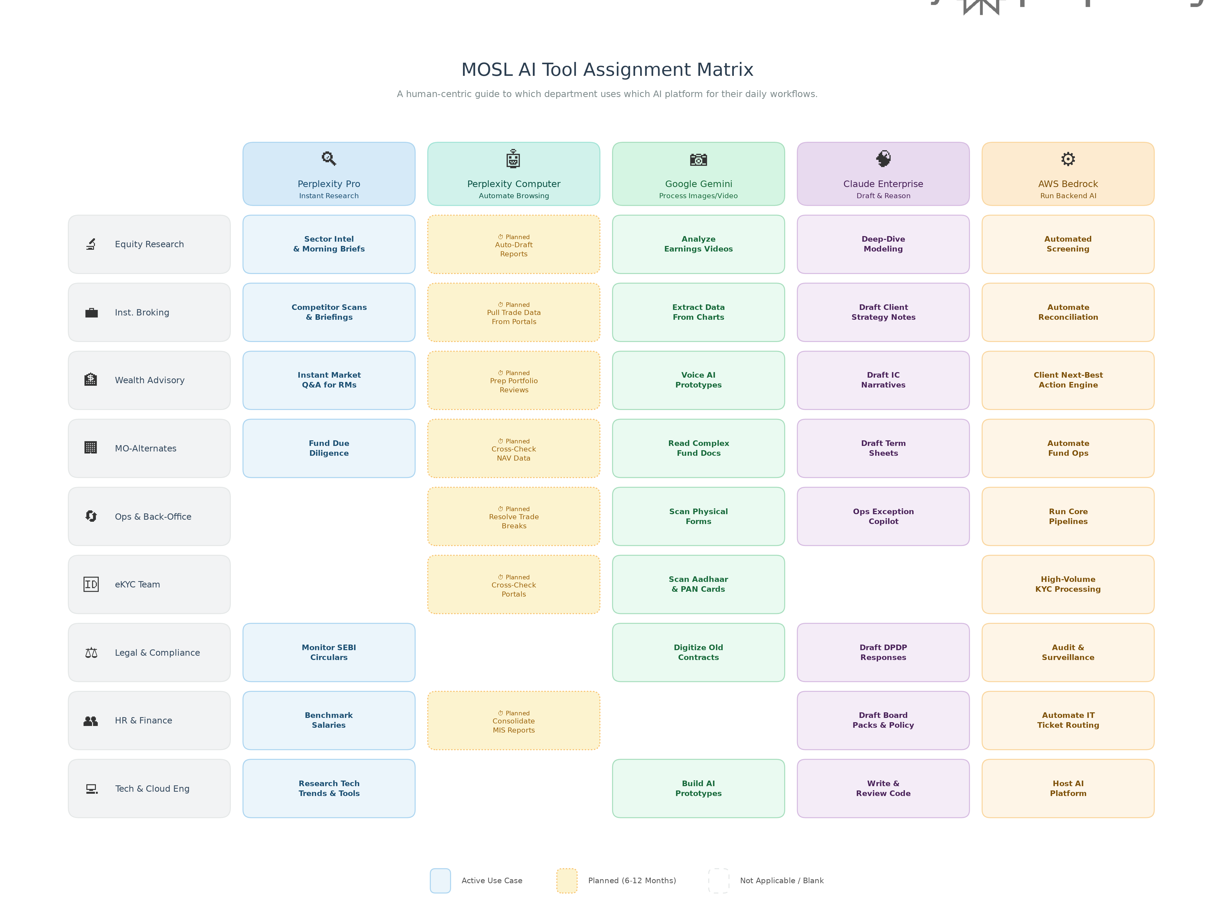

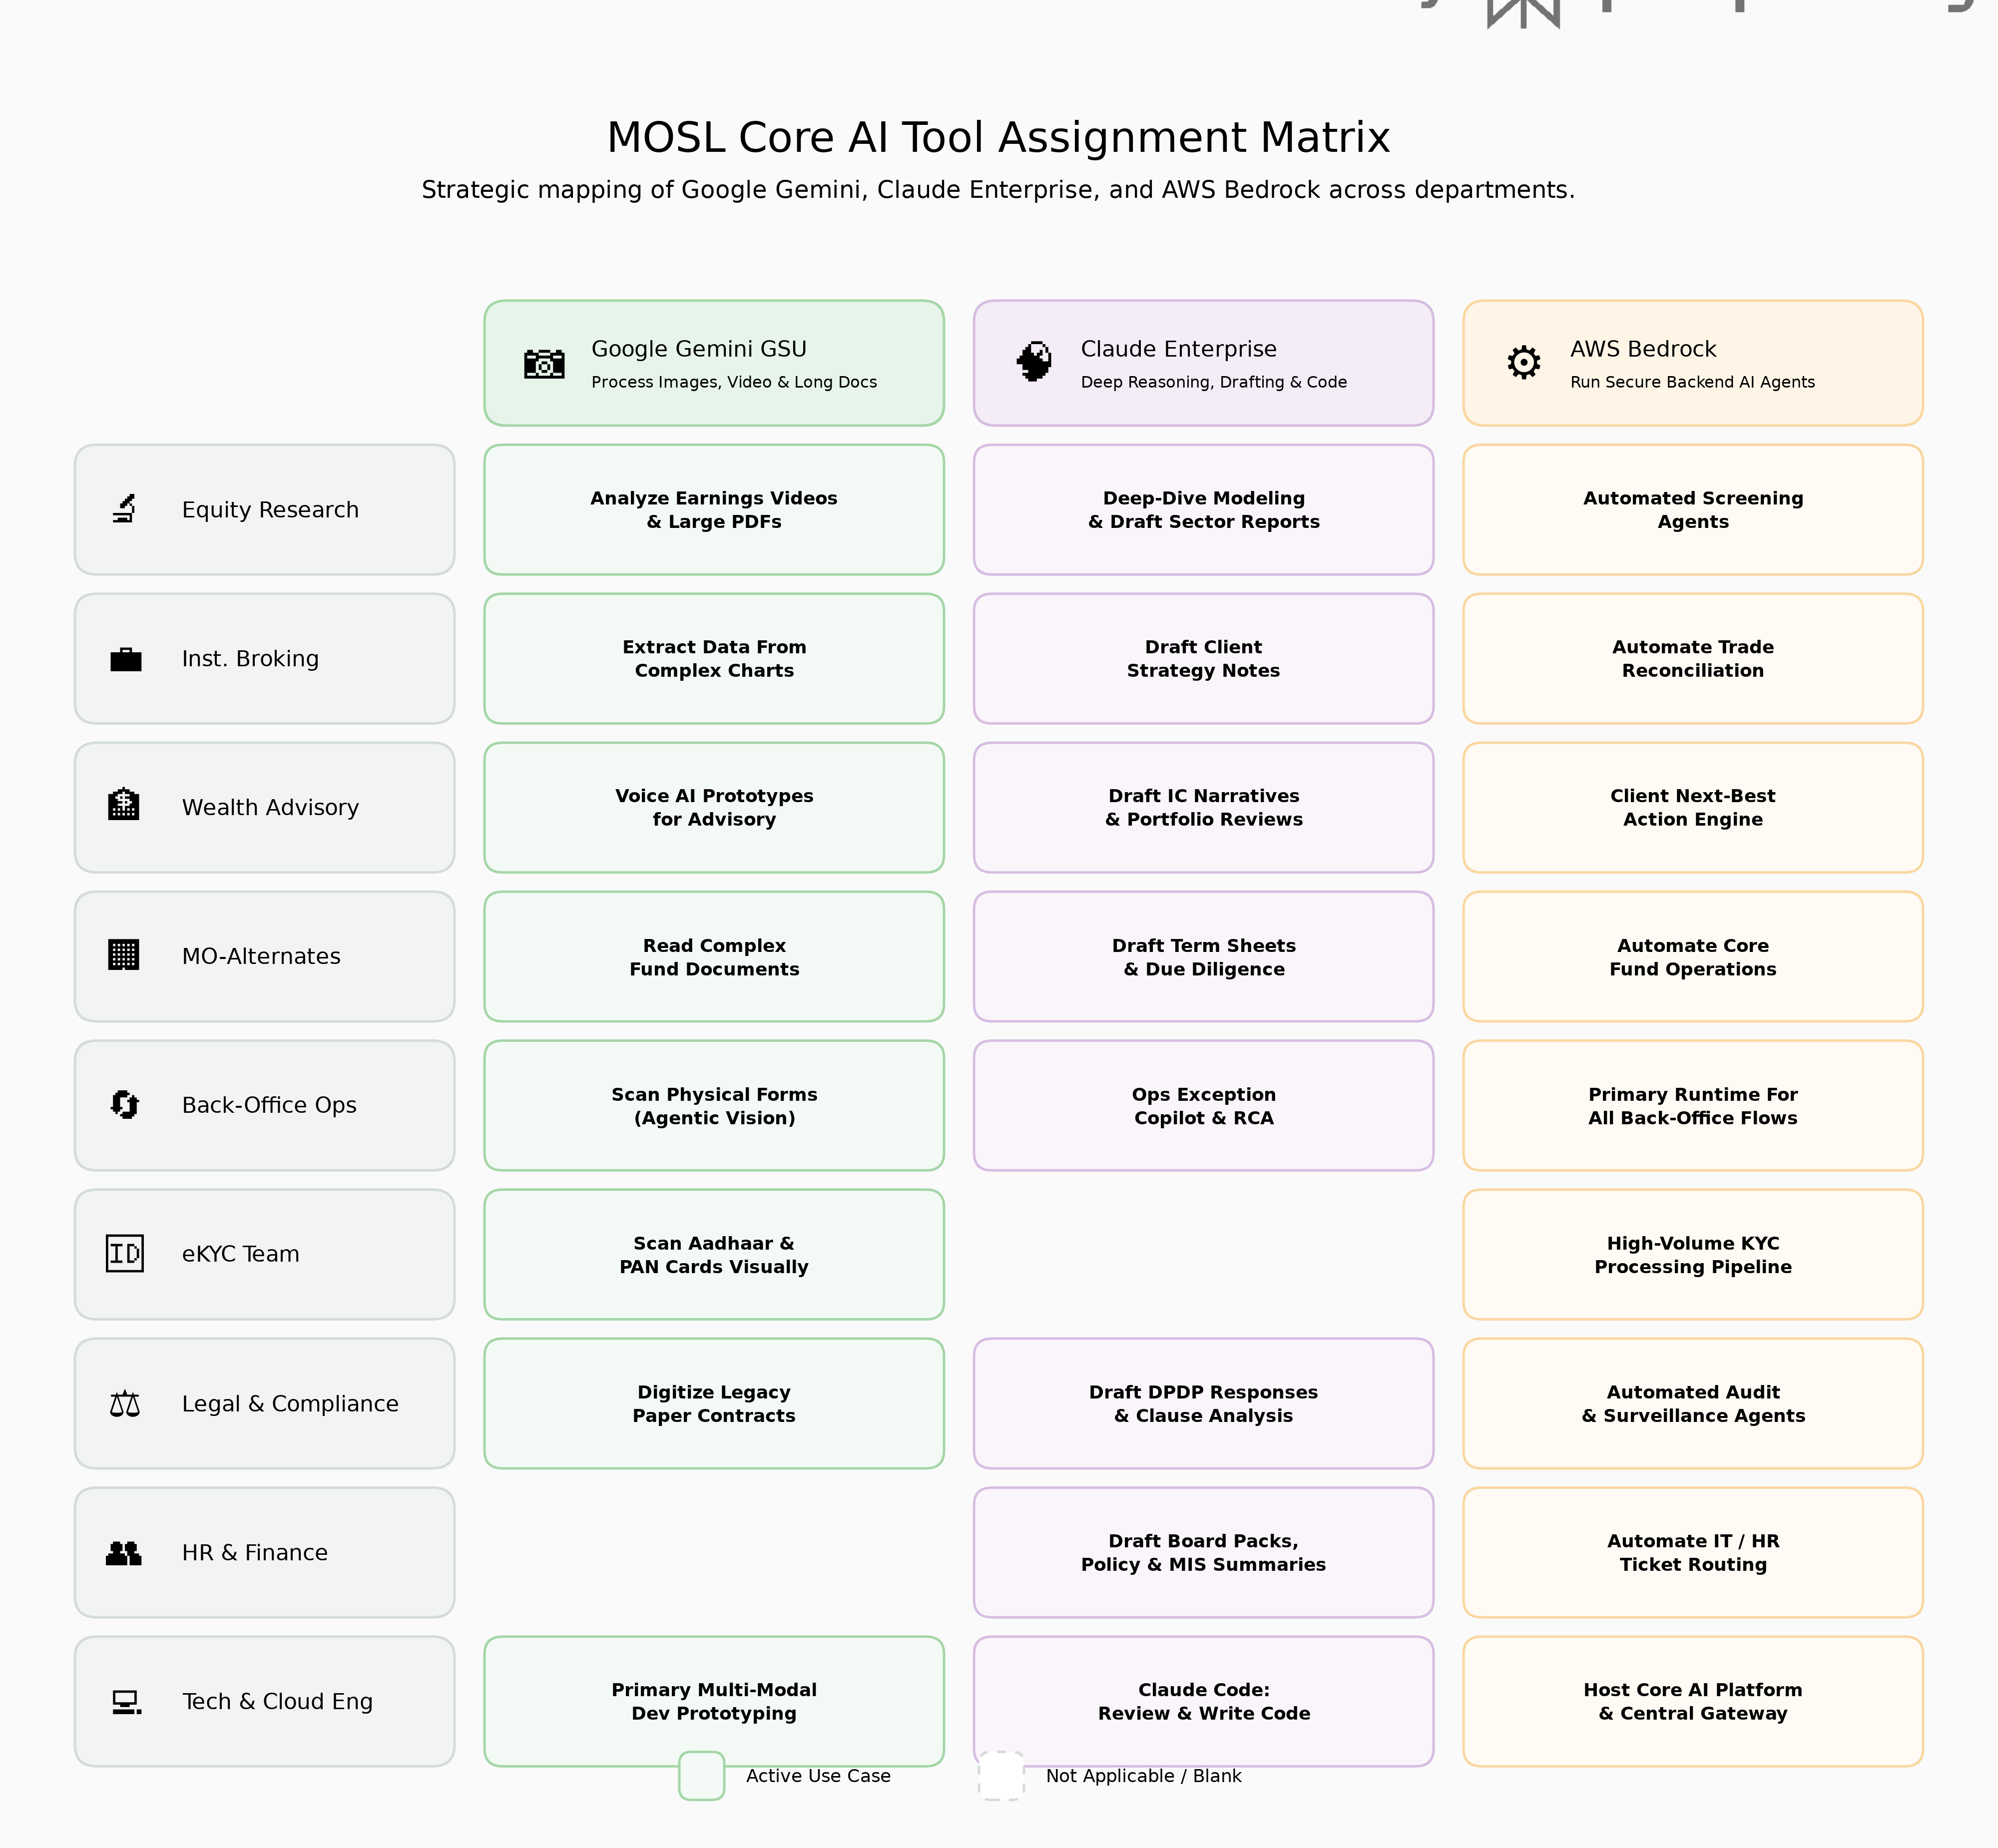

Architecture Decision Summary for MOSL
Dimension | Claude Enterprise | Perplexity Enterprise
Primary use | PII workflows, DB-integrated agents, governance-heavy processes | Non-PII research, market intelligence, cited knowledge retrieval
DB/DWH connectivity | ✅ Databricks, PostgreSQL, On-Prem SQL via MCP | ❌ Not available natively
Hosted in our cloud | ✅ AWS VPC / Vertex AI / Azure (our perimeter) | ❌ Perplexity cloud only
India data residency | ✅ AWS Mumbai / Hyderabad confirmed | ⚠️ Not confirmed
DPDP-safe for PII | ✅ Yes | ❌ Not until residency confirmed
Multi-model access | ❌ Claude models only | ✅ 19 models (Claude, GPT, Gemini, Grok)
Agentic automation | ✅ Cowork + MCP + Bedrock gateway | ⚠️ Computer (rollout pending, cloud-only)
Employee onboarding | Medium complexity | Very low friction

How the Decision Framework Maps to Three-Platform Strategy
Here is how the Decision Framework maps directly to these three platforms: Claude Enterprise / Gemini Vertex / AWS Bedrock
Q1: Real-time cited research or market intelligence?
Without Perplexity, this capability shifts to Claude Enterprise. However, because Claude does not have native live-web search, our Cloud Engineering team must build an MCP Connector that connects Claude to our internal news feeds, SEC/BSE filing APIs, or use AWS Bedrock's native web-search grounding capabilities. Winner: Claude Enterprise (with custom MCP/Bedrock data feeds)
Q2: Long multi-step autonomous workflow across browser tabs and portals?
Perplexity Computer's unique capability is visual browser automation. To replicate this, we must shift from UI-based automation to API-based automation. We will build backend agents in AWS Bedrock that call the APIs of the NSE, BSE, and clearing houses directly. We will then use Claude Cowork as the 'control panel' where our Ops Leads trigger, monitor, and approve these automated Bedrock workflows. Winner: AWS Bedrock (Execution) + Claude Cowork (Orchestration Interface)
Q3: Image/video/multimodal processing, long-context ingestion, or AI Studio prototyping?
This remains fundamentally unchanged. Google Gemini GSU is our undisputed leader for multimodal processing. Our tech teams will use the Gemini API for eKYC document scanning (Agentic Vision), processing massive PDF fund documents, and ingesting earnings call videos natively. Winner: Google Gemini GSU / AI Studio API
Q4: Deep reasoning, document drafting, strategic analysis, code, or high-governance content creation?
This remains the core strength of Claude Enterprise. It is our primary PII-safe platform, hosted inside our AWS VPC in Mumbai, making it the only acceptable UI for drafting Legal, Compliance, Wealth, and Alternate Fund documents. Developers will use Claude Code heavily for application building. Winner: Claude Enterprise
Q5: Production backend agent, system integration, automated transaction workflow, or KYC/compliance pipeline?
This remains unchanged. Any workflow that executes financial transactions or runs autonomously without human intervention must run on AWS Bedrock. It provides the necessary IAM, KMS, and CloudWatch governance required by SEBI and our internal InfoSec teams. Winner: AWS Bedrock

Summary of the 3-Platform Strategy
By consolidating to just three platforms, we accept a slight increase in engineering overhead (building MCP connectors for live web data instead of buying Perplexity) in exchange for a significantly tighter security boundary (everything runs natively inside AWS or Google Cloud, fully compliant with DPDP data residency requirements).
- Claude Enterprise becomes our universal 'front door' for all human employees.
- AWS Bedrock becomes our universal backend engine.
- Google Gemini serves as our specialized multimodal processing layer.

Document Version: 2.0 | Last Updated: March 2026 | Classification: Internal Use

