AutoCAD grading program instructions.

When drawing the drawing, if you are using layers (e.g. chapter 3 and beyond), use the following layer names, as indicated in the textbook so that the program will recognize them:

CENTER

CONSTRUCTION

CUTTING

DIMENSION

HIDDEN

LAYOUT

VISIBLE

0

An example of submitting a file for grading is in the video

<http://youtu.be/dVjtusDMSqA>

After you have finished your drawing, from the AutoCAD button, save it as a DXF file

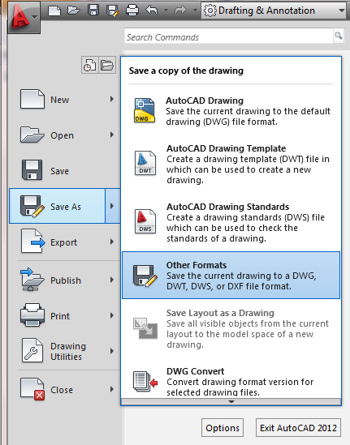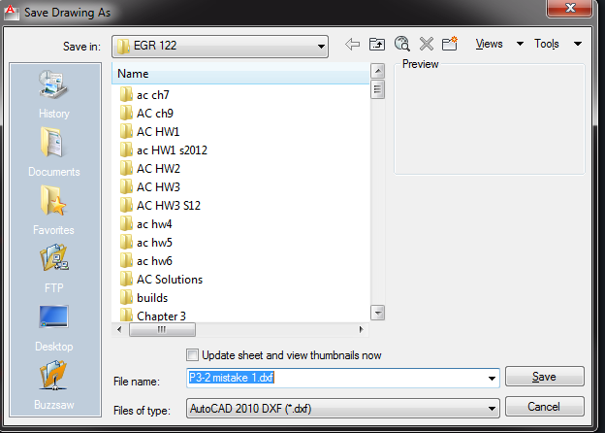

Then email it as an attachment to [EGRgrading@calbaptist.edu](mailto:EGRgrading@calbaptist.edu) with the subject line being the problem you are working on.

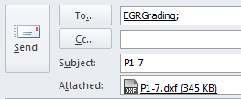

If things work well, in a couple of minutes you will receive an email back with your score

The email that the grading program sent was

Score: 90.6  
  
Item            # in Key          # of Matches  
Line                16.0              13.0  
Circle               0.0               0.0  
Arc                  0.0               0.0  
Arc Radii            0.0               0.0  
Ellipse              0.0               0.0  
Polygon              0.0               0.0  
Text                 0.0               0.0  
Dimention            0.0               0.0  
Hatch                0.0               0.0  
MLeader              0.0               0.0  
  
Extra Items:  
Solution Line Extras  
Page    Layer                       X Start     Y Start         X End       Y End         Delta X       Delta Y  
Model  VISIBLE                  5.9642      2.5990      7.9642      2.5990      2.0000      0.0000  
Model  VISIBLE                  6.9642      3.5990      7.9642      3.5990      1.0000      0.0000  
Model  VISIBLE                  6.9642      4.5990      7.9642      4.5990      1.0000      0.0000  
Student Line Extras  
Page    Layer                       X Start     Y Start         X End       Y End         Delta X       Delta Y  
Model  HIDDEN                 6.9642      3.5990      7.9642      3.5990      1.0000      0.0000  
Model  VISIBLE                  1.9687      4.5990      4.2147      4.5990      2.2460      0.0000  
Model  VISIBLE                  4.2147      3.5990      4.9687      3.5990      0.7540      0.0000

The first number is your score on the assignment. Next is the summary of the elements in the drawing. This drawing only consisted of lines, and there are 16 total lines in the key, of which 13 matched what was in the key.

One common mistake students make is having the lengths about right but not exactly. With AutoCAD your dimensions should be exact, so use objet snaps and the keyboard for accurate drawings.

The differing items are then listed. It is easier to visualize which items are wrong by looking at the two attached pictures in the email, which highlights the differences using orange lines. In the right middle, there is a line that is dashed in the student graph and solid in the solution graph, indicating it is on the wrong layer. Looking at the extra items list, you can see that the student line is on the HIDDEN layer while the solution line is on the Visible layer.

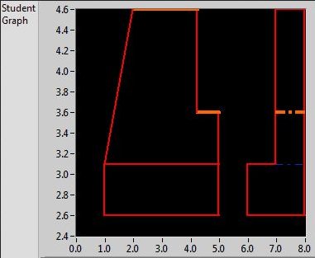 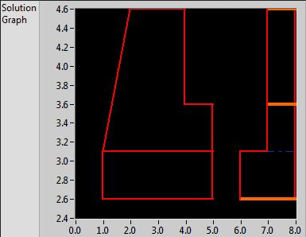

The second error is the notch in the middle of the student graph. The coresponding error is highlighted at the top right of the solution graph, since the line is the same length and orientation (1” horizontal) as the middle line. (The program matches relative line lengths so the location on the page is not important.)

The final error also occurs in two places, on the top left of the student graph, and the bottom right of the solution graph. It is shown in the wrong place on the solution graph because the top left line and the bottom right line have the same lenth and orientation. Looking at the extra items list, The student has a deltaX of 2.246 while the solution has a deltaX of 2.

There are 2 other options for the program. This is detailed in the video <http://youtu.be/k02vPcA29xA>

If the subject line is

ADD ID #########

The program will associate your student ID to your email address. Your grade is based on your student ID, so you will need to do this once in the semester.

If the subject line is

CHECK ID

The program will email you the current ID associated with your email address.