EGR 101 Worldview - TR – 9/8/2020 Dr. D Group #___ for your group give a name

Have one person record your group answers and email the result to each member and copy the TA COETA01@calbaptist.edu and Dr. D adonaldson@calbaptist.edu

Any questions about this process email to coega01@calbaptist.edu with question in the heading.

Important! Put your initials by the part of the response that is yours.

From the Poplin reading
Chapter 1-
Q1 what are the main points of the author?
That the dominant metanarrative shifted from the Judeo-Christian story of God to a dominant metanarrative of secularism. As humans evolved we believed we did not need the social construct of God or Gods.

We now only acknowledge human reason and scientific evidence.

Secular views are often seen as more “normal” and “progressive” because they transcend faith commitments.

Religious worldviews often contradict worldviews based on science.

Each of the 4 global worldviews start with a FAITH COMMITMENT
what does the author say is the dominant metanarrative of today? (when she wrote it in 2014 and now?)
Metanarrative of Secularism

Chapter 2-
What stuck out to you about her change?

Chapter 3
How is a worldview like an operating system?

What are the four main types of worldviews and how are they distinct?

What are the five main characteristics of all worldviews?

From the Kraft reading… Alternative views of Reality (R vs r) Chapter 2
- Denying there is any difference between one’s own position and what is absolutely right. (r=R)
- Nobody’s completely wrong or right (all r’s are equally good)
- The agnostic (we can’t know R, if it exists)
- The two-realities Position (R and r)
Which one is closest to your thinking at this point? And why?

We See Largely What We Are Taught to See… 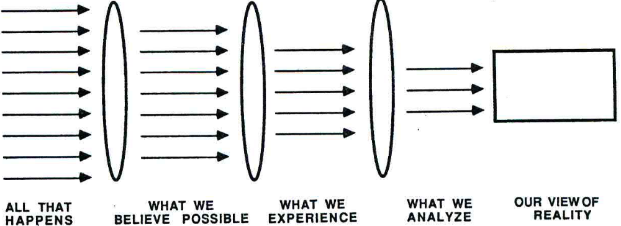
Kraft gives us four examples of how we are taught to “see”
- Pick one of these examples and illustrate it form your own life. Share it with your group when asked to.
- My experience growing up in Florida is different than the experience of people who grew up elsewhere. The culture, atmosphere, people, and beliefs are all different and ultimately shaped my view of reality.
- Kraft shows different lens or filters which affect our perception of R, thus reducing it to r…pick one of them and share how it has affected you or someone you know
The echo chamber of politics has affected not just me but everyone in the United States. This filter is a big part of everyone’s perception of R.

