Syllabus

EGR101 (EGR 301)

Intro to Engineering from a Christian Worldview

(4 units)
Instructors: Matthew Rickard. Ph.D. and Anthony Donaldson, Ph.D.
Course Description: Serves as an introduction to the exciting field and vocation of engineering and the value of engineering training. Guest lectures from engineers, and introduction to teams through a group project will be included. Exploration of the concept of worldview from a Christian perspective is stressed. Emphasis will include Christian perspectives on purpose, integrity, discernment and service as they relate to the vocation of engineering. An assessment of ones learning style, temperament and potential strengths and weaknesses as part of self-discovery will be included. The first course required of all students considering engineering as a major. Note: Required Course for Engineering, Computer Science, and Construction Management Majors.
Pre/co-requisites: None other than an inquisitive mind, an eagerness to learn and grow, and a willingness to pursue enjoyment in the curricula presented.

Course Materials:
- Studying Engineering: A Road Map to a Rewarding Career by Raymond B. Landis, Steffen Peuker, and Jennifer Mott 5th Ed
- Do Hard Things: A teenage rebellion against low expectations by Alex and Brett Harris
- A Cal Baptist email account that is checked daily.
- Access to the University BB systems (announcements and assignments will be posted there).
- Recommended additional Reference Texts:
  - Thriving at College by Alex Chediak and
  - Christianity with Power by Charles Kraft (for world view sessions)
  - Handouts on worldview and class handouts.

General Course Objectives
This course has 26 course objectives/outcomes which are related to the College of Engineering Student Outcomes as indicated in peripheries (SO’s:_X) following each outcome. A copy of the CoE SO’s is provided at the back of this syllabus.

By the end of the course, the student will….
Worldview
Outcome 1: Be able to describe what a worldview is, what some characteristics of a Christian Worldview are and why this is important in the practice of engineering. (SO’s: 4, 8)
Outcome 2: Begin to be aware of some of the cultural and personal filters one has that limits their view of reality. (SO’s: 8)
Outcome 3: See the foundational importance of an accurate understanding of who God is as the basis for developing a relationship with Him, obtaining wisdom and discovering and living out one’s purpose. (SO’s: 8)
Outcome 4: Be able to describe the role that service plays in being fully human. (SO’s: 8)

Discernment
Outcome 5: Have developed a personal model of discernment and can apply it to help determine reality in a given situation. (SO’s: 8)

Engineering
Outcome 6: Have developed their own personal one sentence definition of what engineering is that they can articulate at a moment’s notice when asked.
Outcome 7: Be able to articulate some skills and attributes of successful engineers.
Outcome 8: Be able to describe briefly a wide range of things that different types of engineers do.
Outcome 9: Be able to describe briefly and enthusiastically some interesting current problems that engineers are working on.

Community
Outcome 10: Identify by sight and pronounce correctly the names of all of their classmates. (SO’s: 5)
Outcome 11: Find ways to appropriately encourage, support and help their peers achieve their objectives. (SO’s: 5)

Communication
Outcome 12: Be able to produce an excellent one page executive summary of materials studied or read. (SO’s: 3)
Outcome 13: Understand the importance of and be able to formulate good questions. (SO’s: 3)
Outcome 14: Be able to listen, understand and articulate another’s perspective. (SO’s: 5, 3)
Outcome 15: Participate appropriately in group, team and one on one discussions. (SO’s: 5, 3)
Outcome 16: Be able to follow written and oral instructions. (SO’s: 5, 3)
Outcome 17: Understand and begin to practice good patterns of communication with professors and others in authority. (SO’s: 5, 3)
Outcome 18: Be able to provide constructive feedback which can lead to course improvement. (SO’s: 5, 3)
Outcome 19: Use the assertion evidence method to design slides for oral presentations. (SO’s: 3)

Teamwork
Outcome 20: Be able to participate productively on a team. (SO’s: 5)
Outcome 21: Be able to reflect on the role of competition in improving design and performance for a team. (SO’s: 5)

Self-Awareness
Outcome 22: Begin to understand and reflect on their personal learning style. (SO’s: 7)
Outcome 23: Be able to access the strengths and weaknesses of one’s own temperament and in general the various temperament types. (SO’s: 7)
Outcome 24: Be able to develop goals for their engineering education and plan for success Resourcefulness
Outcome 25: Understand and begin to practice those habits which lead to academic success at CBU such as effective time management.
Outcome 26: Begin to effectively use Blackboard, the web, library resources, and people as sources of information.

Class meeting time
Each section meets three times per week (as shown for Section A-I in the below table): once in the evening section taught by Dean Donaldson (Tues at 3:45 PM or Thurs at 5:30 PM) and twice per week with the individual section instructor.
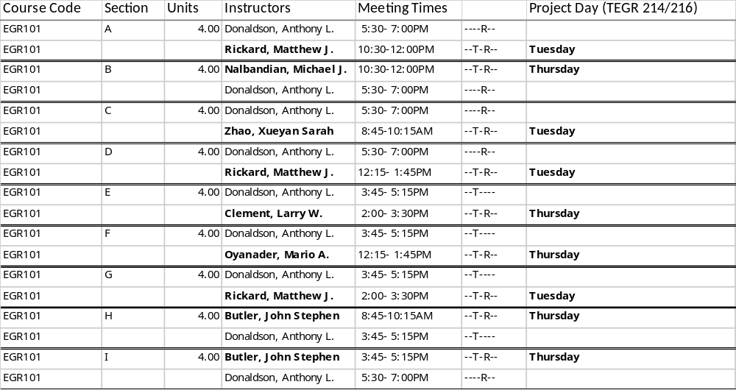

Note: EGR 301 fulfills the requirement of EGR 101 for transfers with upper division status. Serves as an introduction to the exciting field and vocation of engineering and the value of engineering training. Guest lectures from engineers, and introduction to teams through a group project will be included. Exploration of the concept of worldview from a Christian perspective is stressed. Emphasis will include Christian perspectives on purpose, integrity, discernment and service as they relate to the vocation of engineering. An assessment of one’s learning style, temperament and potential strengths and weaknesses as part of self discovery will be included. The first course required of all students considering engineering as a major.
- EGR 301 Section A meets at the same time as EGR 101 Section C.
- EGR 301 Section B meets at the same time as EGR 101 Section F.
- EGR 301 Section C meets at the same time as EGR 101 Section G.
- EGR 301 Section D meets at the same time as EGR 101 Section H.

Instructor Contact Information
Dr. Anthony Donaldson
adonaldson@calbaptist.edu OR 951-343-4972
For emails, put “EGR101” in the subject line
Office: TEGR356A; Office Hours: Friday 3-5pm and by arrangement
Professor Matthew Rickard, Ph.D.
mrickard@calbaptist.edu OR 951-343-4951
For emails, put “EGR101” in the subject line
Office: TEGR 364
Office Hours (email to setup):
M: 9AM to noon
Tu: by appt
We: 1 to 5 pm
Th: by appt
Fr: 11 AM to noon

Class preparation
It is the general policy that the student will contribute a minimum of two hours of preparation time for each one hour of class time.

Attendance is required. Class activities have been planned to enhance your understanding of the material and to help you complete assignments. Excessive absences for any reason will adversely affect your grade. Therefore, class attendance is regarded mandatory due to the applied nature of course content and group learning formats. Each unexcused absence will result a 20% reduction in that students’ attendance/participation score.
Late work is unacceptable - the course moves too quickly through new and challenging material. Late submissions are given a grade of zero, though they are required. Also, the instructor may assign penalty assignments (additional work) for late submissions. If all work has not been turned in (including any penalty assignments), then you will receive an F in the course. Unexcused late work assignments will cause your COURSE grade to be reduced per the following additional penalties:
First Late Submission – no additional penalty
Second Late Submission – Max possible grade in the course is a B.
Third Late Submission – Max possible grade in the course is a C.
Fourth or more Late Submissions – Max possible grade in the course is a D
(which is FAILING – and, thus, requires repeating the course).

Course Point Distribution: Graded assignments will be weighted as follows:
The below Table applies if all work has been turned in. If all work has not been turned in, then you will receive an F in the course.
Individual Section Assignments (20%) / Participation (5%) | 25%
Combined Section (Donaldson) Assignments /WV Final/ Participation  Attendance (virtual) with Participation and COVID compliance = 5%, In class assignments 20% note the grades are also multiplicative… if any assignment is not turned in then a 0 is given for this portion of the course | 25%
Project Activities (more info to come) | 30%
Accountability Journal | 10%
Final Exam (in-Section) WV portion will be announced in Dr. D’s virtual class. | 10%
The course point distribution (Graded Assignments) is subject to change based on the progress of the class. Instructor will announce any changes to the syllabus in class and then post a summary of those changes on Blackboard. In the event a GPA-type score is used on an assignment, that grade will be converted to a percentage using the following formula (prior to averaging with other grades): [(GPA_SCORE)/4 + 5.5]*10.

Final Grades
The following scale will be used to calculate final grades:
A | 93%-100% |  | A- | 90%-92% |  | B+ | 87%-89%
B | 83%-86% |  | B- | 80%-82% |  | C+ | 77%-79%
C | 73%-76% |  | C- | 70%-72%

Checking Grades
Be sure to check your grades often via Blackboard.

EXPECTATIONS

Attendance
Students are encouraged to read the university catalog which covers the attendance policy. Failure to follow this attendance policy may result in academic withdrawal and/or a failing grade. Class starts promptly each session. Students who elect to arrive late or leave early will be counted as absent. If you do not want to be marked absent for the entire class session, personally inform the professor prior to the class that you will be leaving early. Or, personally notify the professor after class if you were late. In the event that a session is scheduled for testing, a student electing to arrive late, will not be given extra time to complete the test. As a professional, you are expected to collaborate with your fellow students during in-class activities or out-of-class group projects, and to respect one another during all interactions, presentations, and class discussions. For student requesting remote option, you must comply with the alternative plan provide by your instructor. NOTE: For in-person project activities, you MUST comply with the provided COVID safety guidelines – including face coverings - or else you risk failing the course. Please also refer to CBU’s Health and Safety: Fall 2020 Specific Actions Plan
https://calbaptist.edu/fall2020/specific_actions_plan

In the event a student wants to request that an absence be excused, the student must follow the below procedure:
- Email the relevant EGR 101 instructor with your name, ID number, reason for missing class, and specific date missed.
- The instructor will provide you with an alternative engagement activity with a deadline. Examples could be a written make-up assignment or, for missed projects days, possibly a written plan on how you will make up the missed hours for your team (with your team cc’d).
- Complete the alternative engagement activity by the deadline.
- If your Make Up Assignment is approved, a previously-recorded “Unexcused” showing on InsideCBU will be changed to “Excused”. (Note: Generally, course grades other than attendance/participation will be posted in Blackboard in the Grade Center.) It is your responsibility to check both Blackboard and InsideCBU regularly for accurate grade and attendance entries.
Polling will be used in order to improve lecture interactivity and also as means of recording attendance / participation. No points will be awarded for correct answers; however, responding to each question will ensure you receive both participation and attendance credit for that day. Each unexcused absence will result in a 20% reduction in that students’ attendance/participation score for the course.
Academic Honesty - Any incident of academic dishonesty (cheating, plagiarism, copying, and other forms) must be reported to the Dean of Students. A detailed discussion of academic dishonesty appears in the CBU Student Handbook. As a point of information and clarification, you may wish to visit the following website: http://www.plagiarism.org
Penalty Notice: Evidence of copying or cheating of any kind will result in a failing grade for the assignment and can result in failing the course. This includes inappropriate behavior inside of Webex or Zoom call including, but not limited to, falsely identifying yourself and/or intentionally causing disturbances.
Students with Disabilities - Students who have qualified disabilities and wish to arrange the appropriate accommodations, in addition to the general academic support services coordinated by the Academic Resources Center, must identify themselves to the Director of Disability Services. Disabled students who wish to arrange appropriate accommodations must complete and submit a Request for Accommodations form and provide recent (not older than 3 years) diagnostic test results.

Course Schedule and Key Dates - Each week, Tuesday individual section meetings are typically utilize Webex, Zoom, or Online Polling, group discussions, and other activities to expand upon textbook readings. Once per week individual section meetings are a typically hands-on project day. (For student requesting remote option, you must comply with the alternative plan provide by your instructor.) Late afternoon or evening sessions, taught by Dean Donaldson, demonstrate how Christian perspectives on purpose, the characteristics of God, service, and discernment directly relate to the vocation of engineering.

Waste Disposal - For any hazardous waste generated in this course, including batteries, students are expected to follow their trainings in this course and/or instructions from their instructor. If you are not sure how to dispose anything, contact your instructor. Violation of waste disposal procedure could result in grade reduction and/or even failing of the course.

AUG/SEPTEMBER
Tuesday and Thursday Individual Section Meetings: Do Hard Things, Landis Ch. 1, Project Labs, Begin Project Design.
Evening (Worldview) Sessions: See handout from Dr. Donaldson
Key Dates*: Note that STEPCON20 is a virtual event on October 8, 2020. Keep an eye on this event as CBU engineering departments will be creating content to present to the public.

OCTOBER
Tuesday and Thursday Individual Section Meetings: Landis Ch’s 2-5. Project Build and Test.
Evening (Worldview) Sessions: See handout from Dr. Donaldson
Key Dates*: None.

NOVEMBER
Tuesday and Thursday Individual Section Meetings: Inventor Assignment, Technical Presenting (Michael Alley), Final Exam; Project Activity: TBD
Evening (Worldview) Sessions: See handout from Dr. Donaldson
Key Dates*: TBD.
The course schedule is subject to change based on the progress of the class. Instructor will post all course schedule changes on Blackboard after in class announcement.

CBU’s College of Engineering Mission Statement:
"Preparing engineering students of excellence and character, with a Christian worldview who are called to serve, equipped to lead and sent to engage the world with their lives and the appropriate use of technology."

Student Outcomes
Student Outcomes (SO’s) describe what students are expected to know and be able to do by the time of graduation. These relate to the knowledge, skills, and behaviors that students acquire as they progress through the program. The SO’s that are addressed by the Course Outcomes are in parenthesis following the Course Outcomes list. The detail information on the various programs in the CBU Gordon and Jill Bourns College of Engineering can be found on the programs’ websites.

Engineering Student Outcomes:
EGR #1. an ability to identify, formulate, and solve complex engineering problems by applying principles of engineering, science, and mathematics (ABET)
EGR #2. an ability to apply engineering design to produce solutions that meet specified needs with consideration of public health, safety, and welfare, as well as global, cultural, social, environmental, and economic factors (ABET)
EGR #3. an ability to communicate effectively with a range of audiences (ABET)
EGR #4. an ability to recognize ethical and professional responsibilities in engineering situations and make informed judgments, which must consider the impact of engineering solutions in global, economic, environmental, and societal contexts (ABET)
EGR #5. an ability to function effectively on a team whose members together provide leadership, create a collaborative and inclusive environment, establish goals, plan tasks, and meet objectives (ABET)
EGR #6. an ability to develop and conduct appropriate experimentation, analyze and interpret data, and use engineering judgment to draw conclusions (ABET)
EGR #7. an ability to acquire and apply new knowledge as needed, using appropriate learning strategies. (ABET)
EGR #8: an ability to articulate a Christian worldview on personal, professional, technical, and societal issues
EGR #9: An ability to develop attributes of a leader in an innovation-driven environment

