***Bury Your Dead* writing assignments**

**Please read the following before starting the assignments! There are specific directions on the different columns as well as on the cartoon.**

**For your writing assignment on *Bury Your Dead*, you will pick three of the following five newspaper possibilities:**

1. **A front-page article** which focuses on the death of Gamache’s agents **(700 words). This will not be in chronological order.**  Look below for instructions.

2. **A travel article** on Quebec and its culture **(700 words).** Imagine thatyou have traveled to Quebec City **or** Three Pines. Tell us about what there is to see and do there. Use the novel for your source of information.

3. **An advice column** (2 letters + 2 answers) Two of the characters in the book write to an advice columnist (you) asking for advice with something they are dealing with. They get answers from the columnist - you. You will write all of the above as if they are all real people and you are a real advice columnist. **(700 words)**

4. **An editorial** on Augustin Reynaud’s murder and the social tensions that gave rise to it **(700 words)**

5. **A cartoon or a comic strip** which addresses an issue or a character in the book in an ironic, politicized or exaggerated manner.

**All of these must contain information gleaned from the novel. Do not enhance your content by making up information about your topic or trying to find something online. This assignment is to test your understanding of the book. If you copy and paste from the internet, you will receive a 0 and not be able to make it up.**

**A Front Page Article - Format and Structure**

The structure of a frontpage article is often compared to an inverted triangle: **the most important details are at the beginning of the article,** and the least important information placed at the end of the article.

**Photos and illustrations are useful, but not obligatory**.

The article is not written in chronological order. A newspaper article includes the following (in order):

* Headline and by-line (reporter's [your] name).
* An opening paragraph (introduction) of about 25-40 words. **It provides the most important and interesting news first, while answering who, what, where, when (how and why are often reserved for later).**
* Further short paragraphs of about 30-40 words apiece. Each one has a main idea and a different fact. They may also include quotes from people involved or experts.
* **Details are given in order of importance, with the least important details at the end of the article.** This allows readers to skim over the start of the article to gain the essential facts before deciding to read on.
* **At the end of the article** the facts and opinions may be summarized, detailing the issue or event.

**The Headline**

**Headlines convey information and attract attention using the following:**

* Short phrases and incomplete sentences
* Figurative language
* Stereotypes
* Exaggeration
* Puns

**2. *Tips for Writing Travel Articles* -See the document in this content folder**

**3. An example of an advice column is in this content folder**

**4. Writing an Editorial – See the document in this folder**

**5. *How to draw a stick figure* *comic* is in this folder**

The cartoon or comic strip must address a situation from ***Bury Your Dead.*** It cannot be something that you have cut and pasted from the internet. It needs to be your own work. Stick figures are fine. See below.

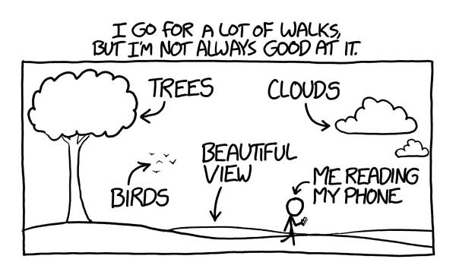

**Here are a few of the most respected newspapers or magazines in English in the world:**

The New York Times: <https://www.nytimes.com/>

The Guardian: <https://www.theguardian.com/us>

The Economist: <https://www.economist.com/>

The Washington Post: <https://www.washingtonpost.com/>

**You may want to read some articles of the type that you are considering writing from any of these papers in order to get a sense of how to write your article.**

**This will tell you how to get around the paywalls to the New York Times and The Washington Post:**

<http://blog.agupieware.com/2016/04/how-to-get-around-new-york-times-and.html>