**A neuroscientist who studies rage says we are all capable of doing something terrible**

August 4, 2018

[[Olivia Goldhill](https://qz.com/author/ogoldhillqz/)](https://qz.com/author/ogoldhillqz/)

By [**Olivia Goldhill**](https://qz.com/author/ogoldhillqz/)

Investigative reporter

James Holmes, the 24-year-old who in 2012 killed 12 people at a screening of *Dark Knight Rises*in Aurora, Colorado*,*was always a “super-nice kid,” according to [a high school acquaintance](http://nymag.com/daily/intelligencer/2012/07/james-holmes-seemed-like-a-normal-dude.html). Ed Gein, also known as “The Butcher of Plainfield,” killed two women in the 1950s, adding them to a collection of corpses he had collected from graveyards. He was [described by a neighbor](https://books.google.com/books?id=vB2G-9lgvCEC&pg=PA186&lpg=PA186&dq=%E2%80%9CGood+old+Ed.+Kind+of+a+loner+and+maybe+a+little+bit+odd+with+that+sense+of+humor+of+his,+but+just+the+guy+to+call+in+to+sit+with+the+kiddies+when+me+and+the+old+lady+want+to+go+to+the+show.%E2%80%9D&source=bl&ots=pVEwo9y6w_&sig=AAsFW3S6veKT3s_ef6lLKvfGq8A&hl=en&sa=X&ved=2ahUKEwj0g5PLg8rcAhXDzlkKHdR_CWkQ6AEwAHoECAEQAQ#v=onepage&q=%E2%80%9CGood%20old%20Ed.%20Kind%20of%20a%20loner%20and%20maybe%20a%20little%20bit%20odd%20with%20that%20sense%20of%20humor%20of%20his%2C%20but%20just%20the%20guy%20to%20call%20in%20to%20sit%20with%20the%20kiddies%20when%20me%20and%20the%20old%20lady%20want%20to%20go%20to%20the%20show.%E2%80%9D&f=false) as “just the guy to call in to sit with the kiddies when me and the old lady want to go to the show.”

These and similar comments about other violent criminals suggesting the normality of mass murderers are now a standard, almost clichéd, feature of the reporting on atrocious crimes. And those confused neighbors and childhood friends are not simply naive, they are accurate. There is no credible way of predicting whether someone is capable of committing murder: science has not revealed any tell-tale signs that a seemingly normal person is on the path to violent criminality. As neurologist Robert Burton[recently wrote in *Aeon*](https://aeon.co/essays/think-you-can-tell-what-others-are-thinking-think-again), even after 30 years of attempting to study and track patterns, psychiatrists and psychologists are[terrible at predicting violence](https://www.bmj.com/content/345/bmj.e4692?view=long&pmid=22833604). People who do terrible things seem to be just like everyone else until the day they cross into the realm of criminal violence and, all of a sudden, they are not like us at all.

This raises the question: If we are incapable of knowing what others are capable of, do we know what we could potentially do? Most of us, after all, have thought about committing murder. David Buss, professor of psychology at the University of Texas-Austin,  [surveyed 5,000 people](https://www.wnycstudios.org/shows/radiolab) for his book, [*The Murderer Next Door: Why the Mind is Designed to Kill*](https://www.amazon.com/The-Murderer-Next-Door-Designed/dp/0143037056?tag=bisafetynet2-20), and found that 91% of men and 84% of women had thought about killing someone, often with very specific hypothetical victims and methods in mind.

The terrifying reality is that we are biologically predisposed to violence in certain situations. Douglas Fields, neuroscientist and author of the book [*Why We Snap*](https://www.amazon.com/Why-We-Snap-Understanding-Circuit-ebook/dp/B00SI02CTQ)*,*says our brains have evolved to monitor for danger and spark aggression in response to any perceived danger as a defense mechanism. “We all have the capacity for violence because in certain situations it’s necessary for our survival,” he says. “You don’t need to be taught defensive aggression, because it’s a life-saving behavior that’s unfortunately sometimes required.”

These responses have to be quick, so as to effectively deal with dangerous situations. The problem is, they can be overly sensitive. “Of course, it goes wrong [sometimes], just like any burglar alarm will have a misfire,” says Fields. “Our brain never evolved to deal with the situations and threats encountered in that environment. The modern world presses on the defense mechanism circuitry in ways that can lead to misfires.”

We see this all the time, when people explode with rage in traffic jams or respond to flippant insults with physical aggression. We might like to think that people freaking out in stop-and-go traffic have a problem, and that it could never happen to us. But Fields notes that stress can make anyone more sensitive to potential threats, and jumpier.  Even seemingly good normal people—even you—could be pushed to do something terrible.

“It’s not an opinion, it’s a fact,” says Fields. “Look at the amount of crime committed in rage, not a conniving crime but a rage-induced aggressive responses. They are people who gave no reason to believe previously that they had aggressive tendencies.”

That is not to say we are entirely at the whim of these aggressive reflexes. Fields says that being aware of how our brain works can help us temper our responses to perceived threats. Ideally, we could all recognize that stress makes us overly sensitive, and so understand that the jolt of rage we feel when we are late for an important meeting and someone cuts through traffic is a misfiring, rather than an appropriate response.

Middle- and high-school students should be taught about the biological triggers for aggression, argues Fields, considering that the prefrontal cortex— the part of the brain that inhibits and controls the threat detection mechanism—is not fully developed in teenagers. “You can use the biology to help a teenager understand specifically why they’re angry, and that it’s a misfire, so there’s no advantage in an aggressive response,” Fields says. “I think that’s helpful and better than telling them to control their anger. You’re asking them to do something that their brain is not equipped to do.”

Societal pressures, including cultural norms and legal guidelines, [do influence our biological impulses to murder](https://www.nature.com/articles/nature19758), and the rate of human violence [varies considerably](https://www.theatlantic.com/science/archive/2016/09/humans-are-unusually-violent-mammals-but-averagely-violent-primates/501935/) across time periods and cultures. But while we are not controlled by the evolutionary impulses in our brain, we are not free from them either. It is comforting to think that those everyone who commits violence is a criminal, and fundamentally different from you. Plenty of criminals used to think the same.

Retrieved April 25, 2020 from <https://qz.com/1348203/a-neuroscientist-who-studies-rage-says-were-all-capable-of-doing-something-terrible/>

Here's What Happens in the Brain When People Kill

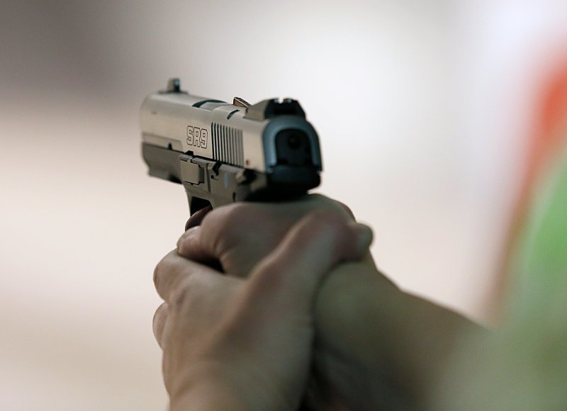

Pulling the trigger is hard—and that's very good

George Frey—Getty Images

BY [**JEFFREY KLUGER**](https://time.com/author/jeffrey-kluger/)

APRIL 10, 2015 10:35 AM EDT

Evil isn’t easy. Say what you will about history’s monsters, they had to overcome a lot of powerful neural wiring to commit the crimes they did. The human brain is coded for compassion, for guilt, for a kind of empathic pain that causes the person inflicting harm to feel a degree of suffering that is in many ways as intense as what the victim is experiencing. Somehow, that all gets decoupled—and a new study published in the journal *Social Cognitive and Affective Neuroscience* brings science a step closer to understanding exactly what goes on in the brain of a killer.

While psychopaths don’t sit still for science and ordinary people can’t be made to think so savagely, nearly anyone can imagine what it would be like to commit the kind of legal homicide that occurs in war. To study how the brain reacts when it confronts such murder made moral, psychologist Pascal Molenberghs of Monash University in Melbourne, Australia, recruited 48 subjects and asked them to submit to functional magnetic resonance imaging (fMRI), which could scan their brains while they watched three different scenarios on video loops.

Top of Form

Bottom of Form

In one, a soldier would be killing an enemy soldier; in the next, the soldier would be killing a civilian; and in the last, used as a control, the soldier would shoot a weapon but hit no one. In all cases, the subjects saw the scene from the shooter’s point of view. At the end of each loop, they were asked “Who did you shoot?” and were required to press one of three buttons on a keypad indicating soldier, civilian or no one—a way of making certain they knew what they’d done. After the scans, they were also asked to rate on a 1 to 7 scale how guilty they felt in each scenario.

Even before the study, Molenberghs knew that when he read the scans he would focus first on the activity in the orbitofrontal cortex, a region of the forebrain that has long been known to be involved with moral sensitivity, moral judgments and making choices about how to behave. The nearby temporoparietal junction (TPJ) also takes on some of this moral load, processing the sense of agency—the act of doing something deliberately and therefore owning the responsibility for it. That doesn’t always makes much of a difference in the real world—whether you shoot someone on purpose, or the gun goes off accidentally, the victim is still dead. But it makes an enormous difference in how you later reckon with what you’ve done.

In Molenbergh’s study, there was consistently greater activity in the lateral portion of the OFC when subjects imagined shooting civilians than when they shot soldiers. There was also more coupling between the OFC and the TPJ—with the OFC effectively saying I feel guilty and the TPJ effectively answering You should. Significantly, the degree of OFC activation also correlated well with how bad the subjects reported they felt on their 1 to 7 scale, with greater activity in the brains of people who reported feeling greater guilt.

The OFC and TPJ weren’t alone in this moral processing. Another region, known as the fusiform gyrus, was more active when subjects imagined themselves killing civilians—a telling finding since that portion of the brain is involved in analyzing faces, suggesting that the subjects were studying the expressions of their imaginary victims and, in so doing, humanizing them. When subjects were killing soldiers, there was greater activity in a region called the lingual gyrus, which is involved in the much more dispassionate business of spatial reasoning—just the kind of thing you need when you’re going about the colder business of killing someone you feel justified killing.

Soldiers and psychopaths are, of course, two different emotional species. But among people who kill legally and those who kill criminally or promiscuously, the same brain regions are surely involved, even if they operate in different ways. In all of us it’s clear that murder’s neural roots and moral roots are deeply entangled. Learning to untangle them a bit could one day help psychologists and criminologists predict who will kill—and stop them before they do.

Retrieved April 26, 2020 from <https://time.com/3816212/brain-murder-morality/>