Assignment Submission Portal
with Continuous Integration, Automated Testing and Local Test Reporting
Project Report
Field | Details
Student name | [Your full name]
Registration number | [Your registration number]
Course | [Course name and code]
Instructor | [Instructor name]
Submission date | [Date]
GitHub repository | [https://github.com/YOUR-USERNAME/assignment-portal]
GitHub Pages URL | [https://YOUR-USERNAME.github.io/assignment-portal/]

Table of Contents
1. Introduction 4
2. Tools and Technologies 4
3. System Overview 5
4. Repository Structure 5
5. Implementation Steps 7
Step 1: Setting up the tools 7
Step 2: Creating the GitHub repository 7
Step 3: Cloning the repository to my computer 8
Step 4: Creating the Python virtual environment and installing packages 8
Step 5: Writing the validation logic (validation.py) 9
Step 6: Writing the storage module (storage.py) 10
Step 7: Building the web server (app.py) and page (templates/index.html) 10
Step 8: Running the portal manually 10
Step 9: Writing the automated tests (pytest.ini and tests/test_portal.py) 12
Step 10: Writing the report builder (scripts/build_report.py) 12
Step 11: Building the local report receiver (receiver/receiver.py) 13
Step 12: Starting the tunnel with Docker (Cloudflare Tunnel) 14
Step 13: Adding the GitHub secrets 15
Step 14: Creating the CI pipeline (.github/workflows/ci.yml) 15
Step 15: Creating the static portal for GitHub Pages (docs/index.html) 16
Step 16: Writing the README 17
6. Test Cases 18
7. Test Report Format (testreport.json) 18
8. Demonstration 20
8.1 Run 1: All tests pass 20
8.2 Run 2: Introducing a defect (failing run) 21
8.3 Run 3: Fixing the defect (passing run) 23
9. Bonus Tasks 25
9.1 Conditional deployment to GitHub Pages 25
9.2 Email report 25
10. Requirements Checklist 27
11. Challenges and Solutions 27
12. Conclusion 27
Appendix A: Source Code 29
A.1 requirements.txt 29
A.2 .gitignore 29
A.3 pytest.ini 29
A.4 validation.py 29
A.5 storage.py 30
A.6 app.py 30
A.7 templates/index.html 31
A.8 tests/test_portal.py 31
A.9 scripts/build_report.py 32
A.10 receiver/receiver.py 33
A.11 .github/workflows/ci.yml 34
A.12 docs/index.html 35

(Right-click the table above and choose Update Field after adding your screenshots, so the page numbers are correct.)

1. Introduction
Our department needed a simple portal where students can submit assignment links. Earlier updates to such systems sometimes broke the submission feature without anyone noticing. To prevent this, every change to the code must be tested automatically, and the instructor needs a local record of the test results.
In this project I built:
- An assignment submission portal (Python Flask) where students enter their name, registration number, assignment title and submission URL. The portal validates the input, saves valid submissions and displays them.
- Three automated tests (pytest) that check the main behaviours of the portal.
- A continuous integration (CI) pipeline on GitHub Actions that runs the tests on every push.
- A local HTTP receiver on my computer that automatically receives the test report from GitHub and saves it as testreport.json.
- A tunnel (Cloudflare Tunnel, run through Docker) so that GitHub's cloud runner can reach the receiver on my computer.
- Bonus: conditional deployment of a static version of the portal to GitHub Pages, and an email report after every run.

2. Tools and Technologies
Tool | What I used it for
Python 3.12 | Programming language for the portal, tests, report script and receiver
Flask | Lightweight web framework used to build the portal
pytest | Testing framework used to write and run the automated tests
Git | Version control: tracking changes and pushing code to GitHub
GitHub | Hosting the repository
GitHub Actions | CI pipeline that runs the tests on every push
Docker + Cloudflare Tunnel | Gives my local receiver a public HTTPS address that GitHub can reach
Visual Studio Code | Code editor and integrated terminals
GitHub Pages | Hosting the static demo of the portal (bonus)
Gmail SMTP | Sending the test report by email (bonus)

3. System Overview
The complete workflow works as follows:
- I change the code on my laptop and run git push.
- GitHub receives the push and automatically starts the CI workflow defined in .github/workflows/ci.yml.
- A GitHub-hosted runner (a temporary Ubuntu machine in the cloud) checks out the pushed commit, installs the dependencies and runs the tests with pytest.
- pytest writes the results to results.xml. If any test fails, pytest returns a non-zero exit code and the test step is marked as failed (red).
- Whether the tests passed or failed, the next steps still run (if: always()): a Python script converts results.xml into testreport.json, adding the repository, branch, commit SHA, run ID and timestamp.
- The runner sends the report with an HTTP POST request to the public tunnel URL. The tunnel forwards it to the receiver running on my computer at port 5001.
- The receiver checks a secret token, then saves the report as testreport.json on my computer and keeps a copy in the reports/ folder.
- The report is also emailed to a configurable address (bonus).
- Only if all tests passed and the push was to main, the deploy job publishes the static portal to GitHub Pages (bonus). If tests fail, deployment is skipped and the previous site stays online.
Why a tunnel is needed: the GitHub runner is a machine in the cloud. For that machine, localhost means the runner itself, not my laptop, so it cannot reach my receiver directly. The tunnel gives my laptop's port 5001 a public HTTPS address that the runner can reach.
[ Paste screenshot here: Architecture / workflow diagram of the complete system ]
Figure 1: Architecture / workflow diagram of the complete system

4. Repository Structure
assignment-portal/
├── requirements.txt Python packages needed (flask, pytest)
├── .gitignore files that must not be uploaded to GitHub
├── pytest.ini pytest settings
├── validation.py validation rules for the form
├── storage.py save / load submissions (JSON file)
├── app.py Flask web server (the portal)
├── templates/index.html HTML page: form + list of submissions
├── tests/test_portal.py the three automated tests
├── scripts/build_report.py converts test results to testreport.json
├── receiver/receiver.py local HTTP receiver that saves the report
├── .github/workflows/ci.yml CI pipeline definition
├── docs/index.html static version of the portal for GitHub Pages
└── README.md instructions to run everything
[ Paste screenshot here: Project folder structure in VS Code ]
Figure 2: Project folder structure in VS Code

5. Implementation Steps
This section describes every step I performed, in the order I performed it. Throughout, Terminal A is the VS Code terminal used for Git and tests, Terminal B runs the receiver, and Terminal C runs the tunnel.

Step 1: Setting up the tools
What I did
I made sure Python 3.12, Git, Visual Studio Code and Docker Desktop were installed, and that I had a GitHub account. I verified the installations from the terminal.
Why this step is needed
Python runs the portal, tests and receiver; Git sends code to GitHub; Docker runs the Cloudflare tunnel without installing anything else.
Where I ran it
Windows PowerShell / Command Prompt.
Commands / code
python --version
git --version
docker --version
[ Paste screenshot here: Terminal showing the Python, Git and Docker versions ]
Figure 3: Terminal showing the Python, Git and Docker versions

Step 2: Creating the GitHub repository
What I did
On github.com I created a new public repository named assignment-portal with a README file.
Why this step is needed
The repository stores the application, tests, pipeline configuration and receiver (Requirement 2). GitHub Actions runs the pipeline whenever code is pushed to it. It is public so that GitHub Pages can be used for free.
Where I ran it
github.com → + → New repository.
[ Paste screenshot here: New repository page on GitHub ]
Figure 4: New repository page on GitHub

Step 3: Cloning the repository to my computer
What I did
I copied the repository to my computer, set my Git identity and opened the folder in VS Code.
Why this step is needed
Cloning gives me a local copy where I can write and test code before pushing it back to GitHub.
Where I ran it
Command Prompt.
Commands / code
cd %USERPROFILE%\Documents
git clone https://github.com/[YOUR-USERNAME]/assignment-portal.git
cd assignment-portal
git config --global user.name "[Your Name]"
git config --global user.email "[your email]"
code .
Explanation
- git clone downloads the repository.
- git config sets the name and email that appear on my commits.
- code . opens the current folder in VS Code.
[ Paste screenshot here: Terminal output of git clone ]
Figure 5: Terminal output of git clone

Step 4: Creating the Python virtual environment and installing packages
What I did
I created requirements.txt listing flask and pytest, created a virtual environment and installed the packages. I also created a .gitignore file.
Why this step is needed
A virtual environment keeps this project's packages separate from the rest of the computer. requirements.txt lets both my laptop and the GitHub runner install exactly the same packages. .gitignore stops temporary and local files (venv, data, reports) from being uploaded.
Where I ran it
Terminal A (VS Code terminal).
Commands / code
python -m venv venv
venv\Scripts\activate
pip install -r requirements.txt
Explanation
- python -m venv venv creates the environment in a folder called venv.
- venv\Scripts\activate switches it on; (venv) appears at the start of the prompt.
- pip install -r requirements.txt installs Flask and pytest.
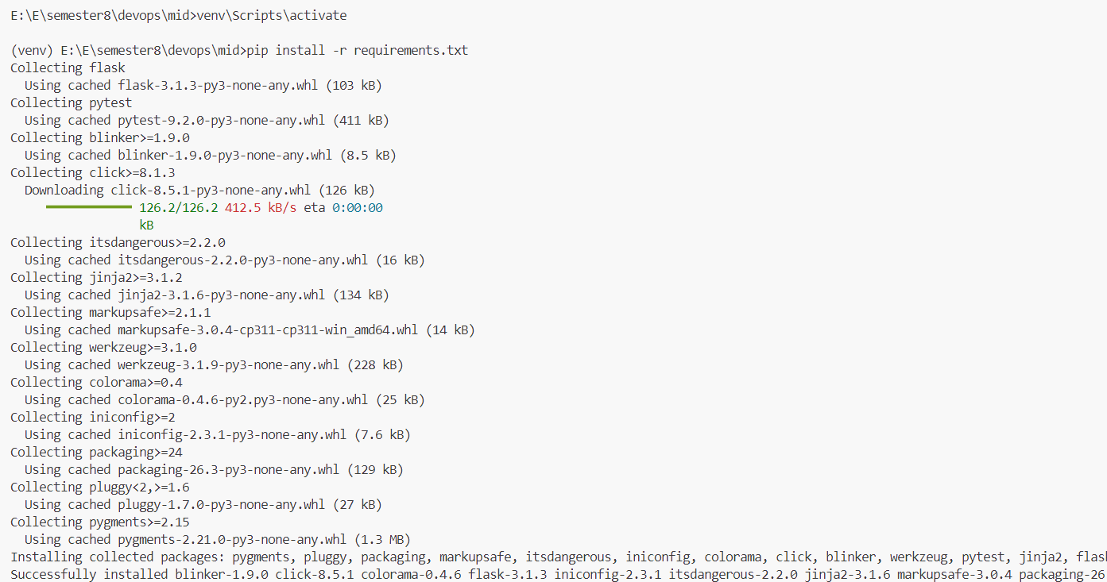
Figure 6: Packages installed successfully inside the virtual environment

Step 5: Writing the validation logic (validation.py)
What I did
I wrote a function validate_submission() that trims spaces from all four fields, checks that none of them is empty, and checks that the URL starts with http or https and contains a host name.
Why this step is needed
Requirement 1 says required fields and the URL must be validated. Keeping the rules in a separate file makes them easy to understand and to test.
Where I ran it
VS Code, file validation.py in the main folder.
Explanation
- REQUIRED maps each form field to the label used in error messages.
- Each empty field adds an error such as "Registration number is required."
- urlparse() splits the URL into parts. If the scheme is not http/https or there is no host (netloc), the error "Submission URL must be a valid http(s) link." is added.
- The function returns the cleaned data and the list of errors. An empty list means the submission is valid.
The full code is in Appendix A.

Step 6: Writing the storage module (storage.py)
What I did
I wrote two functions: load(path) reads all submissions from a JSON file, and save(path, item) appends a new submission and writes the file back.
Why this step is needed
Valid submissions must be saved and displayed. A JSON file is simple and needs no database server. The file path is a parameter so the tests can use a temporary file instead of the real data.
Where I ran it
VS Code, file storage.py in the main folder.

Step 7: Building the web server (app.py) and page (templates/index.html)
What I did
I created the Flask application with two routes. GET / shows the form and the list of saved submissions. POST /submit validates the form; if there are errors it shows them with HTTP status 400 and saves nothing, otherwise it adds a timestamp, saves the submission and shows "Submission saved."
I created templates/index.html with the form (name, registration number, assignment title, submission URL), error and success messages, and a table of saved submissions.
Why this step is needed
This is the portal itself (Requirement 1). The create_app() function accepts the data file path so that the tests can create an isolated copy of the app.
Where I ran it
VS Code, files app.py and templates/index.html.
Explanation
- @app.get("/") and @app.post("/submit") connect web addresses to Python functions.
- Returning status 400 for invalid input makes the rejection clear and easy to test.
- The template uses Jinja ({% for %}, {{ }}) to show errors and loop over submissions. Jinja escapes text automatically, which prevents script injection.
- If a submission is rejected, the values the student typed are kept in the form so they do not have to retype them.

Step 8: Running the portal manually
What I did
I started the app and tested it in the browser with a valid submission, an empty registration number and an invalid URL.
Why this step is needed
To confirm the portal works as expected before writing the automated tests.
Where I ran it
Terminal A, then the browser at http://127.0.0.1:5000.
Commands / code
python app.py
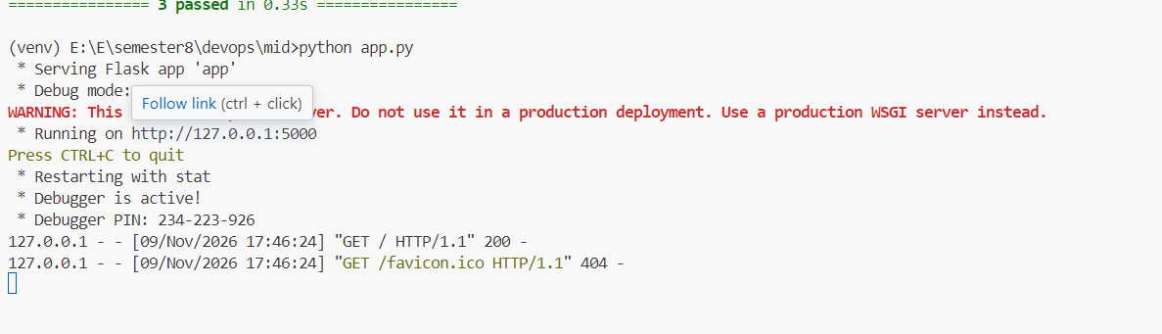
Figure 7: Portal home page with the submission form
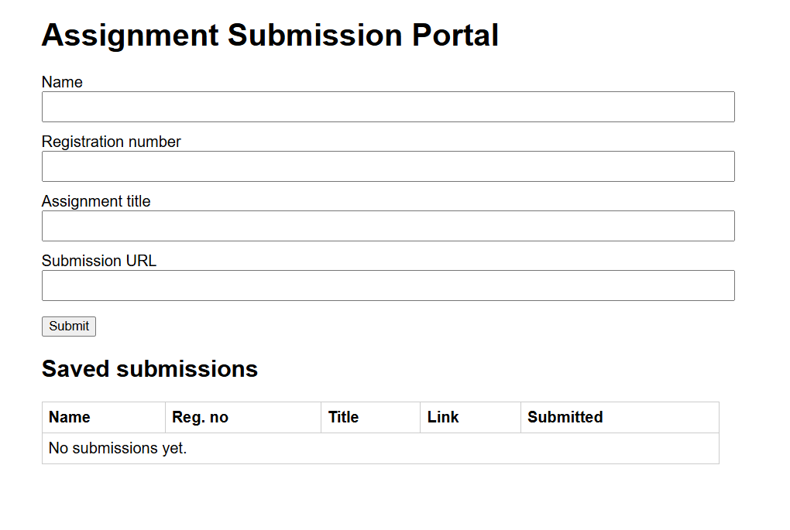
Figure 8: Valid submission saved and shown in the list
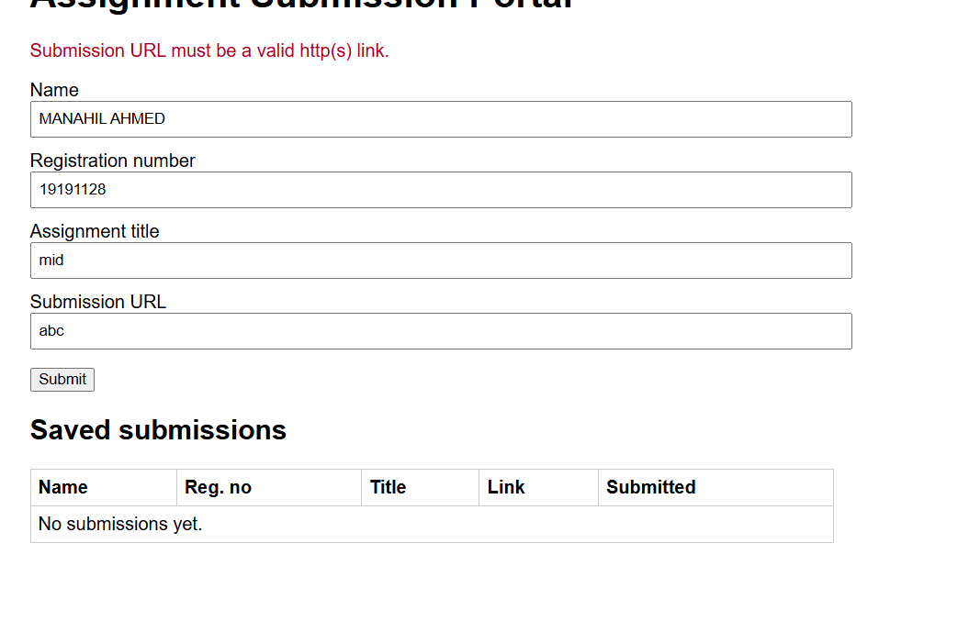
Figure 9: Validation error for missing registration number
Figure 10: Validation error for an invalid URL

Step 9: Writing the automated tests (pytest.ini and tests/test_portal.py)
What I did
I wrote three pytest tests that use Flask's test client (a simulated browser). Each test gets its own temporary data file through a fixture. I also added pytest.ini so pytest can import the app from the main folder.
Why this step is needed
Requirement 3 needs at least three automated tests. The results must come from actually executing the tests, and a failing test must make the pipeline fail.
Where I ran it
VS Code (files), Terminal A (running the tests).
Commands / code
pytest -v
Explanation
- The fixture client_and_file uses pytest's tmp_path so the tests never touch the real submissions.json.
- Test 1 posts valid data and checks status 200, one saved record, and that the title appears on the page.
- Test 2 posts data with an empty registration number and checks status 400, the error message, and that nothing was saved.
- Test 3 posts an invalid URL and checks status 400, the error message, and that nothing was saved.
- If any assert is false, pytest exits with a non-zero code, which marks the CI step as failed.
[ Paste screenshot here: pytest output showing 3 passed ]
Figure 11: pytest output showing 3 passed

Step 10: Writing the report builder (scripts/build_report.py)
What I did
I wrote a script that reads the JUnit XML file produced by pytest and creates testreport.json. It also creates a short text summary for the email.
Why this step is needed
Requirement 4 asks for a JSON report containing repository details, each test's result and the totals. pytest's XML output contains the real results; the script converts it to the required format.
Where I ran it
VS Code (file), Terminal A (local test).
Commands / code
pytest -v --junitxml=results.xml
python scripts/build_report.py results.xml testreport.json
Explanation
- The script loops over each <testcase> in the XML. A <failure> or <error> element means the test failed, and its message is copied into failure_message.
- It counts total, passed and failed tests. The overall status is "passed" only if there are tests and none failed.
- Repository, branch, commit SHA, run ID and run number are read from environment variables that GitHub Actions provides (GITHUB_REPOSITORY, GITHUB_REF_NAME, GITHUB_SHA, GITHUB_RUN_ID, GITHUB_RUN_NUMBER). When run locally they show "local".
- The execution timestamp is recorded in UTC.
[ Paste screenshot here: testreport.json generated locally ]
Figure 12: testreport.json generated locally

Step 11: Building the local report receiver (receiver/receiver.py)
What I did
I wrote a small HTTP server using Python's built-in http.server. It listens on port 5001, accepts POST /report, checks a secret token in the X-Token header, and saves the JSON body as testreport.json. It also saves a timestamped copy in the reports/ folder and prints a summary line.
Why this step is needed
Requirement 4 needs a local HTTP receiver that automatically receives the completed test report and saves it as testreport.json on my computer. The token prevents anyone else from writing files through the public tunnel.
Where I ran it
Terminal B (kept running during the whole demonstration).
Commands / code
venv\Scripts\activate
$env:RECEIVER_TOKEN="[my-secret-token]"
python receiver/receiver.py
Explanation
- do_GET returns "Receiver is running", which I used to check the tunnel in the browser.
- do_POST rejects wrong paths (404), wrong tokens (401) and invalid JSON (400).
- The server listens on 0.0.0.0 so the Docker-based tunnel can reach it through host.docker.internal.
[ Paste screenshot here: Receiver running in Terminal B ]
Figure 13: Receiver running in Terminal B

Step 12: Starting the tunnel with Docker (Cloudflare Tunnel)
What I did
I started a Cloudflare quick tunnel in a Docker container that forwards a public HTTPS address to port 5001 on my computer.
Why this step is needed
The GitHub-hosted runner cannot reach localhost on my laptop. The tunnel provides a public address that forwards requests to my receiver. Using Docker meant I did not need to install or register for anything else.
Where I ran it
Terminal C (kept running during the whole demonstration).
Commands / code
docker run --rm cloudflare/cloudflared:latest tunnel --no-autoupdate --url http://host.docker.internal:5001
Explanation
- docker run --rm starts the container and removes it when stopped.
- host.docker.internal is how a Docker container reaches the host computer.
- The output shows a URL like https://xxxx.trycloudflare.com. I opened it in the browser and saw "Receiver is running", which confirmed the path worked.
- The URL changes each time the tunnel restarts, so I kept it running and updated the GitHub secret when needed.
[ Paste screenshot here: Cloudflare tunnel output showing the public URL ]
Figure 14: Cloudflare tunnel output showing the public URL
[ Paste screenshot here: Browser showing "Receiver is running" through the tunnel URL ]
Figure 15: Browser showing "Receiver is running" through the tunnel URL

Step 13: Adding the GitHub secrets
What I did
In the repository settings I added the secrets RECEIVER_URL (the tunnel URL) and RECEIVER_TOKEN (the same token used by the receiver). For the email bonus I also added MAIL_USERNAME, MAIL_PASSWORD (a Gmail app password) and MAIL_TO.
Why this step is needed
The workflow needs these values, but they must not be written in the public code. GitHub secrets are encrypted and only available while the workflow runs.
Where I ran it
github.com → repository → Settings → Secrets and variables → Actions.
[ Paste screenshot here: GitHub repository secrets list (values are hidden) ]
Figure 16: GitHub repository secrets list (values are hidden)

Step 14: Creating the CI pipeline (.github/workflows/ci.yml)
What I did
I created the workflow file with two jobs: test and deploy.
Why this step is needed
Requirement 3 requires automatic testing of every pushed revision. Requirement 4 requires the report to be delivered for both passing and failing runs. The bonus requires deployment only when all tests pass.
Where I ran it
VS Code, file .github/workflows/ci.yml.
Explanation
- on: push runs the workflow for every push to any branch.
- actions/checkout downloads the exact commit that was pushed; actions/setup-python installs Python; pip install installs the packages.
- pytest -v --junitxml=results.xml runs the tests. It has no continue-on-error, so a failing test fails the test stage.
- The report, send, artifact and email steps use if: always(), so they run even after a test failure. This is how the report is delivered for failing runs as well.
- The send step uses curl to POST testreport.json to RECEIVER_URL/report with the X-Token header.
- upload-artifact also keeps a copy of the report on GitHub as extra evidence.
- The deploy job has needs: test and if: github.ref == 'refs/heads/main' && needs.test.result == 'success', so it only runs on main when the test job succeeded.
[ Paste screenshot here: ci.yml open in VS Code ]
Figure 17: ci.yml open in VS Code

Step 15: Creating the static portal for GitHub Pages (docs/index.html)
What I did
I created a browser-only version of the portal that uses the same validation rules in JavaScript and stores submissions in the browser's localStorage. I set GitHub Pages to deploy from GitHub Actions.
Why this step is needed
GitHub Pages only hosts static files and cannot run Flask. A static demo is sufficient for the bonus task.
Where I ran it
VS Code (file), github.com → Settings → Pages → Source: GitHub Actions.
Explanation
- validate() mirrors the server-side rules, including the http/https URL check using new URL().
- esc() escapes text before inserting it into the page to prevent script injection.
[ Paste screenshot here: GitHub Pages settings with Source set to GitHub Actions ]
Figure 18: GitHub Pages settings with Source set to GitHub Actions

Step 16: Writing the README
What I did
I wrote README.md explaining how to run the application, execute the tests, start the receiver and the tunnel, which secrets are required, and the Pages URL.
Why this step is needed
Requirement 2 asks for a README explaining how to run the application, execute the tests and start the receiver.
Where I ran it
VS Code, file README.md.
[ Paste screenshot here: README displayed on the GitHub repository page ]
Figure 19: README displayed on the GitHub repository page

6. Test Cases
# | Test function | Input | Expected result | How it is checked
1 | test_valid_submission_is_saved_and_listed | All four fields valid, URL https://github.com/alikhan/lab5 | Submission is saved and appears in the list | Status 200; 1 record in the file; title appears on the page
2 | test_missing_registration_number_is_rejected | Registration number empty | Rejected with a validation message | Status 400; "Registration number is required." shown; 0 records saved
3 | test_invalid_url_is_rejected_and_not_saved | URL not-a-valid-link | Rejected and not saved | Status 400; URL error shown; 0 records saved

7. Test Report Format (testreport.json)
Every pipeline run produces a report in the following format. This example is from a failing run:
{
"repository": "YOUR-USERNAME/assignment-portal",
"branch": "main",
"commit_sha": "3f2a9c1e...",
"pipeline_run_id": "1234567890",
"pipeline_run_number": "2",
"pipeline_run_url": "https://github.com/YOUR-USERNAME/assignment-portal/actions/runs/1234567890",
"execution_timestamp": "2026-10-30T15:20:11+00:00",
"tests": [
{ "name": "test_valid_submission_is_saved_and_listed", "result": "passed", "failure_message": null },
{ "name": "test_missing_registration_number_is_rejected", "result": "passed", "failure_message": null },
{ "name": "test_invalid_url_is_rejected_and_not_saved", "result": "failed",
"failure_message": "assert 200 == 400 ..." }
],
"summary": { "total": 3, "passed": 2, "failed": 1, "overall_status": "failed" }
}
Requirement | Field(s) in the report
Repository name | repository
Branch | branch
Commit SHA | commit_sha
Pipeline run identifier | pipeline_run_id (plus pipeline_run_number and pipeline_run_url)
Execution timestamp | execution_timestamp
Each test's name, result, failure message | tests[].name, tests[].result, tests[].failure_message
Total, passed, failed, overall status | summary.total, summary.passed, summary.failed, summary.overall_status

8. Demonstration
Before each push, the receiver (Terminal B) and the tunnel (Terminal C) were running, and the RECEIVER_URL secret contained the current tunnel URL.

8.1 Run 1: All tests pass
What I did
I committed and pushed the complete project.
git add .
git commit -m "Add portal, tests, CI pipeline, report receiver and Pages demo"
git push
Result
The workflow ran automatically. All three tests passed, the run was green, the receiver printed the report summary and testreport.json on my computer was updated automatically. The deploy job published the portal to GitHub Pages.
Item | Value
Commit SHA | [commit SHA]
Run ID / number | [run id] / [run number]
Tests | 3 total, 3 passed, 0 failed
Overall status | passed
Deploy job | Ran successfully

[ Paste screenshot here: Run 1 – GitHub Actions run (green) ]
Figure 20: Run 1 – GitHub Actions run (green)
[ Paste screenshot here: Run 1 – test step log showing 3 passed ]
Figure 21: Run 1 – test step log showing 3 passed
[ Paste screenshot here: Run 1 – Terminal B showing the report was received ]
Figure 22: Run 1 – Terminal B showing the report was received
[ Paste screenshot here: Run 1 – testreport.json on my computer (overall_status: passed) ]
Figure 23: Run 1 – testreport.json on my computer (overall_status: passed)

8.2 Run 2: Introducing a defect (failing run)
What I did
I deliberately disabled the URL check in validation.py, so that invalid URLs would be accepted, and pushed the change.
# validation.py – defect introduced
if parsed.scheme not in ("http", "https") or not parsed.netloc:
pass # errors.append("Submission URL must be a valid http(s) link.")
git add .
git commit -m "Introduce defect: URL validation disabled"
git push
Result
The test test_invalid_url_is_rejected_and_not_saved failed because the invalid URL was accepted (status 200 instead of 400). The test step failed and the run was marked red. Because the report steps use if: always(), the report was still built and delivered: Terminal B printed the summary and testreport.json was updated with the failure message. The deploy job was skipped, so the previously published Pages site stayed unchanged.
Item | Value
Commit SHA | [commit SHA]
Run ID / number | [run id] / [run number]
Tests | 3 total, 2 passed, 1 failed
Overall status | failed
Failed test | test_invalid_url_is_rejected_and_not_saved
Deploy job | Skipped (previous site unchanged)

[ Paste screenshot here: Run 2 – GitHub Actions run (red) ]
Figure 24: Run 2 – GitHub Actions run (red)
[ Paste screenshot here: Run 2 – test step log showing the failed test ]
Figure 25: Run 2 – test step log showing the failed test
[ Paste screenshot here: Run 2 – deploy job skipped ]
Figure 26: Run 2 – deploy job skipped
[ Paste screenshot here: Run 2 – Terminal B showing the failed report was received ]
Figure 27: Run 2 – Terminal B showing the failed report was received
[ Paste screenshot here: Run 2 – testreport.json (overall_status: failed, with failure message) ]
Figure 28: Run 2 – testreport.json (overall_status: failed, with failure message)

8.3 Run 3: Fixing the defect (passing run)
What I did
I restored the original line in validation.py and pushed the fix.
git add .
git commit -m "Fix defect: restore URL validation"
git push
Result
All three tests passed again, the run was green, testreport.json was updated to a passing report, and the portal was redeployed to GitHub Pages.
Item | Value
Commit SHA | [commit SHA]
Run ID / number | [run id] / [run number]
Tests | 3 total, 3 passed, 0 failed
Overall status | passed
Deploy job | Ran successfully

[ Paste screenshot here: Run 3 – GitHub Actions run (green) ]
Figure 29: Run 3 – GitHub Actions run (green)
[ Paste screenshot here: Run 3 – Terminal B showing the report was received ]
Figure 30: Run 3 – Terminal B showing the report was received
[ Paste screenshot here: Run 3 – testreport.json (overall_status: passed) ]
Figure 31: Run 3 – testreport.json (overall_status: passed)
[ Paste screenshot here: Actions tab showing all three runs: pass, fail, pass ]
Figure 32: Actions tab showing all three runs: pass, fail, pass
[ Paste screenshot here: reports/ folder containing a saved copy of each run's report ]
Figure 33: reports/ folder containing a saved copy of each run's report

9. Bonus Tasks

9.1 Conditional deployment to GitHub Pages
The deploy job depends on the test job (needs: test) and only runs when the branch is main and the test job succeeded. It uploads the docs/ folder with actions/upload-pages-artifact and publishes it with actions/deploy-pages. In Run 2 the deploy job was skipped, so the previously published version remained online.
Deployed URL: [https://YOUR-USERNAME.github.io/assignment-portal/]
[ Paste screenshot here: Deployed portal on GitHub Pages ]
Figure 34: Deployed portal on GitHub Pages
[ Paste screenshot here: Deploy job details showing the Pages URL ]
Figure 35: Deploy job details showing the Pages URL

9.2 Email report
The last step of the test job uses dawidd6/action-send-mail with if: always(), so an email is sent after both passing and failing runs. The subject contains the job status, repository and commit SHA; the body contains the overall result, test counts and each test's result; and testreport.json is attached. The Gmail address, app password and recipient address are stored as GitHub secrets (MAIL_USERNAME, MAIL_PASSWORD, MAIL_TO), so the recipient is configurable without changing code.
[ Paste screenshot here: Email received for a passing run ]
Figure 36: Email received for a passing run
[ Paste screenshot here: Email received for a failing run ]
Figure 37: Email received for a failing run

10. Requirements Checklist
Requirement | How I met it | Evidence
1. Submission portal (8) | Flask app with form, validation of required fields and URL, saving to JSON and a list of submissions | Step 7–8, Figures in Step 8
2. GitHub repository (4) | App, tests, workflow, receiver and README stored in the repository | Section 4, Step 16
3. Tests on every push (10) | on: push workflow; three pytest tests; failing test fails the stage | Steps 9 and 14, Section 6, Section 8
4. Report to localhost as JSON (14) | build_report.py creates the report from real results; curl posts it through the tunnel to receiver.py, which saves testreport.json; if: always() delivers it for pass and fail | Steps 10–14, Section 7, Section 8
5. Demonstration (4) | Pass → fail (defect) → pass (fix), with pipeline results and updated JSON each time | Section 8
Bonus: Pages (5) | Deploy job only on main when tests pass; skipped on failure | Section 9.1
Bonus: Email (5) | Email after every run with commit, result, counts, per-test results and attached report; credentials in secrets | Section 9.2

11. Challenges and Solutions
Challenge | Solution
The GitHub runner cannot reach localhost on my laptop | Used a Cloudflare Tunnel (run in Docker) to give the receiver a public HTTPS address
The report also had to be sent when tests fail, but a failed step normally stops the job | Added if: always() to the report, send, artifact and email steps
Tests must not affect the real data | Made the data file configurable and used pytest's tmp_path for a separate file per test
Anyone could post to the public tunnel URL | The receiver requires a secret token in the X-Token header
The Docker tunnel could not reach a server bound only to 127.0.0.1 | Made the receiver listen on 0.0.0.0
GitHub Pages cannot run Python | Created a static JavaScript version of the portal in docs/
The quick-tunnel URL changes on restart | Kept the tunnel running during the demonstration and updated the RECEIVER_URL secret when it changed

12. Conclusion
I built a working assignment submission portal and protected it with an automated CI pipeline. Every push is tested automatically on GitHub Actions, a failing test makes the pipeline fail, and a JSON report with the real test results is delivered automatically to my computer for both passing and failing runs. The demonstration showed that a deliberately introduced defect was caught immediately, recorded in the local report, and prevented from being deployed, and that fixing it returned the pipeline to a passing state. As bonus features, the static portal is deployed to GitHub Pages only when all tests pass, and the report is emailed after every run.

Appendix A: Source Code

A.1 requirements.txt
flask
pytest

A.2 .gitignore
venv/
__pycache__/
submissions.json
results.xml
testreport.json
report_summary.txt
reports/

A.3 pytest.ini
[pytest]
pythonpath = .
testpaths = tests

A.4 validation.py
from urllib.parse import urlparse

REQUIRED = {
"name": "Name",
"reg_no": "Registration number",
"title": "Assignment title",
"url": "Submission URL",
}

def validate_submission(data):
"""Returns (cleaned_data, list_of_error_messages)."""
clean = {key: (data.get(key) or "").strip() for key in REQUIRED}
errors = []
for key, label in REQUIRED.items():
if not clean[key]:
errors.append(f"{label} is required.")
if clean["url"]:
parsed = urlparse(clean["url"])
if parsed.scheme not in ("http", "https") or not parsed.netloc:
errors.append("Submission URL must be a valid http(s) link.")
return clean, errors

A.5 storage.py
import json
import os

def load(path):
if not os.path.exists(path):
return []
with open(path, encoding="utf-8") as f:
return json.load(f)

def save(path, item):
items = load(path)
items.append(item)
with open(path, "w", encoding="utf-8") as f:
json.dump(items, f, indent=2)

A.6 app.py
from datetime import datetime, timezone
from flask import Flask, render_template, request
from validation import validate_submission
import storage

def create_app(data_file="submissions.json"):
app = Flask(__name__)
app.config["DATA_FILE"] = data_file

def page(errors=None, form=None, success=None, status=200):
subs = storage.load(app.config["DATA_FILE"])
return render_template("index.html", submissions=subs,
errors=errors or [], form=form or {},
success=success), status

@app.get("/")
def index():
return page()

@app.post("/submit")
def submit():
clean, errors = validate_submission(request.form)
if errors:
return page(errors=errors, form=clean, status=400)
clean["submitted_at"] = datetime.now(timezone.utc).isoformat(timespec="seconds")
storage.save(app.config["DATA_FILE"], clean)
return page(success="Submission saved.")

return app

if __name__ == "__main__":
create_app().run(debug=True)

A.7 templates/index.html
<!doctype html>
<html>
<head>
<meta charset="utf-8">
<title>Assignment Submission Portal</title>
<style>
body{font-family:sans-serif;max-width:700px;margin:2rem auto;padding:0 1rem}
label{display:block;margin-top:.7rem} input{width:100%;padding:.4rem}
.err{color:#b00020} .ok{color:#1b7f1b}
table{width:100%;border-collapse:collapse;margin-top:1rem}
th,td{border:1px solid #ccc;padding:.4rem;text-align:left}
</style>
</head>
<body>
<h1>Assignment Submission Portal</h1>

{% if success %}<p class="ok">{{ success }}</p>{% endif %}
{% for e in errors %}<p class="err">{{ e }}</p>{% endfor %}

<form method="post" action="/submit">
<label>Name <input name="name" value="{{ form.name or '' }}"></label>
<label>Registration number <input name="reg_no" value="{{ form.reg_no or '' }}"></label>
<label>Assignment title <input name="title" value="{{ form.title or '' }}"></label>
<label>Submission URL <input name="url" value="{{ form.url or '' }}"></label>
<p><button type="submit">Submit</button></p>
</form>

<h2>Saved submissions</h2>
<table>
<tr><th>Name</th><th>Reg. no</th><th>Title</th><th>Link</th><th>Submitted</th></tr>
{% for s in submissions %}
<tr><td>{{ s.name }}</td><td>{{ s.reg_no }}</td><td>{{ s.title }}</td>
<td><a href="{{ s.url }}" target="_blank">open</a></td><td>{{ s.submitted_at }}</td></tr>
{% else %}
<tr><td colspan="5">No submissions yet.</td></tr>
{% endfor %}
</table>
</body>
</html>

A.8 tests/test_portal.py
import pytest
import storage
from app import create_app

VALID = {
"name": "Ali Khan",
"reg_no": "FA22-BSE-001",
"title": "Lab 5 - Git Basics",
"url": "https://github.com/alikhan/lab5",
}

@pytest.fixture
def client_and_file(tmp_path):
data_file = str(tmp_path / "submissions.json")
app = create_app(data_file)
app.config["TESTING"] = True
return app.test_client(), data_file

def test_valid_submission_is_saved_and_listed(client_and_file):
client, data_file = client_and_file
response = client.post("/submit", data=VALID)
assert response.status_code == 200
saved = storage.load(data_file)
assert len(saved) == 1 and saved[0]["reg_no"] == "FA22-BSE-001"
page = client.get("/").get_data(as_text=True)
assert "Lab 5 - Git Basics" in page

def test_missing_registration_number_is_rejected(client_and_file):
client, data_file = client_and_file
response = client.post("/submit", data={**VALID, "reg_no": ""})
assert response.status_code == 400
assert "Registration number is required." in response.get_data(as_text=True)
assert storage.load(data_file) == []

def test_invalid_url_is_rejected_and_not_saved(client_and_file):
client, data_file = client_and_file
response = client.post("/submit", data={**VALID, "url": "not-a-valid-link"})
assert response.status_code == 400
assert "Submission URL must be a valid http(s) link." in response.get_data(as_text=True)
assert storage.load(data_file) == []

A.9 scripts/build_report.py
import json, os, sys
import xml.etree.ElementTree as ET
from datetime import datetime, timezone

xml_path = sys.argv[1] if len(sys.argv) > 1 else "results.xml"
out_path = sys.argv[2] if len(sys.argv) > 2 else "testreport.json"

tests = []
if os.path.exists(xml_path):
root = ET.parse(xml_path).getroot()
for tc in root.iter("testcase"):
failure = tc.find("failure")
if failure is None:
failure = tc.find("error")
if failure is not None:
result = "failed"
message = failure.get("message") or (failure.text or "")[:500]
elif tc.find("skipped") is not None:
result, message = "skipped", None
else:
result, message = "passed", None
tests.append({
"name": tc.get("name"),
"classname": tc.get("classname"),
"result": result,
"failure_message": message,
"duration_seconds": float(tc.get("time", 0)),
})

passed = sum(t["result"] == "passed" for t in tests)
failed = sum(t["result"] == "failed" for t in tests)
status = "passed" if tests and failed == 0 else "failed"

repo = os.getenv("GITHUB_REPOSITORY", "local")
run_id = os.getenv("GITHUB_RUN_ID", "local")
report = {
"repository": repo,
"branch": os.getenv("GITHUB_REF_NAME", "local"),
"commit_sha": os.getenv("GITHUB_SHA", "local"),
"pipeline_run_id": run_id,
"pipeline_run_number": os.getenv("GITHUB_RUN_NUMBER", "local"),
"pipeline_run_url": f"{os.getenv('GITHUB_SERVER_URL', 'https://github.com')}/{repo}/actions/runs/{run_id}",
"execution_timestamp": datetime.now(timezone.utc).isoformat(timespec="seconds"),
"tests": tests,
"summary": {"total": len(tests), "passed": passed, "failed": failed, "overall_status": status},
}

with open(out_path, "w", encoding="utf-8") as f:
json.dump(report, f, indent=2)

lines = [f"Overall: {status.upper()} ({passed}/{len(tests)} passed, {failed} failed)",
f"Repository: {report['repository']} Branch: {report['branch']}",
f"Commit: {report['commit_sha']}",
f"Run: {report['pipeline_run_url']}", "", "Tests:"]
for t in tests:
lines.append(f" [{t['result'].upper()}] {t['name']}" + (f" -> {t['failure_message']}" if t["failure_message"] else ""))
with open("report_summary.txt", "w", encoding="utf-8") as f:
f.write("\n".join(lines))

print(f"Report written to {out_path}: {status} ({passed}/{len(tests)})")

A.10 receiver/receiver.py
import json, os
from datetime import datetime
from http.server import BaseHTTPRequestHandler, HTTPServer

PORT = int(os.getenv("RECEIVER_PORT", "5001"))
TOKEN = os.getenv("RECEIVER_TOKEN", "")
OUT_FILE = os.getenv("REPORT_PATH", "testreport.json")

class Handler(BaseHTTPRequestHandler):
def _reply(self, code, text):
self.send_response(code)
self.send_header("Content-Type", "text/plain")
self.end_headers()
self.wfile.write(text.encode())

def do_GET(self):
self._reply(200, "Receiver is running")

def do_POST(self):
if self.path != "/report":
return self._reply(404, "Not found")
if TOKEN and self.headers.get("X-Token") != TOKEN:
return self._reply(401, "Invalid token")
length = int(self.headers.get("Content-Length", 0))
try:
data = json.loads(self.rfile.read(length))
except json.JSONDecodeError:
return self._reply(400, "Body is not valid JSON")

with open(OUT_FILE, "w", encoding="utf-8") as f:
json.dump(data, f, indent=2)
os.makedirs("reports", exist_ok=True)
stamp = datetime.now().strftime("%Y%m%d-%H%M%S")
with open(f"reports/{stamp}-run{data.get('pipeline_run_id', 'x')}.json", "w", encoding="utf-8") as f:
json.dump(data, f, indent=2)

s = data.get("summary", {})
print(f"[{datetime.now():%H:%M:%S}] Report received | commit {str(data.get('commit_sha'))[:7]} | "
f"{s.get('overall_status')} | {s.get('passed')}/{s.get('total')} passed")
self._reply(200, "Saved")

if __name__ == "__main__":
print(f"Receiver listening on port {PORT}")
HTTPServer(("0.0.0.0", PORT), Handler).serve_forever()

A.11 .github/workflows/ci.yml
name: CI

on:
push:

jobs:
test:
runs-on: ubuntu-latest
steps:
- name: Check out the pushed revision
uses: actions/checkout@v4

- name: Set up Python
uses: actions/setup-python@v5
with:
python-version: "3.12"

- name: Install dependencies
run: pip install -r requirements.txt

- name: Run tests
run: pytest -v --junitxml=results.xml

- name: Build JSON test report
if: always()
run: python scripts/build_report.py results.xml testreport.json

- name: Print report
if: always()
run: cat testreport.json

- name: Send report to local receiver
if: always()
env:
RECEIVER_URL: ${{ secrets.RECEIVER_URL }}
RECEIVER_TOKEN: ${{ secrets.RECEIVER_TOKEN }}
run: |
curl --fail-with-body -sS -X POST "${RECEIVER_URL}/report" \
-H "Content-Type: application/json" \
-H "X-Token: ${RECEIVER_TOKEN}" \
--data-binary @testreport.json

- name: Keep report as a downloadable artifact
if: always()
uses: actions/upload-artifact@v4
with:
name: testreport-${{ github.run_id }}
path: testreport.json

- name: Email test report
if: always()
uses: dawidd6/action-send-mail@v3
with:
server_address: smtp.gmail.com
server_port: 465
secure: true
username: ${{ secrets.MAIL_USERNAME }}
password: ${{ secrets.MAIL_PASSWORD }}
to: ${{ secrets.MAIL_TO }}
from: CI Bot <${{ secrets.MAIL_USERNAME }}>
subject: "CI ${{ job.status }} - ${{ github.repository }} @ ${{ github.sha }}"
body: file://report_summary.txt
attachments: testreport.json

deploy:
needs: test
if: github.ref == 'refs/heads/main' && needs.test.result == 'success'
runs-on: ubuntu-latest
permissions:
pages: write
id-token: write
environment:
name: github-pages
url: ${{ steps.deployment.outputs.page_url }}
steps:
- uses: actions/checkout@v4
- uses: actions/configure-pages@v5
- uses: actions/upload-pages-artifact@v3
with:
path: docs
- id: deployment
uses: actions/deploy-pages@v4

A.12 docs/index.html
<!doctype html>
<html>
<head>
<meta charset="utf-8"><meta name="viewport" content="width=device-width,initial-scale=1">
<title>Assignment Submission Portal (demo)</title>
<style>
body{font-family:sans-serif;max-width:700px;margin:2rem auto;padding:0 1rem}
label{display:block;margin-top:.7rem} input{width:100%;padding:.4rem}
.err{color:#b00020} .ok{color:#1b7f1b}
table{width:100%;border-collapse:collapse;margin-top:1rem}
th,td{border:1px solid #ccc;padding:.4rem;text-align:left}
</style>
</head>
<body>
<h1>Assignment Submission Portal</h1>
<p><em>Static demo: submissions are stored only in this browser.</em></p>
<div id="msg"></div>
<form id="form">
<label>Name <input name="name"></label>
<label>Registration number <input name="reg_no"></label>
<label>Assignment title <input name="title"></label>
<label>Submission URL <input name="url"></label>
<p><button type="submit">Submit</button></p>
</form>
<h2>Saved submissions</h2>
<table><thead><tr><th>Name</th><th>Reg. no</th><th>Title</th><th>Link</th></tr></thead>
<tbody id="list"></tbody></table>
<script>
const KEY = "submissions";
const esc = s => String(s).replace(/[&<>"']/g, c => ({"&":"&amp;","<":"&lt;",">":"&gt;",'"':"&quot;","'":"&#39;"}[c]));
const load = () => { try { return JSON.parse(localStorage.getItem(KEY)) || []; } catch { return []; } };
const store = items => { try { localStorage.setItem(KEY, JSON.stringify(items)); } catch {} };
const LABELS = {name:"Name", reg_no:"Registration number", title:"Assignment title", url:"Submission URL"};

function validate(d) {
const errors = [];
for (const k in LABELS) if (!d[k]) errors.push(LABELS[k] + " is required.");
if (d.url) {
try { const u = new URL(d.url); if (!["http:","https:"].includes(u.protocol) || !u.host) throw 0; }
catch { errors.push("Submission URL must be a valid http(s) link."); }
}
return errors;
}
function render() {
const items = load();
document.getElementById("list").innerHTML = items.length
? items.map(s => `<tr><td>${esc(s.name)}</td><td>${esc(s.reg_no)}</td><td>${esc(s.title)}</td><td><a href="${esc(s.url)}" target="_blank">open</a></td></tr>`).join("")
: `<tr><td colspan="4">No submissions yet.</td></tr>`;
}
document.getElementById("form").addEventListener("submit", e => {
e.preventDefault();
const fd = new FormData(e.target), d = {};
for (const k in LABELS) d[k] = (fd.get(k) || "").trim();
const errors = validate(d), msg = document.getElementById("msg");
if (errors.length) { msg.innerHTML = errors.map(x => `<p class="err">${esc(x)}</p>`).join(""); return; }
store([...load(), d]); e.target.reset();
msg.innerHTML = `<p class="ok">Submission saved.</p>`; render();
});
render();
</script>
</body>
</html>

