1. Signup UI

1. Login UI

1. Add Task UI

1. Task list with filter UI

1. Edit Task UI

1. Delete Task UI

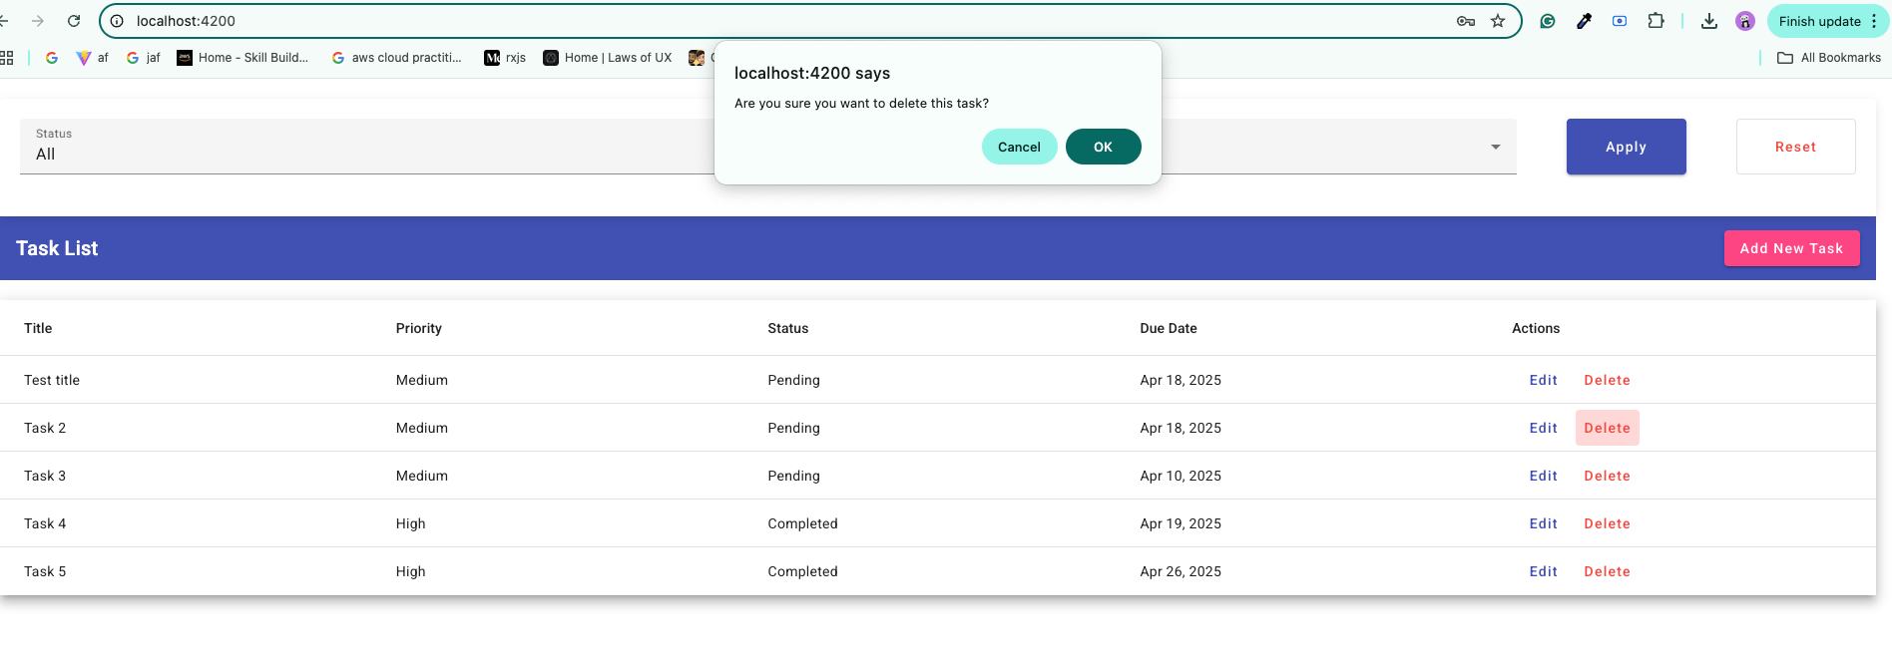

1. Task list with Filter.

