Contents

User guide 2

Main menu 2

Creating a guest entry 2

Finding a parked car 4

Return car to the user and remove user from program 5

List all cars 6

Pseudocode 7

Testing 8

Software Test Record 8

# User guide

## Main menu

The main menu consists of 5 options. 1 will handle a new guest arrival so employee can input details and park the car. 2 will find all parked cars. 3 will return the car to the user, using his name or licence plate. 4 will list the cars and 5 will exit the program.

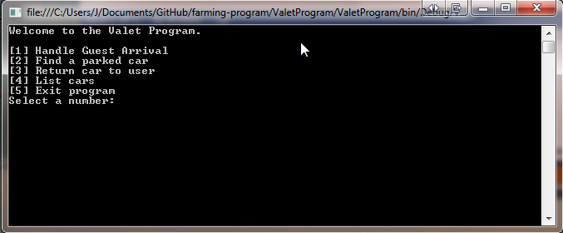

## Creating a guest entry

1. Enter 1 as the number input when at the main menu

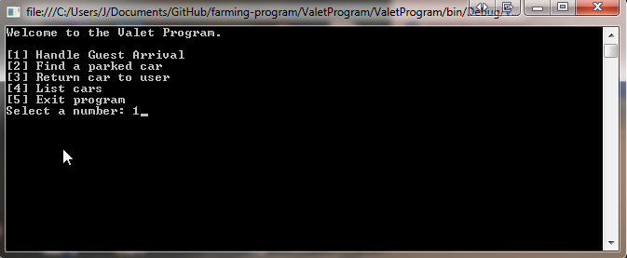

1. Enter the guest name and license plate (These cannot be left blank)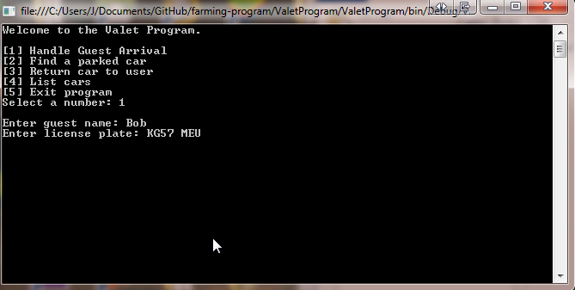
2. Confirm the booking with a Y for yes or a N for No

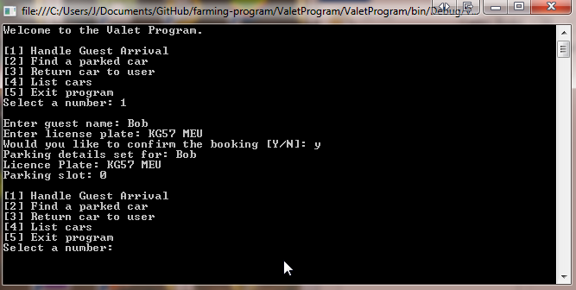

## Finding a parked car

1. Enter 2 as the number input when at the main menu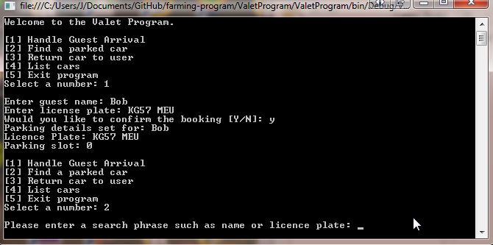
2. Enter either a license plate or a customer name then the search details will be displayed.

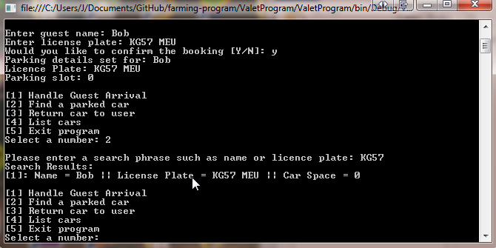

## Return car to the user and remove user from program

1. Enter 3 as the number input at the main menu

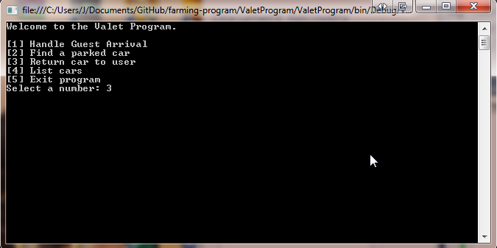

1. Enter the name of the customer or the license plate and a search result will be displayed.

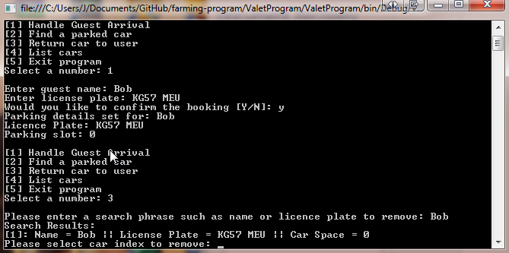

1. To remove a parking just enter the number inside the brackets .e.g. if we want to remove Bob we enter number 1 because it is inside the ‘[#]’. Then we confirm with a Y for a yes and a N for a No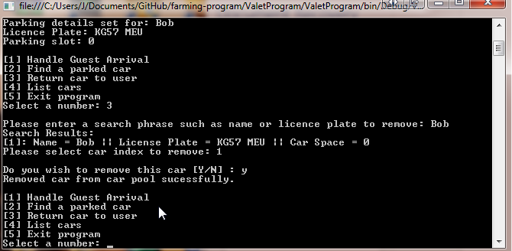

## List all cars

1. Select the number 4 to list all cars in the pool.

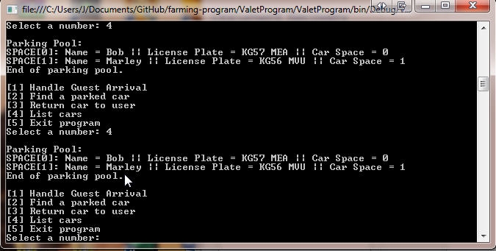

# Pseudocode

While mainMenu

Ask user for main menu input

If user input was 1 Handle action Guest Arrival

Ask user for name

Ask user for licence plate

Save Details in array list of size 10

If user input was 2 handle action Find parked car

Ask user for a search input phrase

Loop through details array list to find a number plate or name match

Store search results in Hash map

Display search results

If user input was 3 handle action Return car to user

Ask user for a search input phrase

Loop through details array list to find a number plate or name match

Store search results in Hash map

Grab search results from hash map and display them as indexes

Remove user index chosen

If user input was 4 handle action list cars

Loop through details array list

Display details on the console

If user input was 5

Quit program

# Testing

## Software Test Record

|  |  |  |  |  |  |  |  |
| --- | --- | --- | --- | --- | --- | --- | --- |
| Test No. | Purpose of Test | Procedure | Test Data | Expected Result | Pass/Fail | Date | Notes |
| 1 | To see what happens when a letter is entered at the main menu | Enter a letter on the main menu | Number Format Exception | Number format exception | Pass | 24/10/2014 | Used int.tryParse which returns if the string did parse to fix the issue |
| 2 | Enter a number higher than the menu options to find errors | Enter number less than 1 and greater than 5 | Main menu message keeps repeating | Main menu message keeps repeating | Pass | 24/10/2014 | Used a check, if the number is in between 1 and 5 |
| 3 | If guests can be saved without a name | Enter 1 on main menu and type leave name blank | Name saved as blank | Name saved as blank, this should not be allowed | Pass | 24/10/2014 | Added a ‘String.IsNullOrWhiteSpace check’ to avoid blank name saving |
| 4 | If guests can be saved without a licence plate | Enter 1 on main menu and type a name then leave the licence plate empty | Licence plate was saved as blank | Licence plate was expected to save as blank this should not be allowed | Pass | 24/10/2014 | Added a ‘String.IsNullOrWhiteSpace check’ to avoid blank licence plate saving |
| 5 | To test the search function | Enter 2 on main menu then search for a parking detail. Type a number higher than the search numbers | Out of bounds exception due to a very high index | Out of bounds exception due to a very high index | Pass | 24/10/2014 | Used a try and catch when obtaining the ParkingDetail object if an error occurred Console prints invalid number and relays the SelectIndex label |