Stage 2 Clustering Analysis Report
Customer Churn Analysis

Elbow method and K-Means
K-Means solutions from k=1 to k=10 were compared using within-cluster sum of squares. The practical elbow was selected at k=4. A four-cluster K-Means model was then trained using scaled numeric and one-hot encoded categorical customer features. Churn was excluded from model fitting and used only after clustering to interpret the segments.
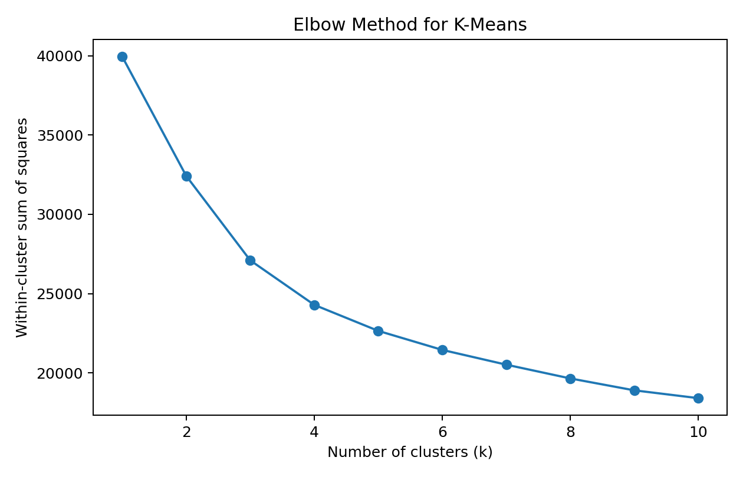

Cluster profiles
Cluster 0: Newer Higher-Cost Customers. 2,058 customers, average tenure 12.5 months, average monthly charges 73.8, observed churn rate 44.8%.
Cluster 1: Lower-Cost Mid-Tenure Customers. 2,037 customers, average tenure 29.1 months, average monthly charges 26.5, observed churn rate 11.2%.
Cluster 2: Long-Tenure Higher-Value Customers. 1,806 customers, average tenure 58.2 months, average monthly charges 88.2, observed churn rate 13.5%.
Cluster 3: Senior Higher-Risk Customers. 1,142 customers, average tenure 33.3 months, average monthly charges 79.8, observed churn rate 41.7%.
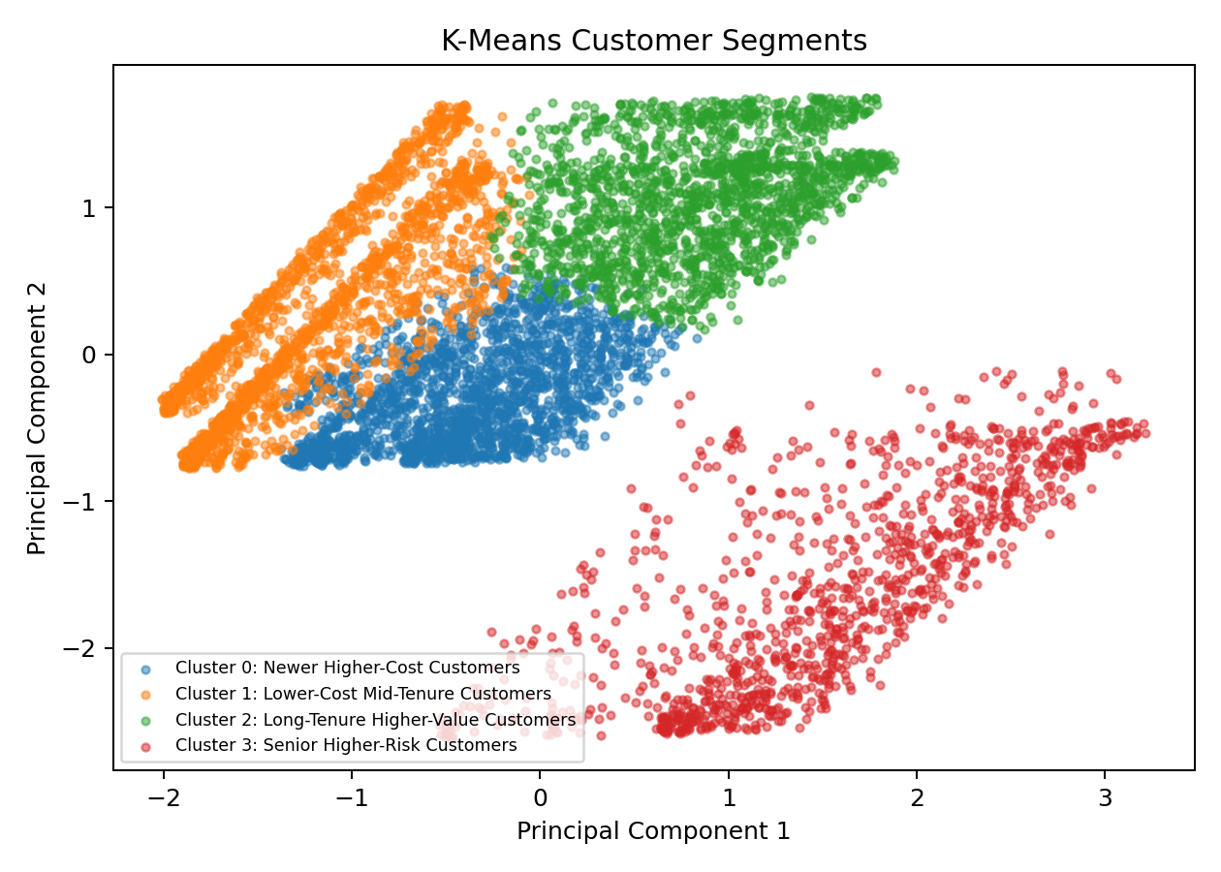

Interpretation
The segments give the team a practical way to compare customer groups and discuss retention priorities. Higher observed churn in some segments can be used as a guide for later predictive modelling, but the cluster labels are descriptive rather than causal.

