**SQL BASICS**:-  
Structured Query Language(SQL) is the database language by the use of  
which we can perform certain operations on the existing database and also  
we can use this language to create a database. SQL uses certain  
commands like Create, Drop, Insert, etc. to carry out the required tasks.    
These SQL commands are mainly categorized into three categories as:   
1. DDL – Data Definition Language  
2. DML – Data Manipulation Language  
3. DCL – Data Control Language

**DDL**  
DDL or Data Definition Language actually consists of the SQL commands   
that can be used to define the database schema. It simply deals with   
descriptions of the database schema and is used to create and modify the   
structure of database objects in the database. DDL is a set of SQL   
commands used to create, modify, and delete database structures but not   
data.  
List of DDL commands:   
• CREATE : This command is used to create the database or its  
objects (like table, index, function, views, store procedure, and  
triggers).  
• DROP : This command is used to delete objects from the database.  
• ALTER : This is used to alter the structure of the database.  
• TRUNCATE : This is used to remove all records from a table,  
including all spaces allocated for the records are removed.  
• COMMENT : This is used to add comments to the data dictionary.  
• RENAME : This is used to rename an object existing in the  
database.

DML:-  
The SQL commands that deals with the manipulation of data present in the   
database belong to DML or Data Manipulation Language and this includes   
most of the SQL statements. It is the component of the SQL statement that   
controls access to data and to the database. Basically, DCL statements are   
grouped with DML statements.  
List of DML commands:   
• INSERT : It is used to insert data into a table.  
• UPDATE : It is used to update existing data within a table.

• DELETE  : It is used to delete records from a database table

•CREATE TABLE Student

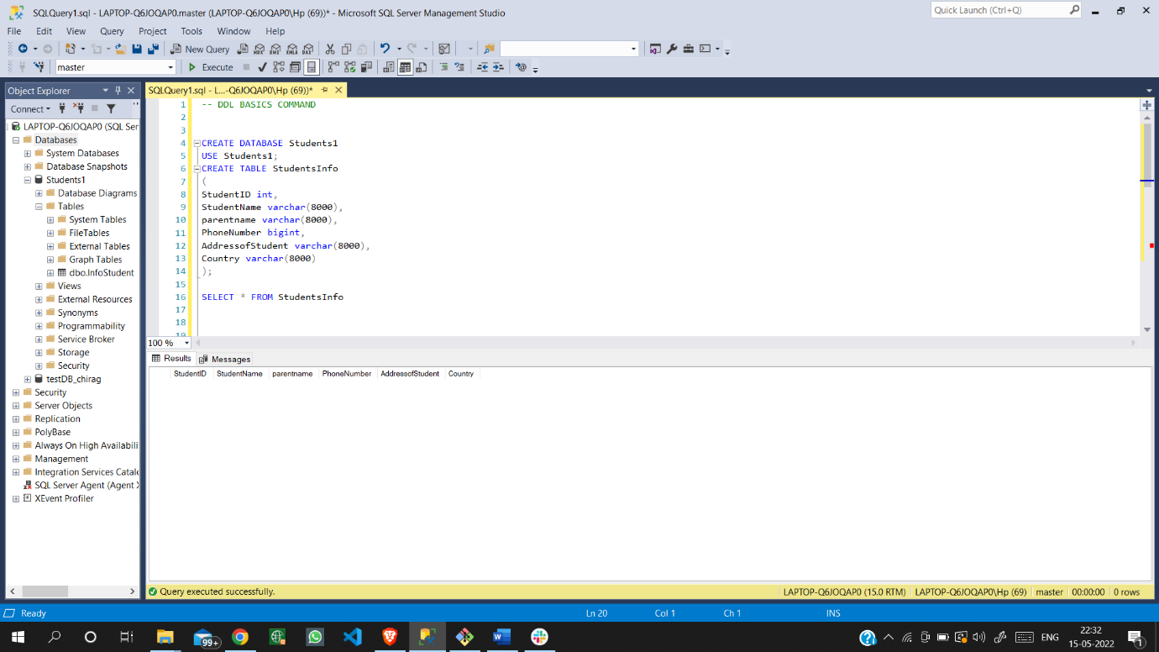

•ALTER TABLE StudentsInfo AND SELECT * FROM StudentsInfo 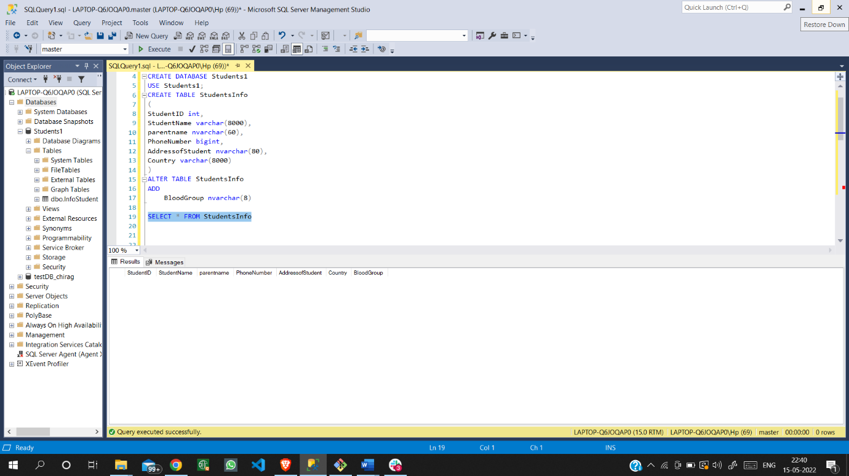

• INSERT TABLE StudentsInfo AND SELECT * FROM StudentsInfo

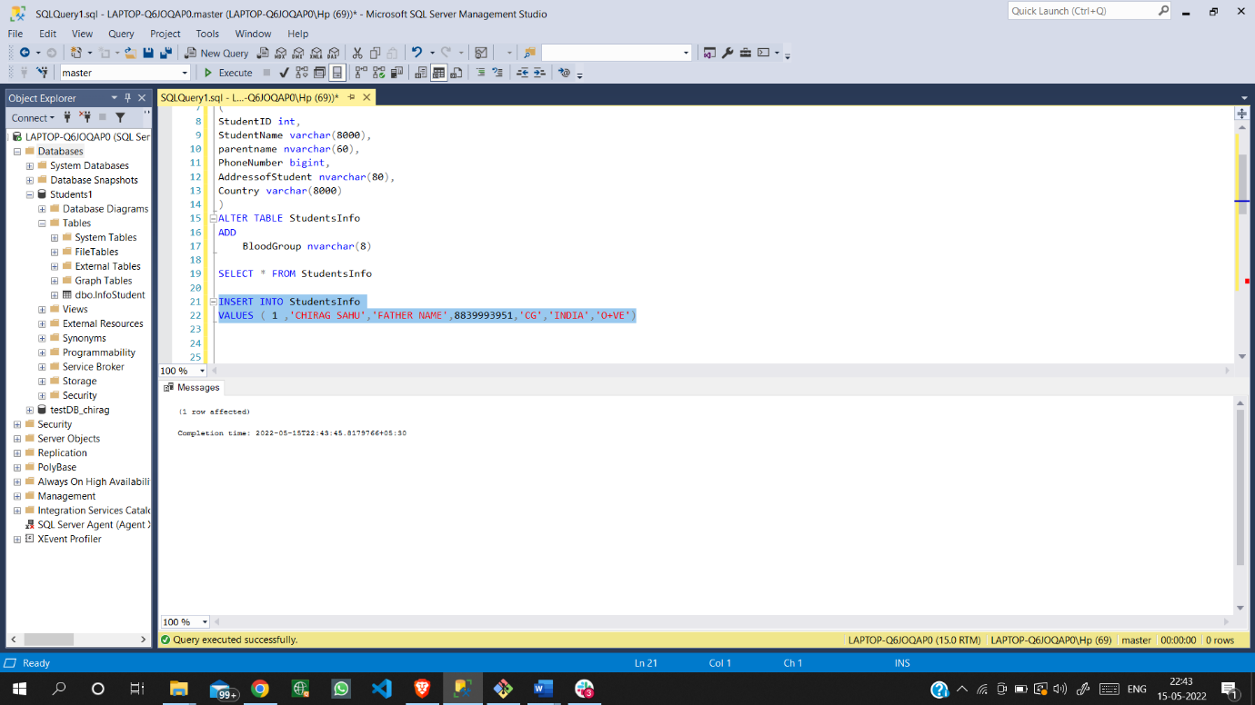

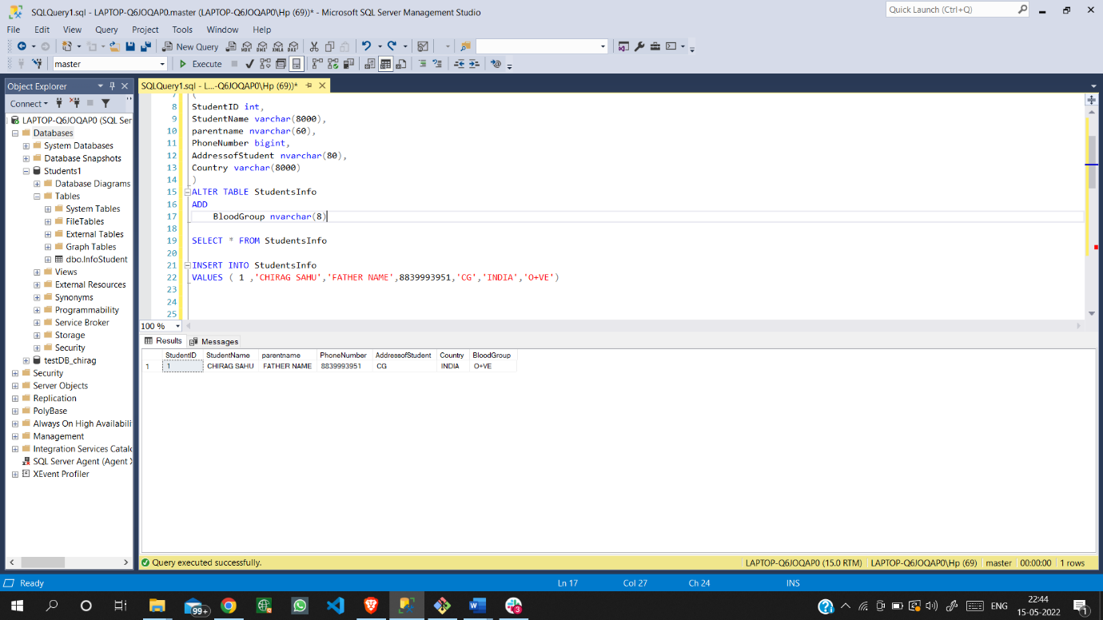

• Update Table StudentsInfo

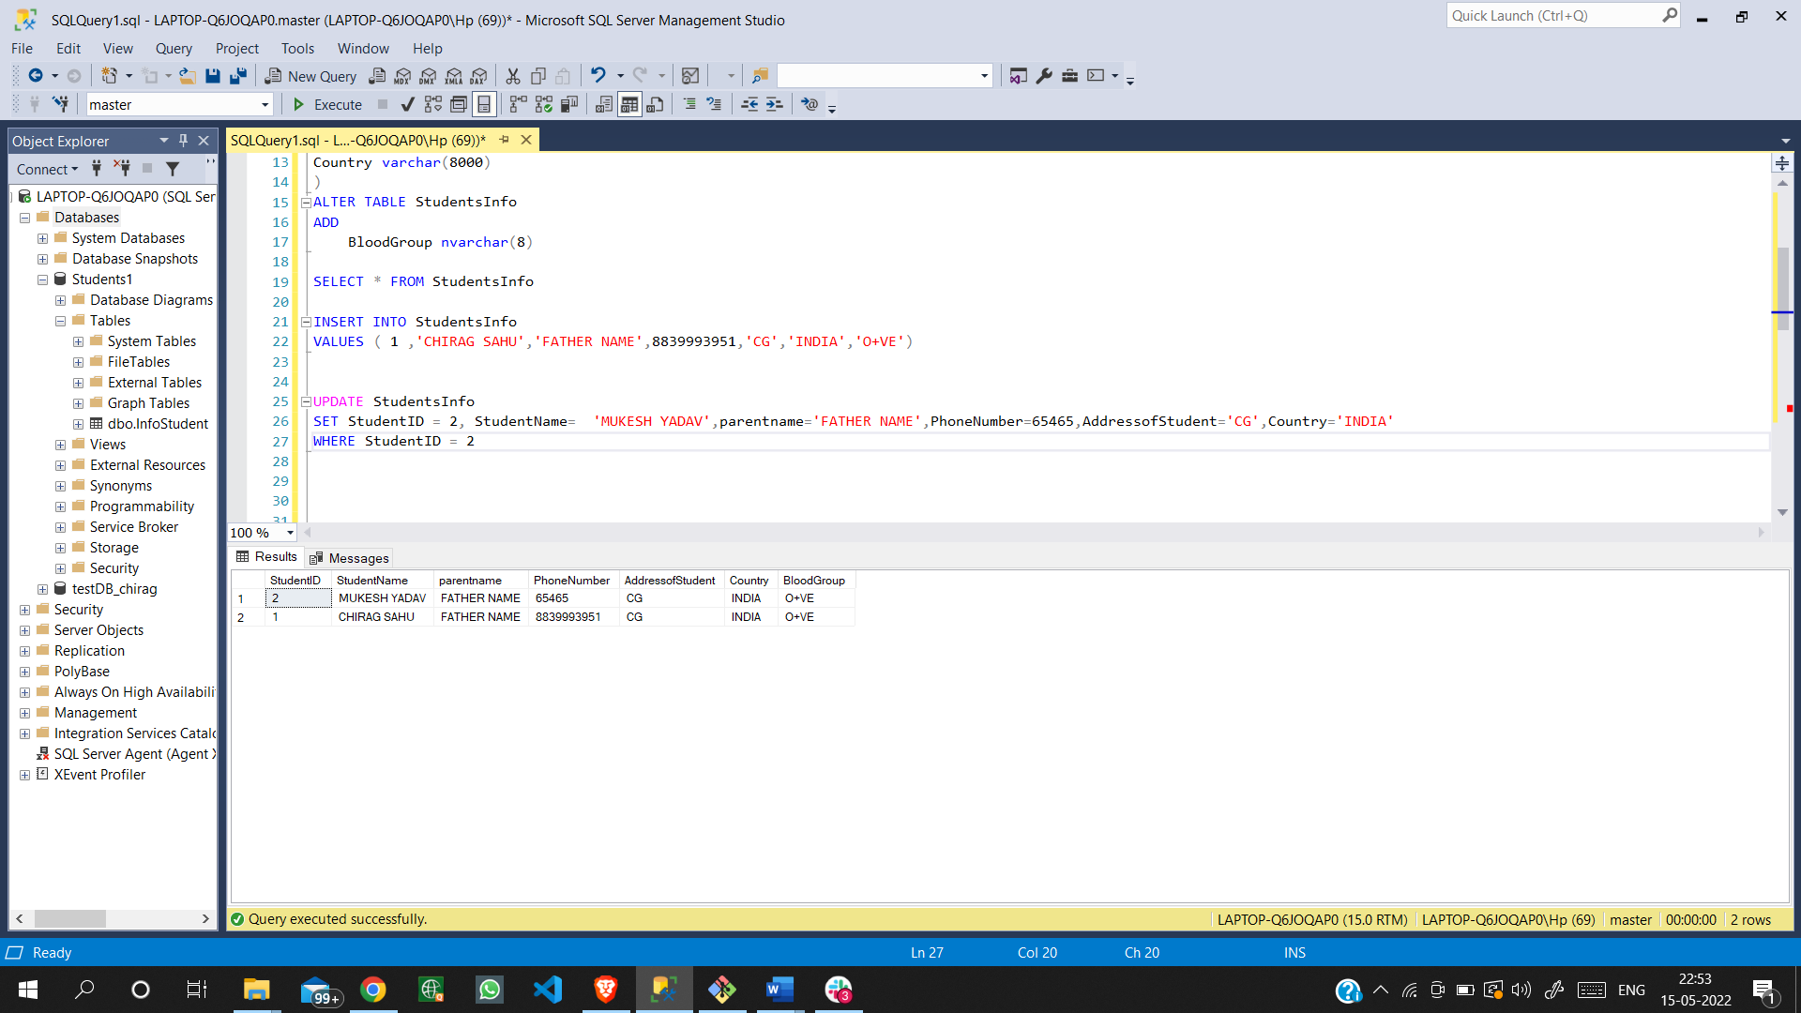

• Delete Table StudentsInfo

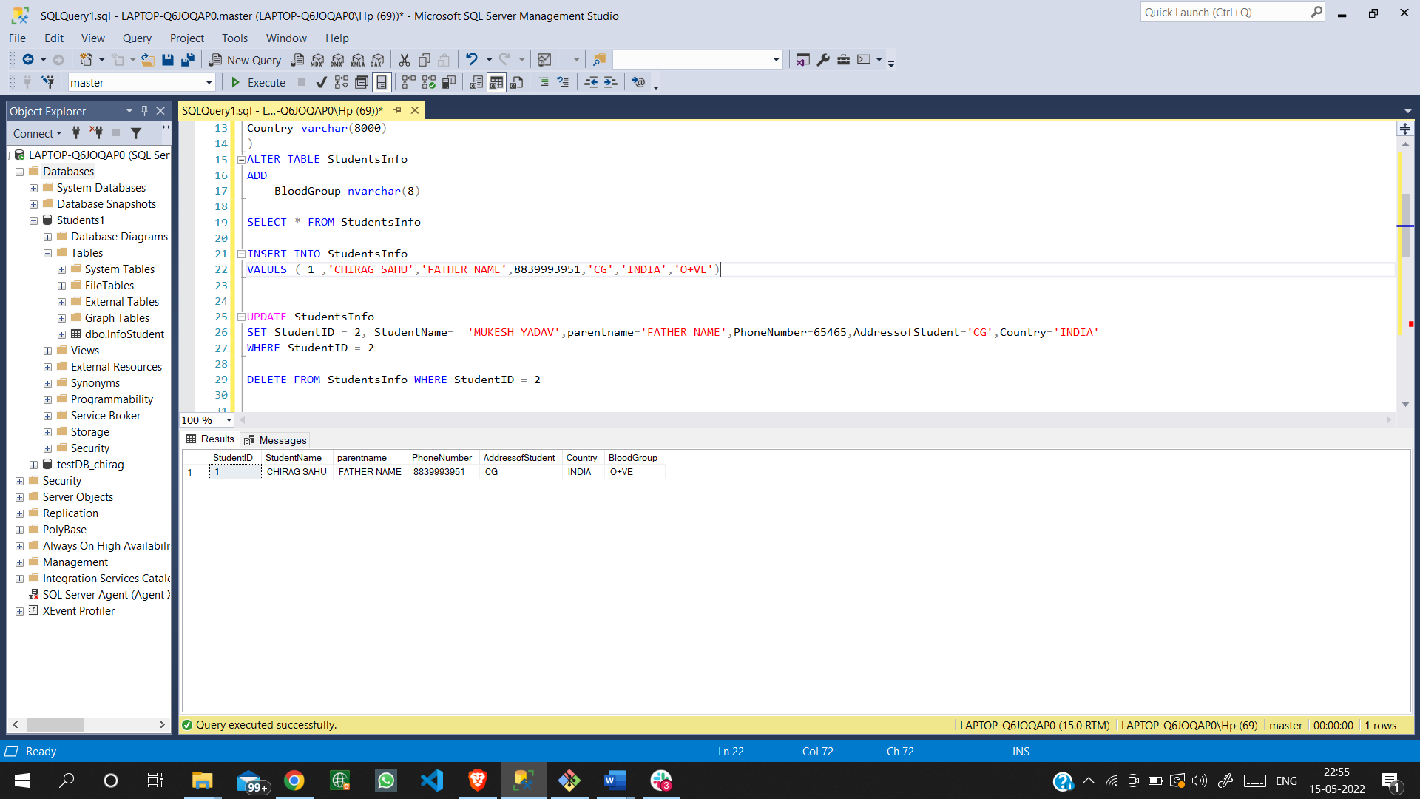

**SQL Join (Inner, Left, Right and ull Joins) :**

SQL Join statement is used to combine data or rows from two or more tables based on a common field between them. Different types of Joins are as follows:

1. INNER JOIN
2. LEFT JOIN
3. RIGHT JOIN
4. Inner Join:

The INNER JOIN keyword selects all rows from both the tables as long as the condition is satisfied. This keyword will create the result-set by combining all rows from both the tables where the condition satisfies i.e value of the common field will be the same.

1. Left Join:

This join returns all the rows of the table on the left side of the join and matches rows for the table on the right side of the join. For the rows for which there is no matching row on the right side, the result-set will contain null. LEFT JOIN is also known as LEFT OUTER JOIN.

1. Right Join:

RIGHT JOIN is similar to LEFT JOIN. This join returns all the rows of the t able on the right side of the join and matching rows for the table on the left side of the join. For the rows for which there is no matching row on the left side, the result-set will contain null. RIGHT JOIN is also known as RIGHT OUTER JOIN.