**SQL Join (Inner, Left, Right and ull Joins) :**

SQL Join statement is used to combine data or rows from two or more tables based on a common field between them. Different types of Joins are as follows:

1. INNER JOIN
2. LEFT JOIN
3. RIGHT JOIN
4. Inner Join:

The INNER JOIN keyword selects all rows from both the tables as long as the condition is satisfied. This keyword will create the result-set by combining all rows from both the tables where the condition satisfies i.e value of the common field will be the same.

1. Left Join:

This join returns all the rows of the table on the left side of the join and matches rows for the table on the right side of the join. For the rows for which there is no matching row on the right side, the result-set will contain null. LEFT JOIN is also known as LEFT OUTER JOIN.

1. Right Join:

RIGHT JOIN is similar to LEFT JOIN. This join returns all the rows of the t able on the right side of the join and matching rows for the table on the left side of the join. For the rows for which there is no matching row on the left side, the result-set will contain null. RIGHT JOIN is also known as RIGHT OUTER JOIN.

* Create database name as employee and table as EMPLOYEE

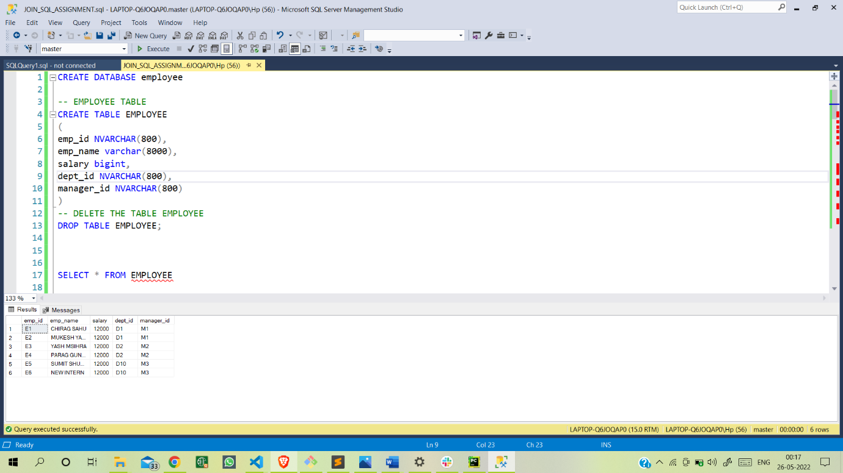

* INSERT parameters in EMPLOYEE table:-

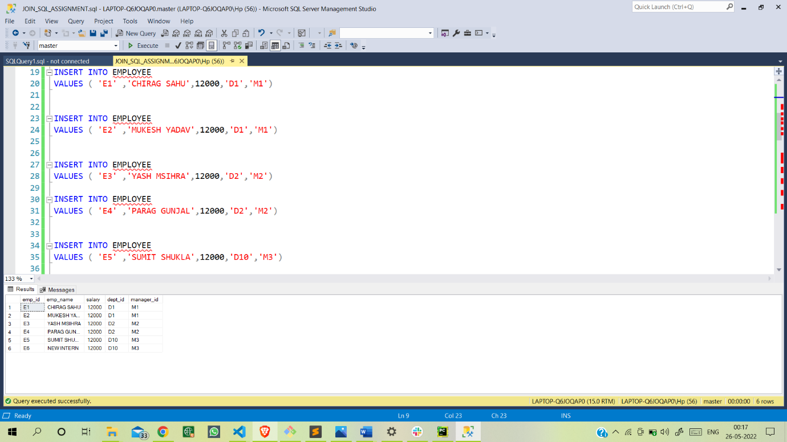

* CREATE a table named as DEPARTMENT and INSERT parameters in the table:-

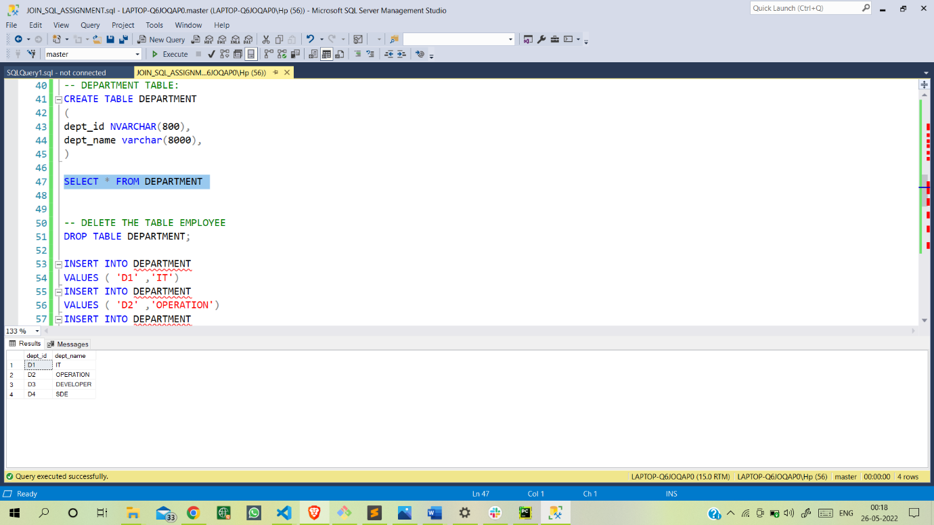

* Fetch the employee name and the department name they belong to

**INNER JOIN/ JOIN :-**

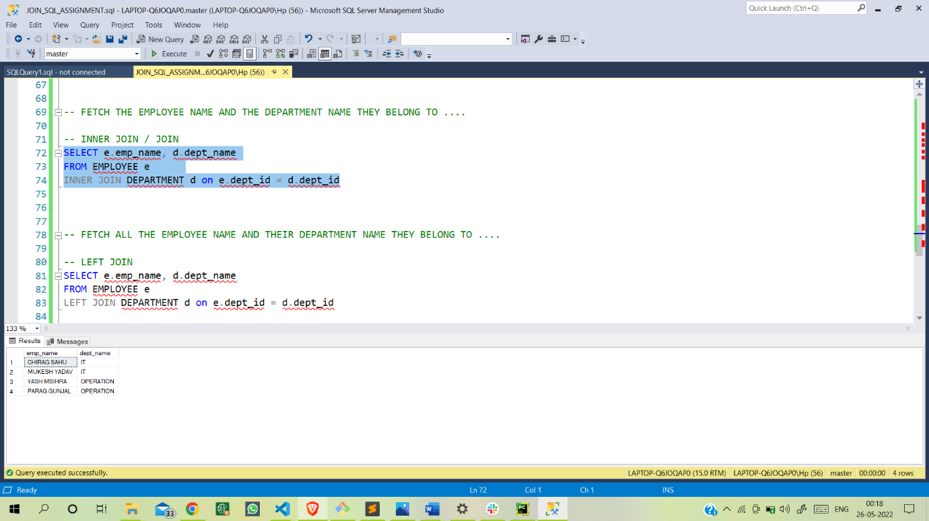

* Fetch all the employee name and their department name they belong to

**LEFT JOIN**:-

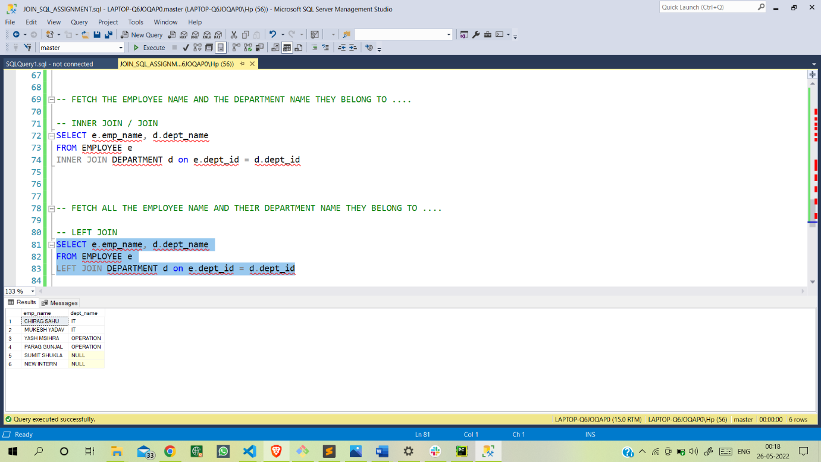

* **RIGHT JOIN:-**

