Ghost AI — MVP Product Requirement Document
Document version: MVP-1.0 Scope: Live Demo Only Stack locked: Vite · React Flow · Yjs · Express · Claude claude-sonnet-4-6

1. Product Context & Problem Statement

The Problem
When engineers and architects need to sketch a system design today, they jump between disconnected tools — Lucidchart for diagrams, Figma for wireframes, Notion for notes, and Slack for discussion. None of these tools understand software architecture natively. None allow an AI to actively participate in the design. And critically, none give multiple team members a single shared canvas where they can see each other’s thinking appear in real time.
The result: hours are spent dragging boxes and drawing arrows instead of thinking about the actual system. Architecture discussions happen asynchronously, diagrams fall out of date, and the gap between “what we discussed” and “what we built” widens.

The MVP Solution
Ghost AI is a shared, living architecture canvas where AI and humans co-design systems together — in the same room, at the same time.
The Analogy: Imagine Google Docs — but instead of typing text collaboratively, your team draws architecture diagrams together on a shared infinite canvas. And instead of staring at a blank whiteboard, you simply describe your system in plain English. An AI instantly sketches the architecture for you — nodes, connections, labels — and every teammate sees it materialise on their screen at the exact same moment. No refresh. No file upload. No version mismatch.

2. MVP Scope Boundaries: What vs. How

Core MVP Scope
The live demo demonstrates exactly two capabilities.
Capability 1 — Prompt to Architecture Generation
A user types a plain-English system description into the sidebar. The backend sends this to Claude (claude-sonnet-4-6) using structured tool calling. Claude responds by invoking add_node, add_edge, and finalize_design tools, producing a typed JSON payload of nodes and edges. These are written into the shared Yjs document and rendered live on the canvas for all connected users simultaneously.
Capability 2 — Real-Time Multiplayer Canvas
Two or more browser tabs sharing the same ?room= URL parameter are connected to a shared Yjs CRDT document over WebSocket. Node positions, AI-generated edges, and live cursor positions (with colour-coded avatars and user names) are all synchronised in real time across every connected client with zero manual refresh.

Scope Exclusions
The following are explicitly out of scope for the MVP demo and must not be built or implied during the presentation.
Excluded Feature | Reason Deferred
User authentication / login | No user accounts needed for a room-based demo
Data persistence (database) | Canvas lives in memory only; resets on server restart
Architecture lint / suggestion rules | Requires deterministic rule engine — post-MVP layer
Load simulation slider | UI complexity not needed for demo story
Scaffold / code export | Requires template system — separate workstream
Streaming node-by-node animation | Full generation is fast enough for demo
Inline node label editing | UX polish; not critical to demo the core loop
Room history / session undo | Requires event sourcing — post-MVP

3. Comprehensive Tech Stack & Library Rationalization
Layer | Technology | Role in MVP | Why This Choice
Frontend Framework | Vite + React 18 + TypeScript | SPA shell, component tree, strict typing | Vite gives sub-second HMR critical for demo iteration. TypeScript catches shape mismatches between AI output and canvas types at compile time. Chose over Next.js — zero SSR need, pure client canvas app.
Styling | TailwindCSS v4 | Dark-theme UI, layout, spacing | Zero-config via @tailwindcss/vite plugin. Design tokens live in index.css as CSS custom properties.
Canvas Engine | @xyflow/react (React Flow) | Renders nodes, edges, zoom/pan, resize handles, connection handles | Purpose-built for interactive node-edge diagrams. Handles SVG edge routing, drag, multi-select, and zoom out of the box. Chose over D3.js (too low-level, requires manual React bridging) and Cytoscape.js (not React-native, heavier bundle).
CRDT Sync | Yjs | Shared document state — Y.Map for nodes, Y.Map for edges | Yjs resolves concurrent edits automatically via CRDT merge without a conflict-resolution server. Chose over plain WebSocket broadcasting because CRDT handles reconnects and out-of-order updates gracefully.
WebSocket Transport | y-websocket | Connects Yjs documents across browser clients | Drop-in WebSocket provider for Yjs. Runs as a server module (setupWSConnection) on the backend and as a WebsocketProvider on the client.
Presence & Cursors | Yjs Awareness Protocol | Broadcasts ephemeral cursor X/Y, user name, and colour | Built into Yjs — no separate pub/sub needed. Awareness data is never written to the CRDT document, so cursor noise never pollutes canvas state.
Backend Server | Express + Node.js | Single process: hosts /api/generate HTTP route + WebSocket upgrade handler | One server on port 3001 handles both AI requests (HTTP POST) and Yjs sync (WebSocket). Chose over Fastify for simplicity and team familiarity.
LLM | Anthropic Claude claude-sonnet-4-6 (tool calling) | Generates typed node + edge JSON from a plain-English prompt | Claude’s tool-use API lets the model call add_node, add_edge, and finalize_design as structured functions — no regex parsing of free text needed. Chose over GPT-4o and Gemini for best-in-class structured tool-calling reliability.
HTTP Proxy | Vite dev proxy | Forwards /api to http://localhost:3001 and /yjs to ws://localhost:3001 in development | Eliminates CORS issues in dev. Frontend uses relative paths that work identically in dev and production.

4. Technical Architecture & Internal Working Logic

System Architecture Diagram
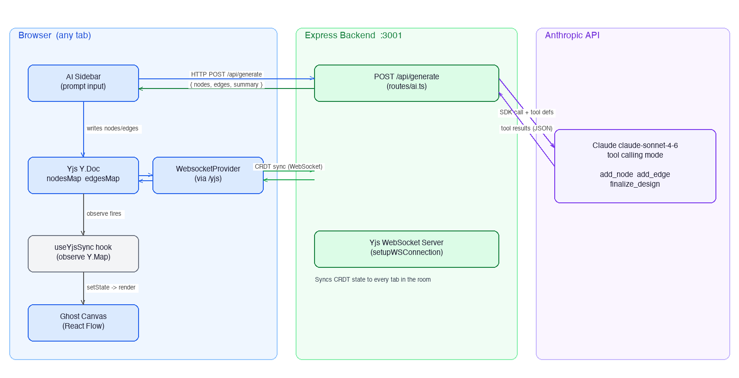
System Architecture
The diagram above shows how the three layers of Ghost AI interact. The browser holds both the AI Sidebar (which triggers generation via HTTP) and the Ghost Canvas (which renders from Yjs state). The Yjs WebsocketProvider connects to the backend’s Yjs WebSocket server, maintaining a live CRDT-synced shared document. The backend’s AI route independently calls the Anthropic API and returns structured node/edge data to the frontend, which then writes it into Yjs to propagate to all connected tabs.

Understanding the System Architecture — A Plain-English Walkthrough
The system is split into three distinct zones, each with a clear responsibility. Here is exactly what each zone does and how they talk to each other.
Zone 1 — The Browser (what every user sees and interacts with)
Think of the browser as the cockpit. Everything the user touches lives here. There are five moving parts inside the browser:
- AI Sidebar is the input panel on the right side of the screen. This is where the user types their system description (e.g. “Design an e-commerce backend”) and hits Generate. It is purely responsible for collecting the user’s prompt and sending it to the backend. When the response comes back, it hands the generated nodes and edges over to the shared state layer.
- Yjs Y.Doc is the single source of truth for the entire canvas. Think of it as a shared Google Doc that lives inside every browser tab simultaneously. It holds two key data structures: a map of all nodes (the boxes on the canvas) and a map of all edges (the arrows connecting them). Any time something changes — whether triggered by the AI or by a user dragging a node — this is where the change is recorded first.
- WebsocketProvider is the communication bridge. It is permanently connected to the backend over a WebSocket connection (a live, always-open channel — like a phone call that stays open rather than a one-off text message). Its entire job is to keep the Y.Doc in sync with every other browser tab in the same room. When the Y.Doc changes in one tab, the WebsocketProvider immediately sends that change to the backend, which relays it to all other tabs.
- useYjsSync hook is the translator between the shared Yjs state and what React Flow can actually render. React Flow needs nodes and edges in a specific JavaScript format. This hook watches the Y.Doc for any changes and whenever something is added or moved, it converts the Yjs data into that format and updates the React component state. This triggers React to re-render the canvas automatically.
- Ghost Canvas (React Flow) is the visual drawing board the user sees. It renders all the nodes as styled boxes and all the edges as arrows between them. It also handles user interactions — drag to move a node, scroll to zoom in and out, click to select. When the user drags a node, that position change goes back into the Y.Doc, which then syncs to every other tab.
Zone 2 — The Express Backend (the brain and the relay station)
The backend runs a single Node.js process on port 3001 and handles two completely separate responsibilities:
- POST /api/generate is a standard HTTP endpoint — the same kind of request a browser makes when you submit a form. When the AI Sidebar sends the user’s prompt here, this route picks it up, builds a detailed instruction for Claude (including the rules for what kinds of nodes and edges to create), and calls the Anthropic API. Once Claude responds with the list of nodes and edges, this route packages them into a clean JSON response and sends it back to the browser. Its job ends there — it does not touch the canvas or the real-time sync layer at all.
- Yjs WebSocket Server runs alongside the HTTP route on the exact same port but handles WebSocket connections (the always-open live channels). Its job is purely routing and relaying: when Tab A’s WebsocketProvider sends a canvas update, this server receives it and immediately broadcasts it to every other tab connected to the same room. It also manages room membership — it knows which tabs are in which room and ensures updates only go to the right audience. Critically, this component never looks at the AI output. It only cares about CRDT updates coming from connected browsers.
Zone 3 — The Anthropic API (the intelligence layer)
Claude claude-sonnet-4-6 is the AI model that does the actual architecture thinking. It receives the user’s prompt along with a set of tool definitions — specifically three tools it is allowed to call: add_node (to create a labelled box with a shape and colour), add_edge (to draw a directed arrow between two nodes), and finalize_design (to signal it is done and provide a summary).
Rather than returning a block of free text that the backend would have to parse and guess at, Claude responds by calling these tools with structured, typed data. For example, to create an API Gateway node it calls add_node({ id: "api-gateway", label: "API Gateway", shape: "rectangle", color: "#3b82f6" }). The backend simply collects all these tool call results and assembles them into a clean list of nodes and edges. This structured approach is what makes the output reliable and consistent — there is no guessing, no regex, no parsing errors.
How the three zones connect — the two data paths
There are two completely independent data paths in this system, and understanding that separation is the key to understanding the whole architecture:
Path 1 — The AI Generation Path (one-time request/response)
User types prompt → AI Sidebar sends HTTP POST to the backend → Backend calls Claude → Claude returns structured node/edge data → Backend sends JSON response back to the AI Sidebar → AI Sidebar writes the nodes and edges into the Yjs Y.Doc → WebsocketProvider detects the Y.Doc change and sends a sync update to the backend’s WebSocket server → WebSocket server broadcasts it to every other tab in the room → Every tab’s Y.Doc updates → useYjsSync hook converts the update to React state → Ghost Canvas re-renders with the new nodes and edges.
Path 2 — The Live Collaboration Path (always-on sync)
Any time a user manually drags a node on the canvas → React Flow calls onNodesChange → useYjsSync writes the new position into the Y.Doc → WebsocketProvider detects the change and sends it to the WebSocket server → WebSocket server broadcasts it to every other tab → Their Y.Docs update → Their canvases re-render showing the node in its new position.
The key insight: The AI Sidebar and the Ghost Canvas never talk to each other directly. They both go through the Yjs Y.Doc in the middle. This means AI-generated content and human edits are treated identically by the sync system — both are just changes to a shared document. This is what makes it possible for multiple people to generate and edit simultaneously without conflicts.

Internal Data Flow — AI Generation Trigger
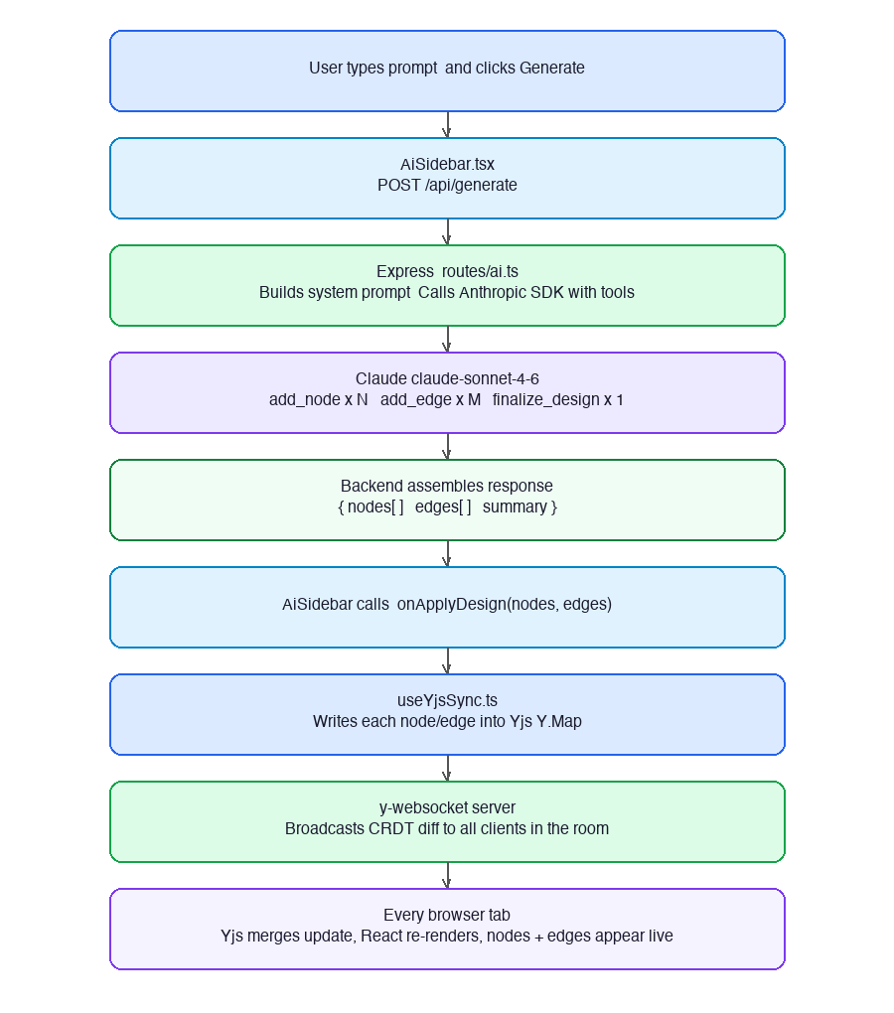
AI Generation Data Flow
The flow above traces exactly what happens from the moment a user clicks Generate to the moment nodes appear on every connected screen. The critical insight is the final step: the frontend does not broadcast directly to other tabs. It writes to Yjs, and the CRDT layer handles propagation — this is what makes conflict-free simultaneous edits possible.

4b. Library Deep-Dive — Why Each One, How Each One Works

React Flow (@xyflow/react)
What is it?
A React library specifically built for drawing interactive node-and-edge diagrams — think flowcharts, architecture maps, workflow builders.
What problem does it solve?
Drawing boxes and arrows sounds simple but is genuinely hard. You need to handle: infinite canvas with pan and zoom, SVG paths that curve between boxes, drag-to-move, resize handles, click selection, multi-select, connection handles that appear on hover. Building all of that from scratch would take weeks. React Flow gives you all of it in one import.
How it works internally:
It renders an SVG layer (for edges and arrows) sitting on top of a div layer (for nodes and boxes). Every node you give it is a React component — so your node boxes are just regular React components with custom styling. The pan and zoom is handled via CSS transforms on a wrapper div. When you drag a node, React Flow fires an onNodesChange callback with the new position — you decide what to do with that (in our case, we write it to Yjs).
Why React Flow and not alternatives?
Alternative | Why Not
D3.js | Extremely powerful but completely imperative. You would be fighting React’s rendering model the entire time. Not React-native.
Cytoscape.js | Good library but designed for graph analysis, not interactive UI. Heavy bundle, not React-native.
Konva / plain Canvas API | You would be building the entire interaction model yourself from zero.
Where exactly it lives in Ghost AI:
GhostCanvas.tsx is the React Flow instance. It receives nodes and edges as props from useYjsSync, renders them, and fires onNodesChange and onEdgesChange when the user interacts. That is its entire job — render and report interactions.

Yjs
What is it?
A CRDT (Conflict-free Replicated Data Type) library. In plain English: a special kind of shared data structure that multiple people can edit at the same time, and it automatically figures out how to merge everyone’s changes without conflicts — even if two people edit the same thing simultaneously, even if someone goes offline and comes back.
What problem does it solve?
Imagine two people editing a Google Doc simultaneously. If Person A types “Hello” and Person B types “World” at the same time, how does the system know the final result should be “Hello World” and not “WorldHello” or just one of them overwriting the other? That merge logic is the hard part. Without a smart sync system, you either get data corruption, or you need a central server that acts as a referee and locks things while someone is editing — like old-school document locking.
Yjs solves this at the data structure level. Every change is represented as an operation with a unique ID and a logical timestamp. When two operations conflict, Yjs has a deterministic rule for resolving them — and every client applies the same rule and arrives at the same result. No server referee needed.
How it works internally:
Yjs gives you special data types — Y.Map, Y.Array, Y.Text — that behave like normal JavaScript objects but secretly track every change as a tiny log entry called an “update.” When you change a Y.Map, Yjs records what changed and assigns it a Lamport timestamp (a logical clock, not a wall clock). When two clients sync, they exchange their update logs. Yjs merges them by replaying all operations in a consistent order. The result is always identical on every client — this is the mathematical guarantee of CRDTs.
Why we need this specifically in Ghost AI:
The canvas is a shared document — multiple people see it, multiple people edit it. When User A drags a node and User B also moves a node at the same moment, we need both changes to appear on both screens without one overwriting the other. Without Yjs, you would have to build a complex conflict resolution system yourself. With Yjs, you just write to a Y.Map and the library handles the rest.
We use two Y.Map instances — nodesMap and edgesMap. Every node on the canvas is an entry in nodesMap. When the AI generates nodes, we write them into nodesMap. When a user drags a node, we update its position in nodesMap. Yjs tracks all of this and syncs it everywhere.
Why Yjs and not alternatives?
Alternative | Why Not
Plain WebSocket broadcasting | Works fine until two people edit simultaneously. You would need to write your own merge logic. Also, if someone disconnects and reconnects, they miss changes that happened while offline.
Automerge | Another CRDT library, also excellent. Yjs is faster, has a smaller bundle size, and has a better ecosystem (y-websocket, y-indexeddb, etc. are all built for it).
Firebase / Supabase Realtime | Managed services that handle sync for you, but require accounts, API keys, and introduce external dependencies. Yjs runs entirely on your own infrastructure.
Operational Transformation (OT) | The older approach used by Google Docs. More complex to implement correctly, requires a central server to order operations. CRDTs like Yjs are mathematically simpler and server-independent.

y-websocket
What is it?
Two things in one package:
- A server module (setupWSConnection) — a plug-in you add to any Node.js WebSocket server. It manages rooms, receives Yjs update messages from connected clients, and broadcasts them to everyone else in the same room.
- A client module (WebsocketProvider) — runs in the browser. It connects to that server, listens for incoming Yjs updates, applies them to the local Y.Doc, and sends local updates out when the local Y.Doc changes.
What problem does it solve?
Yjs itself is just a smart data structure — it knows how to merge changes, but it has no opinion on how those changes travel between computers. It needs a transport layer. y-websocket is that transport layer. It is the pipe that carries Yjs update packets between browsers through your backend server.
Why WebSocket specifically and not regular HTTP?
Regular HTTP is request-response — the browser asks, the server answers, the connection closes. To get updates from the server you would have to keep polling (“any new changes?”) every second. That is slow, wasteful, and introduces visible lag.
WebSocket is a persistent, full-duplex connection — once established, both the browser and the server can send messages to each other at any time, instantly. It stays open for the lifetime of the session. When User B moves a node, the update travels over this open pipe to the server and immediately out to User A’s open pipe — no polling, no waiting.
How it works inside Ghost AI step by step:
- When the app loads, WebsocketProvider opens a WebSocket connection to ws://localhost:3001/yjs
- The Express backend sees this WebSocket upgrade request and calls setupWSConnection(ws, req)
- This registers the client into a room based on the URL parameter (e.g. room=abc123)
- When User A’s Y.Doc changes — say, a new node was written — Yjs encodes that change as a compact binary update
- WebsocketProvider sees the change and sends it as a WebSocket message to the server
- setupWSConnection receives it, looks up all other clients in room abc123, and forwards the binary update to each of them
- Their WebsocketProvider receives it and feeds it into their local Y.Doc
- Yjs applies the CRDT merge, the Y.Map fires its observe callback, useYjsSync converts the new state into React state, React re-renders, the canvas updates
This entire chain — from one user moving a node to another user seeing it move — takes under 50 milliseconds on a local network.
Why y-websocket and not alternatives?
Alternative | Why Not
Socket.io | Popular but adds its own protocol layer on top of WebSocket. Yjs has its own binary protocol. Mixing them adds unnecessary complexity.
Liveblocks / PartyKit | Managed multiplayer services. They work great but you are paying for and depending on an external service. y-websocket runs on your own server with zero external dependencies.
y-webrtc | Uses peer-to-peer connections between browsers directly with no server in the middle. Works for small groups but does not scale — every new peer needs a direct connection to every other peer. Also unreliable in corporate network environments with firewalls.

How the three work together — the complete end-to-end sequence
React Flow handles the rendering. Yjs handles the state. y-websocket handles the transport. Each does exactly one job. None of them could replace another. Here is the exact sequence when User A generates an architecture and User B sees it appear on their screen:
- User A clicks Generate → AiSidebar POSTs the prompt to the Express backend
- Backend calls Claude → Claude returns structured nodes and edges as JSON
- AiSidebar receives the JSON and calls addNodes(nodes) and addEdges(edges)
- useYjsSync.addNodes() creates a new Y.Map for each node and sets it in nodesMap — this is a Yjs write operation
- Yjs encodes this change as a binary update packet
- y-websocket’s WebsocketProvider detects the Y.Doc changed, takes the binary update, and sends it as a WebSocket message to the backend
- y-websocket’s setupWSConnection on the backend receives this message, looks up all other clients in the same room, and forwards the binary update to each of them
- User B’s WebsocketProvider receives the binary update and feeds it to their local Y.Doc
- Yjs applies the CRDT merge to User B’s nodesMap — now both nodesMap instances are identical
- The nodesMap.observe() callback fires in User B’s useYjsSync hook
- useYjsSync reads the updated nodesMap, converts it to a CanvasNode[] array, and calls setNodes()
- React Flow re-renders with the new nodes — they appear on User B’s canvas

5. End-to-End User Journey — The Demo Walkthrough
Setup: Two laptops, both open to http://localhost:5173?room=abc123. Both show the same empty dark canvas. The navbar on both screens shows 2 avatar circles confirming both users are connected.

Step 1 — Room Entry
User A opens the app. No login prompt appears. The URL auto-generates a ?room= parameter (e.g. ?room=88z61ux). User A copies the URL and shares it with User B. User B opens it. The navbar on both screens now shows 2 avatar circles and the count 2 — confirmed connected via Yjs Awareness.

Step 2 — Live Cursor Presence
User B moves their mouse across the canvas. User A immediately sees a colour-coded cursor labelled with User B’s generated display name (e.g. “Calm Hawk”) tracking across their screen in real time. No page refresh. No polling. The Yjs Awareness Protocol broadcasts ephemeral cursor state over WebSocket at every mouse move event.

Step 3 — AI Architecture Generation
User A opens the Ghost AI sidebar (top-right button). They click the starter chip “Design an e-commerce backend.” User A clicks Generate. The sidebar shows a typing indicator. In the background:
- The frontend POSTs { prompt: "Design an e-commerce backend" } to /api/generate
- The backend calls Claude claude-sonnet-4-6 with tool definitions for add_node, add_edge, and finalize_design
- Claude responds by invoking those tools, producing 8–12 nodes (Client App, API Gateway, Auth Service, Product Service, Order Service, Payment Gateway, PostgreSQL, Redis Cache) and 10–14 directed edges

Step 4 — Canvas Populates on Both Screens Simultaneously
The backend returns the complete { nodes, edges } JSON. The frontend writes them into Yjs Y.Maps. The y-websocket server immediately broadcasts the CRDT diff to all clients in room abc123.
- User A’s screen: nodes and edges appear on the canvas
- User B’s screen: the exact same nodes and edges appear at the exact same moment — without User B having clicked anything
This is the central demo moment: AI-generated architecture appearing live on a shared canvas for all collaborators.

Step 5 — Manual Collaboration
User B drags the “Redis Cache” node to a better position. User A sees it move in real time. User A drags the “PostgreSQL” node. User B sees it move. Both users are now actively editing the same canvas simultaneously with zero conflict — resolved automatically by Yjs CRDT merge semantics.

Step 6 — Second AI Generation
User B opens the sidebar on their screen. They type “Add a notification service.” They click Generate. New nodes (Notification Service, Email Provider, SMS Gateway) and connecting edges appear on both screens, appended to the existing architecture without overwriting anything.

Outcome
In under 3 minutes, two users have gone from a blank canvas to a detailed, collaboratively refined system architecture diagram — generated by AI, edited by humans, visible to everyone in the room, in real time.

