My Choice School



Ocean Pearl
Prospectus

2013 - 2014



Address

Head Office
Unit 3a Mill Green Industrial Estate
Mill Green Road
Haywards Heath
West Sussex
RH16 1XQ

Telephone: 01444 446920

Fax: 01444 446929

Email: a.murphy@my-choice-homes.com

Website: www.my-choice-homes.com

Headteacher

Annie Murphy BSc (Hons) PGCE
a.murphy@my-choice-homes.com

Proprietors

My Choice Children’s Homes Ltd
Unit 3a Mill Green Industrial Estate
Mill Green Road, Haywards Heath
West Sussex, RH16 1XQ

Telephone No. 01444 446920
Fax No. 01444 446929

School Type

Children’s home with education

School Details

Ocean Pearl

DCSF Registration Number: 938/6272

Teacher: James Thomas BSc PGCE

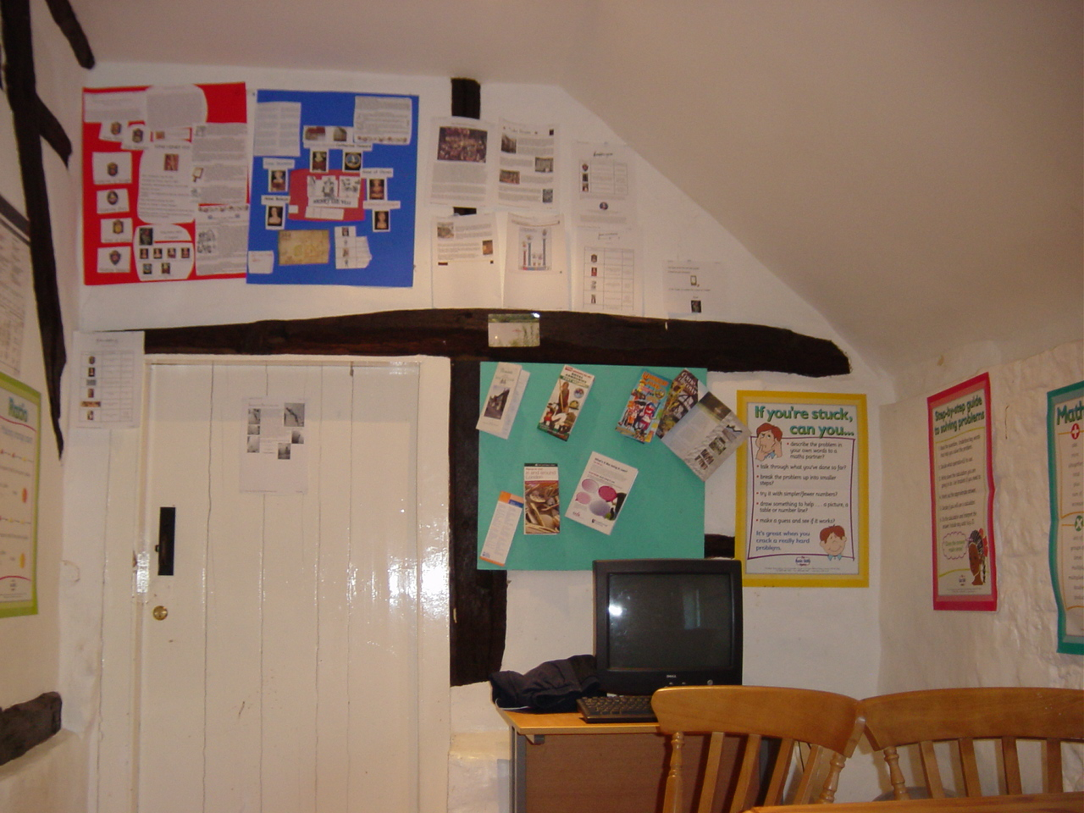
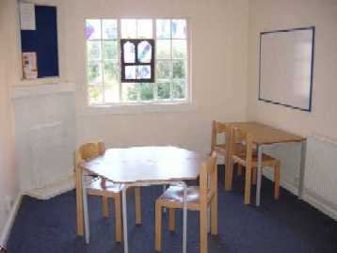

School Uniform

White polo shirt, sweatshirt or hooded top in student’s choice of pink or blue

School Times

9:00am – 12.00pm
1.00pm – 3:15pm

My Choice Term Dates 2013 to 2014

TERM | DATES
Autumn Term 2013 | 4thSeptember 2013 | to | 20th December 2013
Half Term | 28th October 2013 | to | 1st November 2013
Spring term 2014 | 7th January 2014 | to | 4th April 2014
Half term | 17th February 2014 | to | 21th February 2014
Summer Term 2014 | 22nd April 2014 | to | 23rd July 2014
Half Term | 26th May 2014 | to | 30th May 2014

Visiting Arrangements

Visits to the school locations and Head Office are welcome and must be arranged in advance with the Headteacher.

Ethos and Values

My Choice School views each student as an individual with potential to succeed. We concentrate on skills development and have a holistic approach to learning. We provide an individualised programme to suit the needs and abilities of each student. We aim to provide a safe environment in which each student can engage in positive activities, develop their social skills, establish a routine that complements their learning style where they can develop their basic skills and build the foundation on which further learning can take place.

Aims of the School

- To enhance self esteem of all students and promote positive behaviour.
- To develop achievement and skills in all students.
- To involve students and parents / carers in a holistic approach to education and build a successful partnership between home and school.
- To prepare students for adult life.
- To ensure that all Year 11 students achieve a place at post 16 provision or employment.

Admissions Policy

Our current admissions policy is that all students must meet the following criteria:

- Students must be resident at My Choice Children’s Homes.
- Students must be unable to access or sustain a place at either a mainstream school or any other type of school for children with emotional and behavioural difficulties.
- Assessment of student’s needs must indicate that they would benefit academically and socially from a teacher student ratio of 1:3.
- Assessment of student’s needs must indicate that they would benefit from working with the AQA unit award scheme.

Attendance

Attendance at school prepares our students for the world of work and regular attendance ensures continuity of learning. My Choice School and My Choice Children’s Homes Ltd promotes the education of our students and works together to ensure each student is supported in their attendance and punctuality.

All dental, medical and optical appointments must be made outside school time. All meetings where a student is required to attend must be made outside school time wherever possible and in consultation with the Headteacher.

Holidays during term time are not permitted.

School Organisation

The school has a Headteacher and one teacher who work with the care team to support and deliver the school day. The Headteacher has an office in the My Choice Children’s Homes Head Office and is responsible for all 8 My Choice Schools. The Headteacher visits each My Choice School and works closely with the Care Manager of each home. The Care Manager is based in the home/ school Monday to Friday 9am to 5pm and is responsible for the management of the home. The teacher is based in the school location Monday to Friday 9am to 5pm. The teacher will have a maximum of three students and will be supported during the school day by Residential Support Workers providing behaviour support where necessary and supervision on activities. During each school day there will be 3 Residential Support Workers available enabling 1:1 support and where appropriate 2:1 support.

Wherever possible students will be taught within a single year group or key stage however student groupings may sometimes necessitate teachers teaching students across key stage 3 and 4.

Details of staff qualifications (Headteacher, teacher, Care Manager and RSWs) are available from the Headteacher on request.

Curriculum

My Choice School uses the AQA Unit Award Scheme. The school curriculum delivers:

- Mathematics
- English
- Science
- History
- Geography
- Art, Craft and Design
- Cultural Studies
- Physical Education
- PHSE
- ICT
- Life Skills

All students follow the AQA unit award scheme (foundation, intermediate and higher level) as appropriate to their needs and abilities. Key Stage 4 students are encouraged to work toward higher level AQA Unit Award Scheme in all subjects and may also access work experience as appropriate.

ICT is used throughout the curriculum at My Choice School and each school location has access to a computer. Internet access is restricted and supervised at all times in accordance with our policy.

Community facilities are accessed for Physical Education and include swimming, gym, horse riding and badminton. Student numbers restrict opportunity for team games.

Educational visits are encouraged to support all areas of the curriculum both academically and socially.

Key Stage 4 Student Performance 2007 to 2008
Total Year 11 leavers: 1
Total positive outcomes: 1

One Year 11 student achieved a place at Brinsbury College on an Animal Care Course following a successful Year10 in which they made a successful transition to the Key Stage 4 engagement programme for an Animal Care course and completed work experience in animal care throughout Year 11.

Key Stage 4 Student Performance 2008 to 2009
Total Year 11 leavers: 1
Total positive outcomes: 1

One Year 11 student achieved a place at Chichester College on a BTEC Health and Social Care course following a successful transition to Chichester College (part time) in Year 11, achieving 1 GCSE in English and a distinction in foundation Health and Social Care.

Key Stage 4 Student Performance 2009 to 2010
Total Year 11 leavers: 1
Total positive outcomes: 1

One Year 11 student achieved a place at Brighton City College on a child care course.

One Year 10 student attended Brinsbury College in Spring and Summer 2010 on the horticulture Key Stage 4 engagement programme.

Key Stage 4 Student Performance 2010 to 2011
Total Year 11 leavers: 1
Total positive outcomes: 1

One Year 11 student completed a music technology technology course at DV8 training during Year 11 and achieved a place at Chichester College on a BTEC Performing Arts course.

Key Stage 4 Student Performance 2011 to 2012
Total Year 11 leavers: 1
Total positive outcomes: 1

One Year 11 student started a basic skills course at Asphaleia training during Year 11 and will be progressing to the Princes Trust

Key Stage 4 Student Performance 2012 to 2013
Total Year 11 leavers: 1
Total positive outcomes: 1

One Year 11 student obtained a place on a mechanic course at Feltham College.

School Expectations

- Mobile telephones, iPods and MP3s are not permitted during lesson time
- Students and staff will show value and respect towards each other
- Students and staff will listen to each other
- Students are expected to maintain a good standard of appearance and wear uniform
- Students will work to the best of their abilities and staff will recognise their efforts

Complaints Procedure

My Choice School is committed to the education and development of our students and encourages support and welcomes the views of parents and carers. We listen to the views of parents and carers in order to provide an opportunity to improve our service, learn from mistakes, offer solutions and provide clarification to concerns and complaints.

All concerns and complaints will be dealt with honestly, politely and in confidence and looked into thoroughly and fairly. We will endeavour to deal with concerns and complaints quickly and will keep parents and carers informed of progress and how we will deal with the concern or complaint.

Concerns should initially be raised informally with the student’s teacher or, in the event of the teacher being unavailable, with the Headteacher. If the response to the initial concern is not satisfactory a formal complaint in writing should be made to the Headteacher.

A full copy of the complaints policy and procedure is available from the Headteacher.

TERM | NUMBER OF COMPLAINTS RECEIVED
Autumn Term 2012 | 0
Spring Term 2013 | 0
Summer Term 2013 | 0

Discipline & Exclusions

My Choice School seeks to avoid permanent and fixed term exclusions from school by exercising alternatives to maintain inclusion and to support behaviour. Alternatives to exclusion include review of strategies to support students, adjusted timetables and fixed term internal exclusions. Full particulars of the My Choice School exclusion policy are available from the Headteacher.

The promotion of positive behaviour is essential to creating a safe and constructive learning environment. Rewards take precedence over sanctions in the promotion of behaviour; however, sanctions will be used if appropriate and will be in proportion to the incident. Sanctions are decided by the teacher and care team together. Details of forbidden and permitted sanctions and guidelines for behaviour management are included in the school behaviour policy.

Special Educational Needs

A child has a learning difficulty if he/she:-

- Has a significantly greater difficulty in learning than the majority of children the same age.
- Has a disability which either prevents or hinders the child from making use of the educational facilities of a kind provided for children of the same age within the area of the local education authority.

Supporting students with Special Education Needs
All teachers at My Choice School are responsible for students with Special Educational Needs in their classrooms. The provision for students with Special Educational Needs required the support of the whole school/home community. Besides creating a learning environment which is encouraging and sensitive to needs, we see education as more than academic performance. It is also about fostering qualities of independence, self advocacy, positive self-esteem and a respect for others.

To achieve this, some students may need extra support beyond what is considered the normal level of provision. Supporting students who have a wide range of Special Educational Needs requires a flexible use of support strategies. In My Choice School support may be offered in a variety of forms. These may include:

- In-class support – where an additional adult is available in the classroom to respond to the Special Educational Needs of students in that particular class.

- Small group teaching – where class sizes are no greater than 3 students.

My Choice School Policies

My Choice School has policies on:

- Assessment
- Special Educational Needs
- Curriculum
- IT and Internet use –students and staff
- Health and safety of students on educational visits
- Behaviour – including permitted and non permitted sanctions and positive handling strategies (TEAM TEACH)
- Anti Bullying
- Child Protection and Safeguarding
- Whistle blowing
- Complaints (including student complaints), including details of the number of complaints recorded under the formal procedure in the previous and current academic year.
- First aid
- Health and Safety
- Exclusions
- SMSC
- English as an additional language

Copies of all My Choice School policies and procedures are available for inspection at each school location and at Head Office and on request from the Headteacher, along with a list of all staff (teacher and RSWs) with a summary of their qualifications and any information on students’ academic performance.

