Statement of Purpose

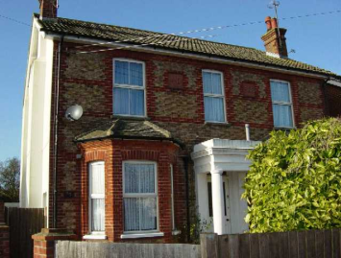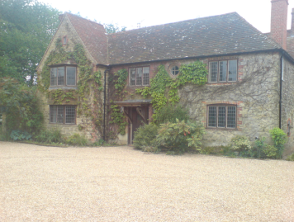

**Kestral House**

**Ofsted URN SC029865**

**Kingfisher View**

**Ofsted URN SC359832**

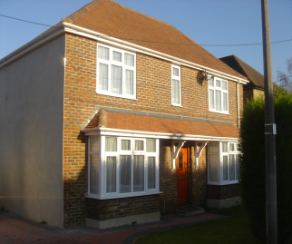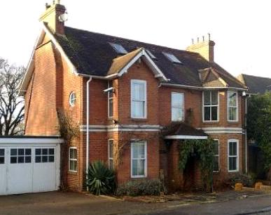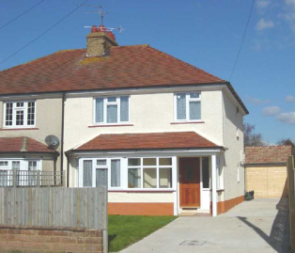

**Maple House**

**Ofsted URN SC364812**

**Ivy Cottage**

**Ofsted URN SC390785**

**Pebble House**

**Ofsted URN SC359812**

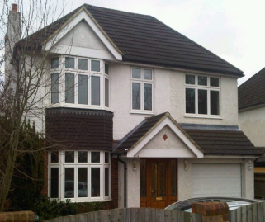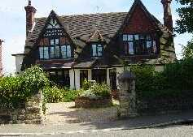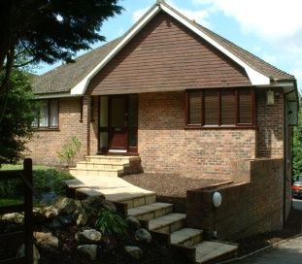

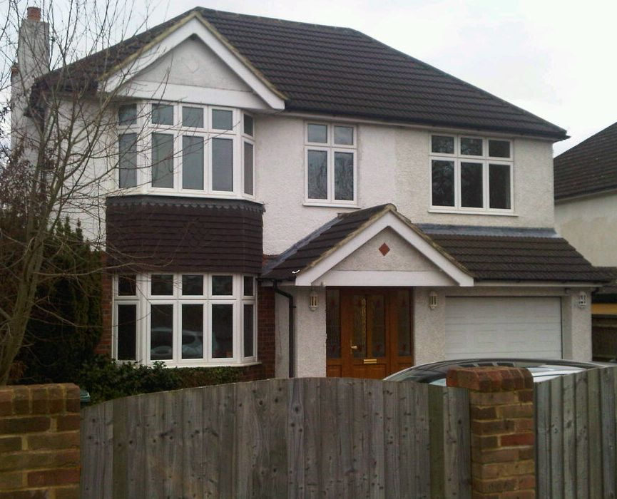

**Osprey House**

**Ofsted URN SC426530**

**Oak House**

**Ofsted URN SC064011**

**Ocean Pearl**

**Ofsted URN**

**SC014650**

**2014**



Table of Contents

Aims and Objectives 2

Facilities and Services 3

Registered Provider 5

Supervision, Training and Staff Development 9

Organisational Structure of the Homes 11

Staffing Policy 12

Client Group 16

Referrals and Admissions 17

Ethos and Philosophy 20

Promotion of Health 21

Education 22

Activities 24

Consulting with the Young People 25

Promoting Positive Behaviour & Relationships 26

Child Protection & Safeguarding 28

Bullying 29

Missing Child Policy 30

Fire Precautions 31

Meeting Cultural Needs 32

Young People's Religious Instruction & Observance 33

Contact with Parents, Relatives and Friends 34

Complaints 35

Reviewing Placement Plans 36

Accommodation 37

Therapeutic Intervention 41

Promoting Independence 42

Anti-discriminatory Practice & Children/Young People’s Rights 43

My Choice Senior Management 44

The National Minimum Standards (NMS) together with the regulations such as the Childrens Homes Regulations 2001 form the basis of the regulatory framework under the Care Standards Act 2000 (CSA) for the conduct of childrens homes providers.

Every Child Matters (ECM) legislation underpins the philosophy of My Choice’s policies and procedures with regards to; Being Healthy, Enjoying and Achieving, Economic Wellbeing, Staying Safe and Providing a Positive Contribution.

# Aims and Objectives

Our aim as a provider of needs led children’s homes is to ensure a safe and supported environment for young people to develop in, enabling them to deal with past and present difficulties.

It is our aim to provide a comfortable, safe, non-institutional environment for young people to begin to work towards a positive future. This may be staying long term with My Choice, rehabilitation into the family home or a foster placement. We will always work to support young people moving on into independent living.

We work closely with the young people to encourage and support them in planning and implementing their care plans. A Key Worker is provided for each young person. There is a commitment to identify their current needs as well as looking towards the future. This is incorporated in the Placement Plan, which outlines all areas as stated in Standard 11 of the Minimum National Standards for Children’s Homes. This standard states that children are welcomed into the home and leave the home in a planned and appropriate manner which makes them feel valued. My Choice aim to ensure this standard is met, through the completion of all the necessary documents in the home.

Our service seeks to provide an effective and supportive framework for young people who would otherwise be hard to place. We aim to achieve this by working in partnership with placing authorities and through joint working with the young person’s Social Worker. We believe open and constant communication between the home, the young person, the Social Worker and all other significant professionals is essential to ensure effective and safe childcare in addition to all other significant parties.

We appreciate that each young person brings with them their own unique life experiences and as such treat each as individuals, being very clear about their specific needs. It is our aim to look after the young person, not the perceived problem or behaviour. We will endeavour to meet the needs of the young person through our own internal resources or through consultation and working in partnership with their Social Worker, family and significant others.

The welfare and safety of the young people in our care is of paramount concern.

# Facilities and Services

Kestral House, Kingfisher View, Oak House, Ocean Pearl, Osprey House and Ivy Cottage are registered by Ofsted for three young people of mixed gender. Pebble House and Maple House are registered for two young people of mixed gender. All homes are registered for young people with emotional and behavioural difficulties. Registered age ranges are as follows:

* Oak House - 11 to 18 years
* Pebble House - 10 to 18 years
* Kestral House - 10 to under 18 years
* Ocean Pearl - 10 to under 18 years
* Osprey House - 10 to under 18 years
* Ivy Cottage - 10 to 17 years
* Kingfisher View - 10 to under 17 years
* Maple House - 8 to 18 years

The home may provide care and accommodation for children outside the specified age range in an emergency situation when notified and agreed by Ofsted.

The following outlines the services available to all the young people in our care:

* External Counsellors / Therapists / Play Therapists
* A Restoritative Justice approach
* My Choice School within the home or supported in mainstream school / college.
* Court Reports, Review Reports, Education Plans, Weekly Reports, Incident Reports to Social Workers
* Independence Training & Plans
* Life Skills Training
* Placement Plans
* 24 Hour Management plans/ stratagies
* Activities
* Preparation for return to home
* Preparation to move on to an alternative family setting
* Escorted travel where sppropriate
* Clothing Allowance

Facilities and Services

* Pocket Money Allowance
* Holidays
* Supervised contacts & support with family members
* Facilitate Life Story work
* Transition Plans & visits on moving in / out
* Single Occupancy

# Registered Provider

**My Choice Children’s Homes Ltd**

**Unit 3a Mill Green Business Estate**

**Mill Green Road**

**Haywards Heath**

**West Sussex**

**RH16 1XQ**

**Telephone Number : 01444 446920**

**Fax Number : 01444 446929**

**Responsible Person**

Peter Kazmarski

**Qualifications & Experience**

Peter has over 18 years experience working with older adults with neuro-disabilities and young people with emotional and behavioural difficulties. He has managed homes and was Deputy Head of Care within a Special needs school for children with emotional and behavioural difficulties and a statement of special educational needs. He is a graduate from the University of Sussex in Applied Psychology and is part qualified with an Advanced Diploma in Therapeutic Counselling.

**Registered Care Manager – Pebble House**

Linda Palfrey

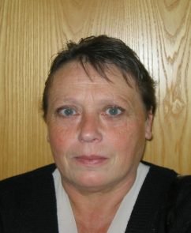**Qualifications & Experience**

Lin has over 15 years experience working with children and young people who present with emotional and behavioural difficulties, learning difficulties and physical disability within educational settings, residential children’s homes and domiciliary care. Lin has achieved the Level 4 Management and Care Qualification and has completed an array of training to develop her understanding towards the young people she works with.

Registered Provider

**Registered Care Manager – Oak House**

Declan Lola

**Qualifications & Experience**

Declan has over 15 years experience working with young people and their families, 8 years in residential settings. Declan has developed his career with My Choice from Residential Support Worker to his current position as Registered Care Manager. Declan is currently undertaking his Open University Degree in Social Work and has achieved the NVQ Level 3 in Care and Level 5 Diploma in Leadership & Management with Young People.

**Registered Care Manager – Ocean Pearl**

Lorna Roberts

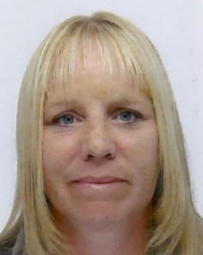

**Qualifications & Experience**

Lorna has over 14 years extensive experience working within different care settings and has worked for 11 years as a Registered Manager for different child care establishments, before becoming the manager at Ocean Pearl. Lorna has achieved the Level 4 Management and Care Qualification.

**Registered Care Manager – Maple House**

Georgios Vramis

**Qualifications & Experience**

Georgios is an experienced care professional with over 9 years experience working within residential care services dedicated to providing a high standard of service to young people. Georgios has developed his career with My Choice from Deputy Care Manager to his current position as Registered Care Manager and has achieved the Level 5 Diploma Qualification in Care, Leadership and Management

Registered Provider

**Registered Care Manager – Kestral House**

Samantha McNeil

**Qualifications & Experience**

Sam has over 10 years experience working with young people who display emotional & behavioural difficulties and challenging behaviour in a residential setting and has achieved the Level 4 Management and Care Qualification. Sam has developed her career with My Choice from Residential Support Worker to her current position as Registered Care Manager.

**Registered Care Manager – Kingfisher View**

Edward Glaves

**Qualifications & Experience**

Ed has over 5 years experience working within residential childcare services. Ed has developed his career with My Choice from Senior Residential Support Worker to his current position of Care Manager. He has worked with a variety of different young people with complex needs and currently undertaking the Level 5 Diploma Qualification in Care, Leadership and Management.

**Care Manager – Ivy Cottage**

Ken Bedwell

**Qualifications & Experience**

Ken has worked at My Choice for over 4 years and has over 12 years experience working with young people. Ken initially worked for PGL as an outdoor instructor working with young people and youth groups. Ken has developed his career with My Choice from Senior Residential Support Worker to his current position as Care Manager.  Ken has achieved the NVQ Level 3 in working with Children and Young People and is currently undertaking the Level 5 Diploma Qualification in Care, Leadership and Management.

**Registered Care Manager – Osprey House**

Ashley Harvey

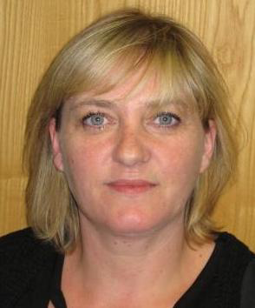**Qualifications & Experience**

Ashley has worked in a variety of different settings within Residential Care, including children’s homes and day centres. Ashley has extensive experience of working with young people with emotional and behavioural difficulties and challenging behaviour. Ashley has developed her career with My Choice from Deputy Care Manager to her current position as Registered Care Manager and has achieved the Level 5 Diploma Qualification in Care, Leadership and Management.

# Supervision, Training and Staff Development

It is My Choice Children’s Homes policy that all staff will receive individual supervision planned and co-ordinated by their prospective line manager. Supervision will be in private and so far as practical free from interruption. Supervision will be every four weeks and will be for one and a half hours in length. Any staff still within their probationary period (within their first 6 months in the company) will receive fortnightly supervision in line with the National Minimum Standards. Additional meetings can also take place between supervisee and superviser where practice issues are discussed or training in regards to internal systems. The company as a whole has a supervision structure. Managers receive monthly supervision from the Assistant Service Manager or Service Manager. Managers also receive group supervision on a regular basis, facilitated at Head Office.

New staff members are invited to a review meeting which usually takes place at the 6-8 week period from their start date. This meeting takes place at head office. The staff member, manager and a representative from head office attend the meeting.

All staff have access to training. Our training policy is in line with Standard 18 from the NMS. This takes the form of an in house and external training program, which covers the following subjects:

Training includes:

* Induction in line with Children’s Workforce Development Council (CWDC) 24 Weeks. NMS 18.3
* Child Protection in a Residential Setting
* Child Focus *
* My Choice School training
* Introduction to the Autistic Spectrum Condition
* Equality & Diversity
* Working with Challenging & Self Injurious Behaviour
* Child Development
* Complaints & Representations
* Recording Information / IT
* The Children Act / OFSTED / Policy & Procedures
* Team Teach (including crisis intervention, de-escalation and restrain training) Intermediate & Advanced
* Diploma Level 3 and Level 5 assessment and in house workshops. The level 5 is in regards to Managers only.
* First Aid
* Food Hygiene

Supervision, Training & Staff Development

Training continued:

* Fire Safety
* First Aid At Work 4 Day Certificate
* Health & Safety / Risk Assessing
* Medicines MAR Systems Training including Controlled Drugs
* Self Harming Behaviours
* Young people Alcohol, Drug & Solvent Awareness
* Undertstanding Adolescent behaviour
* Preparation for Iindependence
* Restoriative Justice training
* Developing Effective Teamwork
* Training in Relation to a Particular Need and Client Group: i.e. Autism, Self Harm, Personality Disorders, Mental Health Issues.
* Bearing the Unbearable training with Christine Bradley

Bearing the Unbearable training is for staff teams working with children with extensive, complex and enduring psychological, social and educational behavioural needs that require specialised and intensive resources that integrate support and treatment across care, education and health.

Christine Bradley is a consultant and trainer in the field of therapeutic work with children and young people. She is a trained psychotherapist and specialist child care worker.

*\*Child focus sessions are co-facilitated by other external professionals dependent on the needs of the young person, these may include CAMHS, health services, therapists, specialist consultants, professors and lecturers.*

In addition to the training My Choice Children’s Homes has a commitment to giving staff the opportunity to undertake Diplomas for staff working with young people in a residential setting. In line with NMS 18.5. This is in connection with Central Sussex College Crawley. The level obtained will depend on the position, skills, knowledge and experience of the individual worker. We believe that having a nationally recognised qualification is of benefit to the organisation, the worker and of course the young people in our care. The company has in-house assessors, Diploma Co-ordinator and an Internal Verifier.

My Choice also achieved the Investor in People Award in March 2005. The review took place in April 2008 for which the award was successfully maintained. The second review took place in March 2011. My Choice was awarded the Bronze Investors in people award in line with the new awarding structure.

# Organisational Structure of the Homes

Registered Person / Directors

Head Office

Head Teacher

Service Department

Senior Managers

Teachers

Care Manager’s

Deputy Care Manager’s

Senior Residential Support Worker

Residential Support Worker

Additional Professionals Involved:

* Head office also provides a Policy, Development Manager, HR Department including Recruitment Manager, Head Teacher, Training Department, IT support, Finance, and administration staff.
* There is also a permanent qualified teacher based at each My Choice School located at each home for the young people during term time.
* Where appropriate a referral can be made to one of several qualified and experienced therapists who undertake work for My Choice.

# Staffing Policy

Senior Residential Support Worker

The staffing policy is in line with NMS 17, sufficient staffing of the home to ensure the needs of the children are met.

My Choice operates with three members of care staff on duty during the day when the home is fully occupied. Pebble House and Maple House operate with two members of care staff on duty at all times due to 2 young people accommodated. Staffing levels will reflect the needs of the young people placed within the home. The Registered Manager will assess the individual care needs of the young people dependant on how many young people are accommodated, therefore the staffing ratio may be reduced to two members of staff (within the 3 bedded homes). The teacher works between 9am and 3.15pm Monday to Friday term time. The philosophy behind the staffing levels provide the young people with an adult who they know is there for them throughout the day and night.

There will be two members of staff sleeping in at night, but no waking night provision is provided. The two sleeping in staff will be able to respond to the residents needs and in the event of an emergency.

In line with our philosophy and ethos there will be no ancillary staff working at the home as this is not, in our opinion, conducive to family style group living. The care staff undertake all cooking and cleaning, with the young people being encouraged to take an active role in this to promote independence tasks.

Staffing Policy

Senior Residential Support Worker

The shift pattern for all full-timeResidential Support Workers working at all ***Ocean Pearl, Oak House, Kestral House, Kingfisher View, Osprey House and Ivy Cottage*** will be two days on followed by three days off. An example rota is illustrated below. The part time rota pattern for the Residential Support Workers is one day on, 4 days off.

|  |  |  |  |  |  |  |  |  |  |
| --- | --- | --- | --- | --- | --- | --- | --- | --- | --- |
|  | **2012** | **RSW 1** | **RSW 2** | **RSW 3** | **RSW 4** | **RSW 5** | **RSW 6** | **RSW 7** | **PART-TIMER** |
| Wed | 01-Jan |  | RSW 2 | RSW 3 |  |  |  | RSW 7 |  |
| Thu | 02-Jan |  |  | RSW 3 | RSW 4 |  |  | RSW 7 |  |
| Fri | 03-Jan |  |  |  | RSW 4 | RSW 5 |  |  | RSW 8 |
| Sat | 04-Jan | RSW 1 |  |  |  | RSW 5 | RSW 6 |  |  |
| Sun | 05-Jan | RSW 1 | RSW2 |  |  |  | RSW 6 |  |  |
| Mon | 06-Jan |  | RSW 2 | RSW 3 |  |  |  | RSW 7 |  |
| Tue | 07-Jan |  |  | RSW 3 | RSW 4 |  |  | RSW 7 |  |
| Wed | 08-Jan |  |  |  | RSW 4 | RSW 5 |  |  | RSW 8 |
| Thu | 09-Jan | RSW 1 |  |  |  | RSW 5 | RSW 6 |  |  |
| Fri | 10-Jan | RSW 1 | RSW 2 |  |  |  | RSW 6 |  |  |
| Sat | 11-Jan |  | RSW 2 | RSW 3 |  |  |  | RSW 7 |  |
| Sun | 12-Jan |  |  | RSW 3 | RSW 4 |  |  | RSW 7 |  |
| Mon | 13-Jan |  |  |  | RSW 4 | RSW 5 |  |  | RSW 8 |
| Tue | 14-Jan | RSW 1 |  |  |  | RSW 5 | RSW 6 |  |  |
| Wed | 15-Jan | RSW 1 | RSW 2 |  |  |  | RSW 6 |  |  |
| Thu | 16-Jan |  | RSW 2 | RSW 3 |  |  |  | RSW 7 |  |
| Fri | 17-Jan |  |  | RSW 3 | RSW 4 |  |  | RSW 7 |  |
| Sat | 18-Jan |  |  |  | RSW 4 | RSW 5 |  |  | RSW 8 |
| Sun | 19-Jan | RSW 1 |  |  |  | RSW 5 | RSW 6 |  |  |
| Mon | 20-Jan | RSW 1 | RSW 2 |  |  |  | RSW 6 |  |  |
| Tue | 21-Jan |  | RSW 2 | RSW 3 |  |  |  | RSW 7 |  |
| Wed | 22-Jan |  |  | RSW 3 | RSW 4 |  |  | RSW 7 |  |
| Thu | 23-Jan |  |  |  | RSW 4 | RSW 5 |  |  | RSW 8 |
| Fri | 24-Jan | RSW 1 |  |  |  | RSW 5 | RSW 6 |  |  |
| Sat | 25-Jan | RSW 1 | RSW 2 |  |  |  | RSW 6 |  |  |
| Sun | 26-Jan |  | RSW 2 | RSW 3 |  |  |  | RSW 7 |  |
| Mon | 27-Jan |  |  | RSW 3 | RSW 4 |  |  | RSW 7 |  |
| Tue | 28-Jan |  |  |  | RSW 4 | RSW 5 |  |  | RSW 8 |
| Wed | 29-Jan | RSW 1 |  |  |  | RSW 5 | RSW 6 |  |  |
| Thu | 30-Jan | RSW 1 | RSW 2 |  |  |  | RSW 6 |  |  |
| Fri | 31-Jan |  | RSW 2 | RSW 3 |  |  |  | RSW 7 |  |

|  |  |  |  |
| --- | --- | --- | --- |
| **Full Time Shift Pattern** | | **Part Time Shift Pattern** | |
| Day one shift starts at | 10am – 11pm | Day one shift starts at | 10am – 11pm |
| Sleep in day one | 11pm – 8am | Sleep in day one | 11pm – 8am |
| Day two shift starts at | 10am – 11pm | Day two finishes as | 8am – 10am |
| Sleep in day two | 11pm – 8am |  |  |
| Day three finishes as | 8am – 10am |  |  |
| Off 3 days (including 8am – 10am on the first day off) | | Off 4 days (including 8am – 10am on the first day off) | |

Staffing Policy

Senior Residential Support Worker

The shift pattern for all full-time Residential Support Workers working at ***Pebble House & Maple House*** will be two days on followed by three days off. An example rota is illustrated below.

|  |  |  |  |  |  |  |
| --- | --- | --- | --- | --- | --- | --- |
|  | **2012** | **RSW 1** | **RSW 2** | **RSW 3** | **RSW 4** | **RSW 5** |
| Wed | 01-Jan |  | RSW 2 | RSW 3 |  |  |
| Thu | 02-Jan |  |  | RSW 3 | RSW 4 |  |
| Fri | 03-Jan |  |  |  | RSW 4 | RSW 5 |
| Sat | 04-Jan | RSW 1 |  |  |  | RSW 5 |
| Sun | 05-Jan | RSW 1 | RSW2 |  |  |  |
| Mon | 06-Jan |  | RSW 2 | RSW 3 |  |  |
| Tue | 07-Jan |  |  | RSW 3 | RSW 4 |  |
| Wed | 08-Jan |  |  |  | RSW 4 | RSW 5 |
| Thu | 09-Jan | RSW 1 |  |  |  | RSW 5 |
| Fri | 10-Jan | RSW 1 | RSW 2 |  |  |  |
| Sat | 11-Jan |  | RSW 2 | RSW 3 |  |  |
| Sun | 12-Jan |  |  | RSW 3 | RSW 4 |  |
| Mon | 13-Jan |  |  |  | RSW 4 | RSW 5 |
| Tue | 14-Jan | RSW 1 |  |  |  | RSW 5 |
| Wed | 15-Jan | RSW 1 | RSW 2 |  |  |  |
| Thu | 16-Jan |  | RSW 2 | RSW 3 |  |  |
| Fri | 17-Jan |  |  | RSW 3 | RSW 4 |  |
| Sat | 18-Jan |  |  |  | RSW 4 | RSW 5 |
| Sun | 19-Jan | RSW 1 |  |  |  | RSW 5 |
| Mon | 20-Jan | RSW 1 | RSW 2 |  |  |  |
| Tue | 21-Jan |  | RSW 2 | RSW 3 |  |  |
| Wed | 22-Jan |  |  | RSW 3 | RSW 4 |  |
| Thu | 23-Jan |  |  |  | RSW 4 | RSW 5 |
| Fri | 24-Jan | RSW 1 |  |  |  | RSW 5 |
| Sat | 25-Jan | RSW 1 | RSW 2 |  |  |  |
| Sun | 26-Jan |  | RSW 2 | RSW 3 |  |  |
| Mon | 27-Jan |  |  | RSW 3 | RSW 4 |  |
| Tue | 28-Jan |  |  |  | RSW 4 | RSW 5 |
| Wed | 29-Jan | RSW 1 |  |  |  | RSW 5 |
| Thu | 30-Jan | RSW 1 | RSW 2 |  |  |  |
| Fri | 31-Jan |  | RSW 2 | RSW 3 |  |  |

Part time rotas could apply depending on current staffing levels

|  |  |  |  |
| --- | --- | --- | --- |
| Full Time Shift Pattern | | Part Time Shift Pattern | |
| Day one shift starts at | 10am – 11pm | Day one shift starts at | 10am – 11pm |
| Sleep in day one | 11pm – 8am | Sleep in day one | 11pm – 8am |
| Day two shift starts ate | 10am – 11pm | Day two finishes as | 8am – 10am |
| Sleep in day two | 11pm – 8am |  |  |
| Day three finishes as | 8am – 10am |  |  |
| Off 3 days (including 8am – 10am on the first day off) | | Off 4 days (including 8am – 10am on the first day off) | |

Staffing Policy

Senior Residential Support Worker

The staff will sleep in from 11pm, back on shift by 8am but as stated earlier will be available to the residents in times of need allowing for flexibility for example around morning and night time routines. Breaks are managed within the shift pattern by the registered care manager.

The Care Manager at all My Choice homes will work between 9am and 5pm. However, it is an expectation that the Care Manager will manage their hours so as to have a full picture of life at the home and that this may mean evening and weekend work. Clear arrangements are in place to ensure appropriate management of the home when the Registered Manager is absent. Options for this could be, for example; Deputy acting up if assessed as appropriate, Deputy from another home, or member(s) of Senior Management. Out of Hours Emergency On-Call is always available and is organised by the Care Manager and the Senior Management.

The respective managers will undertake On-Call requirements Monday to Thursday evenings (after 5pm). Friday – Monday mornings, the Company provides a rota of Managers who take emergency On-Call responsibilities.

There are times when staff are alone with the young people for short periods of time. When this is the case a risk assessment identifies any risks to the young people, staff member or if away from the home any risks member of the public. This is recorded and filed in the young person's working file.

For staff sickness and absence please refer to the staff handbook.

It is our policy wherever possible to have a mixed gender staff group. However, we need to take into account the varied needs and life experiences of the young people, when planning an appropriate team.

My Choice have a group of bank workers who, before starting work, undertake a full induction and are subsequently booked on the company mandatory training. This then reduces the need to use agency staff within the homes. Bank staff receive formal supervision with respective managers after competing 8 shifts, this is in line with the national care standards for Children’s Homes.

Should there be a need to use agency workers we will always endeavour to use workers who are known to the staff team and young people.

We adhere to equal opportunities and endeavour to have a team of staff within the home that reflects the culture, ethnicity and race of the young people placed with us.

# Client Group

All My Choice homes provide accommodation for up to three young people, or 2 depending on the home, (of mixed gender) between the ages of 10 to under 18 years.

My Choice homes have looked after young people with emotional and behavioural difficulties, challenging behaviour and / or learning difficulties. We have extensive experience with working with young people who self harm, have minor physical difficulties for example encopresis and enuresis also have substance misuse concerns which encompass some mental health issues. We have also worked with young people who are on the autistic spectrum and personalilty disorders and children at risk of sexual exploitation.

We thoroughly assess the needs of each individual young person at point of referral and continue to assess throughout their placement to ensure the young persons needs are met at all times. My Choice homes work towards the Disability Discrimination Act 1995 and have a disability accessibility plan. The plan is reviewed annually.

We work closely with all involved with the young person for example, social workers, youth offending teams, therapists, individuals from CAMHS and mental health teams. If specific training is required due to particular behaviours or difficulties for example self harming, My Choice will provide the necessary training for staff. The Senior Managers and homes managers have a range of experiences with young people who display challenging behaviour, mental health concerns, learning difficulties, speech and language difficulties and substance misuse.

Young people referred come to My Choice through either planned or emergency admissions. The homes aim to provide a safe environment for the young people often at times when they are at crisis in their lives. We seek to support them with their past experiences and to give them the tools and opportunity to build a more sustained future.

In general the young people our service provides care for have emotional/behavioural difficulties and special educational needs which often culminate in very challenging behaviour.

# Referrals and Admissions

Our admissions and placement policy is line with NMS 11 preparation for a placement. Where children are welcomed into the home.

All My Choice Homes can take planned and emergency referrals for young people. The procedure for referrals and admissions is as follows. All referrals are co-ordinated by Dawn Ives, Operations Manager or Alex Hyland Director:

The procedures for admissions are as follows:

* Directors and Operations Manager accept referrals via email or phone calls to head office. [a.hyland@my-choice-homes.com](mailto:a.hyland@my-choice-homes.com) or [d.ives@my-choice-homes.com](mailto:d.ives@my-choice-homes.com)
* Initial phone consultation and information shared between professionals, and via email.
* The Senior Manager at My Choice coordinating the referral will request detailed written information, for example referral form from the local authority.
* If the referral is assessed as appropriate the information is then shared with the manager of the home where the vacancy is based.
* Homes manager and the Senior Manager from head office agree if the placement is suitable and the outcome is then feedback to the local authority. This process is within the same day of the referral.
* Detailed providers response form is completed by the Senior Manager at My Choice and emailed to the local authority, outlining the provision and how the home will ensure the young persons needs are met.
* Confirmation is then received from the local authority clarifying placement.
* The plan at this stage is then to agree for a member of My Choice team to visit the young person. This is part of their admission plan.
* If appropriate or in stead of we then arrange for the young person to visit the home.
* The manager and staff at the home will then complete risk assessments, initial strategies and 24 hour management program. This is supported by the manager, social worker and individuals at the young persons current placement liaising to ensure the most up to date information is recorded and assessed.
* That information is disseminated through to the staff team and teaching staff to ensure they are fully prepared.
* The current young people at the home are informed and given appropriate information.

Referrals and Admissions

* During this period and following meeting the young person prior to placement, their personal choices are reflected in their new bedroom. It is redecorated and can include poster, pictures and magazines of their choice. The room is equipped to a high standard.  We also provide a welcome pack, which includes, young person guide, toiletries, towels, books etc.
* A keyworker is then assigned to the young person and the Working file is set up.
* Finally the placement planning meeting is arranged at the home.

The procedure for emergency admissions are as follows:

* Directors and Operations Manager accept referrals via email or phone calls to head office. [a.hyland@my-choice-homes.com](mailto:a.hyland@my-choice-homes.com) or [d.ives@my-choice-homes.com](mailto:d.ives@my-choice-homes.com)
* Initial phone consultation and information shared between professionals, or via email.
* The Senior Manager at My Choice coordinating the referral will request detailed written information, for example referral form from the local authority.
* If the referral is assessed as appropriate the information is then shared with the manager of the home where the vacancy is based.
* Homes manager and the Senior Manager from head office agree if the placement is suitable and the outcome is then feedback to the local authority. This process is within the same day of the referral.
* Detailed providers response form is completed by the Senior Manager at My Choice and emailed to the local authority, outlining the provision and how the home will ensure the young persons needs are met.
* Confirmation is then received from the local authority clarifying placement.
* The manager and staff at the home will then complete risk assessments, initial strategies and 24 hour management program. This is supported by the manager, social worker and individuals at the young persons current placement liaising to ensure the most up to date information is recorded and assessed.
* That information is disseminated through to the staff team and teaching staff to ensure they are fully prepared.
* The current young people at the home are informed and given appropriate information.

Referrals and Admissions

* During this emergency assessment period prior to placement, their personal choices are reflected in their new bedroom. It is redecorated and can include poster, pictures and magazines of their choice. The room is equipped to a high standard.  We also provide a welcome pack, which includes, young person guide, toiletries, towels, books etc.
* Arrangements are then made with the social worker to collect the young person, a member of My Choice team is available if appropriate.
* A keyworker is then assigned to the young person and the Working file is set up.
* Finally the placement planning meeting is arranged at the home.

# Ethos and Philosophy

We provide a holistic framework in which young peoples’ emotional, cultural, religious, social, intellectual and health needs are met. Our perspective is that effective childcare has to encompass all areas of a young person's live, in line with Every Child Matters legislation; which includes working in partnership with their parents/family the Local Authority who have placed them in our care, youth offending workers, CAMHS workers, therapists and all other professional individuals.

The philosophy underpinning the work undertaken is to empower and enable individual young people to make choices within a safe, proactive environment facilitating exploration of their growing awareness of themselves and their place in society. It is our belief that positive feedback and reward enhances self-esteem. We therefore endeavour to discourage negative behaviour by consistently reinforcing positive attitudes and behaviours.

Young people who are placed at our homes have access to A School if not in mainstream/PRU schooling/college. They also have access to therapeutic input outside of the home if required. If further outside support is required for any young person it is always our intention to find the most appropriate person to undertake this work with them.

**Outcomes for Young People**

We will create a stable, nurturing, caring experience for the young people placed in our homes. Subsequently this can allow the young person to move on to a future independent life, accomplishing the skills built upon throughout the time with us. Developing into young adults able to successfully manage their life safely.

The aim for our young people is to see them into current or future education, building a strong and stable network of support, either mainstream school or college.

Young people have completed feedback questionnaires and within these have expressed positive comments regarding their experience:

Example comments from previous young people:

*“I feel that with the help of theose at My Choice I’ve become a very mature, independent adult”*

*“You helped me control my temper and to grow into the person I am today”*

*“It was a good home for me, thanks”*

*“Now I am in college and I love it and enjoy it now”*

# Promotion of Health

It is our policy that all young people's health needs are met in line with the 'Looked after Children' guidelines, in terms of routine medical, eye and dental checks. Also in line with ECM, being healthy criteria and the NMS 6 Promoting good health and wellbeing.

Each young person has a health plan Placement Plan Part 3 located in the Working File. The health plan records the young persons’ medical history, appointments attended and all health needs e.g. optical, hearing, dental etc.

In addition to this we encourage the young people to eat a healthy balanced diet and to have some understanding of the importance of this on their health. Alongside this we encourage and provide opportunities to undertake exercise through participating in activities that they enjoy (e.g. swimming, bike riding and the gym).

We are committed to promoting the health of the young people we work with as well as putting great emphasis on their safety and wellbeing. If something were to happen to them whilst in our care, the Care Manager and each member of staff will have undertaken the certificated Appointed Person first aid course.  In addition all staff will undertake basic first aid training during their induction and the managers complete the 3 day First Aid at Work course.

It is the Government and Company's policy that smoking is prohibited throughout any My Choice home and in the homes cars. Designated smoking areas are located outside at each home. There are individual risk assessments specifying the exact location. Staff smoking areas are separate to that of the young people.

Our ethos is to incorporate all aspects of health taking into consideration a young person’s physical health, mental health and wellbeing and encopresis and enuresis issues.

# Education

My Choice is committed to increasing access to education and supporting active participation in education for all young people. Where any young person is unable to access school in their community (mainstream or SEBD provision) they will be registered at My Choice School.

My Choice School is DCSF registered and provides a teacher and a resourced classroom within each home. Teachers at My Choice School are qualified and experienced in working with challenging and complex behaviours and work with flexibility and enthusiasm while providing boundaries, structure and opportunity to succeed. RSWs provide support to the student in the classroom and on activities.

My Choice School aims to:

* Enhance the self esteem of all students and promote positive behaviour.
* Develop achievement and skills in all students.
* Involve students and parents / carers in a holistic approach to education and build a successful partnership between home and school.
* Prepare students for adult life.
* Ensure all Year 11 students achieve a positive outcome of a place at post 16 provision or employment

My Choice School uses the AQA Unit Award Scheme as its curriculum and all subjects are offered including core subjects and Life Skills. All students follow the AQA unit award scheme at foundation, intermediate or higher level as appropriate to their needs and abilities.

Key Stage 4 students are encouraged to work toward higher level AQA Unit Award Scheme in all subjects and can also access work experience and part time college. ICT is used throughout the curriculum at My Choice School and each classroom has a computer. Internet access is restricted and supervised at all times in accordance with our policy. Community facilities are accessed for Physical Education and include swimming, gym, horse riding and badminton. Educational visits are regularly planned to support all areas of the curriculum both academically and socially.

Students' achievements are celebrated at the end of each term with Certificate Day when students receive My Choice School Certificates of Achievement and AQA Unit Award Scheme Certificates.

Education

Senior Residential Support Worker

Further information about each My Choice School can be found in the relevant prospectus.

**Annie Murphy – Headteacher**

Annie has a BSc (hons) in Experimental Psychology and a PGCE. Annie has 26 years experience of working with vulnerable and marginalised children, young people and adults (including the long term unemployed, those with mental health issues and disabilities, and the homeless community) and within this has 19 years experience of managing services for children and young people in residential, play, training and education settings. Annie is responsible for the registration and management of all My Choice Schools maintaining DCSF and Ofsted standards, the recruitment and management of teachers, monitoring and assessing the education and development of all students at My Choice, and writing and implementing school policies and school development plans.

For further information and enquiries about My Choice School please email Annie Murphy at: [a.murphy@my-choice-homes.com](mailto:a.murphy@my-choice-homes.com)

My Choice School policies are available on request and include:

* Assessment
* Curriculum
* SEN
* IT and Internet use
* Health and Safety of Students on Educational Visits
* Behaviour
* Anti Bullying
* Child Protection and Safeguarding
* Whistle Blowing
* Complaints
* First Aid
* Health and Safety
* SMSC Development
* Exclusions
* English as an additional language

Young people who attend other schools are supported in their education with a Personal Education Plan indicating identified needs and the support provided by the school at which they are registered. Key workers liaise with appropriate contact staff at the school and a strong home school relationship is developed in order to fully support the young person in their school experience and development. Support from RSWs and access to study facilities are available within the home for completion of homework and coursework.

# Activities

My Choice activity policy is written in line with NMS 7 and 10, where there is access to the necessary facilities for a full range of activities which will promote the young people’s development. Children are also able to enjoy their interests, develop confidence int heir skills and are supported to engage in leisure activities.

Young people are encouraged to undertake activities both as a group and individually. We endeavour to give opportunities to pursue leisure interests, and hobbies which take into consideration the young person’s abilities, culture, race, religion and language.

Within the home a balance is sought between organised activities and unstructured time which the young people can choose to spend as they wish, for example board games with staff, cooking, trampolining, football , watching television, or playing appropriate games on play-stations. It is My Choice’s policy that young people can only have access to games and videos/DVD’s that are age appropriate to them.

My Choice also has a commitment to providing opportunities for young people to act and think independently whilst being safe. This is reflected in the activities which are agreed with them to do. For example if the young person’s age and understanding is appropriate for them to get a train to go shopping alone a full discussion and risk assessment for this would be undertaken.

In relation to undertaking organised activities; there would also be a risk assessment carried out to ensure it was safe and the young person’s welfare was not at risk.

Wherever possible, when appropriate, the young people are encouraged to make friends outside the home and these friends can come back to visit the home if arranged previously. We cannot unfortunately facilitate overnight stays. However, if a young person wishes to visit a friend’s home we have a commitment to making sure this is arranged in conjunction with their social worker and that all the necessary and appropriate checks are undertaken. Children can stay overnight with friends if the manager considers it appropriate and subject to the requirements of care or placement plans, without a requirement that friends’ parents should be CRB checked. My Choice would expect the manager to assess this and ensure conversations are held and documented with the social worker before this takes place.

We view special days for the young people (e.g. birthdays, cultural and religious festivals) with great importance and endeavour to involve the young people in planning and celebration of these wherever possible.

# Consulting with the Young People

My Choice policy in regards to consulting with young people is in line with NMS 1. Young people are aware that their views, wishes and feelings are taken into account in all aspects of their care. Young people are supported to understand why it may not be possible to act upon their wishes in all cases.

The young people are actively encouraged to share their wishes and feelings within the home. They are aware that they can talk to staff at any time if they have concerns or need to talk to someone. In addition to this there are young people’s meetings for all residents to attend. This is an opportunity for them to share their feelings regarding the day to day running of the home, and talk about issues they may currently have. Young peoples meetings also provide a forum for young people to discuss menu options, holidays and environmental improvements. They can discuss the things they think are going well and generally share their views and feel listened to.

Young people also have individual Key Workers who meet with them on a regular basis to discuss how things are going and to look at specific areas they would like to work on developing for themselves, for example in relation to behaviour. Key workers complete monthly Key Worker Sessions and Short Term Care Plans.

My Choice have internal questionnaires for the young people to complete on a regular basis. This enables senior managers to review the service provision.

It is important that young people are aware how to obtain support and to make a complaint if necessary.

My Choice has a clear young person complaints policy, it is outlined in the young person guide. The manager of the home will respond to a young persons complaint within 24 hours.

# Promoting Positive Behaviour & Relationships

My Choice aims to work in a manner that promotes the welfare, safety and needs of both the young people and the staff. This is achieved through consistency and working in a non-confrontational way, giving young people choices and support in making them. The ethos of My Choice is to praise and reward positive behaviour. However, where necessary, appropriate sanctions will be put into place. Part of keeping young people safe, is having to say no at times, even when they find this hard to accept. My Choice works within the ethos of Resoritative Justice in connection with the Youth Offending Service, which is an approach to responding to wrong doing through 5 outcomes;

* Repect
* Responsibility
* Repair
* Relationship
* Reintegration

Staff will work with the young people following an incident and ask, what happend? Who has been affected? And what needs to happen to put it right? Shift from sanctions/ punishment to how to make people feel better.

It is our policy that a young person will only be restrained when they are in danger of hurting themselves or others. In exceptional circumstances a restraint may be used, to prevent injury to any person (including the child who is being restrained) or to prevent serious damage to the property of any person (including the child who is being restrained). This is in line with NMS 3.13

It is our aim for all staff to complete Team Teach restraint training.

The Team-Teach Approach was founded in 1997 and is a multidisciplinary and multi-agency in composition, with trainers from Learning Disabilities, Child & Adolescent Services (covering health, social services, mainstream and special educational needs.) As well as developing and delivering training, Team Teach also has a keen interest in policy and strategy development. The aim of Team Teach is to work together to safeguard people and services.

Team Teach is advised and supported by a broad based group of people with recent and relevant personal experience in a range if settings. These include senior officers in a number of local authorities, principals, Head Teachers and managers of a range of services for children and adults with severe learning difficulties, autism and emotional and behavioural difficulties. Members of the Team- Teach steering group have also advised the Department of Education and Skills, the Department of Health and the Home Office. Team- Teach also made a significant contribution to the development of the British Institute of Learning Disabilities (BILD) Code of Practice.

Promoting Positive Behaviour & Relationships

Team-Teach is affiliated to the National General Services Association and was one of the first training organisations in the UK to be fully accredited by BILD under the government sponsored scheme.

Inspection bodies and the Health and Safety Executive have also commented favourably in their reports on the positive impact that the Team Teach training framework has had when adopted by leadership, management and a whole setting holistic approach.

Two members of senior management are Team Teach tutors and regularly undertake this training with teams at both an intermediate and advanced level.

Restraint is emotionally stressful for the young people and the staff involved. As such we need to be clear when and why this needs to take place. It is always the last resort not a first option, but sometimes it is necessary to ensure the welfare of the young people or the safety of others. We would always use de-escalation techniques to avoid having to restrain. As adults we have a responsibility to ensure that all young people in our care are safe from harm.

Restraint is not used as a punishment, nor to force compliance with instructions where significant harm or serious damage to property are not otherwise likely.

# Child Protection & Safeguarding

My Choice Child protection and safeguarding policy is written in line with NMS 4.

Children need to feel safe and are safe. They are protected from significant harm including neglect, abuse and accident.

The welfare and wellbeing of the young people at My Choice is always our priority. There are clear procedures and guidelines for staff in the event of a child protection incident. Staff receive training not only in child protection but also signs and symptoms of child abuse and the potential effects this has on the young people they work with.

My Choice Policies and Procedures in regards to Child Protection have been completed in line with the Sussex Child Protection and Safeguarding Procedures that have been produced by the local Safeguarding Children’s Boards of Brighton and Hove, East Sussex and West Sussex.

It is our ethos to always work in partnership with the young people’s placing authorities and where appropriate their parents.

The young people are aware that they can talk to any member of staff on duty at any time. In addition to this they can request contact with their Social Worker at any time and have access to telephone numbers (e.g. Childline, NSPCC) to contact. My Choice endeavours to be a safe place through placing great emphasis on strong communication between the staff and young people. Staff have clearly defined boundaries within their relationships with the residents. It is seen that an atmosphere where residents feel confident about taking any problems to staff is one that promotes safety.

# Bullying

My Choice has a clearly defined anti-bullying policy and it is in line with NMS 3.11 as we acknowledge different people can interpret bullying in different ways. Some examples of bullying are:

* Name calling
* Teasing
* Verbal or written abuse
* Physical assault
* Threatening behaviour
* Humiliating behaviour
* Rumours spread about somebody
* Money or possessions being taken from somebody
* Racial discrimination
* Any form of prejudice against others
* Cyber bullying

If a young person is being bullied then they are feeling very scared and upset. Bullying can affect them in lots of different ways. For example a young person being bullied will often have extremely low self esteem and they could quite possibly feel that there is something wrong with them.

Bullying will not be tolerated in any form at My Choice in relation to the young people or the staff who work with them. Bullying incidents or allegations will be investigated by the manager.

It is important that staff at the homes understand their role in helping to prevent and counter bullying by any adult or child living or working in the home.

# Missing Child Policy

When a young person leaves any one of our homes without permission or letting staff know where they will be, there are procedures in place to do everything possible for their safe return. The first point of contact would be to notify the Care Manager/On call of the absconsion, followed by reporting them as missing to the police and filling in the appropriate abscontion paperwork which includes a description of the young person and what they were last wearing. All appropriate parties will also be notified:

* Senior Managers - need to be notified within 1 hour via email - also the status of ‘missing’ or ‘absent’ and the person making the decision, i.e. police officer’s name and reason for this decision
* Local Authority / Social Worker
* Parent(s) (if appropriate)
* My Choice On-Call Manager
* Police

My Choice has a clear abscontion policy and procedure for staff. There is clear guidance relating to each young person within their 24 hour management plan and risk assessments located in their working files.

My Choice’s policies and procedures in regards to children missing from care is in line with NMS 5, the local Runaway and Missing from Home and Care protocols (RMFHC) and the recent joint Sussex Protocol to Reduce the Prosection of Looked After Children.

Meetings between the child, the responsible authority and the homes staff may be organised if a child goes missing and there is subsequence concern for their welfare. These meetings will consider what actions should be taken to prevent the child going missing in the future.

Concise written records are kept within the home, incluiding a running chronology and those informed. The Young Person Missing or Absent from the Home form replaces the Young Person Abscontion Form.

# Fire Precautions

It is our policy that all reasonable fire precautions will be taken within our philosophy of providing care in non institutional homes. This means that fire extinguishers, fire blankets and smoke detectors are all available, accessible and fitted in the homes.

All My Choice homes have a fire file and it is the duty of the Care Manager to ensure that any shortcomings in our fire protection are brought to the immediate attention of Senior Managers/Responsible Person to ensure rectifying action is taken. There is an emergency escape plan located in the fire file. (NMS 10.9) Fire risk assessments are also recorded on file and reviewed by the Care Manager.

Each smoke detector, emergency lighting and extinguisher is tested weekly and this is recorded in the fire file. All young people and staff will be given a fire safety guides upon arrival at any home. There are also simulated fire drills/ that take place in the home. There is a monitoring procedure in the home to ensure that staff and young people receive 4 fire drills each year. These will take place day and night. These are recorded and any problems dealt with.

In the event of a fire, the Fire Brigade will be called regardless as to whether the staff have attempted to tackle the fire. The priority is always the individuals within the home. Possessions would be left and the home vacated immediately. The home will not be re-entered until the Fire Brigade have said it is safe to do so.

All electrical equipment is tested in line with the National Minimum Standard guidelines. All My Choice homes will take all reasonable precautions to prevent fire. Smoking is not permitted in any ‘My Choice’ building.

There is an appointed fire warden in each home who is responsible for the upkeep of the file. All other staff receive basic fire awareness training within induction initially then within other head office training.

# Meeting Cultural Needs

We aim to support the young people’s individual cultural needs within the homes. We employ a diverse staff team through the organisation. The staff come from a variety of different ethnic backgrounds or share different values, religions and beliefs.

We support the young people to learn to respect and enjoy diversity. This enables them to develop their own cultural identity for now and the future.

At My Choice we aim to;

* provide advice and information on general and/or specific identity related issues.
* provide positive relationships, professional and personal, that support self esteem within the young person.
* Enable children to have access to appropriate school based curriculum support in regards to cultural issues.
* provide accessible and appropriate leisure and social activities, delivered via extended services and /or school based timetable.
* Staff work with young people in the community setting to support cultural needs.
* Staff will ensure all appropriate specialist products / items are bought and are available in the home. This could be products for hair or skin. There will be extra funding provided by the company for specialist products.
* The company will support all necessary appointments for the young person that meet their cultural needs.

When considering any child/young person’s additional needs it is important to recognise and take account of the following:

* Additional needs may be as a result of individual, family or environmental factors.
* Additional needs exist along a continuum and may require a stepped approach to increased support and intervention to ensure that such support is experienced as empowering.
* Additional needs may be short term or long term in their impact.
* Causes of additional needs may be different for children/young people and therefore require different level of support.

All cultural needs are documented and reviewed within the young person placement plan, education plans and keyworker reports. Weekly reports will identify any areas and services accessed or items purchased.

# Young People's Religious Instruction & Observance

We acknowledge and respect the need for young people to maintain all important religious contacts and practices and will work to maintain these if the young person wishes to do so. All young people’s religious needs and observances will be respected and facilitated. If a young person needs escorting to a place of worship, this will be provided.

Where we have limited knowledge of a particular young person’s cultural or religious needs we will ensure that links are made within the community to seek the information that we will need to provide holistic care for that child.

We welcome family and community support in meeting the cultural and religious needs of the individual.

We support the young people in gaining an understanding of other cultures whilst meeting their own cultural needs.

Young people can live with us with various language differences. This can be supported on an individual assessment of how the home would best meet their needs, e.g. an interpreter for meetings or contacts etc.

# Contact with Parents, Relatives and Friends

Where appropriate all contact with family and friends will be maintained. Children will be supported and encouraged to maintain and develop family contacts and friendships, subject to any limitations set in their care plan or court order.

This will be achieved through:

* Supervised contacts when required.
* Visits to the home.
* Taking the young person to their family home.
* Letters.
* Telephone calls.
* Any other appropriate contact required (as outlined in the young persons care/placement plan).
* Concise contact reports will be provided to the social worker when requested.
* We are committed to support contact needs for the young people in our care.

We regret that overnight accommodation for visitors is not provided at the home although there is a good deal of accommodation available locally.

Our policies are in line with NMS 9, where children have, where appropriate, constructive contact with their parents, grandparents, siblings, half- siblings, families, friends and other people who play a significant role in their lives.

# Complaints

Where a young person makes a complaint, this will be recorded and kept on file.

Young people are aware of how to make a complaint through their Young Person Booklet, and are aware that it is their right to complain. All complaints will be listened to and responded to appropriately. Complaints can be made to any member of staff or to the Care Manager. Young people are also aware that they can make a complaint direct to their Social Worker or the Regulation 33 Visitor who is independent of the home.

It is our commitment that all complaints will be fully responded to within 24 hours and then up to 28 days to formally respond. There are separate recording procedures for staff members and external parties. To use the complaints policy -see the Policy and Procedure Manual and that young people are kept informed during this time as to what is happening.

Social workers and parents (were appropriate) will be informed of all complaints within the home. Ofsted will be notified if a serious complaint is made.

There is a complaints policy that includes guidance on;

* Young person complaints
* External complaints
* And staff complaints.

The policy is within the company’s policy and procedure manual.

# Reviewing Placement Plans

Placement plans are reviewed on a monthly basis by the keyworker and manager. A LAC Review Report os provided in Statutory LAC reviews this is in line with NMS 25.2.

The home supports the young people to understand the purpose and content of their plan and reasons behind decisions made.

If dates are not forwarded to My Choice for a young person’s review the home will send out a letter requesting this to be done. If there is still no further date set within the correct timescales My Choice will set a date themselves and invite all appropriate people. This review will take place regardless of attendance and the details and outcomes of which will be forwarded to all appropriate parties.

In addition to the above My Choice has a commitment to ensuring the needs of the young people they care for are met. If significant changes were to occur within the placement that jeopardised this, a review with all appropriate parties would be requested.

An additional venue for meetings away from the home is available at our head office.

# Accommodation

**Kestral House** is a pleasant detached three storey home in West Sussex. Built in the 1800’s the home has been modernised to a high standard. The home is located close to the local amenities for example stables, leisure centres, cinemas, library and shopping centre. Kestrel House is also near the main line station and is within easy reach of the city of Brighton and Hove and access to all amenities there. Kestrel house has easy access from the M23 motorway.

**Oak House** is a large detached property located in East Sussex and is set within extensive gardens which ensure privacy for the home. The home has good access to road and rail networks. The closest main town is Hastings which is within a mile of the home. Bus services are in operation nearby. There are many leisure centres and activities in the local area for example stables, leisure centres, cinemas, library and shopping centre. Oak House has easy access from the A27 and M20 motorways.

**Ocean Pearl** is a large home located in a quiet area of, West Sussex. The home has a modern design with an upstairs conservatory overlooking the garden. The home is close to local facilities and road and rail networks. The home is within easy reach of Littlehampton and Worthing and access to all amenities there for example stables, leisure centres, cinemas, library and shopping centres. Ocean Peal is accessible form the A24 and A27.

**Kingfisher View** is a large home located in West Sussex. It is in a quiet rural area set within three and a half acres of land. Kingfisher View is within easy access of Horsham and Chichester. The young people have access to Sussex coastal towns and many local leisure amenities for example stables, leisure centres, cinemas, library and shopping centres. Kingfisher View is accessible from A272, A24 and A29.

**Pebble House** is a pleasant family sized home near the coast in West Sussex. The home accommodates 2 young people. There are regular bus services from the main line station. The home is close to local facilities, road and rail networks. The home is within easy reach of Littlehampton and Worthing and access to all amenities there for example stables, leisure centres, cinemas, library and shopping centres. Pebble House is accessible from the A24 and A27.

Accommodation

**Maple House** is a pleasant family sized detached home in West Sussex. Maple is located a short walk from the town centre. The home is located close to local amenities for example stables, leisure centres, cinemas, library and shopping centres. Maple House is also near the main line station and the South Downs. It is within easy reach of the city of Brighton and Hove, and access to all amenities there. Maple house has easy access from the M23 motorway.

**Ivy Cottage** is a large home located in a quiet area of West Sussex. The home is close to local facilities and road and rail networks. The home is within easy reach of Littlehampton, Chichester, Brighton and Worthing and all amenities there, for example, stables, leisure centres, cinemas, library and shopping centres. Ivy Cottage is accessible from the A24 and A27.

**Osprey House** is a large home in a residential area of Surrey. The home is close to local facilities and road and rail networks. The home is within easy reach of Crawley, Redhill and Reigate and access to all amenities therefore example, stables, leisure centres, cinemas, library and shopping centres. Osprey is accessible from the A23.



Ocean Pearl

Kestral House

Kingfisher View



Maple House

Oak House

Ivy Cottage



Osprey House

Pebble House

Accommodation

All young people’s bedrooms are solely for their use and as such no rooms are ever shared. The rooms are all double room size and furnished with a bed, wardrobe, chest of drawers and any other appropriate furniture. The young people are consulted regarding decoration of the communal areas. There are sleeping in rooms for staff and adequate bathrooms for the whole household. Each home has a fully functional kitchen and dining room area where everyone sits to have meals together.

Each home has a lounge which is furnished to a high standard and the place where young people can spend time together and with staff to watch television, play games or generally relax.

The homes have bathrooms and separate toilets for the young people, all of which can be accessed from the outside in an emergency.

The home encourages the young people to personalise their bedrooms which are decorated to the young person’s choice.

Each home also has a school room for young people who are not in mainstream education where they spend their set daily hours with the homes teacher.

In each home there is a secure staff office where the medication and all lockable filing cabinets are located and confidential information stored.

The homes have gardens which are well maintained and can be used for barbecues, activities and generally relaxing.

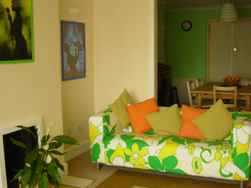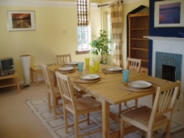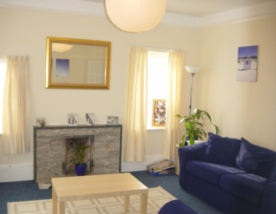

My Choice have installed alarm systems within the homes. Each house has SECOM alarms fitted discretely in the young people’s bedroom door frames and within the front and back doors.

Accommodation

There is a mains control panel located in the staff sleep in room and office, for monitoring purposes. This is to enable staff to react and support the young people if necessary during the night time. Please speak to the homes manager for further information regarding this system. Currently, the alarm system is not fitted in Pebble House.

My Choice has a maintenance team and manager who co- ordinates work required in the homes, including general repairs, decoration and garden maintenance.

# Therapeutic Intervention

In addition to any therapy that young people are already attending before they come to our homes, My Choice Children’s Homes also provides therapeutic input where appropriate. The young people have access to external therapists which is included in the fee structure.

All our therapists receive external professional supervision. These arrangements were in existence before undertaking work for My Choice.

The young people may also access therapy through CAMHS or social workers.

All therapeutic intervention is outlined in the young person placement plan and section allocated in the working file.

# Promoting Independence

Where young people accommodated are at an age where independence work is appropriate this will be put into their Care/Placement Plan. At 15 years an Independence Plan will be devised which looks at their needs holistically. This would include assessing their future educational needs, work experience and general self care. This is arranged with the young people, their Social Workers, the Care Manager and the Key Worker where appropriate the homes teacher.

This policy is in line with NMS 12. In which it states children will receive the care which helps them to prepare for adulthood. This is to ensure they reach their full potential.

The young people will develop skills in regards to shopping and budgeting, cooking and keeping food, washing clothes, personal self care, and understanding and taking responsibility for personal health care.

Pathway plans will be undertaken by the young person social worker and supported within the home.

# Anti-discriminatory Practice & Children/Young People’s Rights

We do not tolerate discrimination under any circumstances that may occur on grounds of race, culture, ethnicity, religion, age, gender, sexuality, class or disability. We value diversity and as such all our work is underpinned by our commitment to deliver a service based on anti-discriminatory practice.

We recognise that all people are unique and have different, but equally valid life experiences.

Our ethos and values in relation to children’s rights are based on the UN Convention of the Rights of the Child.

These are:

* Everyone has a responsibility to support the care and protection of children and young people.
* Children and young people must be protected from all forms of violence and exploitation.
* Children and young people have the right to be listened to and their views respected and responded to.
* Children and young people should be encouraged and enabled to fulfil their potential.
* Every child must have someone to turn to.
* My Choice Children’s Homes endeavour to challenge inequalities for children and young people.

Children’s rights are always a priority at My Choice and the young people are made aware that in addition to having staff available to talk to, they can have contact with Social Workers and family/friends. If there is a nominated child’s rights worker from the young persons originating local authority we would support them in accessing this service.

# My Choice Senior Management

**Peter Kazmarski - Director**

Peter has over 20 years experience working with older adults with neuro-disabilities and young people with emotional and behavioural difficulties. He has managed homes and was Deputy Head of Care within a special needs school for children with a statement of special educational needs. He is a graduate from the University of Sussex in Applied Psychology and is part qualified with an Advanced Diploma in Therapeutic Counselling. Peter is the Responsible Person for the Company and Ofsted.

**Alex Hyland - Director**

Alex has over 20 years experience working with children who display emotional & challenging behaviour. His professional experience includes working with adults who have left Local Authority care & those experiencing mental health difficulties. Alex has worked within the voluntary, public & private sectors. He has considerable management experience of various residential homes ranging in size from 3 to 7 bedded. Trained at Caldecott College (accredited by Greenwich University) he achieved a Graduate Certificate in Therapeutic Childcare.

**Dawn Ives - Operations Manager**

Dawn has over 12 years experience working in childcare and is qualified with the Registered Manager Award, NVQ level 3 and 4 in Child Care and NVQ Assessor’s Award. Dawn has developed her career with My Choice from Residential Support Worker to her current position of Operations Manager.  Dawn manages and supports our Registered managers and  undertakes regular visits to the homes as part of our quality assurance procedures. She works closely with Ofsted, Local Authorities, co-ordinating and managing the company referrals with the Directors, placing young people in our homes.

**My Choice Senior Management**

**Annie Murphy - Head Teacher**

Annie has a BSc (hons) in Experimental Psychology and a PGCE from the University of Sussex. Annie has 25years experience of managing services for children and young people in residential, play, training and education settings; with 11years as the Headteacher of My Choice School. Annie is responsible for the management of all My Choice Schools, including management of teaching staff, writing school policies and development plans, ensuring standards are maintained and raised in line with DfE and Ofsted regulations, monitoring student performance and progress, monitoring IEPs and writing reports for PEPs, EHCP Annual Reviews and LAC reviews.

**Lisa Lawrence - Policy & Development Manager**

Lisa has a Diploma in Social Work with the Post Qualifying Year & Management Qualification. With over 18 years experience within a residential setting, 10 years at senior/management level, Lisa worked initially at a residential school for young people with emotional & behavioural difficulties. Lisa holds the NVQ Assessors & IV Award, develops and implements our Polices & Procedures and co-ordinates our training programme.

**Debbie Woodgate -** **Practice Manager**

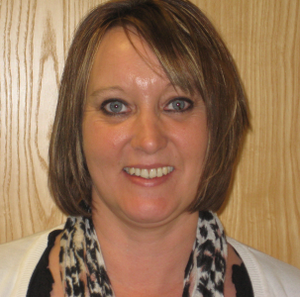Debbie has over 10 years experience working within residential child care services which includes 5 years service at My Choice Children’s Homes. Debbie has developed her career with My Choice from Deputy Care Manager to her current position of Practice Manager. Debbie has achieved her Level 5 Diploma Qualification in Care, Leadership and Management and the NVQ level 3 (Children and young people award) and holds a certificate in substance misuse early intervention with young people. Debbie’s role is to work directly with the homes staff teams and managers reviewing strategies, plans, risk assessments and to ensure effective intervention and high quality care is provided at all times.

**Adrian Adams – Independent Regulation 33 Visitor**

****Adrian is our Independent Regulation 33 Visitor for all My Choice homes. He visits once a month producing a report in line with Ofsted requirements. Reports are located in the homes and are available upon request.

**Jackie D’Vaz – Diploma Assessor & Trainer**

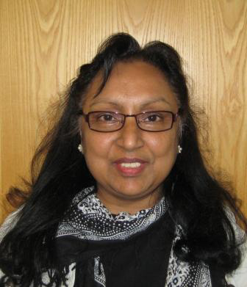Jackie has worked at My Choice for 2 years and has 10 years experience in staff training. Jackie undertakes the role of company assessor for all NVQ Level 3 candidates and Level 5 Manager / Deputy staff. Jackie works directly with the care staff in the homes and also plans sessions fortnightly at our Head Office. Jackie’s role has further developed to facilitating some training within the company namely; Child Protection, Equality and Foundation Training. Jackie has achieved her A1 Assessors Qualification and ensures her CPD is reviewed and kept up to date, this includes child protection and first aid.

**Lauren Kerr – Recruitment Manager**

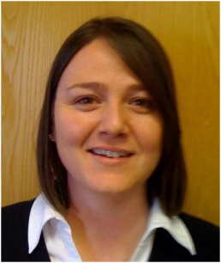Lauren is our Recruitment Manager and has over 15 years experience of working within Human Resources, Recruitment and Selection, Training within a variety of work settings from Pilot Recruitment to Call Centre Staff in the Aviation, Tourism and Social Sector. Lauren has worked at My Choice for four years based at our Head Office and manages the recruitment and selection of our staff.

Full staff lists for each home are available within the individual homes Statement of Purpose or on request.

**MY CHOICE CHILDREN’S HOMES LTD**

**August 2014**