**Shameer Mukhtar**

**SP20-BSE-076**

**BSE-4B**

**Use Case Description:**

**Fully dressed Use Case**

|  |  |
| --- | --- |
| **Name** | Place Order |
| **Scope** | Buyer login with buyer account and order products. |
| **Level** | Order goal is user can order his/her selected item. |
| **Primary Actor** | Buyer and seller |
| **Stakeholder and Interests** | 1. Seller: Who wants to sell the product 2. Buyer: Who wants to but the product |
| **Preconditions** | 1. Buyer: User select item which he/she want to order 2. Seller: : User upload item which he/she want to order |
| **Postconditions** | Confirm order after getting valid Email, Address and Phone No. |
| **Main success scenario** | Buyer: Place Order Successfully after providing the various details.  Seller: Successfully upload products after giving proper description about product. |
| **Extensions** | Condition:   1. Email must be valid. 2. Description must be proper. 3. Valid Phone No. must be provided. |
| **Special requirements** | Valid Email address  Valid Phone Number |
| **Frequency of Occurrence** | Anytime User can place order and Seller can upload products. |

**Place Order:**

Buyer give his/her proper Email , Address and Phone No. to confirm the order of his/her selected product. Order will confirm after send buyer a verification code to confirm buyer phone No. after that he make payment for his order to get a receipt of order. Receipt consist of Buyer order details. On the other hand, Seller upload products which he/she wants to sale. Seller must gives a description about his/her product.

**OPERATION CONTACT: PLACE ORDER**

|  |  |
| --- | --- |
| Operations | Buyer login from buyer account then search product and place order |
| Cross reference | Place order |
| Pre-condition | Buyer select item which he order |
| Post-condition | Order placed |

**System Sequence Diagram:**

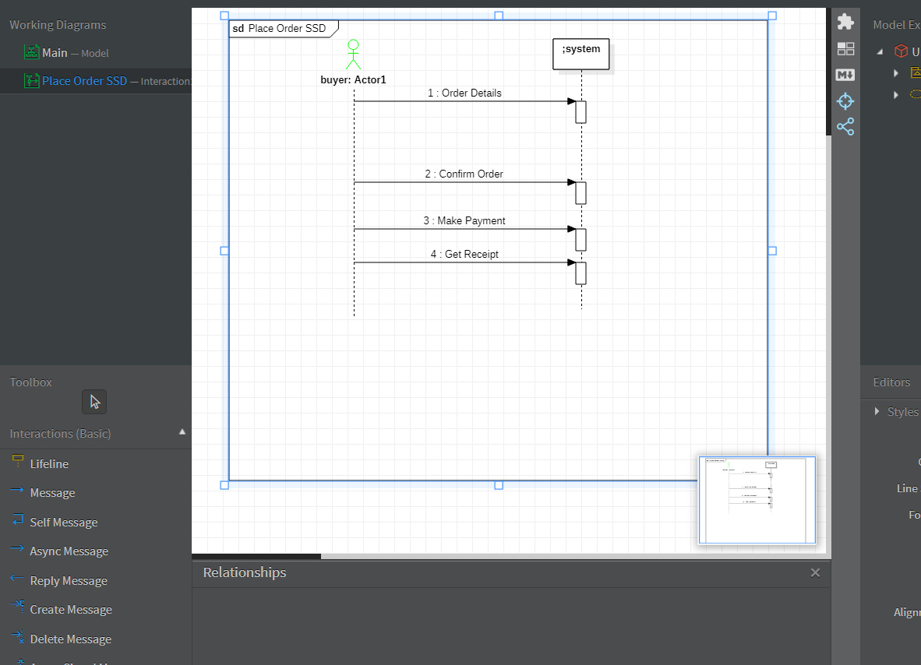

**Forms:**

