CREATING A DOCKER CONTAINER ENVIRONMENT FOR PYTHON DEVELOPMENT:

1. Creating a Project Directory for Docker (docker-app)
2. Creating sample Python file:
   1. App.py:

# app.py

def main():

print("Hello, world!")

if __name__ == "__main__":

main()

1. Create a Requirements File (Optional)
   1. Requirements.txt

Flask

1. Create a Dockerfile
   1. Dockerfile:

# Use the official Python image as a base

FROM python:3.9

# Set the working directory in the container

WORKDIR /app

# Copy the dependencies file to the working directory

COPY requirements.txt .

# Install dependencies

RUN pip install -r requirements.txt

# Copy the content of the local src directory to the working directory

COPY . .

# Run the Python script

CMD ["python", "app.py"]

1. Build the Docker Image

docker build -t <directory-name> .

1. Run the Docker Container

docker run <directory-name>

Docker CONTAINER Created: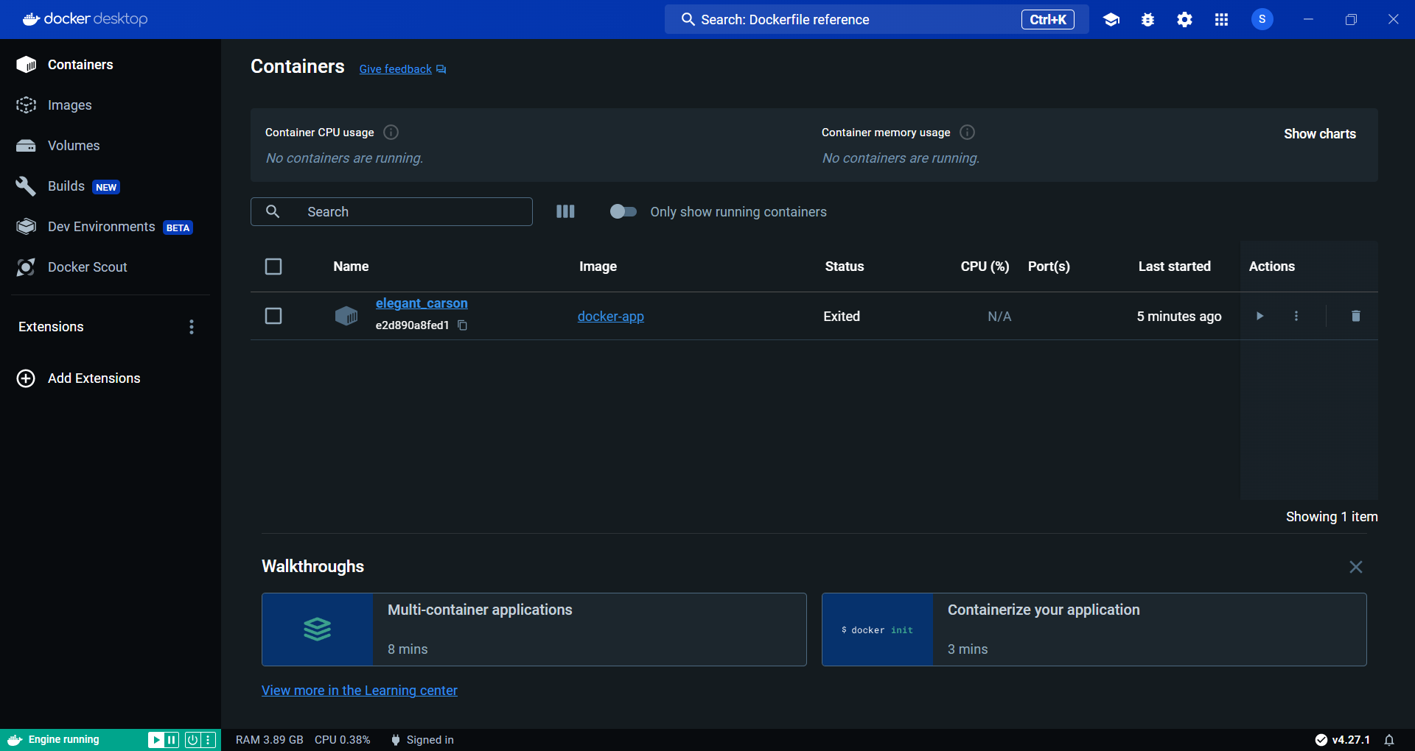

Docker IMAGE Created:

