Assignment

Subject:

NAME:

**Student ID:**

As the data center industry encounters strong development, the need to track down the ideal site and convey limit rapidly has never been more noteworthy. Site determination unites monetary

demonstrating, local area relations, designing plan, development arranging, and, surprisingly, a little fortune telling to convey limit where computerized organizations need it.

The decision of site needs to consider a wide assortment of variables, not which are all instinctive. A data center is a drawn-out venture, and picking an area requires being delicate both the necessities of the business and the encompassing local area.

As you start your excursion toward siting another data center, keep these five guidelines of the street.

* **Rule One: Know Your Surroundings**

More than 33% of organizations gauge that server free time costs more than $1 million every hour, and 15% gauge the cost at more noteworthy than $5 million. Data centers are dependent upon similar powers of nature as any structure; however, the effect of a staggering misfortune is possibly a lot more noteworthy. Actual flexibility is significant, yet so debacle reaction. Consider the accompanying elements.

* **Environment**

The frequency of high temperatures, record precipitation and harming storms has been ascending for a considerable length of time because of environmental change. The effect of climactic powers goes past the breeze and downpour harm of a tempest occasion. Typhoon Harvey, who rammed into the Texas coast in 2017, created storm floods of up to twelve feet. The Mississippi River was at flood levels for almost three months following weighty downpours in 2019. Regions that were once viewed as protected may not be as secure a very long time from now on.

Environment can likewise impact encompassing regions such that influences the data center. For instance, heat waves can cause brownouts that force data center administrators to depend on reinforcement generators. Power outages brought about by typhoons and cyclones can make the similar result. Outrageous weather conditions may likewise impact the capacity of basic representatives to get to work. Site choice necessities to expect these variables and set up suitable reinforcements and redundancies.

* **Seismic Activity**

While the west bank of the U.S. is known to be at high gamble of tremors, pockets of successive seismic movement exist all over North America.

Truth be told, two of the most seismically dynamic regions of the U.S. are Missouri and South Carolina. Portions of the southeast, upper east and northern Rocky Mountains are additionally shaken consistently.

Seismic action can be very restricted. For instance, the U.S. Geographical Survey appraises the probability of a greatness seven tremor striking the San Francisco Bay region during the following 30 years at 51% however Sacramento, which is under an hour and a half drive away, is viewed as one of the most un-weak regions of the state. Seismic occasions can cause disturbances other than property harm, including power misfortune, water line breaks and harm to streets and extensions. Site determination necessities to consolidate risk investigation and suitable failover methodologies.

While choosing a site for a hyperscale office, submit to these five guidelines of the street to keep your business and the encompassing local area fitting together.

* **Availability**

Developing and preparing a data center includes moving heaps of substantial hardware. The state of neighboring streets can be a critical component in guaranteeing protected and productive transportation. Data center administrators ought to likewise think about the simplicity of moving individuals, particularly during a crisis. Openness is a work of art "last mile" issue. The U.S. Public Highway System represents just around 4% of the country's all out open street miles. The area of most serious gamble are the frontage roads to the data center site. The office ought to be securely available by various courses. Proprietors ought to likewise consider vicinity to air terminals and rail transport, remembering that rail lines and airplane approach examples can likewise be risks.

* **Ability**

Frequently disregarded in the siting choice is the significance of having the right abilities nearby. The significance of ability shifts with the necessities and utilizations of the office, going from essential equipment support, organization and framework organization to offices and tasks the board. Uptime Institute's 2018 worldwide study of data center administrators observed that the greater part said they were either experiencing issues finding or holding data center staff.

Metropolitan centers with a centralization of enormous organizations and scholarly establishments give the best admittance to specialized ability, yet at the greatest costs. Minimal expense areas might be a decent choice for data center proprietors that can moderately migrate representatives or that run fundamentally "lights out" tasks.

Throughout the next few weeks, the exceptional report series will likewise investigate the accompanying subjects corresponding to data center site choice: the benefit of knowing the framework, the organization, and your neighborhood partners.

* **Building a datacenter in Kelowna, Canada:**

There are not many spots that are protected from all catastrophic events. Ascertaining the best spot to find a data center comes down to what gambles with you are all right with.

IBM was hoping to construct their greatest data center ever and observed that Kelowna, Canada was probably the most secure spot in North America.

It was appropriate for various different reasons, yet to the extent that wellbeing goes it is an incredible spot.

* **Here is IBM's appraisal of the climate they picked:**

Geologic overviews show that the Okanagan is something like 150 miles from the closest seismic tremor zone. Environment specialists additionally have said that the area in the high desert makes it protected from different calamities like floods, twisters, and significant tempests.

**Part 2)**

* **Floor Plan:**

Control Airflow Using Hot-passageway/Cold-path Rack Layout:

The standard of controlling wind current utilizing a hot-walkway/cold-path rack format is distinct in different archives, including the ASHRAE TC9.9 Mission Critical Facilities. This guideline means to amplify the detachment of IT hardware exhaust air and new admission air by setting cold walkways where admissions are available and hot paths where exhaust air is delivered. This diminishes how much hot air drawn through the hardware's air admission. Doing this permits data centers to accomplish power densities of up to 100 percent.

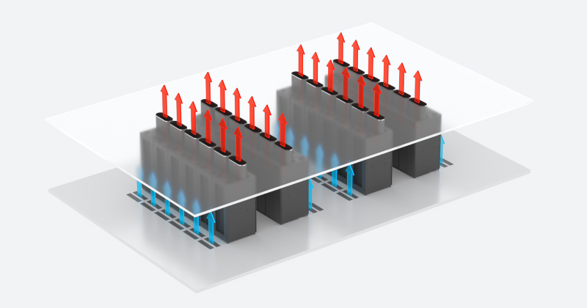

**Part 3)**

Programming items intended to safeguard the protection, classification and security of our client data and interchanges.

security layer under the entirety of our administration’s centers around three regions:

Coherence assurance from startling actual debacles to our hardware or offices (we comprehend that unforeseen applies to when and why, not assuming they will occur)

Interruption assurance from unapproved outside access

Sandbox security from unapproved inside access

We have two extra premium security administrations to safeguard significant data and meet interior or legitimate necessities:

* **Data uprightness security**

Long-lasting data filing and logging, otherwise called unalterable WORM stockpiling

clients rely upon the progression of data to direct business and that the data acquired, created, coordinated, and put away by our clients addresses a huge part of their result and is as a rule their single most significant resource. Due to this every one of our security layers include a few coordinated frameworks to address actual security, network security, frameworks overt repetitiveness and functional controls. These frameworks are set up with the single objective of shielding client data from misfortune or unapproved divulgence.

* **Actual Security**

leases datacenter space in the best data centers on the planet. These areas are safeguarded by ace security specialists and are far more secure from fiascos, outside dangers and authoritative blunders or dangers than most office on location capacity. No Sure Files™ client data is at any point put away on servers beyond level 1 data centers.

With areas in New York, Pittsburg, Chicago, Florida, Virginia and the UK, our facilitated administrations are made do, secure, disseminated, and repetitive to safeguard your data.

* **Normal key elements include:**

Unwavering quality

Three to Seven committed electrical feeds

Controlled by two to five distinct substations

Associated with numerous exchange switches

1,500 kVA of uninterruptible power supply

Different HVAC framework with 1,000 tons of accessible cooling

Repetitive spine network including Level 3, Telia, AT&T and MCI spines

$millions in continuous equipment and foundation redesigns and updates to keep up with best-in-class dependability and effectiveness

* **Security**

Supported austere dividers

Quake and blast safe development

Modern heat proof safeguards and fire anticipation frameworks

Different 24x7 id card access staffed security check focuses outside the data room

24x7 live shut circuit TV checking of all guests

Biometric access control

Auditable access logs of all frameworks authoritative access and exercises

* **Versatility**

Rent arrangements take into account extension to great many gathered servers for items and administrations

* **Overt repetitiveness**

With our associated datacenters in different urban areas and landmasses even devastating data misfortune in one area is safeguarded with day-to-day offsite reinforcements to no less than one substitute geographic area

Datacenter floor plan to see an intelligent exhibition of an average arrangement take a visit through our Hostway Chicago datacenter area here.

* **Network Security**

Correspondences are safeguarded by means of 128-cycle or higher SSL Encryption through HTTPS to shield your data going to and from your PC

Ace framework heads utilizing Cisco IOS Firewall and Microsoft Internet Security Acceleration (ISA) Server

Tripwire™ interruption discovery framework (IDS) used to log and search for strange organization and client conduct inside the inward organization with programmed trigger cautions

Auditable data maintenance strategy to log client access

Functional controls

staff admittance to client frameworks and data is confined exclusively to senior frameworks managers who:

have been conceded admittance by Executive Level workers

comprehend that their admittance to frameworks is observed and might be looked into out of the blue

have marked an including Non-Disclosure Agreement with SureTech.com, forestalling the divulgence of any delicate data

are covered by our Liability and Errors and Omissions protection for up to $1,000,000

client access division is constrained by big business standard security programming:

We use Microsoft's demonstrated Active Directory Organization Units (OUs) to make totally confidential division between clients to guarantee every client can get to just their own data, similarly as though they had a totally devoted framework for themselves

* **Client freedom is constantly ensured:**

Clients generally have direct admittance to duplicate their data from our servers whenever

Clients own all their own product licenses for any client bought programming (rental programming licenses are held by SureTech.com)

With our Togo administration, we synchronize all data and programming locally so that assuming the web association goes down for 5 minutes or we leave business for all time the client will have no deficiency of data or programming keys

We legally ensure clients own all data and documents so these cannot be held up as our resources.

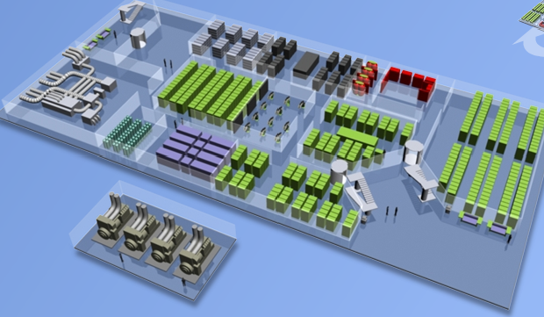

**Part No 4:**

* **Dark fiber:**

Associating remote locales utilizing dull fiber gives the best measure of adaptability and control. The term dull fiber basically implies fiber optics that have been run, however aren't presently being used. If, as an association, you own the dull fiber between remote locales, this is a very smart arrangement as it gives confidential vehicle utilizing anything speeds you can run given the sort of cabling between the two destinations. In any case, on the off chance that you do not possess the fiber running between two areas, it's conceivable that a transporter or region has dull fiber that you can rent. Simply remember that the expense to rent fiber is generally more costly than some other WAN choice accessible today. So, it is ordinarily possibly rented when speed and security are of most extreme significance.

* **MPLS:**

Multi-Protocol Label Switching (MPLS) is a generally utilized WAN arrangement that insightfully courses bundles through a specialist organization network utilizing a four-byte MPLS header that remarkably recognizes every client. MPLS permits clients to swear off complex WAN steering and nature of administration (QoS) strategies and on second thought puts that weight on the specialist co-op. According to the client's point of view, you basically have to course the proper inside networks across the connection.

Transporters ordinarily offer a few throughput choices, frequently going from 1 Mbps for tiny locales as far as possible up to huge number of Mbps. MPLS gives devoted and even data transfer capacity, which incorporates severe assistance level arrangements to guarantee you're receiving whatever would be reasonable. MPLS upholds highlight endlessly highlight multipoint relying upon your traffic-stream needs. MPLS likewise scales enormously well and can extend the globe. In this way, assuming you have an enormous WAN that traverses various topographical districts and require devoted throughput and inertness times, MPLS is logical an incredible choice as long as you can manage the cost of it.

* **Metro Ethernet:**

In the event that your remote locales are in a somewhat nearness, your transporter might offer Metro Ethernet as a less expensive choice contrasted with MPLS. Yet, as the name suggests, the help is restricted to explicit geographic areas. In this way, assuming your remote site falls beyond the Metro Ethernet limit, you must gander at an alternate WAN availability choice. Metro Ethernet is adaptable up too many remote destinations albeit not as versatile as possible MPLS, which can undoubtedly deal with huge number of locales. Metro Ethernet additionally is hugely simple to oversee as the transporter's handoff looks and acts very much like a standard Ethernet connect on your LAN.

Transporters commonly offer different throughput choices, frequently running between speeds a low as 5 Mbps as far as possible up to gigabit speeds. Since Ethernet works at layer two of the OSI model, you can utilize your own IP space for the end goal of steering. This is additionally valid for QoS as you can essentially expand your interior LAN QoS arrangements across Metro Ethernet. According to a data transport perspective, all locales look as though they are associated with a similar Ethernet switch inside the specialist organization cloud. Hence, all destinations are on a solitary multi-access organization and each site can discuss straightforwardly with all others on the WAN.