Hbase hive connectivity images

1)hbase table

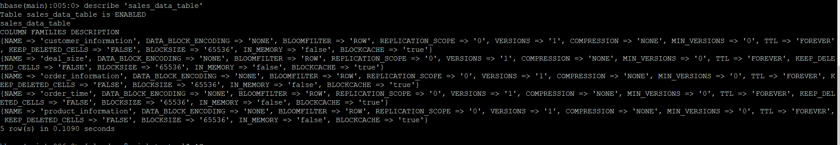

2)hive main table(connected to hbase)

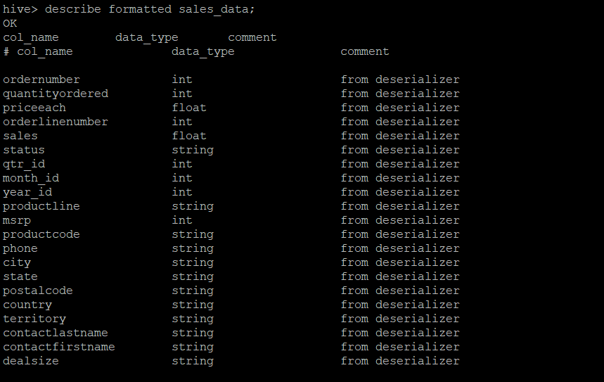

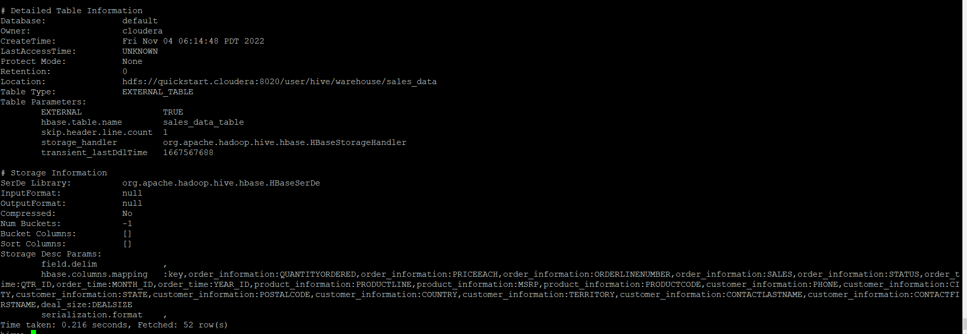

3)hive staging table and Load data from local to Hive Staging table :

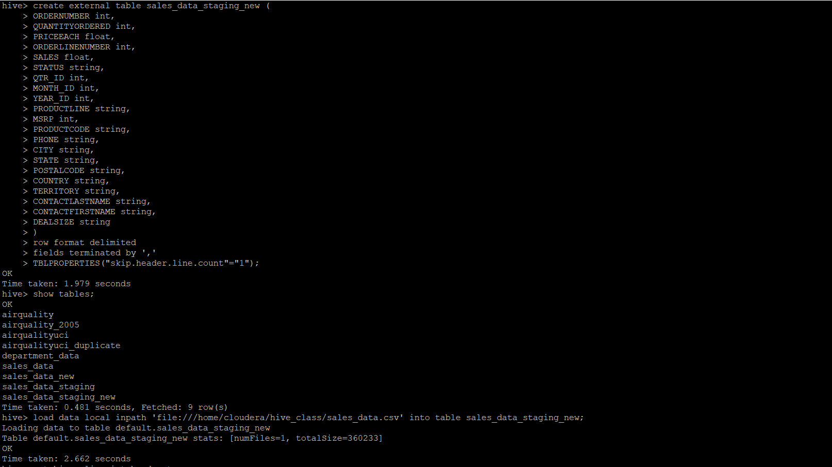

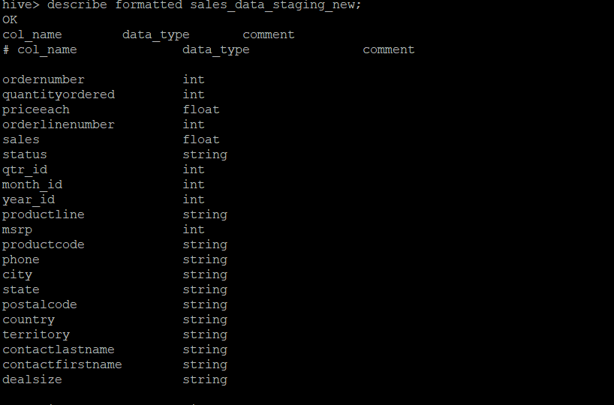

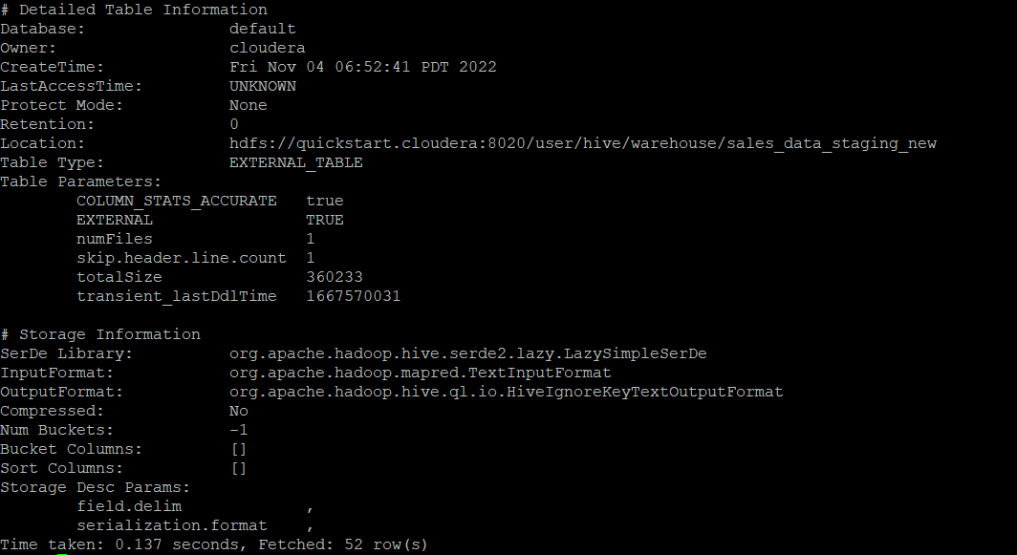

4) Load data into Hive external table(connected to hbase) from staging table

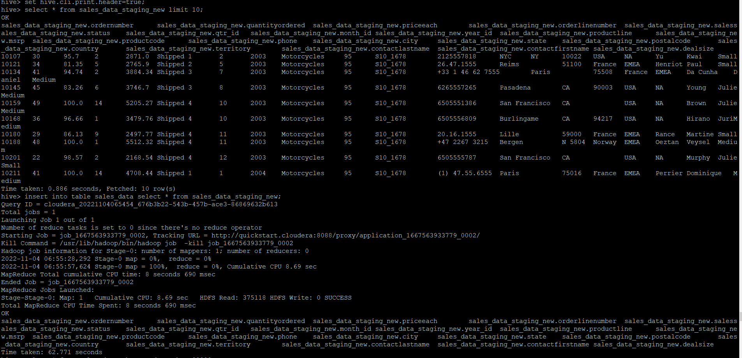

5) Use scan command in HBase to check data

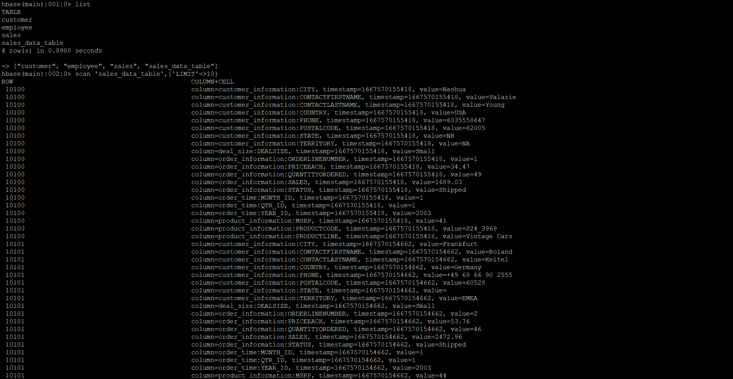

6)use put command to insert data in hbase table and check in hbase if data is inserted

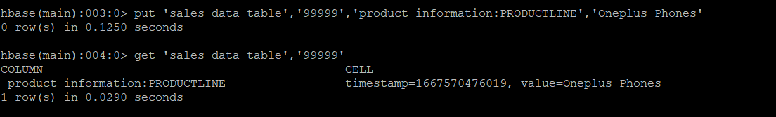

7)check the same data in hive table by runnying any hive query for the same:

