**ASSIGNMENT 2**

I. INTRODUCTION

This assignment is based on five individual countries which include “Algeria”, “Bahamas”, “Belgium”, ”Croatia” and ”Egypt”. The selection of the country has been done based on the climate-changing condition of the year from 1990 to 2019. The analysis is based on the emission of greenhouse gas depending on the urban and rural countryside of the population.

II. METHODOLOGY

This assessment is done in the platform spyder in the python platform from where it can easily visualizer the statistical analysis of the five individual countries of the world. The agenda of this assignment is to analyze the statistical data of the five individual countries to know the climate-changing condition of the last 32 years from 1990 to 2019 [1]. This assignment also provides a glance at the rate of emission of carbon dioxide along with the urban population. This analysis helps to visualize the drastic change in the climate in the middle of five counties.

III. RESULT

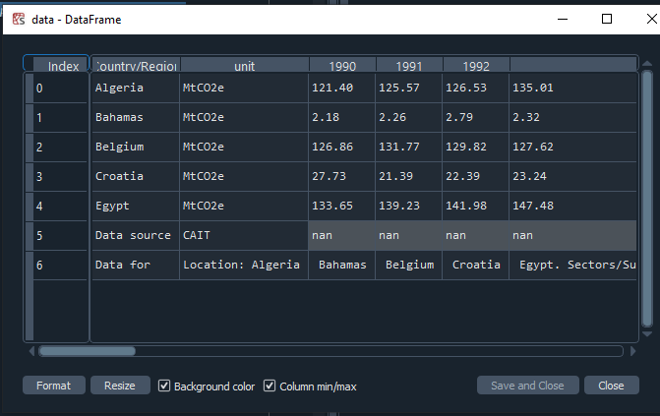

**Figure 1: Importing five individual country**

The above picture describes the details of the five countries which includes “Algeria”, “Bahamas”, “Belgium”, ”Croatia” and ”Egypt” [2]. There are five rows for five different countries and 32 columns which include the climate-changing values of the years starting from the year 1990 and the end of the year 2019. The sources of the data are “CAIT” and the location of the data is “Algeria”, “Bahamas”, “Belgium”, ”Croatia” and ”Egypt”.

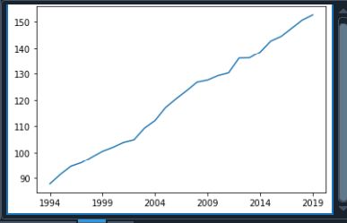

**Figure 2: Plotting of the mean value**

The provided image describes the mean value of the given years from 1994 to 2019. Which also defines the minimum and the maximum value of the year based on the particular year of the specific country [3]. For instance, in the year 1994, it was shown that the changing condition of the climate is low which is under 90 which means the climate change in the year 1994 is very low.

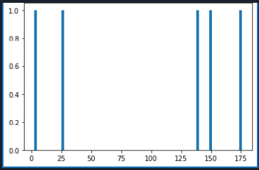

**Figure 3: Visualization of histogram based on the year 1998**

The above picture denotes the histogram visualization based on the year 1998. This denotes that in the year 1998 “149.15”, “2.67”, “138.07”, “25.81”, and “175.75” are visualized and denoted by using blue lines in the given picture.

**Figure 4: Heatmaps**Chart, histogram

Description automatically generated

The heatmaps generated are based on the five regions of the world. The heatmaps are used to display the connection in the middle of several variables and the plot has been done based on the given axis.

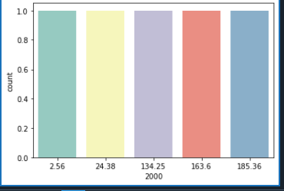

**Figure 5: Count plot of the year 2000**

This picture denotes the count plot of the year 2000 which denotes the observation of the categorical bins by taking help from bars. This image includes 5 individual bars which denote the climate-changing value of the year 2000.

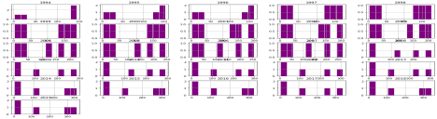

**Figure 6: Visualization of the data from the year 1990 to 2019**

The below image includes 26 bar graphs based on the corresponding data which define the condition of the climate changes based on the particular year.

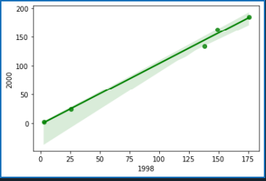

**Figure 7: Regplot of the year 1998**

The replot is used here to denote the comparison in the middle of the two different years which are 1998 and 2000. Additionally, this picture shows the green line which indicates the growth of climate change from the year of 1998 to the year 2000.

IV. CONCLUSION

After analyzing the five individual countries such as “Algeria”, “Bahamas”, “Belgium”, ”Croatia” and ”Egypt”; it can be said that country “Egypt” has a drastic change in the year 2019 which is 351.96 depending on the emission of greenhouse gases. The minimum climate change in the middle of the five countries is “The Bahamas” where the climate change rate is only 2015 based on the emission of carbon dioxide.