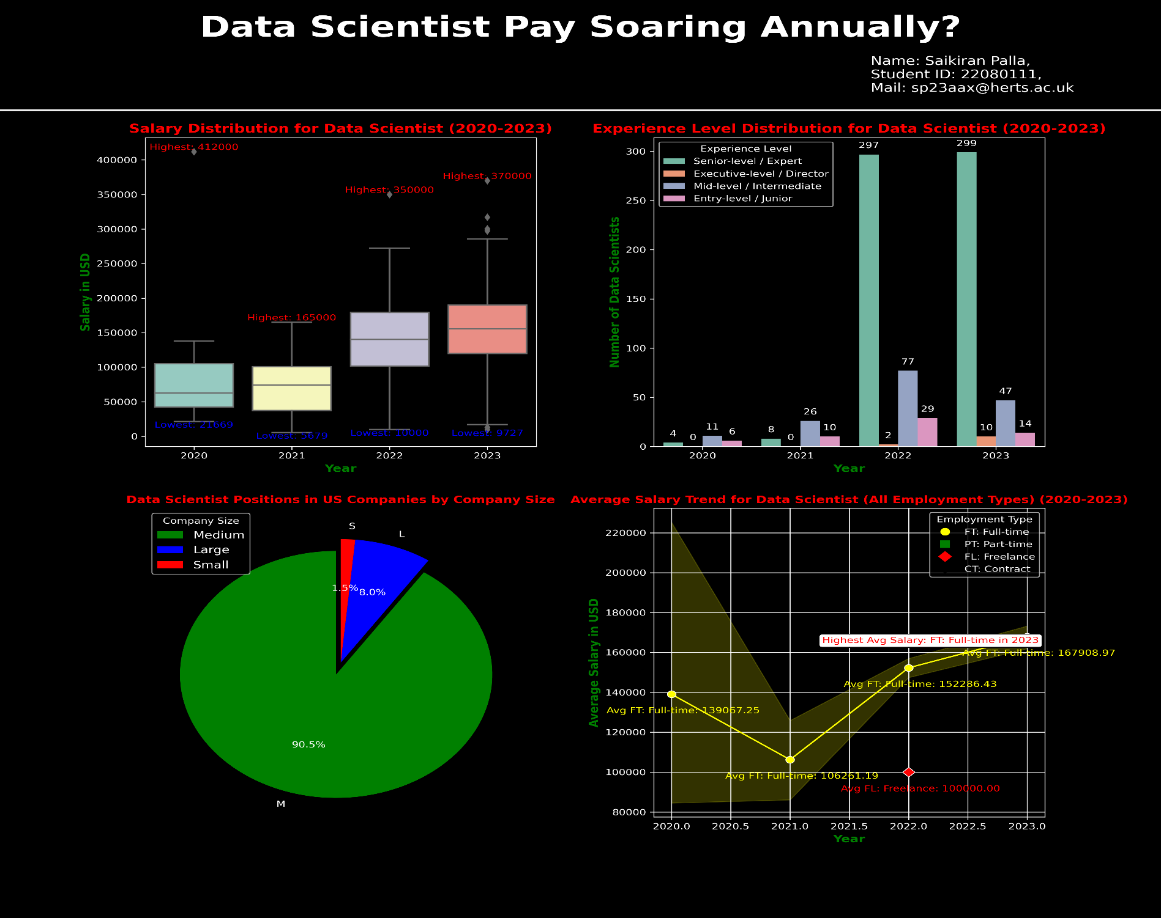

**Brief Description :**

***This Dashboard report describes to understand the Data Scientist’s Salaries in various aspects as this profession becomes increasing demand it may influence Data scientist’s Salaries and this analysis focus on impact on salaries.***

***Embark on narrative journey through the Data Science from the year 2020 to 2023 witness of the salary symphony unfold in a box plot reveals the range and central tendency of salaries during the period. A bar graph comes into view showcasing the Experience Levels over the years this shows highlighting the influx of skills while a pie chart illuminates the magical realm of US companies where 90.5% placed in Medium-sized corporate domains. The Climax reveals line plot showcasing the Average Salary Trend in all Employment Types this resultant has Full-Time commitments reigning supreme.***

***In Conclusion the above visualisation shows that data driven journey from 2020 to 2023 reveals a consistent annual increase in average salaries for Data Scientist, that marking a positive trajectory in the field.***

