PROJECT:
SCHOOL MANAGEMENT SYSTEM

(WEEK 4 ASSIGNMENT TASK 4)
Objective :
This week focuses on finalizing your Data Structures project. You will ensure the program runs smoothly, fix remaining issues, clean and organize your code, prepare final documentation, complete GitHub updates, and participate in a short in-class DS activity
Task A: Make Your DS Project Fully Stable :

Title:
- Task A – Make Your DS Project Fully Stable

Objective:
To make the School Management System fully functional and stable. All major operations should work correctly without crashing.

Major Operations:
- Add/Insert
- Delete/Remove
- Search/Find
- Update (if applicable)
- Display/Traverse

Features of the Project
- Admin, Student, Teacher login
- Student/Teacher/Book management
- Attendance marking
- Fee management
- Library management
- Exam scheduling & analysis
- Bus route (Dijkstra)
- Hostel management
- RFID entry
- Discipline score
- Notifications & events
- Discussion group
MAJOR OPERATION USED ON PROJECT FEATURE

Student / Teacher / Book Management
- Add: New records are inserted
- Delete: Records can be removed
- Search: Search by ID or name
- Update: Modify existing details
- Display: Show all records in GUI table

Attendance Marking
- Add: Mark student attendance
- Search: View attendance record
- Update: Correct attendance if needed
- Display: Show attendance list

Fee Management
- Add: Add fee payment record
- Delete: Remove wrong fee entry
- Search: Find student fee status
- Update: Update payment status
- Display: Show all fee records

Bus Route (Dijkstra Algorithm)
- Add: Add bus stops and routes
- Delete: Remove route
- Search: Find shortest path
- Update: Modify routes
- Display: Show route path and distance

RFID Entry System
- Add: Register RFID entry
- Search: Check student entry record
- Display: Show entry logs

Discussion Group
- Add: Post new messages
- Delete: Remove messages
- Search: Search messages
- Display: Show discussion threads
TABLE ON MAJOR OPERATION ABOUT FEATURE
Feature | Add | Delete | Search | Update | Display
Admin Login | – | – | ✓ | ✓ | ✓
Student Login | – | – | ✓ | ✓ | ✓
Teacher Login | – | – | ✓ | ✓ | ✓
Student Management | ✓ | ✓ | ✓ | ✓ | ✓
Teacher Management | ✓ | ✓ | ✓ | ✓ | ✓
Book / Library Management | ✓ | ✓ | ✓ | ✓ | ✓
Attendance Marking | ✓ | – | ✓ | ✓ | ✓
Fee Management | ✓ | ✓ | ✓ | ✓ | ✓
Exam Scheduling & Analysis | ✓ | ✓ | ✓ | ✓ | ✓
Bus Route (Dijkstra) | ✓ | ✓ | ✓ | ✓ | ✓
Hostel Management | ✓ | ✓ | ✓ | ✓ | ✓
RFID Entry System | ✓ | – | ✓ | – | ✓
Discipline Score | ✓ | – | ✓ | ✓ | ✓
Notifications & Events | ✓ | ✓ | ✓ | ✓ | ✓
Discussion Group | ✓ | ✓ | ✓ | – | ✓

Data Structure used in Project Feature:
Feature / Module | Data Structure Used | Reason / Purpose
Students | Array | Fixed basic student data storage
Teachers | Array | Simple record storage
Books (Library) | Linked List | Efficient insert/delete operations
Student & Teacher Records | ArrayList | Dynamic size, easy add/delete/search
Attendance Records | Queue | FIFO order for daily attendance
Exam Scheduling | Stack | LIFO based exam paper handling
Fees Records | ArrayList | Track student payments dynamically
Login Authentication | HashMap | Fast username-password lookup
RFID Entry Records | Queue | Entry tracking in arrival order
Discipline Score | HashMap | Quick access using student ID
Notifications & Events | Stack | Latest notification shown first
Discussion Group Messages | Linked List | Easy insertion and traversal
Bus Routes | Graph (Adjacency List) | Represent routes between stops
Shortest Bus Path | Graph + PriorityQueue | Dijkstra algorithm implementation
Student Performance | AVL Tree | Balanced tree for fast search & update

GUI Screenshots
Admin Dashboard:
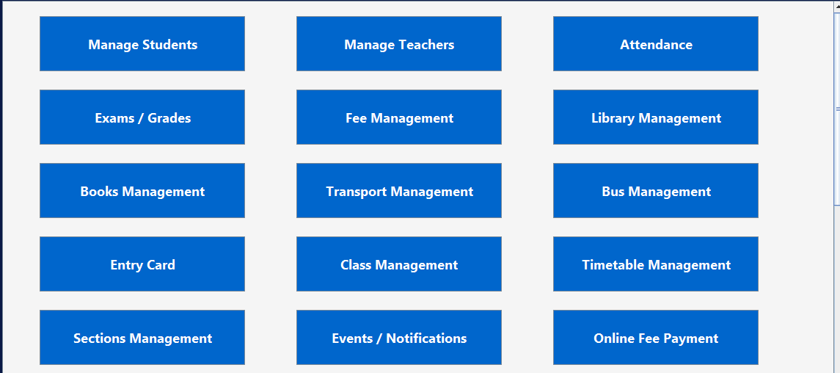
Attendence Manage:
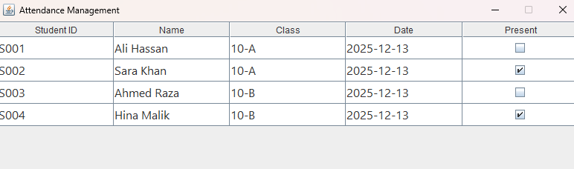
Teacher Manage:
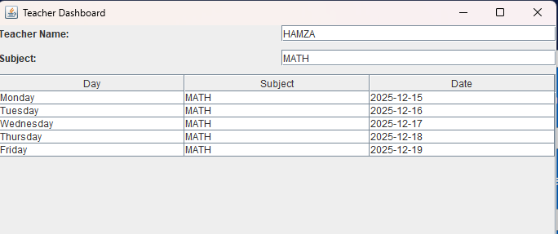
Student Manage:
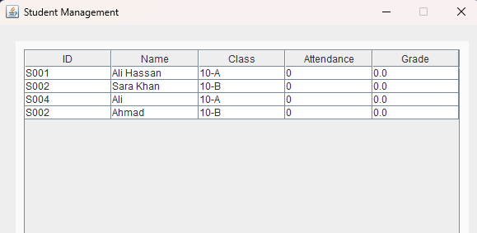

Task B – Code Cleanup and Modular Glow-Up

Title
- Task B – Code Cleanup and Modular Glow-Up

Objective
- Make the project code readable, professional, and modular.

Cleanup Steps
- Remove unused variables & unnecessary comments
- Break long functions into smaller helper functions
- Use clear variable and function names
- Add meaningful comments
- Move at least two functions to helper classes

Step 1: Remove Unused Variables & Comments
- Code me jo variables declare huay hain lekin use nahi ho rahe, unko delete karo.
- Example: int temp = 0; // unused → remove.
- Old or unnecessary comments delete karo.
- Example: // TODO: fix later ya // random test → remove.

Step 2: Break Long Functions into Smaller Helper Functions
- If any method 50+ lines on, use logical parts me split karo.
- Example – addStudent():
private void addStudent() {
if(validateInput()) {
insertStudent();
displayStudents();
}
}

private boolean validateInput() {
// Check fields & duplicates
}

private void insertStudent() {
// Add student to ArrayList
}

Step 3: Use Clear Variable & Function Names
- Short/unclear names replace on them:
- txt1 → txtStudentID
- btn1 → btnAddStudent
- s → student
- Function names clear on them:
- f1() → displayStudents()
- f2() → calculateFee()

Step 4: Add Meaningful Comments
- Write the Every Function on what it does:
- Example:

// Adds a new student after validation and updates the table
private void addStudent() { ... }

- Important logic lines about short inline comment add on them.

Step 5: Move Functions to Helper Modules / Classes:
- functions general utility can also work, To Take in separate file me move on them.
- Example:
- validateInput() → ValidationUtils.java
- displayStudents() → DisplayUtils.java
- GUI classes me helper functions call on them, not direct code repeat.

Step 6: Test & Verify
- Add, Delete, Update, Search, Display functions run on them → check for bugs.
- Ensure GUI crash-free and correct results show on it.

