**Braid (1):** 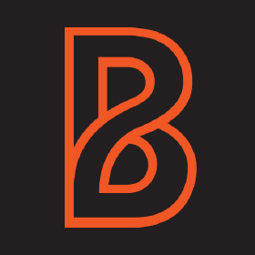

*Presenting June 1st*

*Likely a 7 week Internship*

Website: <https://www.wearebraid.com/about>

LinkedIn: <https://www.linkedin.com/company/wearebraid/>

Location: Charlottesville, VA

Company Info:

We are a developer-led digital agency specializing in apps, websites, and digital experiences.

Braid is an on-demand team of software engineers, tailor-made to function as the development arm for our partner businesses. We understand that the development of applications and websites rests outside of the comfort zone of many organizations, especially considering the vetting, hiring, and management expertise required to smoothly operate a development team. We believe that a better approach is to partner with a technology team that will scale on-demand based on your specific needs. That is exactly what Braid provides to our partners.

Job Description:

Our intern will be writing and shipping code for our clients and/or our internal tools and products. They will work and learn from our senior level developers and interact with all Braid team members. They will get to experience a budding startup in its early stages!

They will need help doing work using HTML, CSS, Javascript, and potentially some Vue.js, React, PHP/Laravel, and User Experience design.

Who you’ll be working with:

Luan Nguyen, Founder & Software Engineer

**(Braid) What clients have you worked with and what scale of projects did they involve? What major purposes did they serve?**

**(Braid) Is there any particular focus that you set your goals on?**

**Digital ReLab (1):** 

*Presenting June 8th*

*Potentially a 8 week Internship*

Website: <https://www.digitalrelab.com/>

LinkedIn: <https://www.linkedin.com/company/digital-relab/>

Location: Charlottesville, VA

Company Info:

Digital ReLab is a technology company changing the way people think about and interact with digital media and metadata. We are creatives creating software for creative people. We manage multimedia content for some of the biggest names in media and entertainment and are rapidly extending our platform and clientbase.

Job Description:

Our Full Stack Engineering student will learn gain real life experience in developing, supporting, and testing Digital ReLab applications. The intern can expect to participate in daily Agile project management activities including stand-up meetings, individual task management and communication of status and **impediments**. As a full stack engineer you will be exposed to the development and support of AWS based infrastructure that supports both development operations (DevOps) and application hosting environments.

Some preferred knowledge would be TypeScript, JavaScript, Node.js, React & Redux, AWS, Relational Databases, HTML & CSS, Git, and Docker.

Who you’ll be working with:

#### John Leimgruber, Senior Developer

**Solovis (1):** 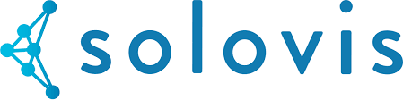

*Presenting June 1st*

*Potentially an 8 week Internship*

Website: <https://www.solovis.com/>

LinkedIn: <https://www.linkedin.com/company/solovis-llc/>

Location: Charlottesville, VA

Company Info:

Solovis is a multi-asset class portfolio management and reporting solution for foundations, endowments, pensions, OCIOs and family offices. Specifically designed and built for the age of open architecture asset management, Solovis is a flexible, robust platform created to generate detailed analysis and dynamic data modeling across multiple portfolios and pools of capital. With the click of a button, the Solovis platform delivers actionable, transparent, customized reports that empower investors spanning the front to back office.

Job Description:

As a Data Analyst Intern at Solovis, you will spend your days building and repairing a variety of VBA-based tools that we will use to facilitate the processing and analysis of complex financial data. These tools will range from basic data integrity checks, to complex reconciliation of performance metrics, across a wide array of financial data from public and private multi-asset class portfolios. At the end of your internship, you will have created a library of tools that will be used by Solovis' Analysts on a day to day basis. In addition to your VBA tasks, you will gain exposure to the institutional investment industry by shadowing and assisting our analysts during active client implementations. You will learn how the Solovis analytics engine handles our clients' multi-asset class portfolios which include investments in Private Equity, Hedge Funds, Fixed Income, Public Equities, etc.

Preferred skills would be **VBA, Excel, SQL(not required),** Must be highly detail-oriented, Above-average ping pong skills, Background in finance, math, economics, computer science or other quantitative fields is preferred but not required. Will require drug test.

Who you’ll be working with:

David Nadolski

**(Solovis) In the end, what kind of features or parts of software would the intern be expected to have built? What sorts of tools?**

**Room Key (1):** 

*Presenting June 8th*

*Likely a 6 week Internship*

Website: <https://www.roomkey.com/>

LinkedIn: <https://www.linkedin.com/company/room-key/>

Location: Charlottesville, VA

Company Info:

Room Key is a hotel search engine that gives travelers access to low Loyalty Rates for more than 60 of the world’s largest hotel chains. Loyalty Rates are typically only available on the hotel’s own website, but Room Key has direct access through its partnerships, making it the only travel site where customers can shop and compare these Loyalty Rates across many hotel chains all at once.  
  
Unlike your typical start-up, we are backed by huge names in the hotel industry, all of whom have a vested interest in our success. We move fast, work hard and have lots of fun along the way. We are nimble despite long-lived applications and deploy quickly. Every team member has a hand in designing and implementing features that go to production daily.

Job Description:

Our front-end engineer will explore a mature code base for a hugely trafficked site built on cutting edge React ecosystem. Engineers have the **opportunity to learn how to work at scale, with automated testing, continuous integration and trunk** based development. Technologies involved include Webpack, Preact (react-light JSX), Mocha, Chai, WebDriver, Mapbox and much more. Front-end engineers should have experience with JavaScript and other web technologies. **Exposure to [p]react is a big plus**.

Who you’ll be working with:

Jerome Dane

**-(Roomkey) What sorts of features would the intern be expected to add to the current development?**

**-(Roomkey) How does trunk based development work with Roomkey's web and software?**

**Sabreez (1):** 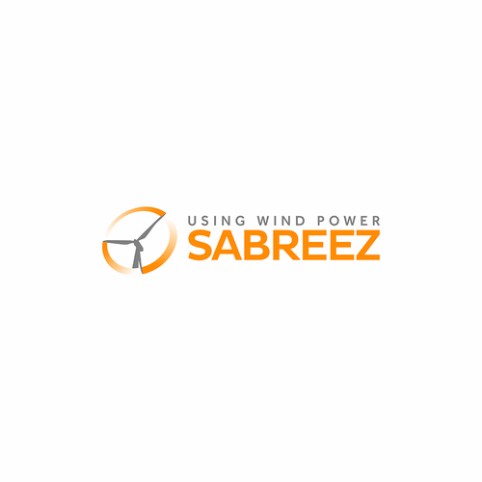

*Presenting June 1st*

*Likely a 7 week Internship*

Website: <https://sabreez.com/>

LinkedIn: <https://www.linkedin.com/company/sabreez-llc/>

Location: Charlottesville, VA

Company Info:

Sabreez is essentially the Weather Channel for energy. We show consumers the Wind Number and Solar Boost, which describe electric power in markets that have a lot of solar and wind in consumer-friendly terms to encourage load shifting. This helps our customers, electric power utilities, telecoms, and smart home companies, encourage load shifting using their product or service.

Job Description:

Sabreez has introduced our API on AWS. This project will take the Weather Company API and CAISO APIs and create a clean energy forecast that will automate our forecast, and update throughout the day.

Who you’ll be working with:

Scott Hoppe

**(Sabreez) How is the software being used by the consumers right now? What purposes does it exactly serve?**

**(Sabreez) What are interns expected to do during the first few weeks of their internship?**

**Meriwether Godsey (2):** 

*Presenting June 8th*

*Potentially an 8 week Internship*

Website: <http://www.merig.com/>

LinkedIn: <https://www.linkedin.com/company/meriwether-godsey/>

Location: Charlottesville, VA

Company Info:

Meriwether Godsey is a contract dining company that operates dining facilities at 28 colleges, day schools, boarding schools and corporate campuses from North Andover, MA to Greensboro, NC. What makes Meriwether Godsey different is our commitment and capacity to create unique, customized dining experiences for each of our client communities; to set higher standards for ourselves and to meet them; and to provide more support to our teams to deliver on these promises. Headquartered in Central Virginia, our partnerships with clients and employees begin with our culture & Core Values. Experience it once and you will understand! We are a family of over 650 talented, and dedicated “owners” — managers, chefs, and service staff — operating from North Carolina to Massachusetts. Learn more by visiting www.merig.com or following us on Facebook.

Job Description:

MG needs 2 software rockstars to help us build a mobile first, web app that will allow our patrons to browse the menu for a specific location and filter for allergen and nutritional values. Our menus are very dynamic. We have a 28 day menu cycle with different menu items each day. Many of our locations feed young children who have allergies and parents would like to be able to filter the menu based on the allergens so they can build a meal that is safe for their child. The app will also allow the user to select what they will eat and calculate the nutritional values for the meal (calories, fat, sugar, salt, etc.). The web app will query **2 separate cloud based databases** through APIs; **a custom menu database and a recipe/allergen/nutrition database from PeachWorks.** The app will allow for personal profile(s) for yourself or your children so you can easily filter based on the profile. The intern should know **Rails or Node, Javascript**

Who you’ll be working with:

Marcus Nucci

**Axle Travel (1):** 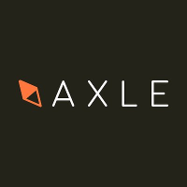

*Presenting June 1st*

*Potentially an 8 week Internship*

Website: <https://axletravel.com/>

LinkedIn: <https://www.linkedin.com/company/axletravel/>

Location: Charlottesville, Va

Company Info:

Axle provides long-distance travelers with end-to-end transportation by combining privately chartered buses with last-mile shared-mobility services. At Axle, we believe that the spaces between cities should never come between friends. That mass-passenger transportation networks should be designed for people, not packages. And that the road to a brighter future is best traveled together.

Job Description:

The intern will **rebuild our website** to auto generate web pages for SEO. Potentially work on Mobile / Web App. Preferred/Expected knowledge should include React and Python (Flask).

Who you’ll be working with:

Shawn Vo

**(Axle Travel) Are there any issues with the current running website? What is the protocol in order to improve and rebuild the site so that it can reach best SEO?**

**(Axle Travel) How is the software currently being used by consumers?**

**(Axle Travel) Any potential for machine learning?**

**Welld Health (1):** 

*Presenting June 1st*

*Potentially an 8 week Internship*

Website: <https://welldhealth.com/>

LinkedIn: <https://www.linkedin.com/company/welld-health/>

Location: Charlottesville, Va

Company Info:

Welld is a Ruby startup aimed at collecting health data in health clubs and through corporate health programs. We reply on data integrations with numerous systems and wearables to deliver an Electronic Wellness Record to individuals seeking to control their own journey to health. As a company that deals with Protected health information (PHI), we ensure HIPAA compliance at all levels of our infrastructure and code.

Job Description:

We are a small shop, and we hope to give the intern exposure to all aspects of our business, including:  
* DevOps (programmatic approach to infrastructure)  
* Creating a database seed file  
* Organizing code infrastructure  
* Feature development (pair programming)  
* Engaging with client support requests  
* Startup environment

Who you’ll be working with:

Jessica Otey

**(Welld Health) What technologies/libraries are used in order to manage the data integration between multiple systems and wearables?**

**(Welld Health) How does Welld Health plan on using the health data it accumulated?**

**(Welld Health) Through what tools have you collected and integrated the data?**

**Tucows/Ting (1):** 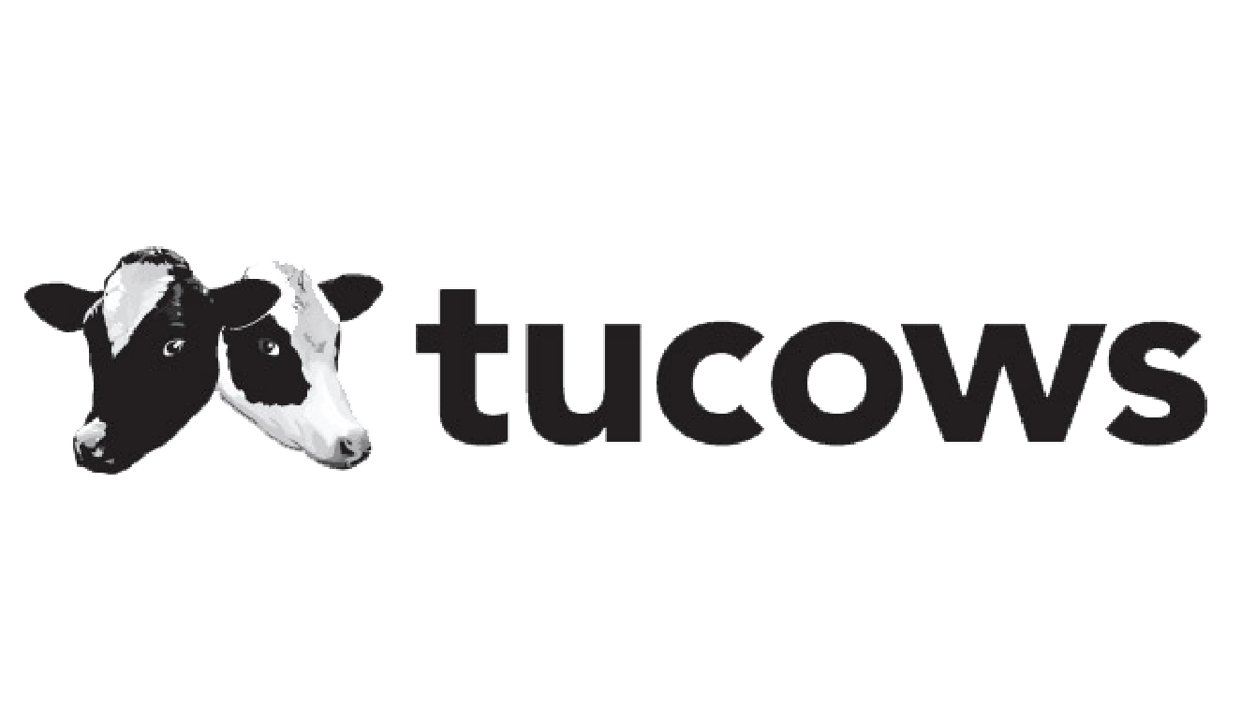

*Presenting June 8th*

*Potentially an 8 week Internship*

Website: <http://www.tucows.com/>

LinkedIn: <https://www.linkedin.com/company/tucows/>

Location: Charlottesville, Va

Company Info:

We offer Internet services to thousands of business partners and millions of end users around the world, including:  
  
• The leading wholesale platforms for selling and integrating domain names. (OpenSRS, Enom)  
• The simplest way for businesses and individuals to manage their domain names. (Hover)  
• A mobile phone service that makes shockingly good sense for US families and businesses. (Ting Mobile)  
• Symmetrical gigabit fiber Internet serving select “Ting towns” in the US. (Ting Internet)

Job Description:

As an intern with Tucows your role will be part of a development team creating microservices that will be part of the backbone that runs all of the company's lines of business. The core components of the microservices technology stack will be Unix, Python, PostgreSQL, Django, and RabbitMQ.  
  
The bulk of your tasks will be to write Python code to complete discrete features of one or more microservices. You'll be working very closely with me to understand the problem, create a design and approach, develop the software solution and requisite test frameworks, and supporting documentation.  
  
While I hope that your contributions will be material to our success, I am really hoping that you learn a lot, and that we have fun!

Preferred experience with Python is very important. A great attitude and the ability to take work direction and ask for help is also very important. Experience with Django and PostgreSQL are nice to have.

Who you’ll be working with:

Doug Ramirez

**Mission Secure (1):** 

*Presenting June 1st*

*Likely an 8 week Internship*

Website: <http://www.missionsecure.com/>

LinkedIn: <https://www.linkedin.com/company/mission-secure-inc-/>

Location: Charlottesville, Va

Company Info:

MSi (Mission Secure, Inc.) is a specialized provider of next generation cyber defense solutions protecting **industrial control systems and critical physical assets in energy, transportation and defense.**  
MSi’s unique technology was built upon R&D at the University of Virginia in cooperation with the U.S. Department of Defense dating to 2010. Multiple pilot programs tested the technology over the years, transforming this innovative approach into a patent-pending hardware and software platform.

Job Description:

The intern will assist in the development of cyber defense software. More information pending presentation will be available.

Who you’ll be working with:

Dan Park, Ed Suhler

**(Mission Secure) What skills sets or technologies should the intern be familiar with to perform best?**

**(Mission Secure) How is the softwa re being currently used right now?**

**ILab at Darden (1):**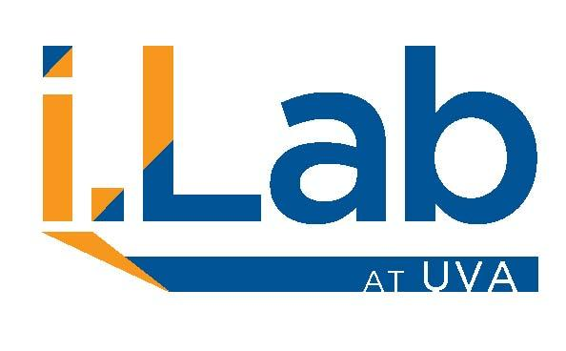

*Presenting June 8th*

*Potentially an 8 week Internship*

Website: <https://www.ilabatuva.org/>

LinkedIn: <https://www.linkedin.com/company/i-lab-uva/>

Location: Charlottesville, Va

Company Info:

The i.Lab is a University-wide initiative that creates a nexus for entrepreneurship and innovation education. Its mission is to foster deep cross-collaboration with no boundaries, across disciplines, schools or ways of thinking. The i.Lab provides coaching, courses and incubation to students, faculty and community members innovating the future. Initiatives such as the i.Lab help create a robust entrepreneurial ecosystem within U.Va. and its surrounding community. The i.Lab is a collaborative effort of 11 schools of the University, the Provost’s Office, and U.Va. Innovation.

Job Description:

The intern will assist in a number of projects in a series of flexible roles for the various entrepreneurs at the Ilab using the Information gained in the Launch program. More information available pending presentation.

Who you’ll be working with:

David Touve

**Dorsata (1):**

*Presenting June 8th*

*Likely a 7 week Internship*

Website: <https://www.dorsata.com/>

LinkedIn: <https://www.linkedin.com/company/dorsata/>

Location: Charlottesville, Va

Company Info:

Dorsata enables healthcare providers to make better decisions that are informed by data and best practices. The company provides teams of clinicians tools to build, share, and then use defined workflows, called care pathways, for efficient decision-making, documentation, and order entry. Leveraging these clinician-developed care pathways, Dorsata is committed to transforming healthcare from a cost-reduction and quality improvement standpoint.

Job Description:

The ideal intern will assist in software development tasks related to the company’s core mission. More information pending there presentation.

Who you’ll be working with:

David Fairbrothers, Greg Herrington

**Psikick (1):** 

*Presenting June 8th*

*Potentially an 8 week Internship*

Website: <http://www.psikick.com/>

LinkedIn: <https://www.linkedin.com/company/psikick/>

Location: Charlottesville, VA

Company Info:

We are developing self-powered wireless sensing systems built upon our breakthroughs in ultra-low-power digital and RF circuit design. The extreme energy efficiency of our devices enables them to be powered without a battery, from a variety of harvested energy sources including indoor solar, thermal gradients, vibration, and radio waves. PsiKick delivers complete end-to-end systems--from data acquisition to cloud analytics--allowing customers to focus on the new, high-value insights delivered by our systems.

Job Description:

The intern will assist in writing backend software and cloud infrastructure, perform maintenance repairs and bug fixes, conduct user interviews, and potentially develop a web application for central engineers.

Who you’ll be working with:

John Greenfield