RESTFUL SERVICE:

In the IService1.cs interface file, under Interface class, we are going to define a sample method named GetData2

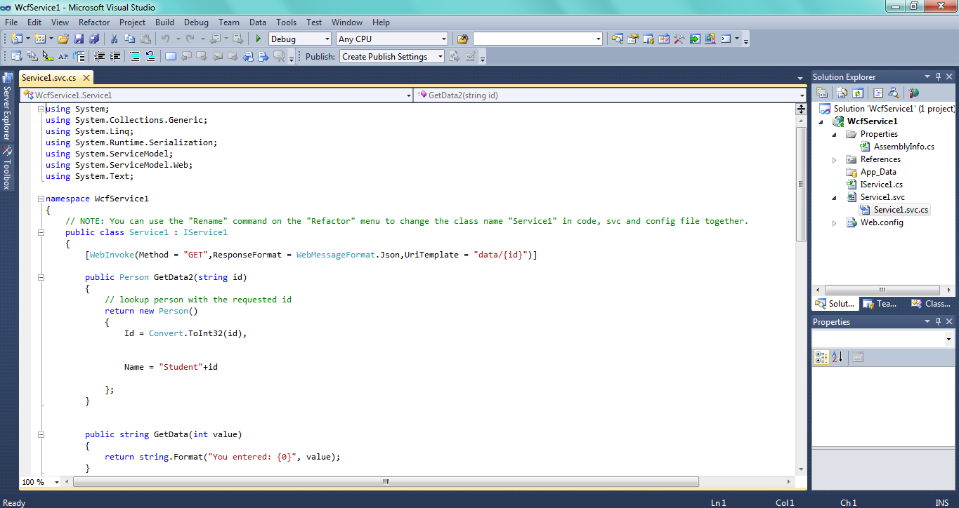

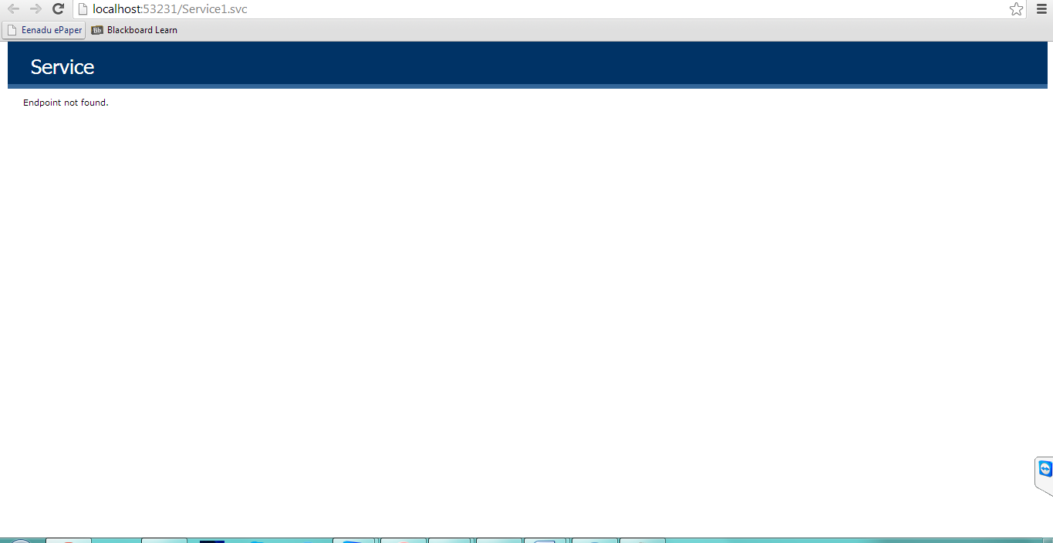

In the Service1.svc.cs file, we will implement the real function under the corresponding interface we get

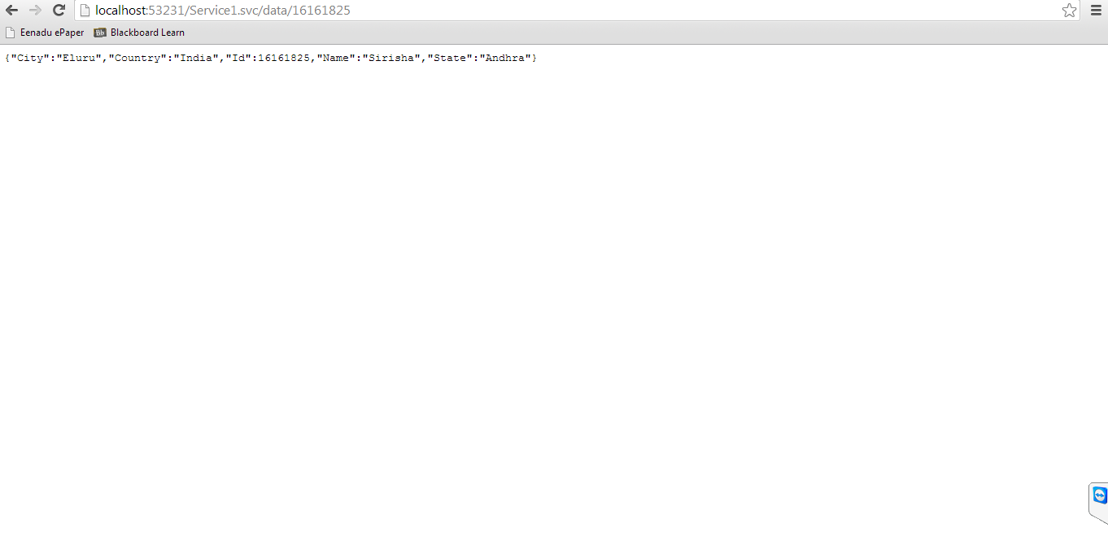

SOAP SERVICE:

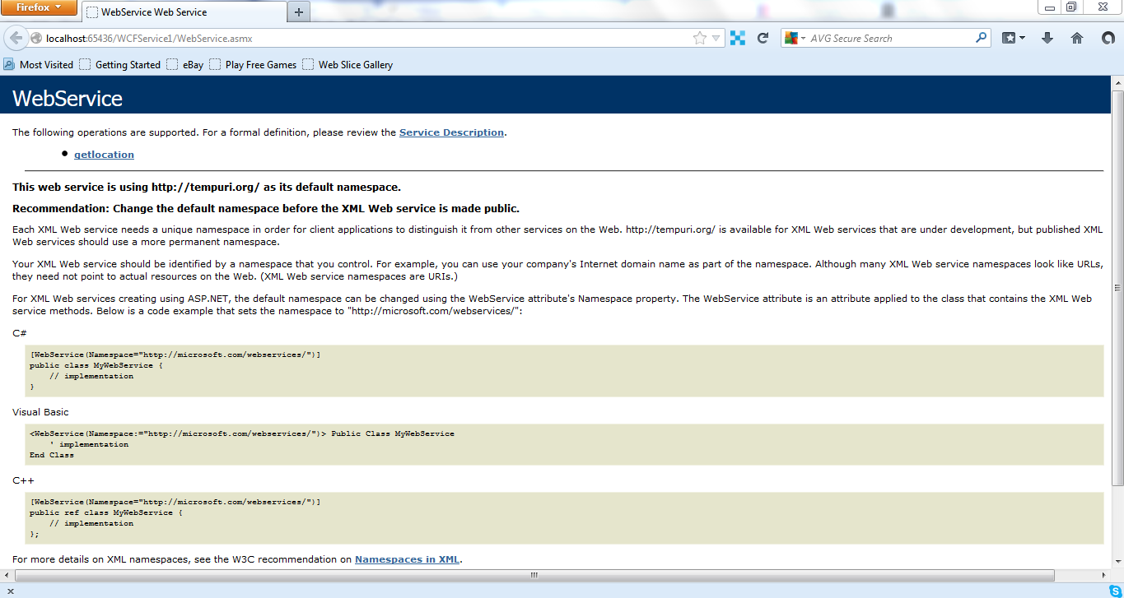

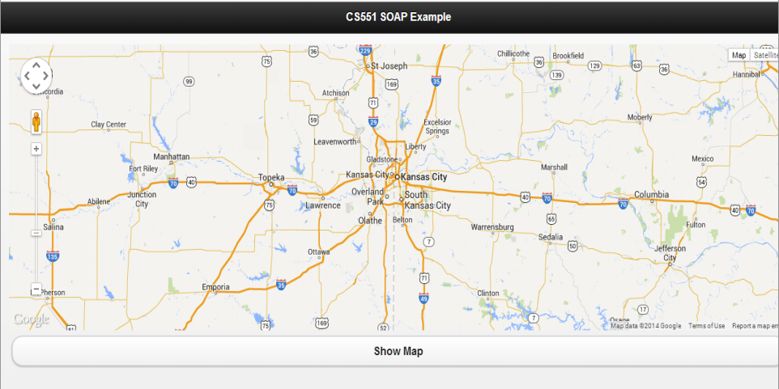

MY ANDROID APP: Opening a file choosing with Camera option in Web view option. In this app I haved used some existing webservices such as capturing form camera, choosing file as an image and I have created my own webservices for url click view of an image.

1. Opening url in webview and showing the progress for particular page.

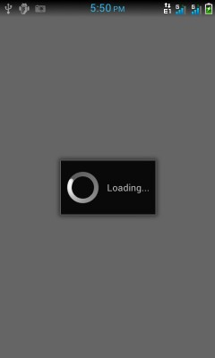

2. Show file chooser for webform file option.  
  
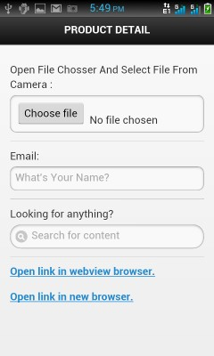

Show camera option in file chooser, capture image from camera and store in sdcard and select image for file option.  
  
**4. For an url open click view**

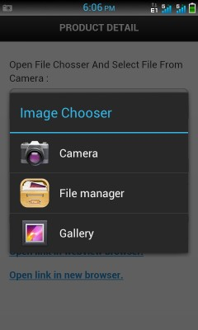  
  
 **5.**  Open link from webview browser to new browser and open link from webview browser to webview browser.

