MASHUP APPLICATION

I have developed a mash up application which is a combination of Geo location and Geo directions.

When I run the code in the js fiddle I have got the following result.

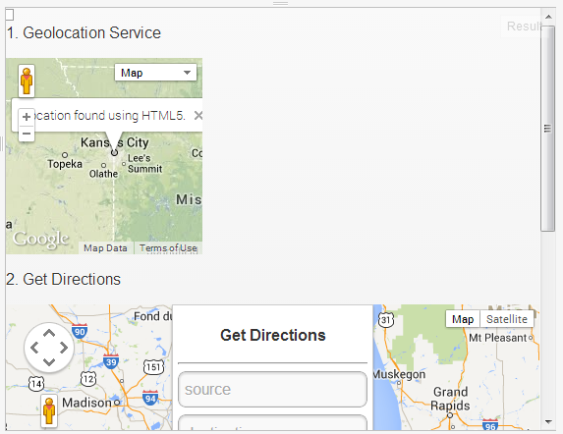

After submitting the source and destination I got the following result

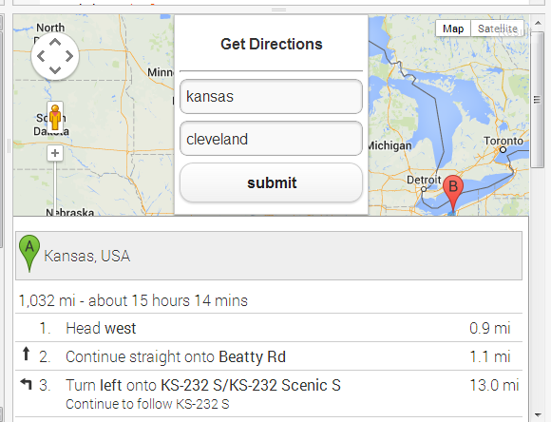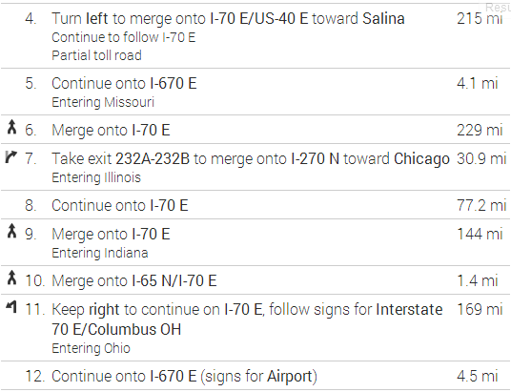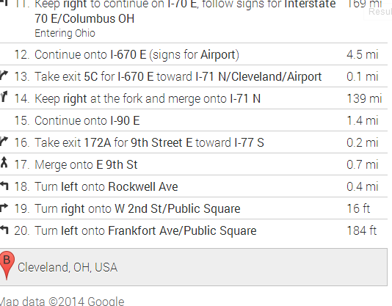

Here is the output link of the jsfiddle: <http://jsfiddle.net/92jqK/2/>