MIDEXAM

Sirisha pakalapati

Id no: 16161825

ARCHITECTURE DIAGRAM:

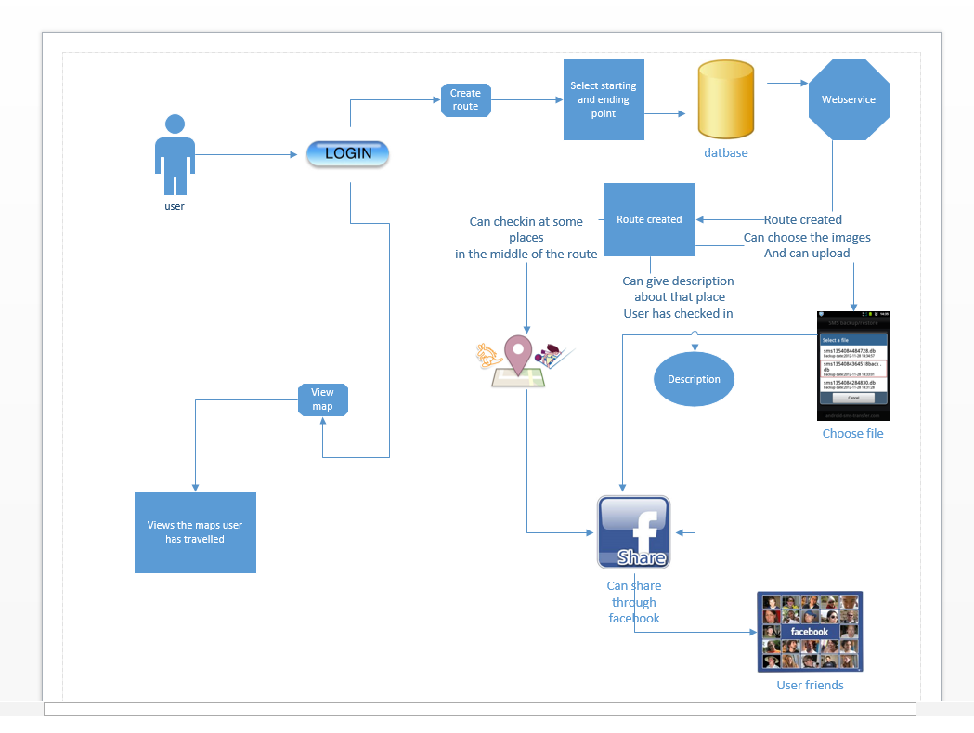

CLASS DIAGRAM:

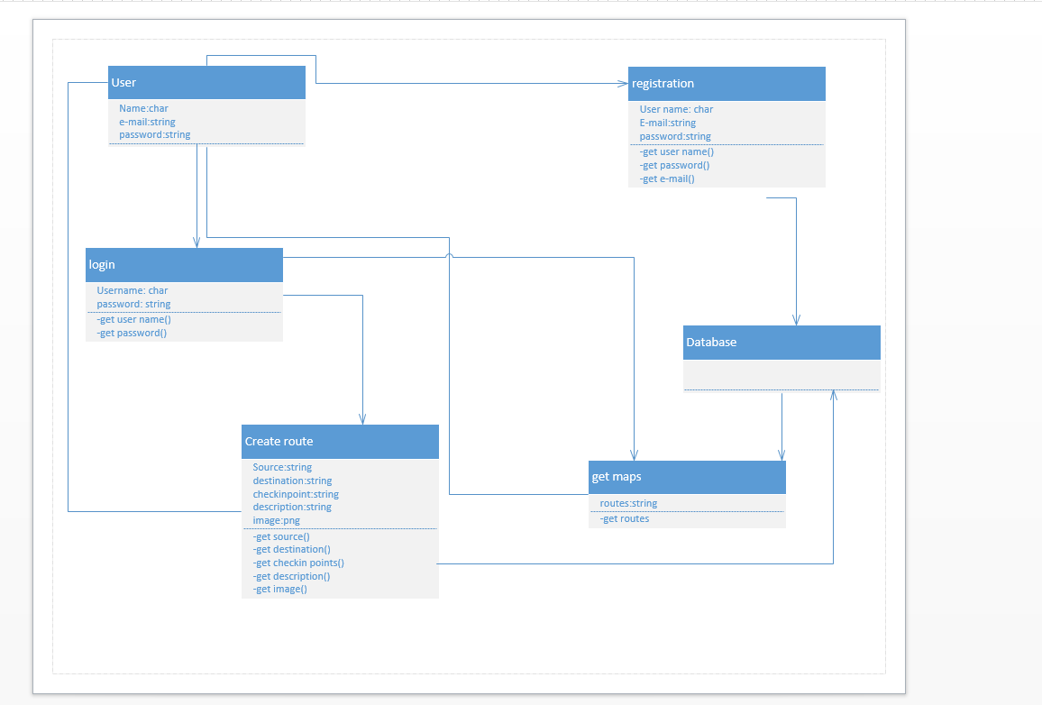

USER INTERFACES:

This is my home page for the given project:

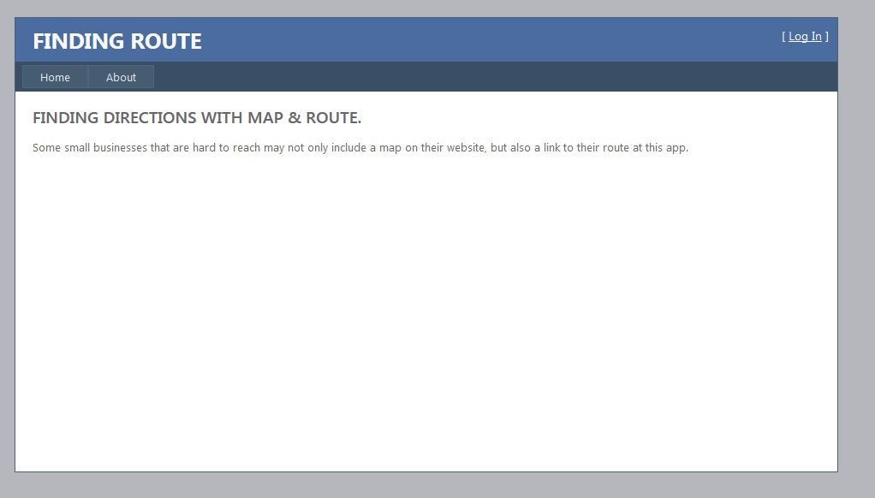

Home button is nothing but, when clicking on it I will get the home page. On clicking the ABOUT button we will get what all this is about.

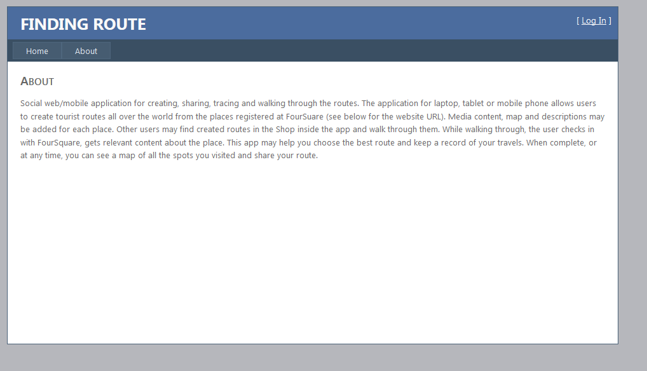On clicking the LOGIN button we will get the following page:

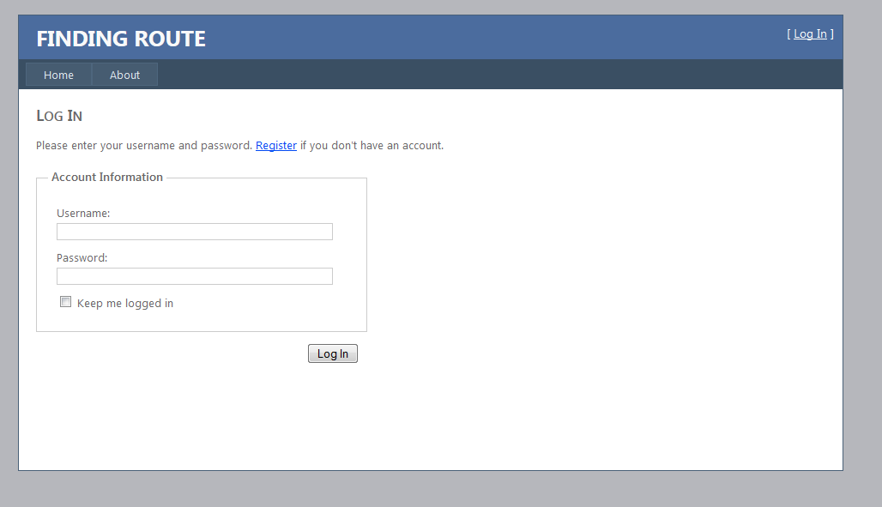

If we didn’t register before we have click on the REGISTER button, we will get the following page:

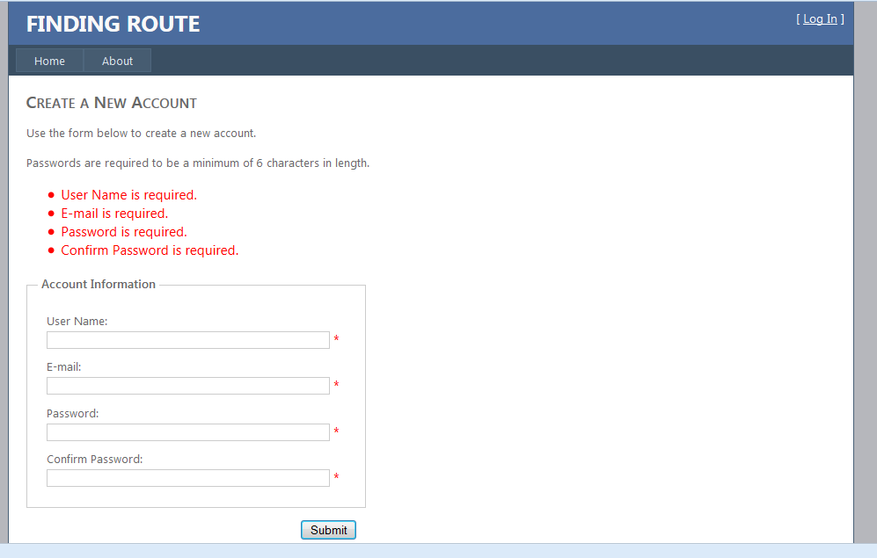

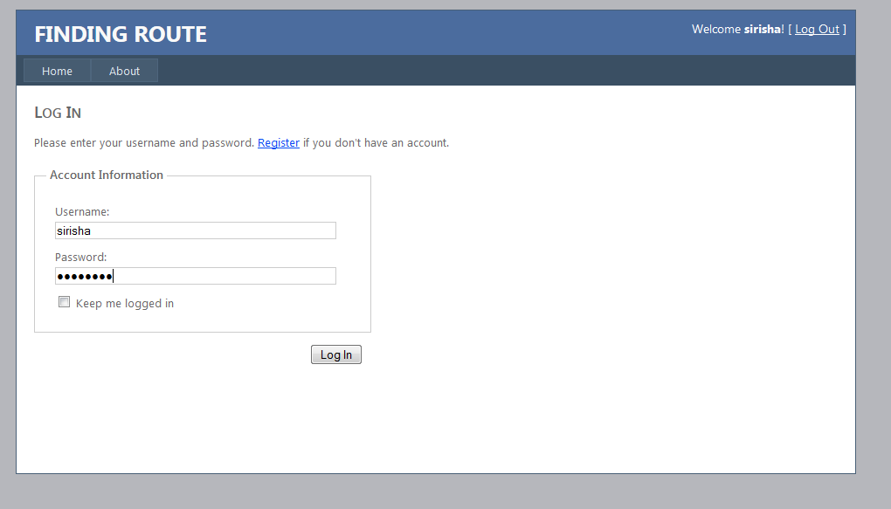

Data is stored in the database:

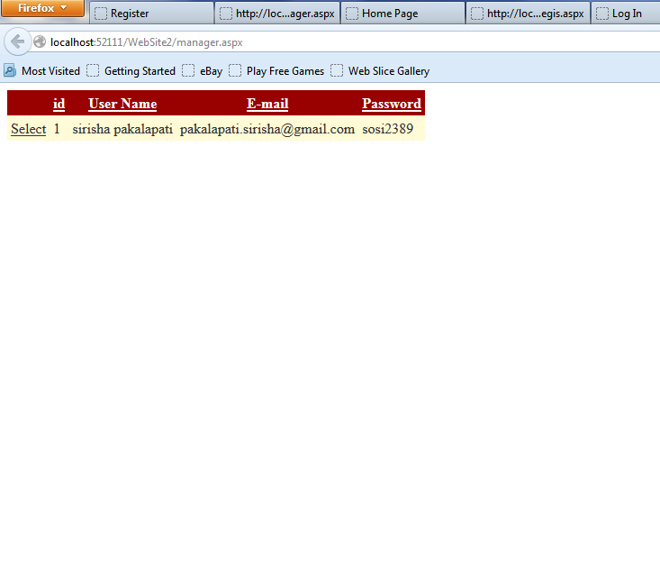

After logging in we will get the following screen:

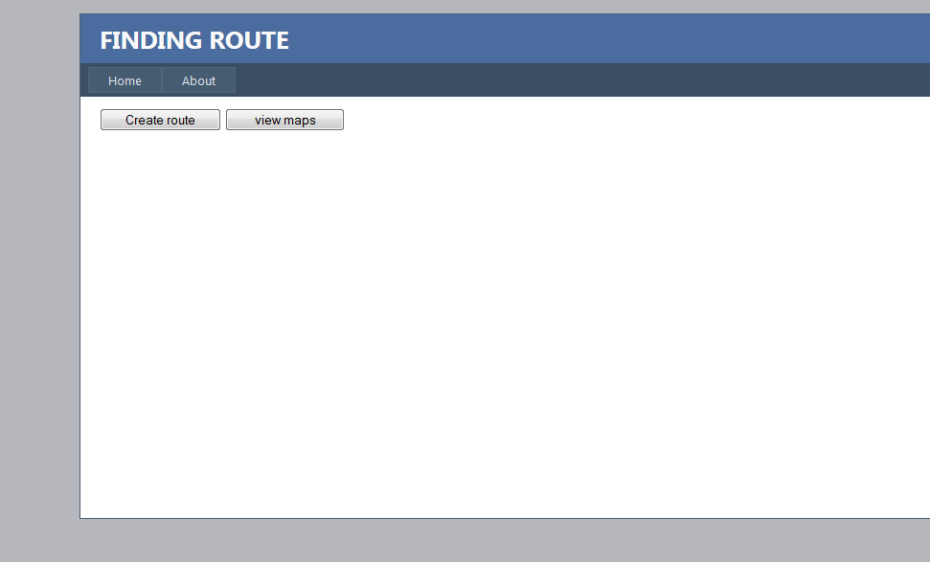

If we click create route then we will get the following screen:

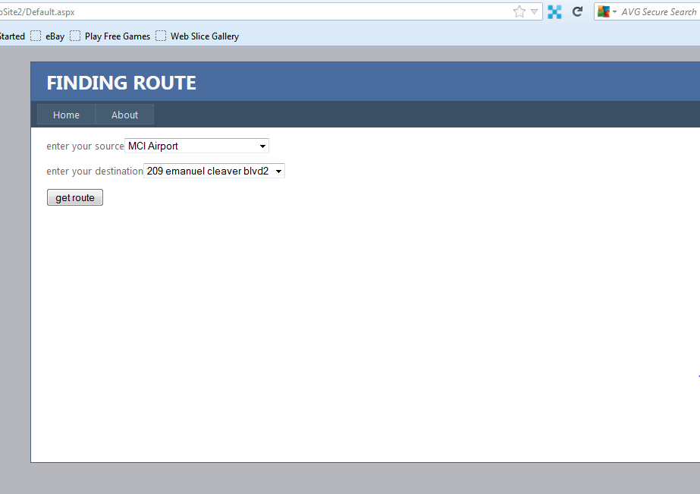

On clicking the get route we will get the following screen:

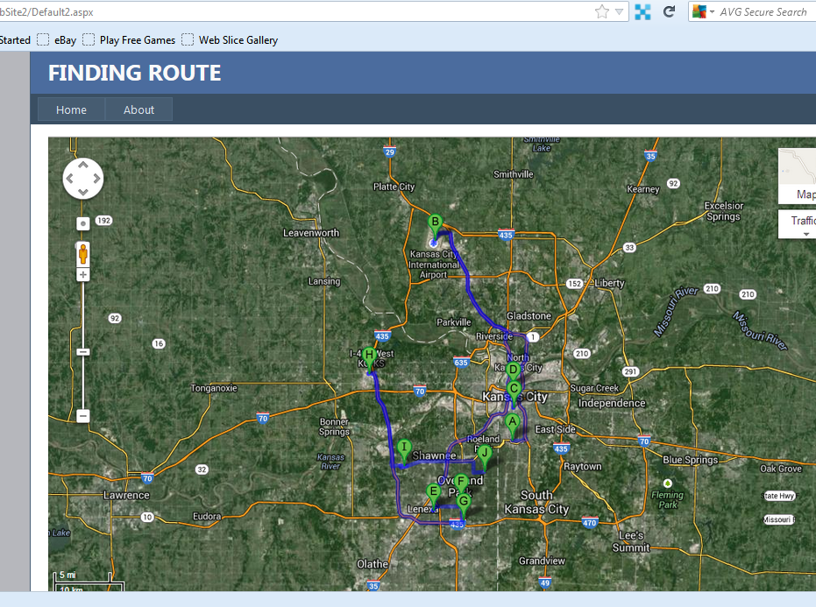

The points on the map such as A,B, C, D are the points of checkinplaces, due to the lack of time I cant be able to upload pictures and post it.

**Software Requirements:**

* Operating system : Windows XP.
* Backend : Jsp ,Servlets
* Frontend : HTML 5, CSS ,JQuery, Ajax
* Data Base : MySQL
* Server : Tomcat 7.0

I have used the API of GOOGLE MAPS for the creation of the route

LIMITATIONS:

I have used the available templates for the creating interfaces due to the time constraint.

The GITHUB link of my midterm is: https://github.com/sp3pd/midexam.git