|  |
| --- |
| **University of Missouri Kansas City** |
| **Smart Tube** |
| **Project Plan** |

**Sree Vishnu Satarajupalli**

**Prakash Garapati**

**Sirisha Pakalapati**

1. **Project Proposal**
2. **Introduction**

Watching videos or listening to music during a get together of friends or while a hangout with friends becomes a tricky task. Satisfying each and every one in the gathering with the videos or music becomes even trickier. While people hanging out would like to listen to music or watch videos together it gets confused as with a number of choices with number of people gathered around it becomes hard to listen to each and everyone’s request and considering everyone’s request and meeting each request. Till now the existing music and video searches have been only for meeting a single user requirement.

1. **Project Goal and Objectives**

* **Overall Goal:**

The objective of the Smart Tube is to create an efficient and user friendly interface to the users of the application such that they can enter their preferences to get the videos or music meeting everyone’s requirements using the interface provided and based on the their and others preferences when all are in a group connected through a group name and a key where the preferences include language, genre, artists.

* **Specific Objectives(Problem Statement):**

The main purpose of this application is provide the users who are gathered and want to play music and videos such that every member in the group gets the chance of hearing to their choice of music and watch videos of their choice. The users set their preferences using the application interface provided to each user with common group name and a key for uniqueness of the group. The preferences include the language, genre, artists etc. After each user in the group set the preferences and asks for results the results are shown according to the preferences set and matching preferences and most number of views for a video or audio.

* **Significance:**

This application can be effectively used for searching of videos and music and primarily when friends hangout and want to listen or watch music and videos. The users can set their preferences and use this application to filter the results so that the results would meet requirements of every user in the group. Many other applications are there which are used to search and filter music or videos but no application have met the requirements of the group of people at the same time. At this scenario the significance of this application can be observed.

1. **Project Background and Related Work**

* **Work done by Others:**

Many applications are based on searching and filtering of the music and videos depending upon preferences like language, date, genre etc. One popular application is YouTube for videos and many others to find music. All these applications are mainly for the use of a single person gives the results according to the user only. But this application takes into account the choices of all the other users in group to display the results and behaves as a smart video search application. The search in this application is based on the combining the preferences from different users in the group and do a smart search to get the results which is a unique feature of this application which we don’t find in any of the searching applications.

The Application we have planned to develop is different from all other applications in the following ways:

1. It provides the search results in such a way that the results meet the requirements of every user in the group requesting for the search of the videos and music.

2. A group name and key is provided to join the group.

3. The search results are combined with results of the preferences set by the user.

4. The results are filtered on the basis of language, genre, and artists.

5. The users can also save their preferences set in the application for the future use.

**4. Proposed System**

4.1. Requirement Specification

Functional Requirements:

* Users have to first register by entering their first name, last name, same group id and key by each member of the group.
* Users can set their preferences like language, genre, and artist.
* Users can save the preferences they have set.
* Users requests for the search results.
* All the users receive the same results.
* Users can like the application and post on Facebook and tweet on twitter.

Non Functional Requirements

* The application must give results pertinent to the preferences set.
* The application should give results as fast as possible without any lag.
* The user interface should be user friendly.

Business Requirements

* System: The system should return results as fast as possible without any delay.
* User: All the users want the results which satisfy every member of the group.

Business/Domain Model:

Domain Model consists of major classes in the basic management of the project. It includes all the crucial abstractions of the business environment. It is like the building block of the project.

Technological and Architectural Requirements:

Technological requirements we need HTML JavaScript, CSS for the user interface. AJAX is also used to avoid total rendering of a page after any postback . Youtube API, facebook API are used to use their services. Cloud instance to compute the results from the YouTube database. Architectural requirements include browser which can open the web application and the Cloud instance for computing.

**4.2 Framework Specification (to be done : interface)**

**4.2.1 Assumptions and Principles**:

The users are assumed to have mobile or compatible browsers to view the web pages. One of the users creates a group with a name and a key shares it with all other group members. The members enter the preferences and search for the results.

The principle used here is the getting the input from various individual users search for their results initially and do the same for all the users in the group and then combining all the results from each user and displaying the results in order of the number if views or hits in YouTube.

**4.2.1Methodologies and Algorithms**:

The algorithm used here in these applications is Map Reduce algorithm where the input from each user in taken and search is performed individually. All the individual results are combined using the map reduce and the algorithm runs and gives the outputs the results as require by the total group.

**4.2.4 System Architecture Diagram**:



**3) SYSTEM SPECIFICATION:**

* **EXISTING SERVICES**: You Tube, URL: <https://www.youtube.com/?gl=IN&tab=w1>
* **BIG DATA SOURCE**: YouTube , URL: <https://www.youtube.com/?gl=IN&tab=w1>

**Description**: We are getting the data of huge data of videos from You Tube which we are going to add it in the cloud form where we will get the desired output for particular group of people.

* **NEW SERVICES TO BE BUILT**: We are building a Mobile application in which a group of people will get their desired video to watch at that time depending on their priorities given in their profile data of that application.

**CLASS DIAGRAM**:

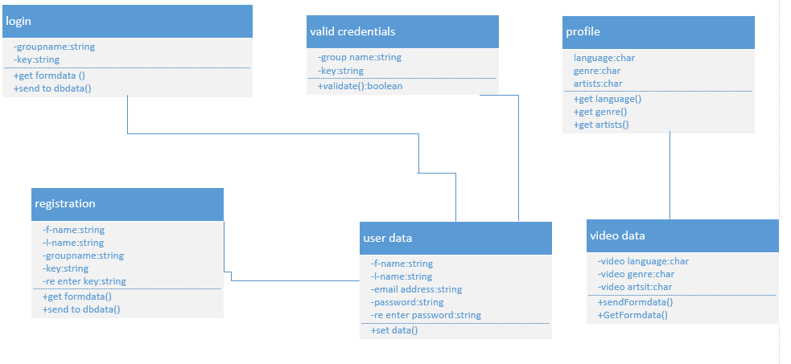

**SEQUENCE DIAGRAM**:



**SERVICE SPECIFICATION**:

**Operational description**:

**Input for services**: In our application input is the data entered by the each user in the group.

**Output for services**: Output will be the desired video according to the priorities of the group given in their profile.

**Constraints:**

**Exceptions:**

**Service flow:** Here in the application when we are entering the details in the profile, the details will go to the data base, now the database will send all the videos in the YouTube to the cloud and now the cloud will sort the videos according to the priorities given by the members of the group.

**Priorities**:

1) Processing is the main priority in our web application. Processing ofdata in cloud according to the preferences and giving the output according to the preference is considered to have the highest priority in our application.

2) Preference of the members of the group which they are given in their profile are also given priority as processing of videos is according to that preferences.

**DESIGN OF MOBILE CLIENT:**

**Features:** submit button, Login button, save button

**Styles:**  CSS

**Technologies**: HTML

JavaScript

Jquery Scripting

Google’s Hadoop

IBM smart cloud

SQL or MYSQL

**HERE ARE SOME OF THE FIGURES WHICH IS A SIMPLE OUTLOOK OF OUR APPLICATION:**

**REGISTRATION PAGE:**

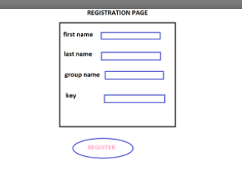

**LOGIN PAGE:**

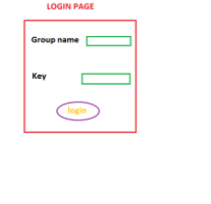

**PROFILE INFORMATION:**

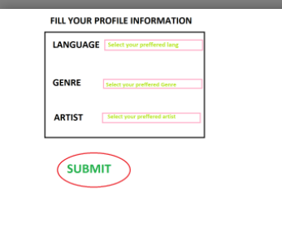

**PROCESSING:**



**RESULT:**

**HERE IS YOUR RESULT**

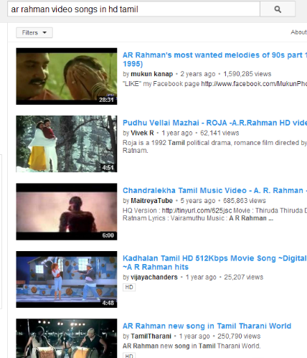

**V) Project Timelines, Members, Task Responsibility:**

**First Increment**: As the first increment, installing all software’s and tools required for project. Then we plan to create the registration page and login page for the users and also develop some code for checking whether login details correct or not. So the Timeline is OCT 04.

**Second Increment**: We shall be creating the user interface for users to enter their interests (i.e. Language, Genre, etc.).And also we want to create cloud as database corresponding tables and storing procedures and functions involved in it.Some of the administrator specific modules shall be completed such as entering with correct ID’s. This is the second increment of project and the Timeline is OCT 18.

**Third Increment**: The third increment of the project is uploading data from YouTube API to cloud by using Glass fish server and also retrieving data from cloud to all the users who are logged in by entering their details. For this increment the Timeline is NOV 01.

**Fourth Increment**: In The final phase of project, the song will be played on all mobiles of users based on the details they entered and chosen of song is based on number of views of that song in YouTube.

**Vi RISK MANAGEMENT**:

* Risks in a project are identified and generally they can be resolved by using some efficient methods. Minor risks involved in our project are:
* Users may forget their passwords.

**Viii BIBLIOGRAPHY:**

* http://en.wikipedia.org/wiki/Audition

• http://www.myspace.com/video/vid/106529870

• www.youtube.com